**Tuning 3D Printed Resorbable Scaffold Strength and Resorption**

Eric Mott1, Xinyi Luo2, Mallory Busso2, Martha O. Wang3, Charlotte E. Vorwald3,

Ali Siblani4, John P. Fisher3, David Dean1

1Deparment of Plastic Surgery, Ohio State University, Columbus, OH 43210; 2Department of Neurological Surgery, Case Western Reserve University, Cleveland, OH 44106; 3Fischell Department of Bioengineering, University of Maryland, College Park, MD 20742; 4EnvisionTEC, Inc., Dearborn, MI 48120

**Background**: Predictable and reliable resorption of scaffolds to treat bone defects is needed if remodeling of the tissue is required to enable the growth of neo-tissue. This neo-tissue must provide mechanical strength, vascularization, and defect site compartmentalization prevention. Thus, 3D printing resorbable scaffolds creates an optimization and control problem for material properties. First, it is necessary to have sufficient “green strength” (i.e., scaffold strength prior to post-fabrication curing) for adequate rendering and to clear unpolymerized polymer from the porous space without destroying the scaffold. Second, it is necessary for the scaffold to be weak enough to resorb by the time the neo-tissue filling the defect site must remodel. **Methods**: Poly(propylene fumarate) (PPF) was prepared as previously described. Diethyl fumarate, the monomer precursor to PPF, was used as a solvent in a 1.5:1 PPF:DEF ratio. These were combined with 3% Irgacure® 819 (BASF, Florham Park, NJ) and 3% Irgacure 784 (BASF). Cylinders (3 mm diameter, 6 mm length) were rendered in an envisionTEC (Dearborn, MI) Perfactory Micro EDU via Continuous Digital Light Processing (cDLP). These cylinders were 3D printed using 90 (N=1), 180 (N=3), and 210 (N=5) seconds exposure per layer and set aside for mechanical testing without post-curing. One specimen (6 mm diameter, 12 mm length) was post-cured in a 3D systems (Rock Hill, SC) ProCureTM 350 UV chamber. Compression testing utilized an Instron (Norwood, MA) 8501 (Figure 1). **Results**: Figure 1, Mechanical Testing of 3D Printed PPF Cylinders: Strength vs. Exposure Time (MPa = megapascals). **Discussion**: The interaction of resin components, especially polymer, initiator, and dye, is critical to scaffold green strength, post-cured strength, and resolution. Irgacure 784 appears to act primarily as a dye during 3D printing allowing highly accurate scaffold fabrication. After clearing the pores, Irgacure 784 appears to act as an initiator during post-curing. Exposure time is correlated with gradually increasing green strength, thereby allowing us to tune the scaffold's strength and, as we expect, its resorption profile.

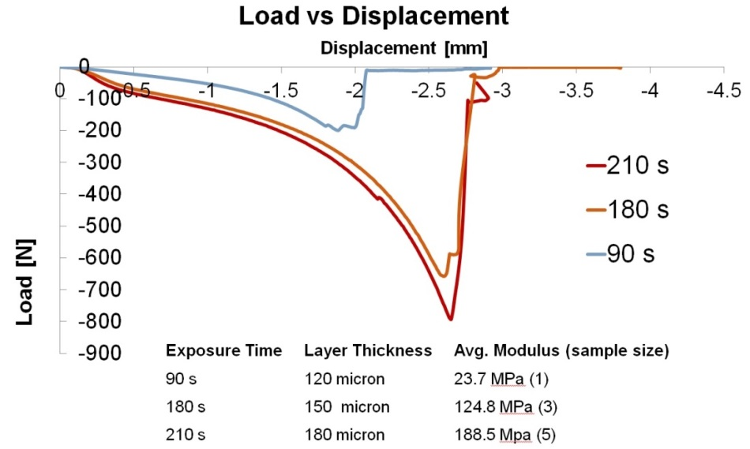

**Figure 1**: Pre- and Post-Curing PPF Scaffold Strength.