**SingleStone .Net API Instructions for Archie Williams**

The database I used is SQL Server. The Create Scripts to recreate the database are included in the project in the SQL folder.

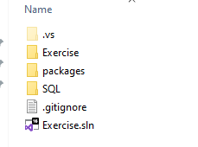

I am using Entity Framework to retrieve the data.

To allow this to run locally you would need to change the connection string property in the web.config.



One way to achieve this is to delete the .edmx file in the Entities folder and recreate it.

After deleting the .edmx file right click on the Entities folder and Add New Item.

When the modal opens click on the section for data and choose ADO.NET Entity Data Model.

I named the Entities ExerciseEntities.

In the next section choose EF Designer from databse and click next.

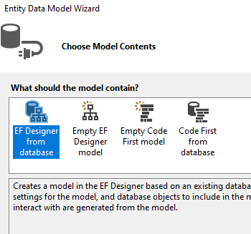

The next section is where you choose your data connection.

If this section does not prepopulate you can click on New Connection and type in your server name.

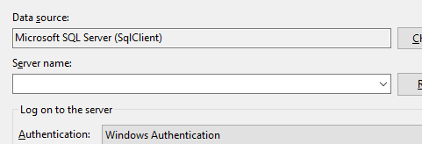

Once you enter your server name then in the Connect to a database section you can use the dropdown list to select the database where you ran the install scripts.

Once that is done click on the button to Test Connection and if it works click OK.

All that is left is to select the four tables Address, Contact, Name and Phone and make sure the checkbox to singularize/pluralize table names is checked.

At this point Entity Framework will update the web.config with your ConnectionString values and you can test the project locally.