**NAVRACHANA UNIVERSITY**

**SCHOOL OF ENGINEERING AND TECHNOLOGY**

**BTECH CSE (TY)**

**SOFTWARE ENGINEERING [CS330]**

**Software Requirements Specification for Vegetable Vendor Tracker**



**Prepared by:**

**ARCHI GANDHI: 21124057**

**AAYUSH PATEL: 21124058**

**KHUSHI PATEL: 21124076**

**KEDAR BHATT: 21124051**

**Table of Contents**

**Table of Contents............................................................................................................... 2**

1. **INTRODUCTION..................................................................................................... 3**
   1. **Purpose.......................................................................................................... 3**
   2. **Document Conventions................................................................................... 3**
   3. **Intended Audience and Reading Suggestions................................................... 3**
   4. **Product Scope................................................................................................. 4**
   5. **References....................................................................................................... 4**
2. **OVERALL DESCRIPTION.......................................................................................... 4**
   1. **Product Perspective......................................................................................... 4**
   2. **Product Function............................................................................................. 5**
   3. **User Classes and Characteristics...................................................................... 5**
   4. **Operating Environment................................................................................... 6**
   5. **Design and Implementation Constraint.......................................................... 6**
   6. **User Documentation....................................................................................... 6**
   7. **Assumptions and Dependencies..................................................................... 7**
3. **EXTERNAL INTERFACE REQUIREMENTS................................................................ 7**
   1. **User Interfaces............................................................................................... 7**
   2. **Hardware Interfaces....................................................................................... 7**
   3. **Software Interfaces....................................................................................... 8**
   4. **Communication Interfaces............................................................................. 8**
4. **SYSTEM FEATURES.............................................................................................. 8**
   1. **Register and Login.......................................................................................... 8**
   2. **Add to Cart and View Cart.............................................................................. 9**
   3. **Confirm Order................................................................................................ 9**
   4. **Add and Update Products............................................................................... 9**
   5. **View Order Details.......................................................................................... 10**
5. **OTHER NON-FUNCTIONAL REQUIREMENTS.......................................................... 10**
   1. **Performance Requirement............................................................................. 10**
   2. **Security Requirements................................................................................... 10**
   3. **Software Quality Attributes.......................................................................... 11**
   4. **Business Rules............................................................................................... 11**

**APPENDIX A: GLOSSARY.................................................................................................. 11**

**APPENDIX B: ANALYSIS MODELS................................................................................ 12-14**

**1. Introduction**

***1.1 Purpose***

The purpose of this document is to provide a comprehensive overview of the **"Vegetable Vendor Tracker"** software. It outlines the functional and non-functional requirements of the system, serving as a reference document for stakeholders, developers, and project managers involved in the development process.

***1.2 Document Conventions***

Throughout this document, the following conventions will be used:

* SRS: Software Requirements Specification
* UI: User Interface
* API: Application Programming Interface
* Vendor: Refers to the vegetable vendors who will use the application.
* Admin: Refers to the administrative users who will manage the system.
* User: Refers to any user of the system, including vendors and admins.

***1.3 Intended Audience and Reading Suggestions***

This document is intended for the following audience:

* Development Team: To gain a comprehensive understanding of the requirements for implementing the Vegetable Vendor Tracker application.
* Project Managers: To align project goals with the outlined requirements and scope.
* Quality Assurance Team: To create test cases and ensure that the software meets the specified requirements.
* Stakeholders: To understand the functionality and features of the proposed system.
* Users: To provide feedback on the system's requirements and features.

Reading Suggestions:

* Stakeholders and project managers may find the "Product Scope" section informative for a high-level project description.
* Developers should focus on the "Functional Requirements" section for detailed feature descriptions and specifications.

***1.4 Product Scope***

The **"Vegetable Vendor Tracker"** is envisioned as a web-based application designed to assist vegetable vendors in managing their inventory, tracking orders, and enhancing interactions with customers. This document will define the features, functionalities, and constraints of the system to ensure that it aligns with the project's objectives.

***11.5 References***

[Include any external documents or resources that are referenced in this SRS. If there are no references, this section can be left empty.]

This is the introductory section of the SRS document, following the specified numbering format. You can continue with the subsequent sections of the document, maintaining the numbering scheme and providing detailed information about the project's requirements.

**2. Overall Description**

***2.1 Product Perspective***

The **"Vegetable Vendor Tracker"** is a standalone web-based application that operates independently. It is designed to assist vegetable vendors in managing their inventory, tracking orders, and interacting with customers. While it functions independently, it may have integration capabilities with external systems or APIs, such as payment gateways, for enhanced functionality.

***2.2 Product Functions***

The primary functions of the **"Vegetable Vendor Tracker"** application include, but are not limited to:

* User registration and authentication.
* Vendor management for onboarding and managing vendors.
* Product inventory management, including adding, updating, and tracking products.
* Order management, which includes order placement, status tracking, and fulfillment.
* Reporting and analytics for data-driven decision-making.
* Notifications to keep users informed about important events and updates.
* User role management to control access and permissions within the system.

***2.3 User Classes and Characteristics***

The system caters to the following user classes:

* Vendors: These are vegetable vendors who use the application to manage their inventory, track orders, and interact with customers.
* Admins: Administrative users who have control over system configurations, user management, and access control.
* Customers: End-users who interact with the system to place orders, view products, and receive notifications.

Each user class has specific characteristics and roles within the system, and the application will provide appropriate features and functionalities to accommodate their needs.

***2.4 Operating Environment***

The **"Vegetable Vendor Tracker"** application is designed to operate in a standard web environment. The following environment considerations apply:

* Web Browser Compatibility: The system will be compatible with commonly used web browsers such as Chrome, Firefox, Safari, and Edge.
* Server Environment: The application will be hosted on a web server with the necessary hardware and software infrastructure to support its functionalities.

***2.5 Design and Implementation Constraints***

The design and implementation of the application will adhere to the following constraints:

* Technology Stack: The application will be developed using specific technologies and frameworks (list them here).
* Budget: The project has budget constraints that must be considered during development.
* Timeframe: The project has a predefined timeline for development and deployment.

***2.6 User Documentation***

User documentation, including user guides and tutorials, will be provided to help users understand and navigate the **"Vegetable Vendor Tracker"** application. This documentation will be made available through the application's user interface.

***2.7 Assumptions and Dependencies***

The successful development and operation of the **"Vegetable Vendor Tracker"** application are dependent on the following assumptions and dependencies:

* Availability of necessary hardware and software resources.
* Accessibility to the internet for users to access the web application.
* Integration with external payment gateways and APIs (if applicable).

**3. External Interface Requirements**

***3.1 User Interfaces***

The user interface of the **"Vegetable Vendor Tracker"** application will be designed to be intuitive and user-friendly. It will include the following elements:

* Login Page: Users (vendors, admins, customers) will enter their credentials to access the system.
* Dashboard: Upon login, users will be presented with a dashboard displaying relevant information and navigation options.
* Vendor Management Interface: For vendor onboarding, profile management, and product inventory management.
* Order Management Interface: To view, process, and fulfill customer orders.
* Reporting and Analytics: Providing data visualization and reporting tools.
* Notification Centre: A section where users can view notifications and updates.
* User Profile: To manage user-specific settings and preferences.

**3.2 Hardware Interfaces**

The **"Vegetable Vendor Tracker"** application will have minimal hardware requirements:

* Web server infrastructure for hosting the application.
* End-user devices such as desktops, laptops, tablets, and smartphones to access the application via web browsers.

***3.3 Software Interfaces***

The application may interact with the following software components or interfaces:

* Web Browsers: The application will be accessible via standard web browsers such as Chrome, Firefox, Safari, and Edge.
* Database Management System (DBMS): The application will utilize a DBMS (specify the DBMS) for data storage and retrieval.
* Third-Party APIs: Integration with external services, such as payment gateways or geolocation services, may be required (list any applicable APIs).

**3.4 Communications Interfaces**

Communication within the **"Vegetable Vendor Tracker"** application will occur over standard web protocols. This includes:

* HTTP/HTTPS: Used for data transmission between the client (user's browser) and the server.
* API Calls: When integrating with third-party services, the application will make API calls using standard REST or SOAP protocols, depending on the specific integration requirements.

**4. System Features**

***4.1 Register and Log in***

*4.1.1 Description*

* + Feature: User Registration
  + Description: Users (vendors, customers) can create accounts by providing required information.
  + User Roles: Customers can register to place orders, while vendors register to manage their inventory and sales.
  + Authentication: Registered users can log in using their credentials.

4.1.2 Acceptance Criteria

* Users can successfully register by providing necessary information.
* Registered users can log in using valid credentials.

***4.2 Add to Cart and View Cart***

*4.2.1 Description*

* Feature: Shopping Cart
* Description: Customers can add items to their shopping carts while browsing vendor products.
* View Cart: Customers can view the contents of their shopping cart before confirming the order.

*4.2.2 Acceptance Criteria*

* Customers can add products to the cart.
* Customers can view the cart and remove items if needed.

***4.3 Confirm Order***

*4.3.1 Description*

* Feature: Order Confirmation
* Description: Customers can confirm their orders after reviewing the cart.
* Payment: If applicable, customers can make payments for their orders during the confirmation process.

*4.3.2 Acceptance Criteria*

* Customers can confirm their orders, and order details are stored in the system.
* Payment processing (if applicable) is successful.

***4.4 Add and Update Products***

*4.4.1 Description*

* Feature: Product Management
* Description: Vendors can add new products to their inventory and update existing product information.
* Inventory: Vendors can manage product quantities and availability.

*4.4.2 Acceptance Criteria*

* Vendors can add new products, including details such as name, price, and description.
* Vendors can update product information and manage inventory.

***4.5 View Order Details***

*4.5.1 Description*

* Feature: Order Details
* Description: Vendors can view order details for orders placed by customers.
* Status Updates: Vendors can update the status of orders (e.g., processing, shipped, delivered).

*4.5.2 Acceptance Criteria*

* Vendors can access order details, including customer information and order contents.
* Vendors can update the order status as needed.

**5. Other Nonfunctional Requirements**

***5.1 Performance Requirements***

*5.1.1 Response Time*

* Requirement: The system shall respond to user requests (e.g., page loads, order confirmations) within 2 seconds, on average, under normal operating conditions.

*5.1.2 Scalability*

* Requirement: The system should be designed to handle a minimum of 100 simultaneous user sessions without significant performance degradation. Scalability should be achieved through load balancing and efficient resource utilization.

***5.2 Security Requirements***

*5.2.1 User Authentication*

* Requirement: User authentication shall be securely implemented using industry-standard encryption methods (e.g., HTTPS). Passwords must be hashed and stored securely.

*5.2.2 Data Protection*

* Requirement: User data, including personal information and payment details, shall be stored securely in compliance with applicable data protection laws (e.g., GDPR).

*5.2.3 Role-Based Access Control*

* Requirement: Role-based access control (RBAC) shall be implemented to ensure that users can only access functionalities and data appropriate for their roles.

***5.3 Software Quality Attributes***

*5.3.1 Usability*

* Requirement: The user interface shall be designed with usability in mind, ensuring that it is intuitive and user-friendly. User testing and feedback shall be utilized to improve usability.

*5.3.2 Reliability*

* Requirement: The system shall have a reliability rate of at least 99.9%, ensuring minimal downtime and data loss. Regular backups shall be performed to prevent data loss.

*5.3.3 Maintainability*

* Requirement: The system shall be designed and documented in a way that facilitates easy maintenance and updates. Code shall adhere to coding standards, and documentation shall be comprehensive.

***5.4 Business Rules***

*5.4.1 Pricing and Discounts*

* Rule: The system shall support the application of discounts or promotional pricing based on vendor-defined rules. Discounts may vary by product or customer type.

*5.4.2 Order Fulfillment*

* Rule: Vendors are responsible for fulfilling and delivering customer orders within the specified timeframe. Order status updates shall be communicated to customers in real-time.

*5.4.3 Vendor Verification*

* Rule: Vendors must undergo a verification process to ensure the authenticity of their business. Only verified vendors can list products on the platform.

**APPENDIX A: GLOSSARY**

* **Vendor**- The individual or business that sells vegetables. Vendors are the primary users of the app.
* **Inventory**- The list of vegetables and quantities that a vendor has available for sale.
* **Stock Management**- The management of available vegetable stock, including tracking quantities, replenishing inventory, and avoiding overstock or shortages.
* **Order Management**- The handling of customer orders, including order placement, fulfillment, and tracking.
* **Customer Database**- A database containing information about the vendor's customers, including contact details and purchase history.
* **Payment Tracking**- Monitoring payments received from customers, including cash, digital payments, and credit transactions.
* **Delivery Management**- Features related to the delivery of orders, including tracking delivery status and providing delivery receipts.
* **GPS Tracking**- The use of GPS technology to track the location of delivery vehicles or vendors for better route planning.
* **Admin Panel**- The backend interface of the app that allows administrators to manage user accounts, settings, and data.
* **Syncing**- The process of updating data between the app and the server to ensure consistency.
* **Data Backup**: The regular backup of app data to prevent data loss in case of technical issues.

**APPENDIX B: ANALYSIS MODELS**

1. **ER DAIGRAM (Entity Relationship Daigram)**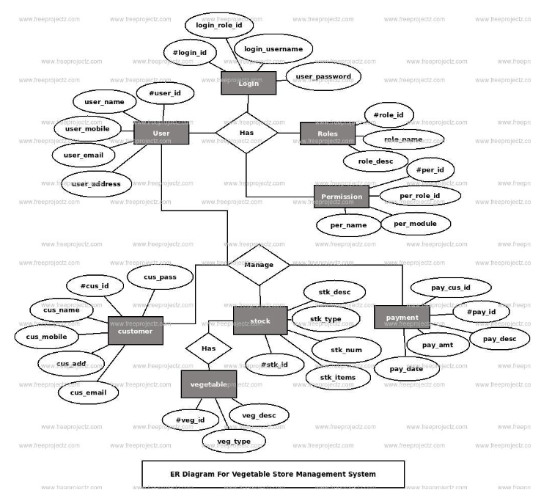
2. **Use Case Diagram**

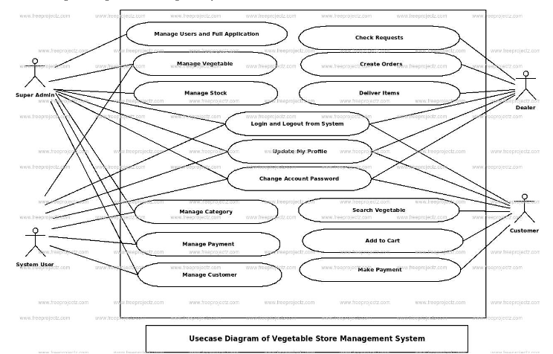

1. **Data Flow Diagram**

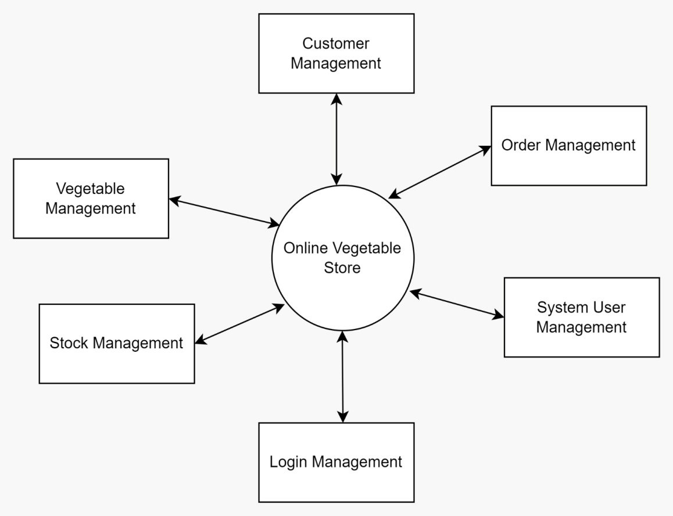

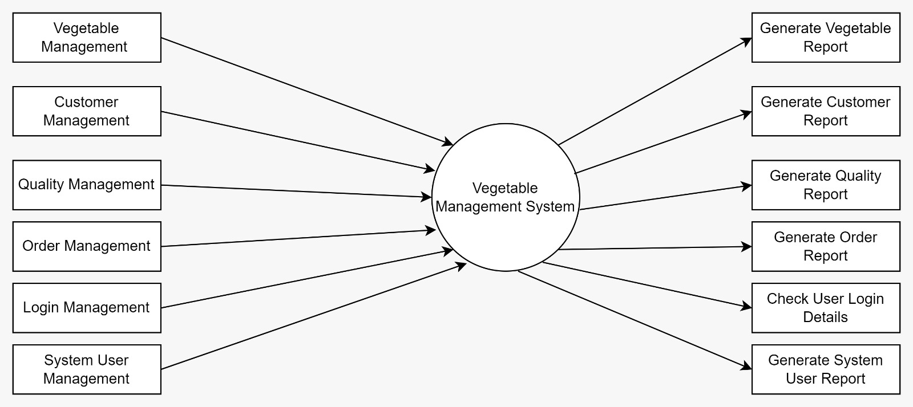

1. **Sequence Diagram**

