AJAY KUMAR GARG ENGINEERING COLLEGE,
GHAZIABAD
DEPARTMENT OF COMPUTER SCIENCE & ENGINEERING


WEB DESIGNING WORKSHOP
(BCS-353)
COURSE : B.Tech
BRANCH : CSE DS
SECTION : 1
SEMESTER : III
GROUP : B

SUBMITTED BY SUBMITTED TO
Name: Divya Agarwal Ms Ritika Dhyani
Roll No.: 2200271540029

PROGRAM 6- To make Cart Page
The Cart Page contains the details about the books wich are added to the cart.
SOFTWARE USED- Visual Studio Code
Required Code:
<!DOCTYPE html>
<html lang="en">
<head>
<meta charset="UTF-8">
<meta name="viewport" content="width=device-width, initial-scale=1.0">
<title>Document</title>
</head>

<style>
table,th,td{
border: 1px solid rgb(12, 4, 4);
border-collapse: collapse;
width: 1270px;

}
th{
background-color: rgb(227, 227, 233);
height: 50px;
color: rgb(0, 5, 8);
}
td{
font-size: large;
height: 10px;
color: black;
}

</style>
<body>
<table>
<th><img src="https://th.bing.com/th/id/OIP.nFqSMtMzU6crAzjDitD_WAHaFj?w=231&h=180&c=7&r=0&o=5&dpr=1.3&pid=1.7" alt="" height="60px"></th>
<th colspan="4"><u><h2>Bookify</h2></u><sub><h4>byAmazon</h4></sub ></th>
<tr>

<td><b>HOME</b></td>
<td><b>Book Name</b></td>
<td><b>Price</b></td>
<td><b>Quantity</b></td>
<td><b>Amount</b></td>

</tr>

<tr>
<td>CSE</td>

<td>
<i> XML BIBLE </i>
</td>

<td>$40</td>
<td> 2</td>
<td>$80</td>
</tr>

<tr>
<td>ECE</td>
<td>
<i> Control System Engineering</i>
</td>
<td>$62</td>
<td>1</td>
<td>$62</td>
</tr>

<tr>
<td>EEE</td>
<td>
<i> Fundamentals of Electrical Engineering</i>
</td>
<td>$35</td>
<td>4</td>
<td>$140</td>
</tr>

<tr>
<td>CIVIL</td>
<td>
<i> Objective Approach To Civil Engineering</i>
</td>
<td>$50</td>
<td>3</td>
<td>150</td>
</tr>
</table>
</body>
</html>

Screenshot of Output Window:

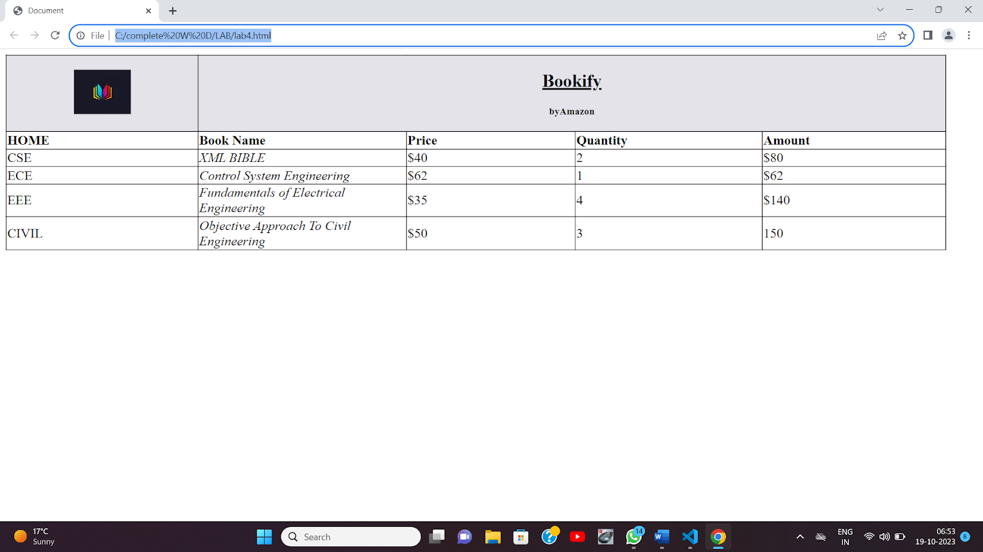

PROGRAM: 7 Write Javascript program to validate the following fields of registration page

Name Password Email

<script>

function validateform(){

var name=document.myform.name.value;

var password=document.myform.password.value;

var email=document.myform.email.value;

var atposition=email.indexOf("@");

var dotposition=email.lastIndexOf(".");

if (atposition<1 || dotposition<atposition+2 || dotposition+2>=email.length){

alert("Please enter a valid e-mail address)");

return false;

}

if (phone.length<10 || phone.length>10){

alert("Phone number must be 10 digits long.");

return false;

}

if (name==null || name==""){

alert("Name can't be blank");

return fals }else if(name.length<6){

alert("Name must be at least 6 characters long.");

return false;

}

else if(password.length<6){

alert("Password must be at least 6 characters long.");

return false;

}

}

</script>

