Database Partitioning and Query Performance Results
Project Evidence and Screenshots
This document presents the database tables, schema details, partition configuration, record count, and query execution plans used during the project analysis.

Figure 1. Database Tables Available in the Project
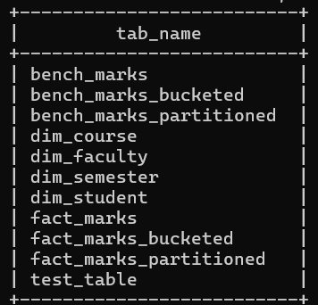

Figure 2. Query Execution Plan for Aggregated Marks Data
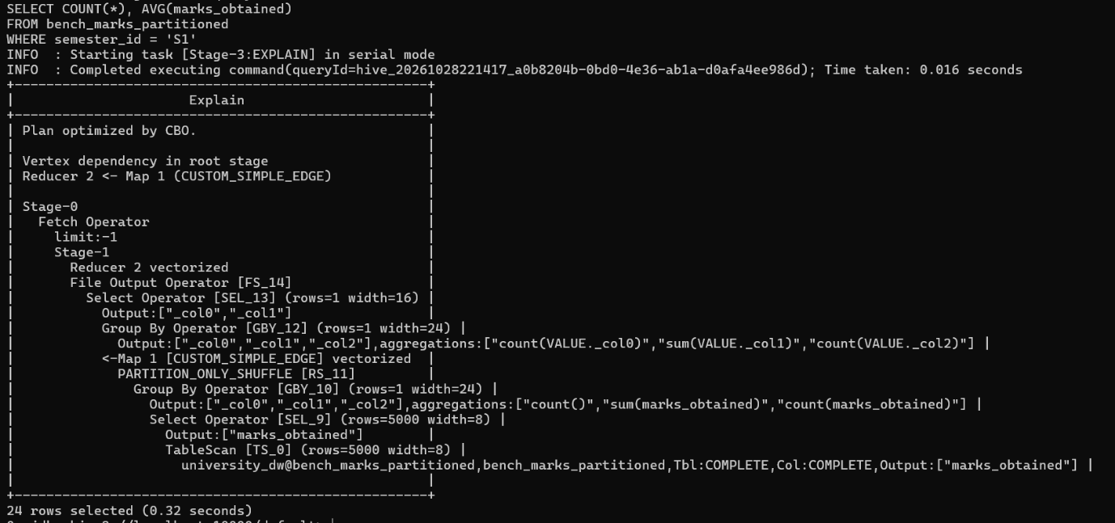

Figure 3. Query Execution Plan for Partitioned Marks Data
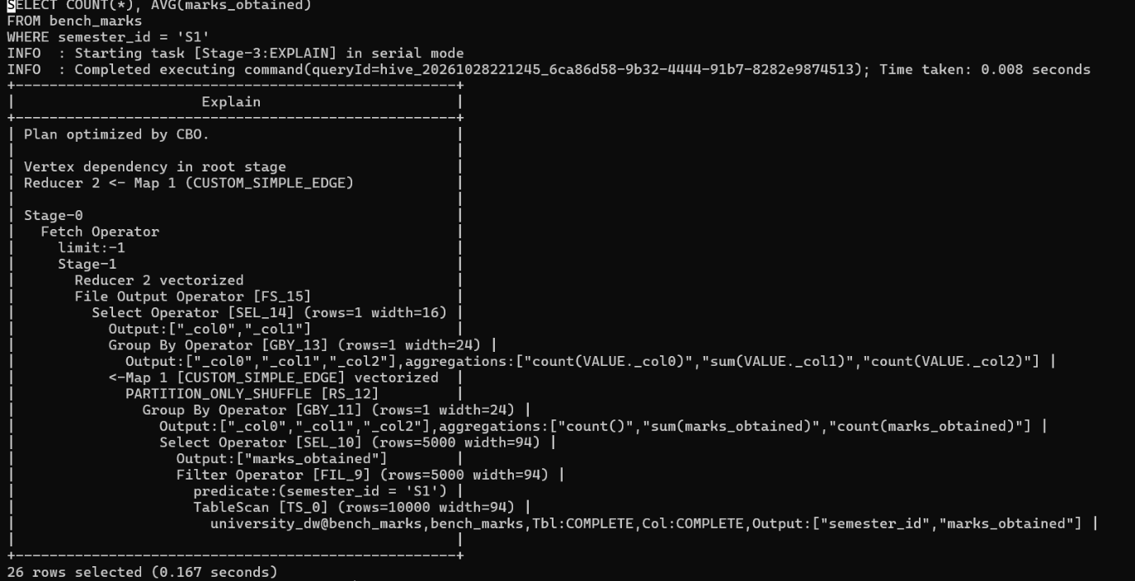

Figure 4. Bench Marks Table Schema and Column Details
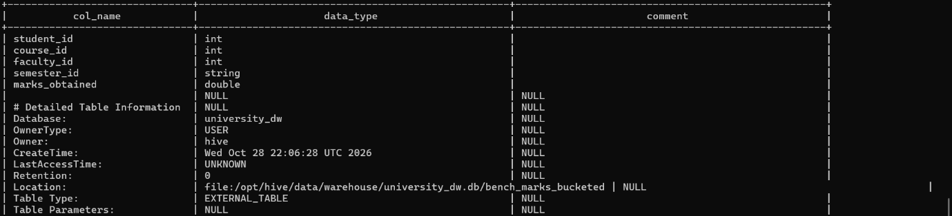

Figure 5. Semester-Based Partition Configuration
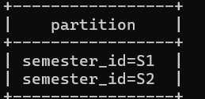

Figure 6. Total Number of Records in the Dataset
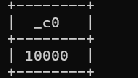

Figure 7. Query Execution Plan for Bucketed Marks Data
