PART 1: GlowKart — Deep Technical Q&A

Schema & Database
Q: Why 9 tables specifically? Could you have done it with fewer?
"Technically yes — I could have stored allergens as a column directly in users, or stored ingredients as a comma-separated string in products. But that would violate normalization. Keeping them as separate tables with proper relationships means I can query, filter, and join on them. A comma-separated string in a column can't be indexed or joined — it's just text. The 9 tables reflect the actual entities and relationships in the domain, not arbitrary design."
Q: Explain 1NF, 2NF, 3NF with an example from your schema.
"1NF means no repeating groups — every column holds one atomic value. In my products table, I don't store multiple ingredient names in one column; each ingredient gets its own row in the ingredients table. 2NF means no partial dependencies — every non-key attribute depends on the whole primary key. In product_ingredients, the primary key is (product_id, ingredient_id) — there are no other columns there that depend on only one of them. 3NF means no transitive dependencies — a non-key column shouldn't depend on another non-key column. In products, I store category_id not category_name — category_name lives in the categories table because it depends on category_id, not on product_id."
Q: What's a foreign key and what does ON DELETE CASCADE do?
"A foreign key enforces a referential integrity rule — it says 'this column's value must exist in that other table.' For example, order_items.order_id must reference a real row in orders. ON DELETE CASCADE means if I delete a parent row — say I delete an order — all its child rows in order_items are automatically deleted too. Without CASCADE, deleting a parent with children would throw a foreign key violation error."
Q: What's the difference between PRIMARY KEY and UNIQUE?
"Both enforce uniqueness, but a table can only have one PRIMARY KEY and it can't be NULL. UNIQUE constraints can be on any column and allow one NULL. In my schema, email in users has a UNIQUE constraint — there's only one primary key (user_id), but I also need emails to be unique across accounts."
Q: How would you query the top 5 selling products?
sql
SELECT p.name, SUM(oi.quantity) AS total_sold
FROM order_items oi
JOIN products p ON p.product_id = oi.product_id
GROUP BY p.name
ORDER BY total_sold DESC
LIMIT 5;
"GROUP BY aggregates all order_items rows per product, SUM counts total units sold, ORDER BY sorts descending, LIMIT 5 takes the top results."
Q: What's an index and when would you add one?
"An index is a data structure that speeds up lookups on a column — instead of scanning every row, the database can jump directly to matching rows. I'd add indexes on columns used frequently in JOINs or WHERE clauses: user_id in orders, product_id in order_items and product_ingredients, ingredient_id in product_ingredients. The tradeoff is that indexes slow down writes slightly since they need to be updated on every INSERT/UPDATE — so you add them strategically, not on every column."

API & Backend
Q: What is REST and how does your API follow it?
"REST is an architectural style for APIs. The key principles: use HTTP methods semantically (GET to read, POST to create, PUT to update, DELETE to remove), make each endpoint represent a resource (like /products or /orders), and keep requests stateless — each request contains everything needed to process it. My API follows this: GET /products returns the product list, POST /orders creates an order, PUT /skin-profile updates a profile."
Q: What's the difference between PUT and PATCH?
"PUT replaces the entire resource — you send all fields even if only one changed. PATCH partially updates — you send only the fields you want to change. I used PUT for skin-profile since there are only two fields (skin_type and allergens) and I always send both."
Q: What is a Pydantic model and why is it useful?
"Pydantic models define the expected structure of incoming request data. FastAPI uses them to automatically validate requests before my function runs — wrong type, missing required field, invalid email format — all caught and returned as a 400-level error with a clear message. Without it, I'd have to manually validate every field, which is tedious and error-prone."
Q: How does password hashing work?
"When a user signs up, I never store their actual password. I run it through sha256_crypt, which produces an irreversible hash — a fixed-length string that looks like random characters. When they log in, I hash what they entered and compare it to the stored hash. If they match, the password is correct. The key is it's one-way — even if someone steals the database, they can't reverse the hash to get the original password."
Q: What is CORS and why did you need it?
"CORS — Cross-Origin Resource Sharing — is a browser security policy that blocks JavaScript on one domain from making requests to a different domain. My frontend is on vercel.app and my backend is on onrender.com. The browser was blocking those cross-origin API calls. I added FastAPI's CORSMiddleware with allow_origins=* to tell the browser the backend accepts requests from any origin. In production I'd restrict it to just my frontend's specific domain."

Deployment
Q: What is the difference between your local setup and production?
"Locally, I run everything on my laptop — uvicorn on localhost:8000, PostgreSQL on my machine. In production, the backend runs on Render's servers, the database is on Supabase's cloud, and the frontend is served by Vercel's CDN globally. The key change: environment variables. Locally my DATABASE_URL is in a .env file. On Render it's set as an environment variable in the dashboard — the code reads it the same way with os.getenv(), but the secret never lives in the codebase."
Q: What is a CDN?
"Content Delivery Network — a network of servers distributed globally that serve static files (like my index.html, CSS, fonts) from whichever server is geographically closest to the user. Vercel uses a CDN, so a user in Japan gets my frontend from a server in Asia, not from a server in the US. Faster load times."
Q: What does Render's free tier limitation mean practically?
"On the free tier, Render spins down the server after 15 minutes of inactivity. The next request takes 30-60 seconds to wake it up — a 'cold start.' For a demo or college project this is fine. In production you'd pay for a plan that keeps the server always running, or implement a workaround like a scheduled ping every 10 minutes to prevent sleep."

PART 2: Your Other Projects

Customer Churn Prediction
Q: Walk me through your ML pipeline.
"I started with the IBM Telco dataset, which has customer demographic and usage data with a churn label. I preprocessed it — handled missing values, encoded categorical variables, scaled numerical features. Then I did exploratory analysis to understand which features correlate with churn (contract type, tenure, monthly charges were strong signals). I trained six models, evaluated each on accuracy, precision, recall, F1, and confusion matrices, and compared them."
Q: Why six models? Which performed best?
"To benchmark — different algorithms have different strengths. Gradient Boosting typically outperforms on tabular data like this because it builds trees sequentially correcting previous errors. Logistic Regression is interpretable and a good baseline. Random Forest is robust and handles nonlinear relationships well. The point was to understand tradeoffs, not just pick one."
Q: What's the difference between precision and recall?
"Precision is: of all the customers I predicted would churn, how many actually did? Recall is: of all customers who actually churned, how many did I correctly identify? For churn prediction, recall matters more — missing a churning customer (false negative) is more costly than wrongly flagging a loyal one (false positive). So you'd optimize for recall even if it sacrifices some precision."
Q: What is a confusion matrix?
"A 2x2 table showing True Positives, True Negatives, False Positives, and False Negatives. It shows exactly where your model is making mistakes — whether it's mostly wrong in one direction. For churn: TP = correctly predicted churn, TN = correctly predicted no churn, FP = predicted churn but customer stayed, FN = missed a churner."

Civic Issue Reporting Platform (SIH)
Q: What did GIS add to this project?
"GIS — Geographic Information Systems — let me attach real geographic coordinates to issue reports and visualize them on a map. Authorities could see clusters of complaints in specific areas rather than reading through a list, which makes prioritization much faster. I used geotagging to capture latitude/longitude from the user's device when they submit a report."
Q: How did you prioritize issues on the dashboard?
"Based on a combination of factors — number of reports for the same location (density signals urgency), issue category (safety issues vs. minor complaints), and time since last resolution. The dashboard sorted by a weighted priority score."

Smart Public Safety System
Q: How did the IoT component work?
"The Arduino microcontroller reads data from sensors — motion detectors, environmental sensors — continuously. When a threat threshold is crossed, it triggers an alert that gets sent to the web app through serial communication. The web app then routes notifications to relevant parties: residents, emergency services. The physical emergency button gives a backup that doesn't depend on sensors — direct human activation."
Q: What was the biggest technical challenge?
"Reliable communication between the hardware and software layers. Serial communication timing had to be precise — dropped signals meant missed alerts. We also had to handle false positives from sensor noise, so we implemented a threshold window — the sensor had to stay above the threat level for a minimum duration before triggering an alert."

PART 3: CS Fundamentals

DBMS
Q: What is ACID?
"ACID stands for Atomicity, Consistency, Isolation, Durability — properties that guarantee database transactions are reliable. Atomicity: the transaction is all-or-nothing — my order placement either fully completes or fully rolls back. Consistency: the database moves from one valid state to another. Isolation: concurrent transactions don't interfere with each other. Durability: once committed, data survives crashes."
Q: What's the difference between SQL and NoSQL?
"SQL databases are relational — structured tables with schemas, JOINs, and ACID transactions. Best for structured data with clear relationships, like e-commerce (users, orders, products). NoSQL databases (MongoDB, Redis, Cassandra) are schema-flexible, horizontally scalable, optimized for specific access patterns. Best for unstructured data, high-volume writes, or document storage. For GlowKart, SQL was the right choice because the relational model — products having ingredients, orders having items — maps naturally to tables."
Q: What is a transaction?
"A group of database operations treated as a single unit. Either all succeed or none do. In GlowKart, placing an order is a transaction — create the order row, insert order items, reduce stock, mark cashback applied. If any step fails — say the stock update errors — the entire transaction rolls back and the order is never created. Without transactions, a partial failure could leave the database in an inconsistent state: an order exists but stock wasn't reduced."
Q: What is normalization and why does it matter?
"Normalization is organizing a database to reduce redundancy and prevent anomalies. It matters because: update anomaly — without normalization, changing a product's category name means updating it in every product row; delete anomaly — deleting the last product in a category might lose the category information; insert anomaly — you can't insert a category until a product exists in it. Normalizing into separate tables with foreign keys prevents all three."

DSA (likely to be asked in coding rounds)
Q: What is the time complexity of a SQL JOIN?
"In the general case, a nested loop join is O(n×m) where n and m are the sizes of the two tables. With proper indexes on the join columns, it reduces to O(n log m) since the index allows binary search-style lookups rather than scanning every row."
Q: Explain a HashMap. Where would you use one in your project?
"A HashMap stores key-value pairs with O(1) average lookup time. In GlowKart's backend, I could use a dict (Python's hashmap) to cache frequently-queried ingredient lists — instead of hitting the database on every recommendation request, store the ingredient lookup in memory and only refresh it when the data changes."
Q: What data structure would you use to implement a cart?
"A list of objects — each object is {product_id, quantity, price}. In my frontend implementation it's a JavaScript array. For a backend cart with persistence, it'd be a database table (cart_items) with user_id, product_id, and quantity — essentially the same structure in relational form."

PART 4: HR & Behavioral Questions
Q: Tell me about yourself.
"I'm a final-year BTech CSE student at VIT-AP with a CGPA of 8.8. I've built projects across full-stack development, ML, and IoT — the one I'm most proud of is GlowKart, a deployed full-stack e-commerce platform I built from scratch, from database schema design to cloud deployment. I'm also involved in the Microsoft Student Chapter at my college on the technical team. I'm actively looking for opportunities where I can build real systems and keep learning at the edges of what I know."
Q: What's your biggest strength?
"I'm good at picking up new things fast under pressure. Building GlowKart, I had never set up a FastAPI backend, handled deployment pipelines, or debugged production database connection issues before — I learned all of it in the span of this project. When I hit something I don't know, I figure it out rather than stopping."
Q: What's a weakness?
"I sometimes over-engineer early — I'll spend time planning the cleanest possible structure before writing any code. I've been working on getting better at starting with something that works and refining it, rather than trying to get the design perfect upfront."
Q: Describe a challenge you faced and how you overcame it.
"During GlowKart deployment, my Supabase connection string was failing with a DNS resolution error — the standard direct connection URL wasn't resolving from Render's servers. I dug into it, found that Supabase now recommends a session pooler connection string instead of the direct one, switched the URL format, and the connection worked immediately. It taught me that deployment issues are often environment-specific and the fix is usually in the configuration, not the code."
Q: Why should we hire you over other candidates?
"I've actually built and deployed a full-stack system — not just written code for a tutorial, but debugged real production issues, made real design tradeoffs, and have a live link to show for it. Most candidates at this level have either strong theory with no practical projects, or tutorial projects they can't explain in depth. I can walk through every design decision in GlowKart, explain why I made it, and what I'd do differently."
Q: Where do you see yourself in 5 years?
"Building and owning systems end-to-end — I want to go deep on backend engineering and system design. In 5 years I'd like to be the person on a team who's responsible for how a service is architected, not just implementing tickets."

PART 5: Questions TO ASK the interviewer
Always have 2-3 ready — not asking looks like disinterest:
- "What does the onboarding process look like for a new engineer joining the team?"
- "What's the biggest technical challenge the team is working on right now?"
- "What does a typical first 3 months look like in this role?"

Quick-reference cheat sheet
Topic | One-line answer
Why FastAPI? | Auto validation, fast to write, better perf than Flask
Why PostgreSQL? | Relational schema fits the domain, ACID compliance
What is 3NF? | No transitive dependencies — every column depends only on the primary key
What is a transaction? | All-or-nothing group of DB operations — commit or rollback
What is a junction table? | Resolves many-to-many relationships
What is CORS? | Browser policy blocking cross-origin requests — handled with middleware
What is hashing? | One-way function to store passwords securely
Cold start? | Free-tier servers sleep after inactivity — first request is slow
What is an index? | Data structure speeding up column lookups at the cost of slower writes
Route ordering bug? | Specific routes must come before dynamic ones in FastAPI

The single most important thing: be able to draw your schema and trace one complete user flow (signup → set allergens → browse → add to cart → checkout with cashback) from browser to database and back, without referring to notes. If you can do that fluently, you'll handle 90% of what gets thrown at you.

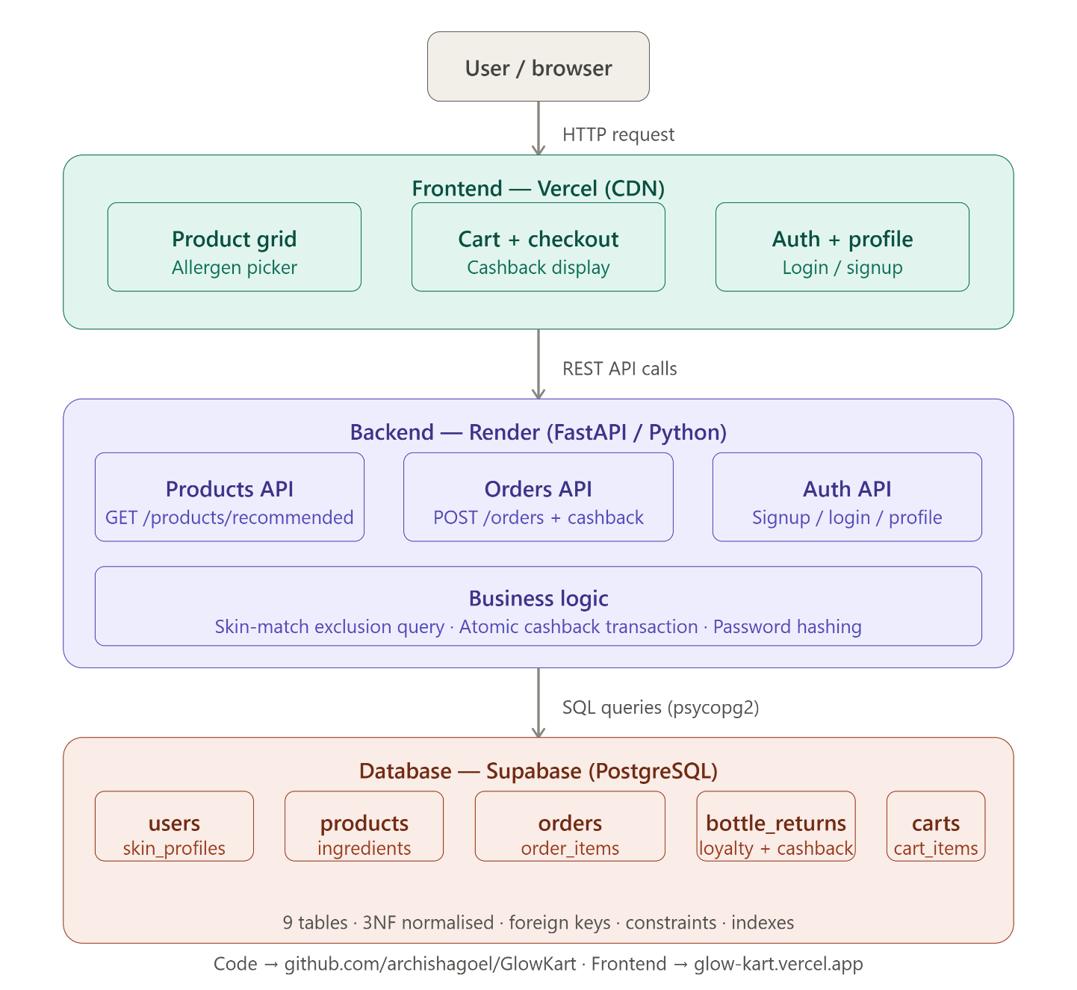
This is your full project architecture in one view — three distinct layers, each running on its own cloud service, each with a clear responsibility.
The flow in one sentence for your interview: "The user's browser loads a static page from Vercel, which makes REST API calls to FastAPI running on Render, which runs SQL queries against a PostgreSQL database on Supabase — and all three layers talk only to the adjacent one, never skipping a layer."
That last point — no direct browser-to-database connection — is actually an important design principle worth mentioning. The backend is the only thing that ever touches the database, which means authentication, business logic (cashback, skin-matching), and data validation all happen server-side, not in the browser where a user could tamper with them.

