**What is supervised learning?**

* It’s a type of machine learning which works on the presence of a supervisor as a teacher.
* We have given a dataset where we split it to train and test data. Then we train machine using the train data and try to predict the output using test data.
* It works on labeled data.

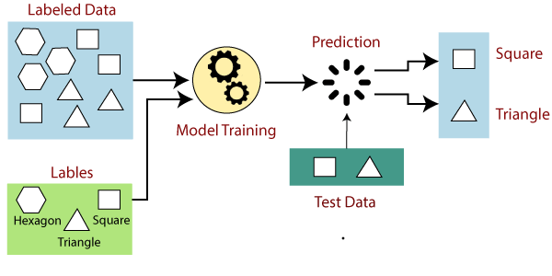

**Types of Supervised Learning:-**

1. **Regression:** Regression is used to predict continuous quantinty such as “weight”,”salary” etc. and it is in form of integar quantity.
2. **Classification:** Classification is used to predict a discrete class lebel.The output variable is a category such as “Male”or “Female”or “black” or “white” etc.

[**https://www.analyticsvidhya.com/blog/2021/05/5-regression-algorithms-you-should-know-introductory-guide/**](https://www.analyticsvidhya.com/blog/2021/05/5-regression-algorithms-you-should-know-introductory-guide/)

[**https://www.jigsawacademy.com/popular-regression-algorithms-ml/**](https://www.jigsawacademy.com/popular-regression-algorithms-ml/)

**Types of regression:**

* [**Linear Regression**](https://www.jigsawacademy.com/popular-regression-algorithms-ml/#Linear-Regression)
* [**Neural Network Regression**](https://www.jigsawacademy.com/popular-regression-algorithms-ml/#Neural-Network-Regression-)
* [**Lasso Regression**](https://www.jigsawacademy.com/popular-regression-algorithms-ml/#Lasso-Regression-)
* [**Decision Tree Regression**](https://www.jigsawacademy.com/popular-regression-algorithms-ml/#Decision-Tree-Regression-)
* [**Random Forest**](https://www.jigsawacademy.com/popular-regression-algorithms-ml/#Random-Forest)
* [**KNN Model**](https://www.jigsawacademy.com/popular-regression-algorithms-ml/#KNN-Model-)
* [**Support Vector Machines (SVM)**](https://www.jigsawacademy.com/popular-regression-algorithms-ml/#Support-Vector-Machines-(SVM))

**Regression :**

**Linear Regression:-**

It predicts a dependent variable (y) based on the independent variable(x).

**Formula: Y=b*x + c**

**b=slope of the line**

**c=Y-intercept**

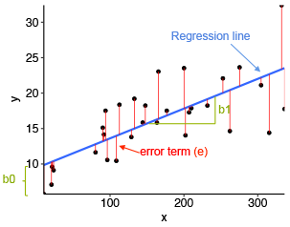

To achieve the best-fit regression line such that the difference between predicted y value(pred) and true value(y) is minimum, we have to update b and c .

cost function(J) of the Linear Regression is

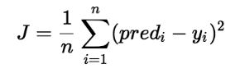

J=Root Mean Squared Error between predicted y value(pred) and true y value(y).

In order to reduce the the cost function we use gradient descent method(starting with random value of b and c and iteratively updating it) ,thus we find the best fit regression line.

**Logistic Regression:**