PROJECT REPORT
Sales Data Analytics Dashboard using Python
IBM SkillsBuild Data Analytics with AI Academic Internship 2026
Conducted by BharatCares in association with AICTE
Submitted by
Archit Mahajan
B.Tech Computer Science and Engineering (2nd Year)

1. Abstract
This project presents a Sales Data Analytics Dashboard built with Python. Retail sales records are cleaned and analysed to understand sales and profit across time, product categories and regions. Two Linear Regression models (trend only, and trend with monthly seasonality) are trained on monthly sales to forecast future demand, and the better one is used for a six month forecast. The analysis is delivered through a Jupyter Notebook and an interactive Streamlit dashboard that lets a user filter by year, region and category and view key performance indicators, charts and the forecast.

2. Introduction
Businesses generate large amounts of sales data every day. Without analysis, this data does not help managers decide what to stock, where to focus marketing or how much revenue to expect. Data analytics turns raw transactions into clear indicators and visual summaries. This project applies the Python data stack to a retail sales dataset and combines descriptive analysis with a simple predictive model.

3. Problem Statement
Managers need a quick and visual way to see how sales and profit are changing, which categories and regions perform best, and what sales to expect in the coming months. Reading spreadsheets of thousands of rows does not give this view. The problem is to build a tool that cleans the data, summarises it, and forecasts future sales in an easy to use dashboard.

4. Objectives
- Load and clean retail sales data using Pandas.
- Calculate KPIs: total sales, total profit and profit margin.
- Visualise sales trends and performance by category, region and sub-category.
- Forecast the next six months of sales using Linear Regression, compare a trend-only model with a trend plus seasonality model, and evaluate them with MAE, RMSE and R-squared.
- Build an interactive Streamlit dashboard with filters.

5. Tools and Technologies
Tool | Use in the project
Python 3 | Programming language
Pandas, NumPy | Data loading, cleaning and aggregation
Matplotlib | Charts and visualisation
Scikit-learn | Linear Regression model and evaluation metrics
Streamlit | Interactive web dashboard
Jupyter Notebook | Step by step analysis and documentation

6. Dataset Description
The project uses the Superstore Sales Dataset from Kaggle (https://www.kaggle.com/datasets/vivek468/superstore-dataset-final). It contains 9,994 order records with 21 columns, covering orders from January 2014 to December 2017 (48 months). The columns used in this project are:
Column | Description
Order Date | Date on which the order was placed
Region | Sales region (West, East, Central, South)
Category / Sub-Category | Product grouping
Segment | Customer segment
Sales | Revenue from the order line
Quantity | Units sold
Profit | Profit from the order line

The dataset had no missing values or duplicate rows in the columns used, and the dates are in month/day/year format, which Pandas converts to datetime.

7. Methodology

7.1 Data cleaning
Duplicate rows are removed, the Order Date column is converted to a datetime type, and rows with a missing date or sales value are dropped. Year and Month columns are derived from the date for grouping.

7.2 Exploratory analysis
Sales are grouped by month, category, region and sub-category. KPIs are computed from the totals. Each view is plotted with Matplotlib and saved as an image.

7.3 Forecasting model
Sales are aggregated by month and each month is given a numeric time index (0, 1, 2, ...). Two Linear Regression models are built. The first (trend only) fits sales against the time index, which gives a straight line. The second (trend plus seasonality) adds one-hot columns for the month of the year, so the model can learn that some months are regularly higher or lower. The last 12 months (2017) are kept aside as a test set to check how well each model predicts unseen months. The better model is then trained on all 48 months and used to predict the next six months.

7.4 Dashboard
The Streamlit app reads the same data, applies the sidebar filters for year, region and category, and updates the KPI cards, charts and forecast table on every change. The number of forecast months can be changed with a slider.

8. Results and Analysis
All figures in this section were produced by running the notebook on the Kaggle Superstore dataset.

8.1 Key performance indicators
Indicator | Value
Total Sales | 2,297,201
Total Profit | 286,397
Profit Margin | 12.47%
Records analysed | 9,994

8.2 Sales trend
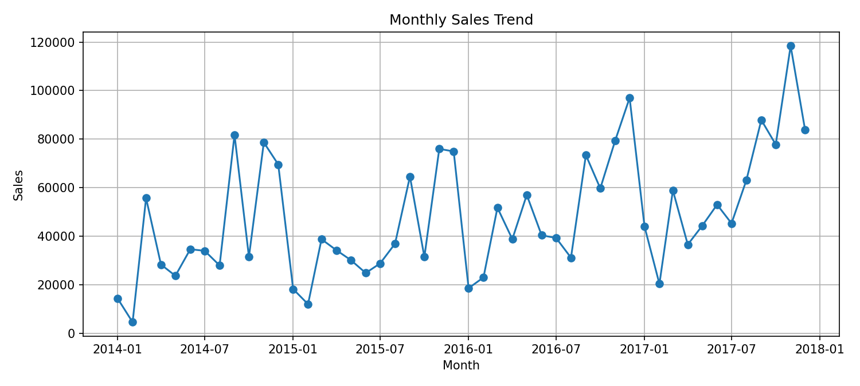
Figure 1: Monthly sales trend
Yearly sales were about 484,000 in 2014, 471,000 in 2015, 609,000 in 2016 and 733,000 in 2017, so sales have grown since 2015. In every year, September, November and December are the three highest sales months. Over the four years they together account for about 43% of all sales (13.4%, 15.3% and 14.2%), while February is the weakest month overall (2.6%).

8.3 Category and region performance
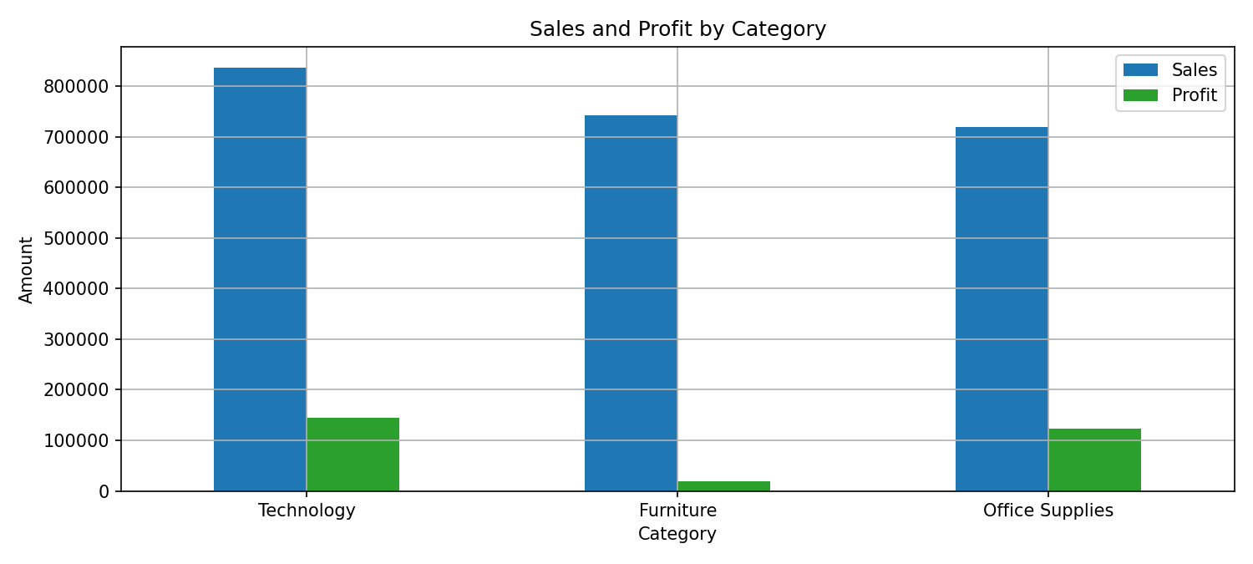
Figure 2: Sales and profit by category
Technology has the highest sales (about 836,000) and the highest profit margin (17.4%). Furniture has almost the same sales as Office Supplies (about 742,000 and 719,000) but earns only a 2.5% margin, a profit of about 18,500 compared with 122,500 for Office Supplies. This shows that high sales do not always mean high profit.
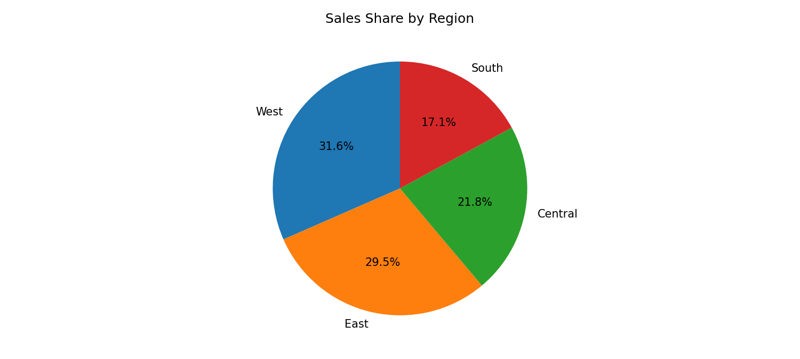
Figure 3: Sales share by region
The West region contributes the largest share of sales (31.6%), followed by East (29.5%), Central (21.8%) and South (17.1%).
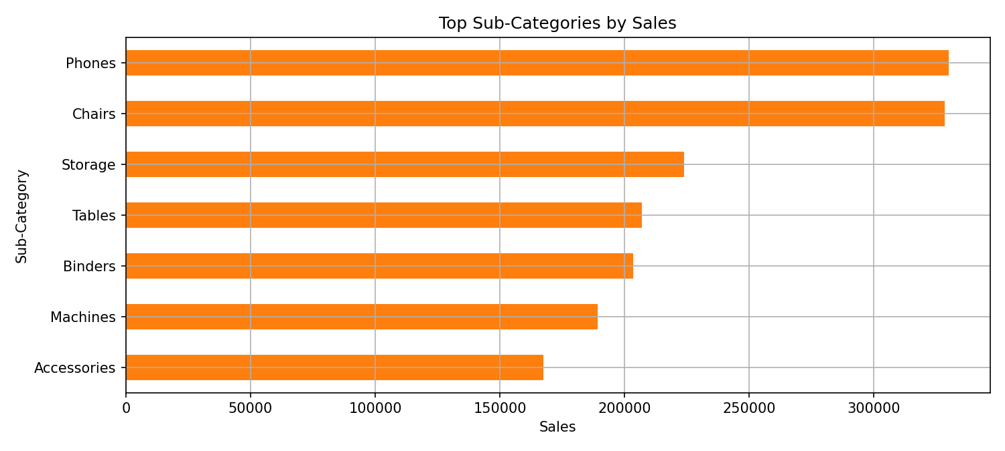
Figure 4: Top sub-categories by sales
Phones (about 330,000) and Chairs (about 328,000) are the two best selling sub-categories.

8.4 Forecast and model evaluation
Both models were tested on the 12 months of 2017, which they had not seen during training.
Model | MAE | RMSE | R-squared
Trend only | 19,664 | 23,665 | 0.157
Trend + Seasonality | 10,794 | 14,558 | 0.681

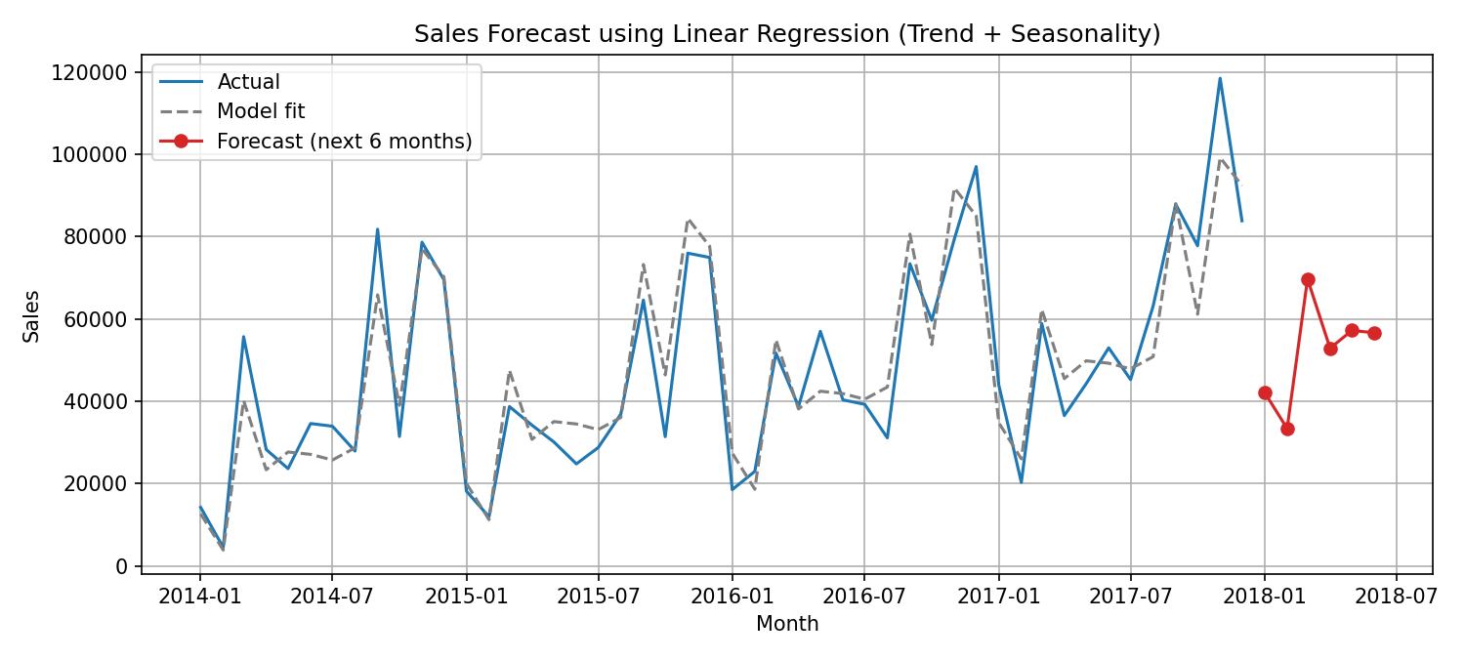
Figure 5: Actual sales, trend line and 6 month forecast
The trend-only model explains little of the variation (R-squared 0.157) because a straight line cannot follow the large September to December peaks. Adding month-of-year features cuts the average error (MAE) almost in half and raises R-squared to 0.681, so this model is used for the final forecast. For January to June 2018 it predicts about 42,200, 33,400, 69,700, 52,900, 57,200 and 56,600, with March the highest and February the lowest. The remaining error shows that month-to-month sales are still affected by factors the model does not see, such as discounts and large individual orders.

9. Conclusion
The project shows how Python can turn raw sales records into KPIs, charts and a forecast inside an interactive dashboard. The analysis reveals strong year-end and September peaks, and that a category with high sales (Furniture) can still earn very little profit. A simple Linear Regression with a time index and month-of-year features is easy to explain and clearly beats a trend-only line (R-squared 0.681 against 0.157), but with only four years of data it remains a basic forecasting method.

10. Future Scope
- Try dedicated time series models such as SARIMA, Holt-Winters or Prophet and compare them with the regression model.
- Add features such as discount, region and category to a multivariate model, and forecast by category or region.
- Connect the dashboard to a database or live data source.
- Deploy the dashboard online using Streamlit Community Cloud.

11. References
- Superstore Sales Dataset, Kaggle: https://www.kaggle.com/datasets/vivek468/superstore-dataset-final
- Pandas documentation: https://pandas.pydata.org/docs/
- Scikit-learn documentation: https://scikit-learn.org/stable/
- Streamlit documentation: https://docs.streamlit.io/
- IBM SkillsBuild: https://skillsbuild.org/

