PROJECT REPORT
Sales Data Analytics Dashboard using Python
IBM SkillsBuild Data Analytics with AI Academic Internship 2026
Conducted by BharatCares in association with AICTE
Submitted by
Archit Mahajan
B.Tech Computer Science and Engineering (2nd Year)

1. Abstract
This project presents a Sales Data Analytics Dashboard built with Python. Retail sales records are cleaned and analysed to understand sales and profit across time, product categories and regions. A Linear Regression model is trained on monthly sales to forecast future demand. The analysis is delivered through a Jupyter Notebook and an interactive Streamlit dashboard that lets a user filter by year, region and category and view key performance indicators, charts and the forecast.

2. Introduction
Businesses generate large amounts of sales data every day. Without analysis, this data does not help managers decide what to stock, where to focus marketing or how much revenue to expect. Data analytics turns raw transactions into clear indicators and visual summaries. This project applies the Python data stack to a retail sales dataset and combines descriptive analysis with a simple predictive model.

3. Problem Statement
Managers need a quick and visual way to see how sales and profit are changing, which categories and regions perform best, and what sales to expect in the coming months. Reading spreadsheets of thousands of rows does not give this view. The problem is to build a tool that cleans the data, summarises it, and forecasts future sales in an easy to use dashboard.

4. Objectives
- Load and clean retail sales data using Pandas.
- Calculate KPIs: total sales, total profit and profit margin.
- Visualise sales trends and performance by category, region and sub-category.
- Forecast the next six months of sales using Linear Regression and evaluate it with MAE, RMSE and R-squared.
- Build an interactive Streamlit dashboard with filters.

5. Tools and Technologies
Tool | Use in the project
Python 3 | Programming language
Pandas, NumPy | Data loading, cleaning and aggregation
Matplotlib | Charts and visualisation
Scikit-learn | Linear Regression model and evaluation metrics
Streamlit | Interactive web dashboard
Jupyter Notebook | Step by step analysis and documentation

6. Dataset Description
The project is designed for the Superstore Sales Dataset available on Kaggle (https://www.kaggle.com/datasets/vivek468/superstore-dataset-final). It contains retail order records with the following columns used in this project:
Column | Description
Order Date | Date on which the order was placed
Region | Sales region (West, East, Central, South)
Category / Sub-Category | Product grouping
Segment | Customer segment
Sales | Revenue from the order line
Quantity | Units sold
Profit | Profit from the order line

If the CSV file is not present, the code creates a sample dataset with the same columns, so the full pipeline can still be run and tested.

7. Methodology

7.1 Data cleaning
Duplicate rows are removed, the Order Date column is converted to a datetime type, and rows with a missing date or sales value are dropped. Year and Month columns are derived from the date for grouping.

7.2 Exploratory analysis
Sales are grouped by month, category, region and sub-category. KPIs are computed from the totals. Each view is plotted with Matplotlib and saved as an image.

7.3 Forecasting model
Sales are aggregated by month and each month is given a numeric time index (0, 1, 2, ...). A Linear Regression model fits sales against this index, which gives a straight line trend. The last six months are kept aside as a test set to check how well the model predicts unseen months. After evaluation, the model is trained on all months and used to predict the next six months.

7.4 Dashboard
The Streamlit app reads the same data, applies the sidebar filters for year, region and category, and updates the KPI cards, charts and forecast table on every change. The number of forecast months can be changed with a slider.

8. Results and Analysis
Note: the figures in this section were produced by running the notebook on the built-in sample data. Running the notebook on the Kaggle Superstore CSV will give figures for that dataset using the same steps.

8.1 Key performance indicators
Indicator | Value
Total Sales | 2,703,920
Total Profit | 311,926
Profit Margin | 11.54%
Records analysed | 8,000

8.2 Sales trend
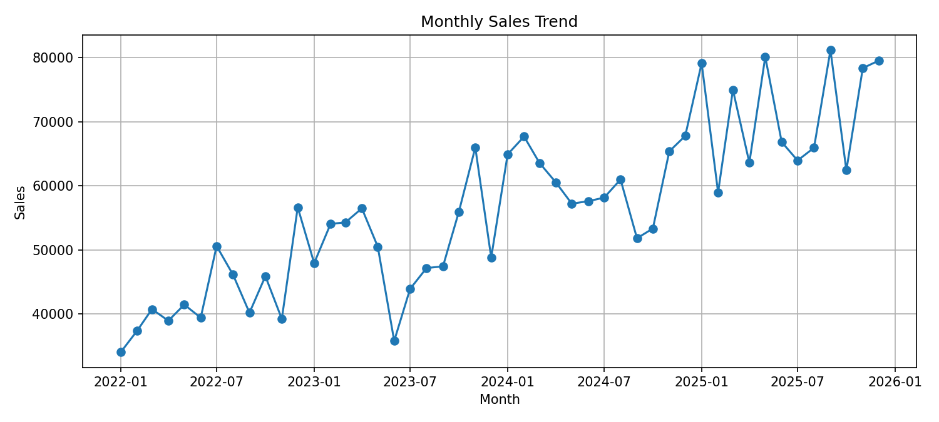
Figure 1: Monthly sales trend
Monthly sales rise over the years with a visible peak in the last months of each year, which suggests a year-end seasonal effect.

8.3 Category and region performance
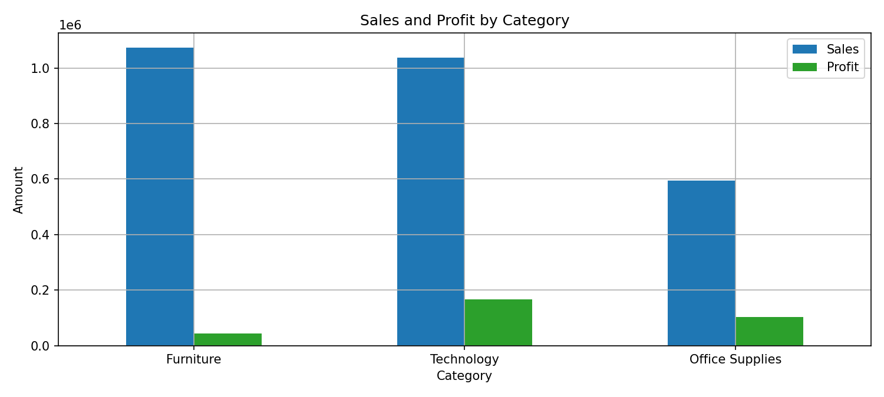
Figure 2: Sales and profit by category
Furniture has the highest sales but the lowest profit margin (about 4.0%), while Office Supplies has the highest margin (about 17.3%). This shows that high sales do not always mean high profit.
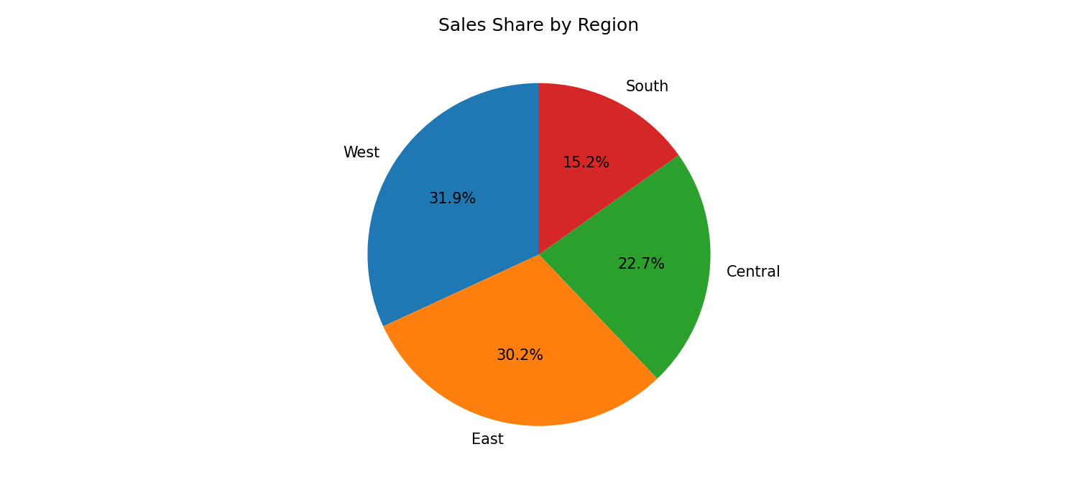
Figure 3: Sales share by region
The West region contributes the largest share of sales.
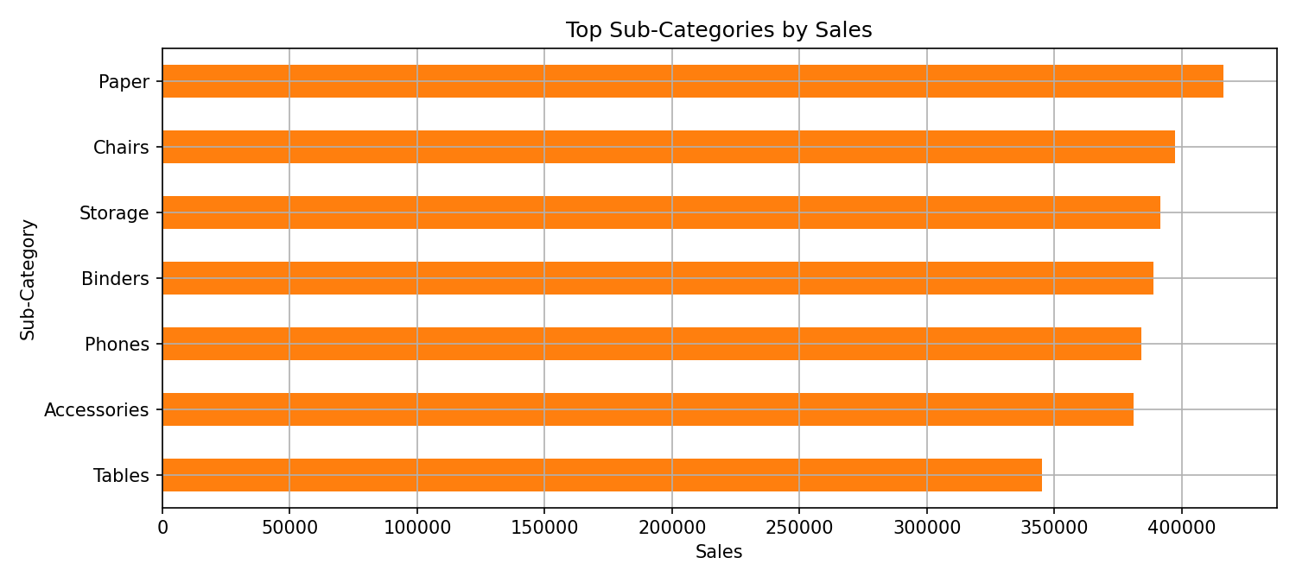
Figure 4: Top sub-categories by sales

8.4 Forecast and model evaluation
Metric | Value (6 month test set)
MAE | 6,874
RMSE | 7,263
R-squared | 0.155

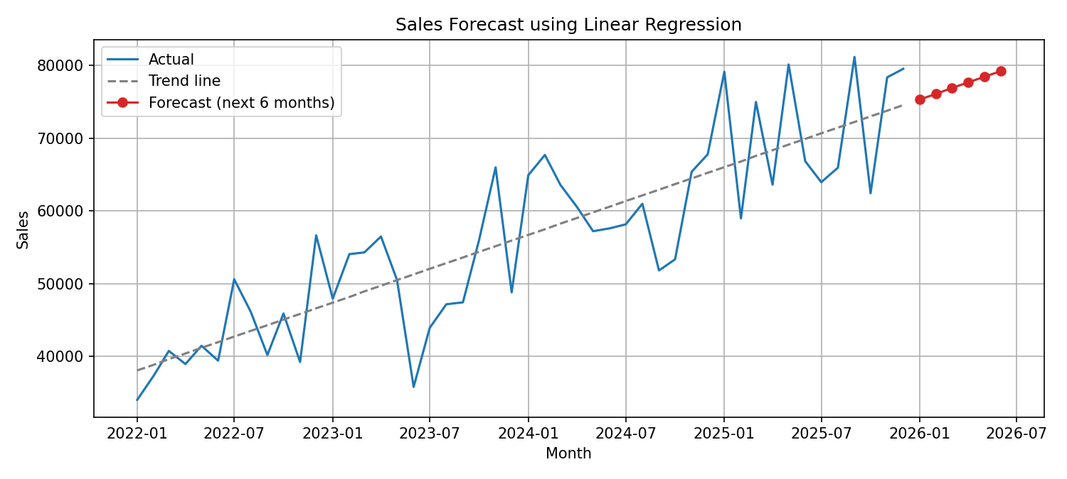
Figure 5: Actual sales, trend line and 6 month forecast
The model predicts monthly sales rising from about 75,300 in the first forecast month to about 79,200 in the sixth. The R-squared value is low because the test months include the year-end peak, and a straight line cannot represent seasonality. The forecast therefore shows the direction of the trend, not exact monthly values.

9. Conclusion
The project shows how Python can turn raw sales records into KPIs, charts and a forecast inside an interactive dashboard. The analysis reveals that sales peak near year end and that the category with the highest sales is not the most profitable. The Linear Regression model is simple and explainable and captures the overall trend, but it does not capture seasonality, which limits its accuracy.

10. Future Scope
- Use seasonal models such as SARIMA, Holt-Winters or Prophet to capture yearly patterns.
- Add features such as discount, region and category to a multivariate model.
- Connect the dashboard to a database or live data source.
- Deploy the dashboard online using Streamlit Community Cloud.

11. References
- Superstore Sales Dataset, Kaggle: https://www.kaggle.com/datasets/vivek468/superstore-dataset-final
- Pandas documentation: https://pandas.pydata.org/docs/
- Scikit-learn documentation: https://scikit-learn.org/stable/
- Streamlit documentation: https://docs.streamlit.io/
- IBM SkillsBuild: https://skillsbuild.org/

