**Week 3-LAB A**

**1)**

#include<iostream>

using namespace std;

void firstRepeatingPair (int a[], int n)

{

bool check=false;

for (int i=0;i<n-1;i++){

for (int j=i+1;j<n-1;j++){

if(a[i]==a[j]&&a[i+1]==a[j+1]){

check=true;

cout<<"Pair: \t"<<a[i]<<","<<a[i+1]<<endl;

cout<<"Output:\t"<<j+1<<endl;

break;

}

}

}

if(!check) {cout<<"No repeating pairs found. "<<endl; } }

int main()

{

int a,n;

cout<<"Enter Number of elements in array:\n";

cin>>n;

int *arr=new int[n];

cout<<"\nEnter elements in array:\n";

for(int i=0;i<n;i++){

cin>>a;

arr[i]=a;

}

firstRepeatingPair (arr, n);

return 0;

}

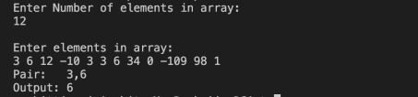***2)***

#include<iostream>

#include<cmath>

using namespace std;

int closestSum (int a[], int N, int sum)

{

int left=0, right=N-1;

int csum=a[left]+a[right];

int lsum=a[left], rsum=a[right];

while (left<right)

{

int curr_sum=a[left]+a[right];

if (abs (curr_sum) <abs (csum))

{

csum=curr_sum;

lsum=a[left];

rsum=a[right];

}

if (curr_sum<sum) {left++; }

else{right--;}

}

return csum;

}

int main(){

int N, sum;

cout<<"Enter no. of elements (N):\t";

cin>>N;

int arr[N];

cout<<endl<<"Enter all the "<<N<<" elements:"<<endl<<endl; for (int i=0;i<N; i++) { cin>>arr[i];}

cout<<endl<<"Enter a closest sum value:\t";

cin>>sum;

for (int i=0;i<N-1;i++)

{

for (int j=0;j<N-i-1;j++)

{

if (arr[j]>arr[j+1])

{

int temp=arr[j];

arr[j]=arr[j+1];

arr[j+1]=temp;

}

}

}

cout<<endl<<"Output: \t"<<closestSum (arr, N, sum) <<endl;

}

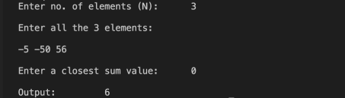

***3)***

#include<iostream>

using namespace std;

void missingAP (int arr[], int N)

{

int d =(arr[N-1]-arr[0])/N;

for (int i=1;i<N;i++)

{

if (arr[i]!=arr[0]+i*d){

cout<<"The missing AP term is "<<arr[0]+i*d<<endl; return;

}

}

cout<<"No AP term missing"<<endl;

}

int main()

{

int A[6]={2,4,6,10,12,14};

cout<<"A={";

for (int i=0;i<6;i++)

{

if (i<5)

{cout<<A[i]<<",";

}

else{ cout<<A[i]<<"}"<<endl<<endl; }

}

missingAP (A, 6);

return 0;

}

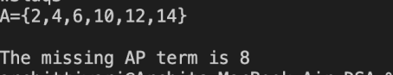***4)***

#include<iostream>

using namespace std;

void findFirstAndLastOccurrence (int A[], int N, int x, int &f, int &l)

{

int low=0, high=N-1, first=-1, last=-1;

while (low<=high)

{

int mid=low+ (high-low)/2;

if (A[mid] ==x)

{

if (first== -1 || mid<first)

{first=mid;}

if (mid>last) {last=mid; }

int temp=mid;

while (--temp>=low && A[temp]==x) {f=temp; } temp=mid;

while (++temp<=high&&A[temp]==x) {l=temp; } break;

}

else if (A[mid]>x) {high=mid-1;}

else{low=mid+1;}

}

}

int main()

{

int A[]={1,2,2,2,3,4,5};

cout<<"A[]={";

for (int i=0;i<7;i++)

{

if (i<6)

{

cout<<A[i]<<",";

}

else{ cout<<A[i]<<"}"<<endl<<endl; } }

int x=2;

cout<<"x="<<x<<endl<<endl;

int first, last;

findFirstAndLastOccurrence (A, 6, x, first, last);

if (first!=-1&&last!=-1)

{

cout<<"First occurrence of "<<x<<" is at "<<first+1<<"th postion"<<endl; cout<<"Last occurrence of "<<x<< " is at "<<last+1<<"th postion"<<endl; }

else { cout<<x<<"Repeating occurence not found"<<endl; }

return 0;

}

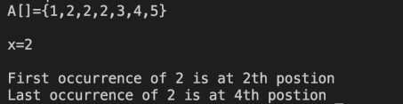

***5)***

#include<iostream>

using namespace std;

void interpolSearch (int a[], int N, int K)

{

int low=0, high=N-1;

while (low<=high && K>=a[low] && K<=a [high])

{

int pos=low+ ((K- a[low])* (high-low))/(a[high]-a[low]);

if (a[pos]==K)

{

cout<<"K="<<K<<" found at "<<pos+1<<"th postion"<<endl;

return;

}

if (a[pos] <K) {low=pos+1;}

else {high=pos-1; }

}

cout<<"K="<<K<<" not found in the array"<<endl;

}

int main()

{

int arr[]={10,12,13,16,18,19,20,21,22,23};

cout<<"A[]={";

for (int i=0;i<10;i++)

{

if (i<9) {cout<<arr[i]<<",";}

else{ cout<<arr[i]<<"}"<<endl<<endl; }

}

int K=20;

interpolSearch (arr, 10, K);

return 0;

}

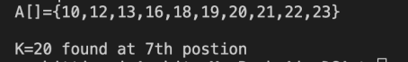***6)***

#include<iostream>

using namespace std;

bool checkSubArr(int a[], int n, int len)

{

for (int i=0;i<=n-len;i++){

if(a[i]>=a[i+len-1]) {return true; }

}

return false;

}

int maxSubLength (int arr[], int n){

int low=2, high=n, result=1;

while (low<=high)

{

int mid=low+(high-low)/2;

if (checkSubArr (arr, n, mid))

{

result=mid;

low=mid+1;

}

else

{

high=mid-1;

}

}

return result;

}

int main()

{

int n;

cout<<"Enter the no. of elements (n): \t";

cin>>n;

int arr[n];

cout<<endl<<"Enter all the "<<n<<" elements: "<<endl<<endl;

for (int i=0;i<n;i++) { cin>>arr[i];}

cout<<endl;

cout<< "The maximum length subarray where the 1st element is greater than or equal to the

last element is: " <<maxSubLength (arr, n) << endl;

return 0;

}



***7)***

#include<iostream>

#include<cstring>

using namespace std;

int strIndex (string a[], int N, string x){

for (int i=0;i<N;i++){

if(a[i]==x)

{return i;}

}

return -1;

}

int main()

{

string s[]={"Hi", "Folks", "ide", "for", "practice"};

cout<<"arr[]={";

for (int i=0;i<5;i++)

{

if (i<4)

{

cout<<"\""<<s[i]<<" \", ";

}

else

{ cout<<" \" "<<s[i]<<" \"}"<<endl<<endl; }

}

string x;

cout<<"Enter a string (x):\t";

getline (cin, x);

cout<<"Output: \t"<<strIndex (s, 5, x) <<endl;

return 0;

}



***8)***

#include<iostream>

using namespace std;

bool linearSearch (int a[], int N, int K)

{

int pos;

for (pos=0;pos<N; pos++)

{

if(a[pos]==K)

{return true; }

}

return false;

}

int main(){

int arr[]={10,12,13,16,18,19,20,21,22,23};

cout<<"arr[]=(";

for (int i=0;i<10;i++)

{

if (i<9)

{cout<<arr[i]<<",";}

else

{cout<<arr[i] <<"}"<<endl<<endl; }

}

int K;

cout<<"Enter an element to be searched (K):\t"; cin>>K;

if (linearSearch (arr, 10, K))

{cout<<"K="<<K<<" present in the array"<<endl; } else {cout<<"K="<<K<<" absent in the array"<<endl; } return 0;

}

