Certificate

This is to certify that Project report for the subject “GUI design and programming ” on the topic of “CHESS” is satisfactorily submitted by Mehta Archit (07CP619) and Students of 3rd level as part of their BE-CP course during the academic year, 2009-10.

Date of submission:______________

Faculty in charge: Ms. Namrata Dave

**Project title** **:- CHESS**

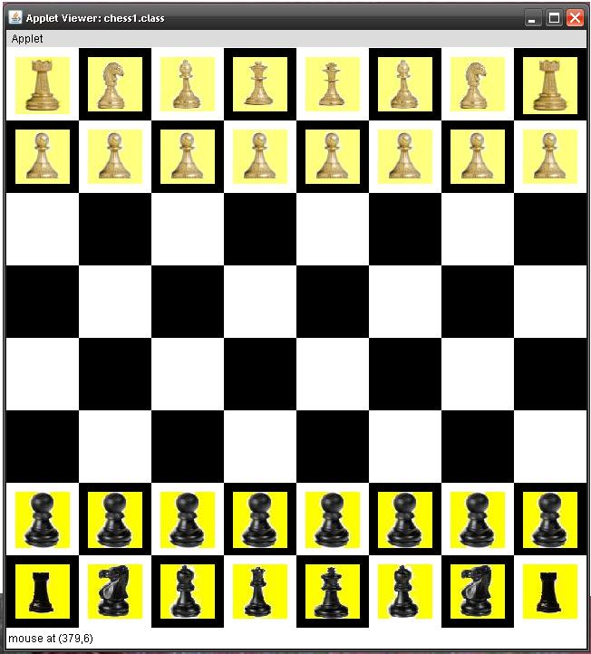

**Submitted By :**

**Archit Mehta (07cp619)**

**INDEX**

|  |  |  |
| --- | --- | --- |
| **Sr. No.** | **Contents** | **Page No.** |
| 1 | Project Profile | 1 |
| 2 | Introduction to Project | 2 |
| 3 | Proposed Application | 3 |
| 3.1 | Scope of Application | 3 |
| 3.2 | Objective of Application | 3 |
|  |  |  |
| 4 | Application Requirements | 4 |
| 4.1 | Hardware Requirements | 4 |
| 4.2 | Software Requirements | 4 |
| 5 | Tools Information | 5 |
| 5.1 | JAVA J2SE 1.4 | 5 |
| 6 | Pictorial Overview | 6 |
| 7 | Reference | 7 |

1. **Project Profile:-**

|  |  |
| --- | --- |
| Project Title | "CHESS" |
| Organization | Sardar Patel University |
| Software | Java J2SE 1.4 |
| Operating System | Windows XP |
| Project Guide | Ms. Namrata Dave |
| Submitted By | Archit Mehta(07cp619) |
| Submitted To | G.H. Patel College of Engineering & Technology VallabhVidhyanagar -388120  Gujrat, India |

**2. Introduction to Project:-**

Since many years this game is very popular in the world & still charm is as it is. It is very good for mind.

In this game there is 16 pieces both player has & in that 8 soldiers , 2 horse, 2 elephant , 2 camel , queen & king is there & every piece has its rule that how it will move. As per rule if king has no way to save his self then he loses game.

**3. Proposed Application:-**

**3.1 Scope of Application:**

Game should be as per the international law & there should not be any kind of breaking of rules & regulation.

Any mistake by user in moving pieces must be handled properly.

**3.2 Objective of Application:**

Provide all thing for 2 player so they can play game anywhere

any time .

**4. Application Requirements:-**

**4.1 Hardware Requirements:-**

🡪Processor: Pentium or after

🡪Hard disk: Min of 1GB

🡪Keyboard: Any

🡪Mouse: Any

**4.2 Software Requirements:-**

🡪Operating System: Windows 98 or after

🡪Front Tools: Java

🡪Web Browser: Internet Explorer 6 or after

**5. Tools Information:-**

**5.1 JAVA J2SE 1.4:-**

JAVA which is particularly designed for graphics user interface so for game like “CHESS” it is more suitable.

Applet is one of its most efficient feature which is used for this game & mouse event & other various method needed for this game are very easy to implement.

Though this game is mostly based on logic most useful method in this game are getpixel(),Repaint(),draw(),update() etc. available in this software

**6. Pictorial Overview:-**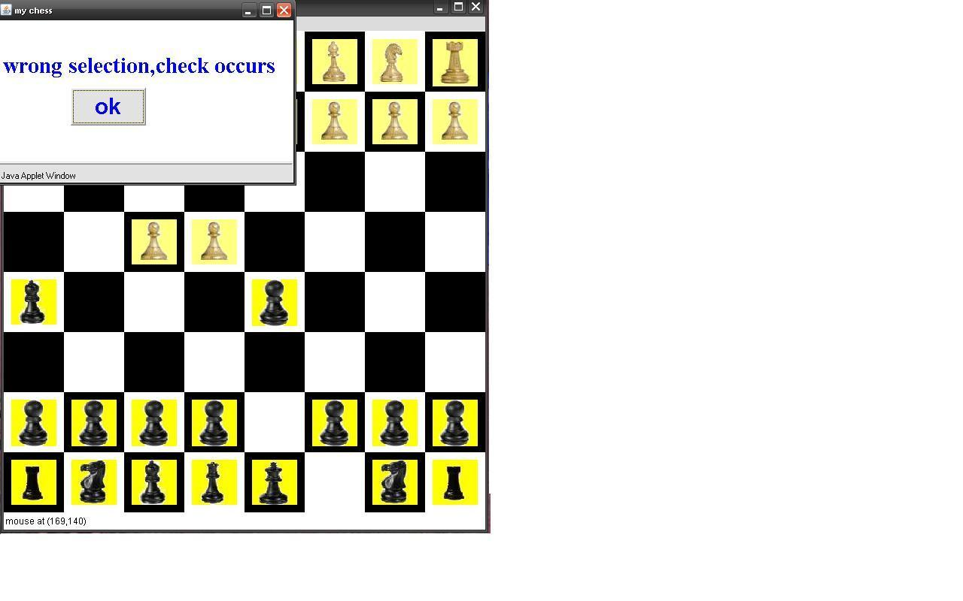

**7. Reference:-**

**Books:-**

**1)Complete Referance of JAVA by Herbert Schiltd**

**WEB:-**

[**www.bing.com**](http://www.bing.com) **(for images)**

[**www.google.com**](http://www.google.com) **(for images)**