Tasks:

1. Create a Highly available Kubernetes cluster manually using Google Compute Engines (GCE). Do not create a Kubernetes hosted solution using Google Kubernetes Engine (GKE). Use Kubeadm(preferred)/kubespray. **Do not use kops**.

* Used kubeadm for installation and flannel as overlay network. Created 2 node cluster 1-master, 1-slave
* Created 2 VM on GCP

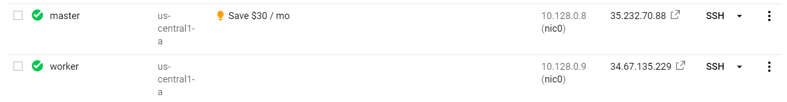

Created kubernetes cluster with 2 VMs

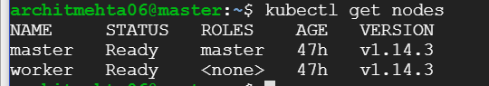

architmehta06@master:~$ kubectl cluster-info  
Kubernetes master is running at <https://10.128.0.8:6443>  
KubeDNS is running at <https://10.128.0.8:6443/api/v1/namespaces/kube-system/services/kube-dns:dns/proxy>  
To further debug and diagnose cluster problems, use 'kubectl cluster-info dump'.  
architmehta06@master:~$ kubectl config current-context  
kubernetes-admin@kubernetes

1. Create a CI/CD pipeline using Jenkins (or a CI tool of your choice) outside Kubernetes cluster (not as a pod inside Kubernetes cluster).  
   🡪 Skipped
2. Create a development namespace.

* Skipped

1. Deploy [guest-book](https://github.com/kubernetes/examples/tree/master/guestbook) application (or any other application which you think is more suitable to showcase your ability, kindly justify why you have chosen a different application) in the development namespace.

* Skipped

1. Install and configure Helm in Kubernetes

* Installed helm



1. Use Helm to deploy the application on Kubernetes Cluster from CI server.

* Skipped

1. Create a monitoring namespace in the cluster.  
   🡪 kubectl create namespace monitoring
2. Setup Prometheus (in monitoring namespace) for gathering host/container metrics along with health check status of the application.   
   🡪 [http://35.232.70.88:30000](http://35.232.70.88:30000/)
3. Create a dashboard using Grafana to help visualize the Node/Container/API Server etc. metrices from Prometheus server. Optionally create a custom dashboard on Grafana  
   🡪<http://35.232.70.88:30233/>  
     
   Deployment Matrics : <http://35.232.70.88:30233/d/XOE4JCfmz/kubernetes-deployment-metrics?orgId=1>

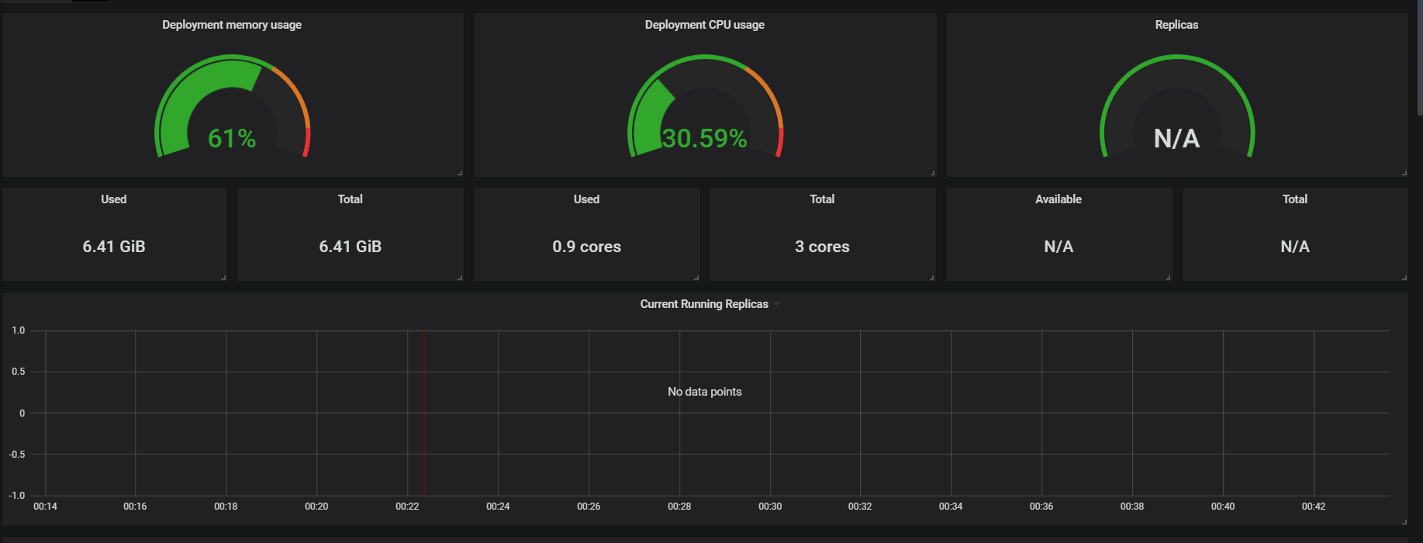

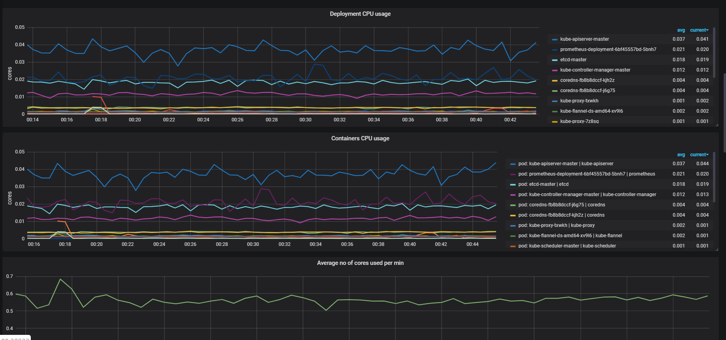

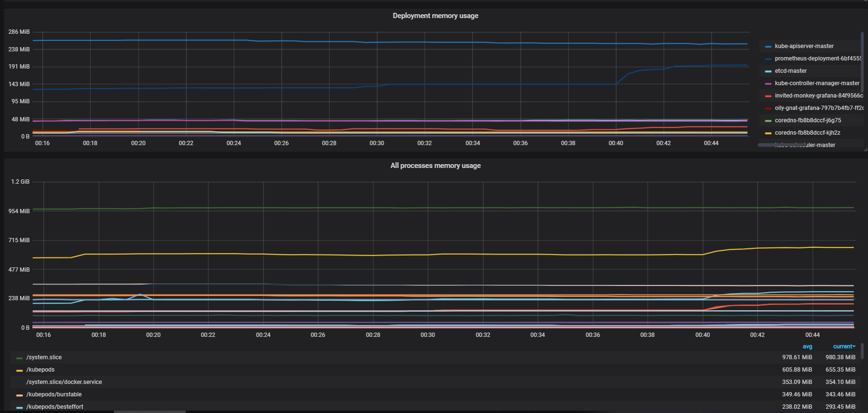

1. Setup log analysis using Elasticsearch, Fluentd (or Filebeat), Kibana.

* Skipped

1. Demonstrate Blue/Green and Canary deployment for the application (For e.g. Change the background color or font in the new version etc.,)  
   🡪 Skipped
2. Write a wrapper script (or automation mechanism of your choice) which does all the steps above.  
   🡪 Skipped
3. Document the whole process in a README file at the root of your repo. Mention any pre-requisites in the README.