***Test Results:***

Working **demo** of out models can be seen in the following youtube videos:

**ISL (images) to alphabets (text)(live streaming)**

1. <https://www.youtube.com/watch?v=d5kGSsQPO-E&feature=youtu.be>

**ISL (Videos) to alphabets/gestures (text)(test images)**

1. <https://www.youtube.com/watch?v=E1d6CupAJHQ&feature=youtu.be>

**ISL (Videos) to alphabets/gestures (text)**

1. <https://www.youtube.com/watch?v=bW8oX36kigw&feature=youtu.be>

**Audio to gestures(video)**

1. <https://www.youtube.com/watch?v=LJ_DwAnrxb0&feature=youtu.be>

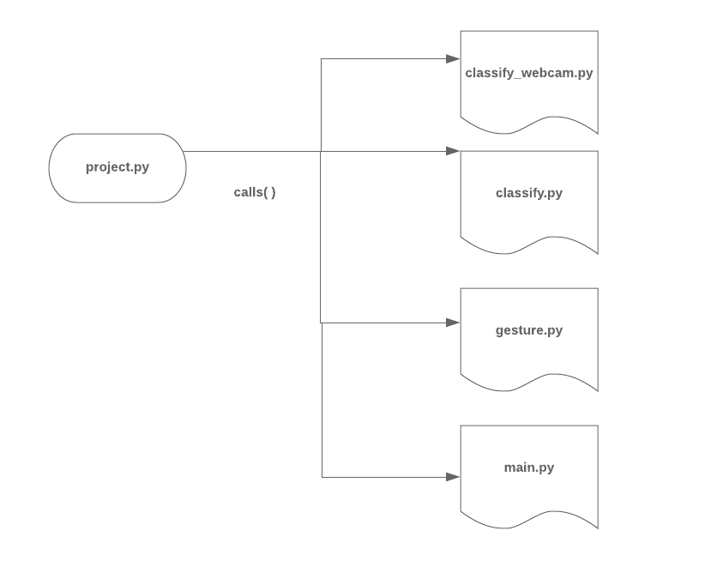

The following screenshots showcase the ***testing*** of the model:

**Test Results:**

**project.py**

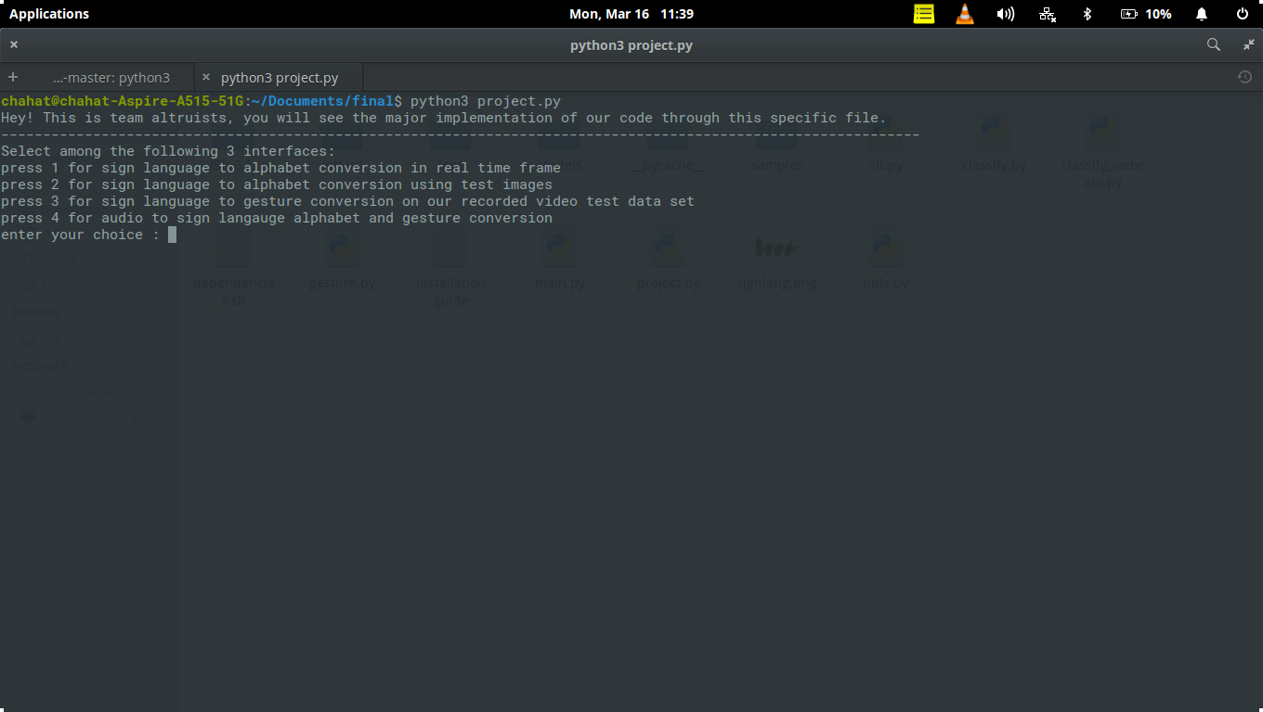

**Python.py executing classify.py for converting ISL to text alphabet**

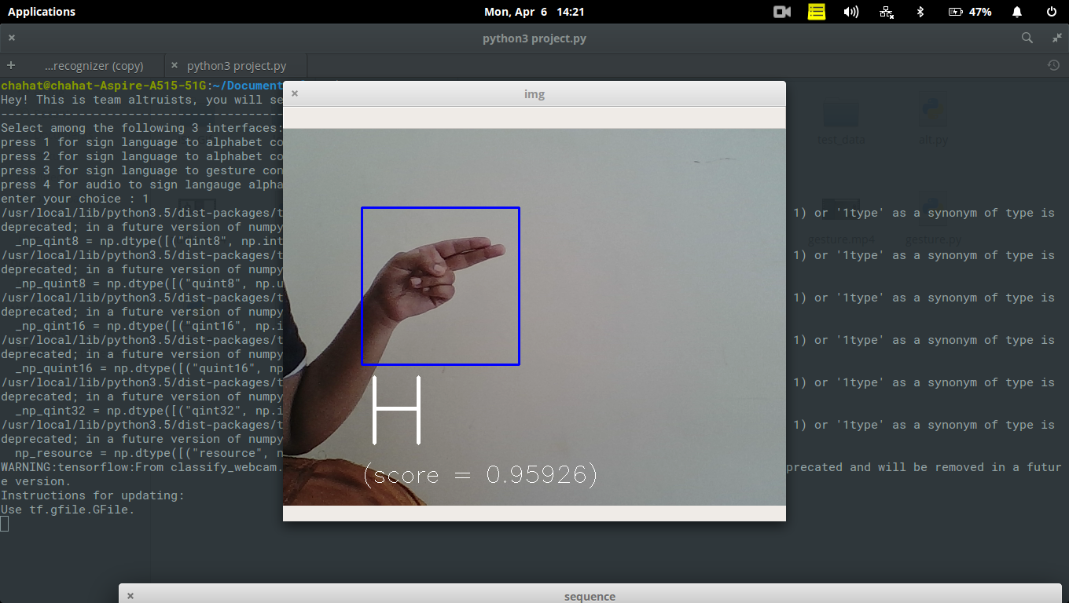

**Project.py executing classify.py**

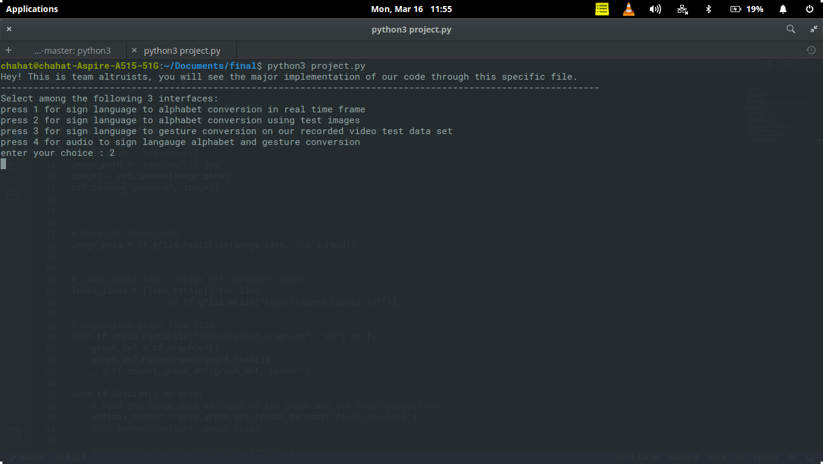

**classify.py**

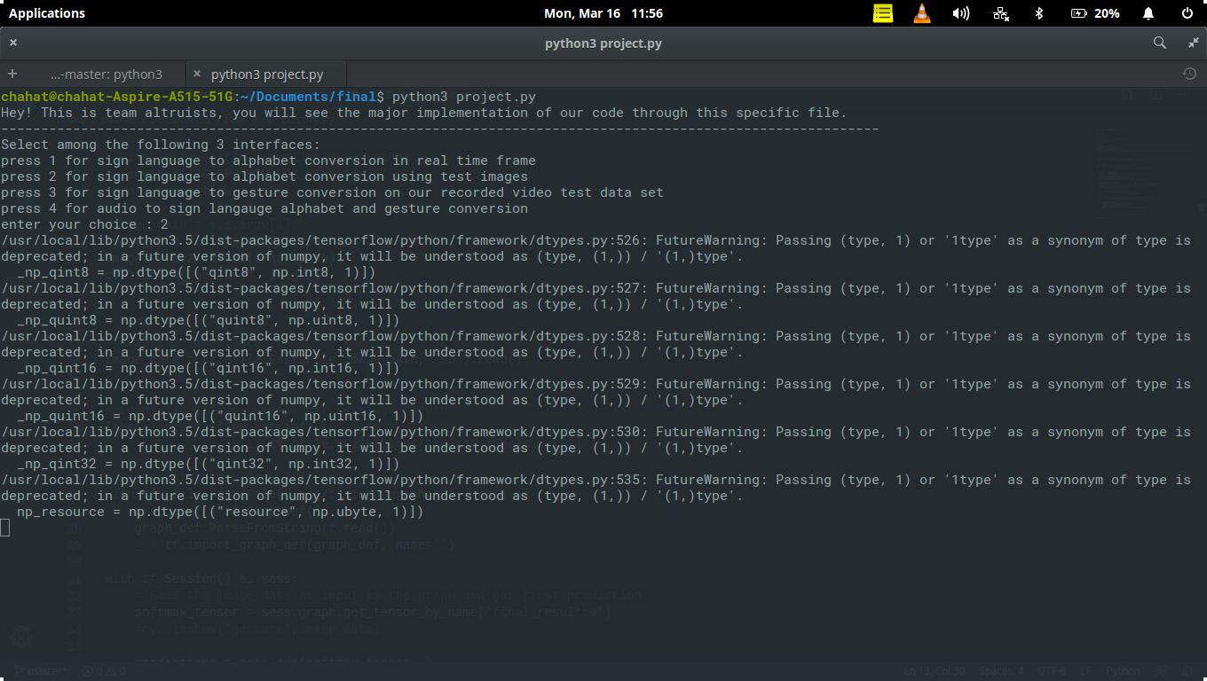

**Classification on samples/E12.png(static image classification results)**

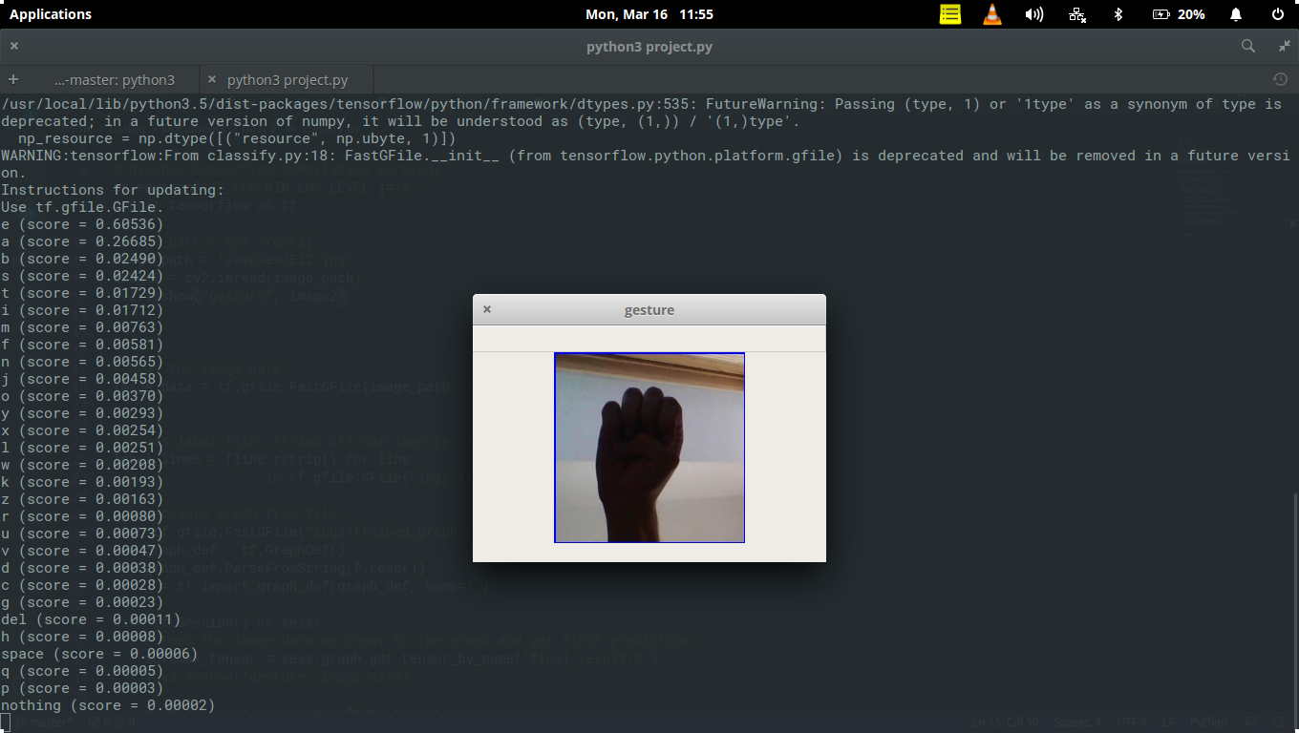

***Highest score stands for E(0.68536), PREDICTION: E***

**Project.py executing gesture.py for Gesture Recognition depicted through a set of frames**

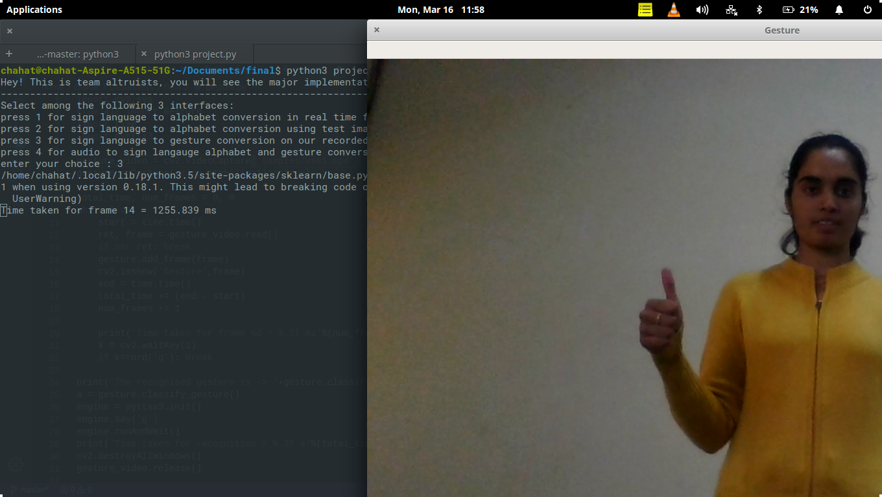

**Project.py executing main.py for conversion of live audio into video of gestures**

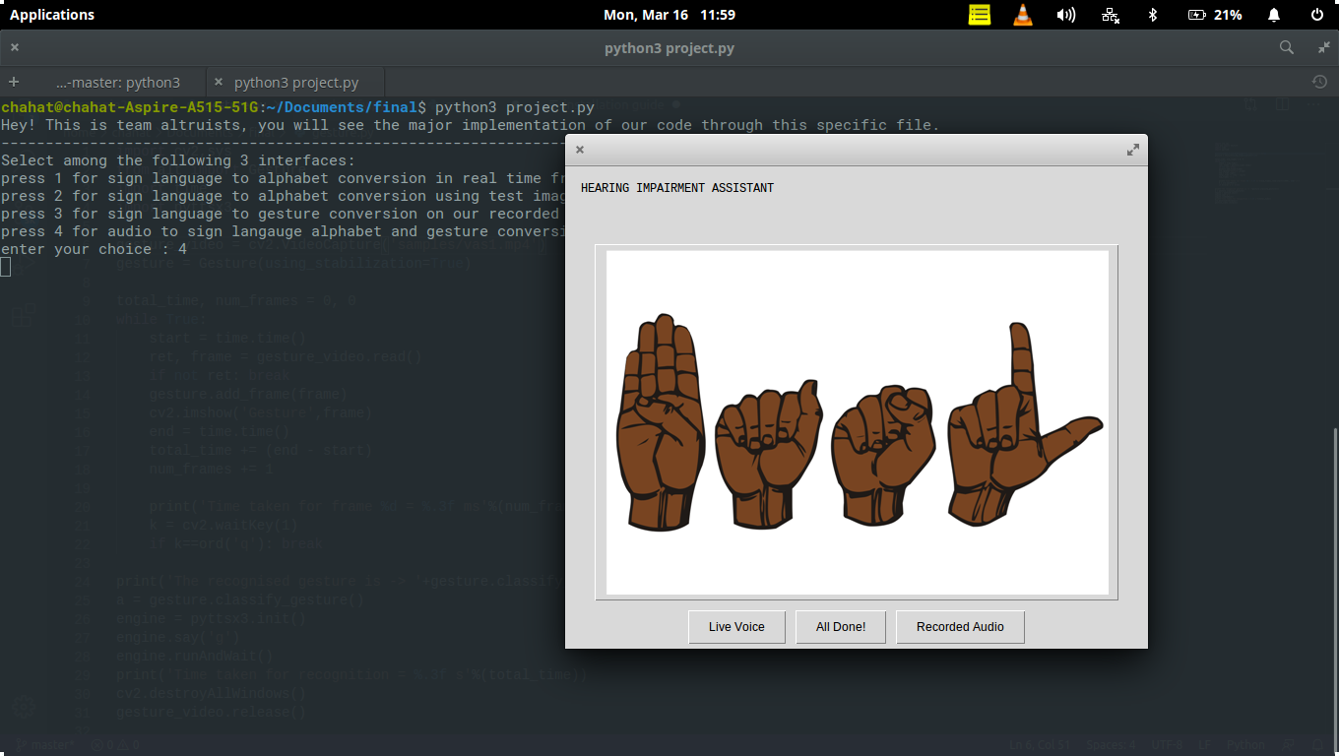

***We strongly recommend seeing the provided links in order to see the test results***