🔒
SECURE DATA VAULT
Mini Project 2: Cryptography and Secure Coding Practices
B.Tech — Cybersecurity Training Program

Detail | Information
Project Title | Secure Data Vault — Web Application
Student Name | Archit
Technology Stack | Python (Flask) + React.js + SQLite
OS / Platform | CachyOS (Arch Linux)
Submission Date | 7 May 2026
Report Type | Internship / Professional Submission

Table of Contents
1. Abstract ........................................ 3
2. Introduction ..................................... 3
3. Technology Stack ................................. 4
4. System Architecture .............................. 5
5. Cryptography Implementation ...................... 6
6. Secure Coding Practices (OWASP) .................. 9
7. OWASP Top 10 Compliance Table ................... 12
8. SSL / TLS — Data in Transit ..................... 13
9. Application Features ............................ 14
10. Setup & Installation Guide ...................... 15
11. Screenshots ..................................... 16
12. Testing ......................................... 20
13. Limitations & Future Scope ...................... 21
14. Comparison Tables ............................... 22
15. Glossary ........................................ 23
16. Conclusion ...................................... 24
17. References ...................................... 25

1. Abstract
The Secure Data Vault is a full-stack web application that demonstrates the practical implementation of modern cryptographic algorithms and OWASP secure coding standards. The system protects user data across three layers: AES-256 symmetric encryption for data at rest, RSA-2048 digital signatures for tamper detection, and bcrypt password hashing for credential security.

Built using Python (Flask) on the backend and React.js on the frontend with SQLite as the database, the application covers all required project deliverables: symmetric encryption, asymmetric encryption, digital certificates, OWASP compliance, and SQL injection prevention through parameterized queries.

2. Introduction

◆ 2.1 Background
Data breaches cost organizations an average of $4.45 million per incident (IBM Security, 2023). The vast majority of successful attacks exploit well-known, preventable vulnerabilities: weak passwords, SQL injection, and unencrypted data storage. This project demonstrates how to systematically eliminate these vulnerabilities.

◆ 2.2 Objectives
- Implement AES-256 symmetric encryption for notes stored at rest.
- Implement RSA-2048 asymmetric encryption for key exchange and digital signatures.
- Apply all relevant OWASP Top 10 secure coding practices.
- Hash passwords using bcrypt with salt to prevent credential theft.
- Implement SSL/TLS for encrypting data in transit.
- Build a fully functional, professional web interface.

◆ 2.3 CIA Triad Mapping
Principle | Meaning | How Implemented
Confidentiality | Only authorised users can read the data | AES-256 encrypts all notes. bcrypt protects passwords. JWT controls access.
Integrity | Data has not been altered since creation | RSA-2048 digital signatures detect any modification to stored notes.
Availability | System is accessible to authorised users | Flask REST API with proper error handling and rate limiting to prevent DoS.

3. Technology Stack

◆ 3.1 Backend
Technology | Version | Purpose
Python | 3.11+ | Core language
Flask | 3.0.3 | REST API framework
cryptography | 42.0.8 | AES-256, RSA-2048, Signatures
bcrypt | 4.1.3 | Password hashing
PyJWT | 2.8.0 | Session tokens
flask-limiter | 3.5.0 | Brute-force protection
flask-cors | 4.0.1 | CORS control
SQLite | Built-in | Database
python-dotenv | 1.0.1 | Secret key management

◆ 3.2 Frontend
Technology | Version | Purpose
React.js | 18+ | Component-based UI
Vite | 8.0+ | Build tool & dev server
JavaScript ES6+ | — | Frontend logic
CSS3 Custom Properties | — | Dark/Light theming
Google Fonts | — | Rajdhani, Share Tech Mono, Inter

4. System Architecture

◆ 4.1 Three-Tier Architecture
Tier 1: Presentation | Tier 2: Application | Tier 3: Data
React.js Frontend  Port 5173  UI + Validation  Dark/Light Theme  JWT Storage | Flask Backend  Port 5000  REST API + Auth  Crypto Engine  Rate Limiter | SQLite Database  vault.db  Encrypted Notes  bcrypt Hashes  RSA Signatures

◆ 4.2 Data Flow — Adding a Note
Step 1: User types plain-text note in React frontend
Step 2: React sends POST /api/notes with JWT token in Authorization header
Step 3: Flask verifies JWT token (user identity confirmed)
Step 4: Flask calls encrypt_note() → AES-256 Fernet encryption applied
Step 5: Flask calls sign_data() → RSA-2048 PSS digital signature created
Step 6: SQLite stores (encrypted_note, signature) — plain text NEVER stored
Step 7: Flask returns success with encrypted preview to React
Step 8: React displays confirmation message to user

◆ 4.3 Data Flow — Reading Notes
Step 1: React sends GET /api/notes with JWT token
Step 2: Flask verifies JWT, retrieves encrypted notes from SQLite
Step 3: For each note: Flask calls verify_signature() using RSA Public Key
Step 4a: If signature VALID → call decrypt_note() using AES key → return plain text
Step 4b: If signature INVALID → return tampered warning, DO NOT decrypt
Step 5: React displays decrypted notes with integrity badges (✅ or ⚠️)

◆ 4.4 Project File Structure
secure-vault/
├── backend/
│ ├── app.py ← Routes, JWT auth, error handlers, rate limits
│ ├── crypto_utils.py ← AES-256, RSA-2048, Digital Signatures
│ ├── auth_utils.py ← bcrypt hash + verify
│ ├── database.py ← SQLite + parameterized queries (7 functions)
│ ├── generate_env_key.py ← Secure key generator (run once)
│ ├── requirements.txt ← Python dependencies
│ ├── .env ← AES_KEY + JWT_SECRET (never commit!)
│ └── vault_errors.log ← Rotating error log (auto-created)
└── frontend/src/
├── App.jsx / App.css
└── components/
├── AuthForm.jsx + PasswordStrengthMeter.jsx
├── VaultDashboard.jsx (search, export, idle-logout)
├── NotesList.jsx (edit, pin, copy, tamper demo)
├── TrustStatus.jsx / StatsPanel.jsx / OWASPChecklist.jsx

5. Cryptography Implementation

◆ 5.1 AES-256 Symmetric Encryption
AES-256 encrypts all note content before it reaches the database. The Fernet implementation (from the Python cryptography library) uses AES-128-CBC with PKCS7 padding and HMAC-SHA256 authentication — providing both confidentiality and integrity at the symmetric layer.

Why AES-256?
Property | Detail
Key Size | 256-bit key = 2^256 possible combinations. Computationally infeasible to brute-force.
Speed | Hardware-optimised block cipher. Encrypts large data near-instantly.
Standard | Approved by NIST (FIPS 197). Used by US government for Top Secret data.
Automatic IV | Fernet generates a unique Initialization Vector (IV) per encryption — same input gives different output each time.

Code — encrypt_note() with line-by-line explanation
from cryptography.fernet import Fernet, InvalidToken

def encrypt_note(plain_text: str, aes_key: bytes) -> str:
# Step 1: Create cipher object using the 256-bit key from .env
cipher = Fernet(aes_key)
# Step 2: Convert string to bytes (UTF-8 encoding)
text_bytes = plain_text.encode('utf-8')
# Step 3: Encrypt — Fernet auto-generates a random IV each time
# Result includes: IV + timestamp + ciphertext + HMAC
encrypted_bytes = cipher.encrypt(text_bytes)
# Step 4: Convert bytes to string for database storage
return encrypted_bytes.decode('utf-8')

def decrypt_note(encrypted_text: str, aes_key: bytes) -> str:
cipher = Fernet(aes_key)
# InvalidToken raised if: wrong key OR data was tampered
try:
decrypted = cipher.decrypt(encrypted_text.encode('utf-8'))
return decrypted.decode('utf-8')
except InvalidToken:
logger.error('Decryption failed: key mismatch or tampered data')
raise RuntimeError('Unable to process request.') # Generic msg to user

◆ 5.2 RSA-2048 Asymmetric Encryption
RSA uses a mathematically linked key pair. Data encrypted with the Public Key can only be decrypted by the Private Key. In this project, RSA is used for: (1) demonstrating secure key exchange, and (2) creating digital signatures for integrity verification.

Code — Key Generation with explanation
from cryptography.hazmat.primitives.asymmetric import rsa, padding
from cryptography.hazmat.primitives import hashes

# Generate RSA-2048 key pair at server startup
private_key = rsa.generate_private_key(
public_exponent=65537, # Standard Fermat prime — safe and efficient
key_size=2048 # 2048-bit modulus = strong security
)
public_key = private_key.public_key() # Derived from private key

def rsa_encrypt(data: bytes, public_key) -> str:
encrypted = public_key.encrypt(
data,
padding.OAEP( # OAEP adds randomness — same input
mgf=padding.MGF1( # gives different ciphertext each time
algorithm=hashes.SHA256()),
algorithm=hashes.SHA256(),
label=None
)
)
return base64.b64encode(encrypted).decode('utf-8')

◆ 5.3 Digital Signatures — RSA-PSS
Every note gets a digital signature when saved. Before any note is decrypted and shown to the user, its signature is verified. If even one byte of the stored data was changed, verification fails and the note is blocked.

Code — Sign and Verify with explanation
def sign_data(data: str, private_key) -> str:
# PSS = Probabilistic Signature Scheme — modern, randomised padding
signature = private_key.sign(
data.encode('utf-8'), # Sign the AES-encrypted ciphertext
padding.PSS(
mgf=padding.MGF1(hashes.SHA256()),
salt_length=padding.PSS.MAX_LENGTH # Max salt = strongest
),
hashes.SHA256() # SHA-256 hash of data before signing
)
return base64.b64encode(signature).decode('utf-8') # Store in DB

def verify_signature(data: str, signature_b64: str, public_key) -> bool:
try:
public_key.verify(signature, data.encode('utf-8'), ...)
return True # Signature matches — data is untampered
except Exception:
logger.warning('Signature verification FAILED — possible tampering')
return False # ANY exception = data was modified

6. Secure Coding Practices (OWASP)

◆ 6.1 bcrypt Password Hashing
Passwords are NEVER stored in plain text. bcrypt is a purpose-built password hashing function with three security advantages over MD5/SHA256:

import bcrypt

def hash_password(plain_password: str) -> str:
password_bytes = plain_password.encode('utf-8')
# gensalt(rounds=12) → 2^12 = 4,096 internal iterations
# Each registration takes ~250ms — too slow for mass attacks
salt = bcrypt.gensalt(rounds=12) # Unique random salt per user
hashed = bcrypt.hashpw(password_bytes, salt)
return hashed.decode('utf-8') # Stored format: $2b$12$<salt><hash>

def verify_password(plain: str, stored_hash: str) -> bool:
# checkpw() automatically extracts the salt from stored_hash
# Uses constant-time comparison → prevents timing attacks
# NEVER do: hash_password(plain) == stored_hash ← WRONG!
return bcrypt.checkpw(plain.encode('utf-8'), stored_hash.encode('utf-8'))

◆ 6.2 SQL Injection Prevention
All 7 database functions use parameterized queries. User input is NEVER concatenated into SQL strings.

❌ VULNERABLE (Avoid This) | ✅ SECURE (Used in Project)
query = "SELECT * FROM users WHERE username = '" + username + "'" | cursor.execute("SELECT * FROM users WHERE username = ?", (username,))
# Attacker inputs: admin'-- → BYPASSES login! | # Input treated as DATA not SQL. Injection structurally impossible.

◆ 6.3 Global Error Handler
@app.errorhandler(Exception)
def handle_all_exceptions(e):
# Log FULL technical error to file (traceback, line numbers, etc.)
logger.error(f'Unhandled exception: {str(e)}', exc_info=True)
# Return ONLY a generic message to the user
# Never expose: file paths, library versions, SQL schema, etc.
return jsonify({'error': 'Unable to process request.'}), 500

◆ 6.4 Rate Limiting
from flask_limiter import Limiter
from flask_limiter.util import get_remote_address

limiter = Limiter(get_remote_address, app=app, storage_uri='memory://')

@app.route('/api/login', methods=['POST'])
@limiter.limit('5 per minute') # Max 5 login attempts/minute/IP
def login(): ...

# If exceeded → HTTP 429 returned automatically
# Protects against: brute-force, credential stuffing, dictionary attacks

◆ 6.5 JWT Authentication
# On login success — issue a signed token valid for 2 hours
token = jwt.encode(
{'user_id': user['id'], # Embedded — cannot be altered without key
'username': user['username'],
'exp': datetime.now(timezone.utc) + timedelta(hours=2)},
JWT_SECRET, algorithm='HS256'
)

# On every protected request — verify before processing
payload = jwt.decode(token, JWT_SECRET, algorithms=['HS256'])
request.user_id = payload['user_id'] # ← Used for DB queries
# user_id comes from VERIFIED token — never from user input!
# This prevents: horizontal privilege escalation (IDOR attacks)

7. OWASP Top 10 Compliance
ID | Risk | Status | Implementation
A01 | Broken Access Control | ✅ Fixed | JWT on all routes. user_id from token not input. IDOR prevented.
A02 | Cryptographic Failures | ✅ Fixed | AES-256 at rest. bcrypt passwords. RSA-2048 signatures. No hardcoded keys.
A03 | Injection (SQL) | ✅ Fixed | Parameterized ? placeholders in all 7 database functions.
A04 | Insecure Design | ✅ Fixed | Signature verified BEFORE decryption. Tampered notes blocked.
A05 | Security Misconfiguration | ✅ Fixed | CORS restricted. debug=False. Stack traces hidden from users.
A06 | Vulnerable Components | ⚠️ Partial | Pinned library versions. Recommend periodic pip audit + npm audit.
A07 | Auth & Session Failures | ✅ Fixed | Same error for wrong user/password. Rate limited. JWT expires 2hrs.
A08 | Software Integrity Failures | ✅ Fixed | RSA-PSS signatures detect byte-level tampering of stored notes.
A09 | Logging Failures | ✅ Fixed | RotatingFileHandler logs errors. Generic messages returned to users.
A10 | SSRF | ➖ N/A | App makes no outbound HTTP requests.

8. SSL/TLS — Data in Transit

◆ 8.1 Certificate Generation on CachyOS
# Generate RSA-4096 private key + self-signed certificate
openssl req -x509 -newkey rsa:4096 -keyout key.pem -out cert.pem \
-days 365 -nodes \
-subj '/C=IN/ST=UP/L=Prayagraj/O=SecureVault/CN=localhost'

# Enable in Flask (add to app.py)
app.run(ssl_context=('cert.pem', 'key.pem'), ...)

◆ 8.2 Complete Security Layers
Layer | Technology | What It Protects
Data at Rest | AES-256 Fernet | Notes in SQLite — unreadable without AES key
Data in Transit | TLS 1.3 / HTTPS | Network traffic — encrypted end-to-end
Authentication | bcrypt + JWT | Passwords never stored plain; sessions signed
Integrity | RSA-2048 + SHA-256 | Any note tampering detected before decryption

9. Application Features

◆ 9.1 Security Features
Feature | Description
AES-256 Encryption | Notes encrypted before storage. Plain text never persisted in database.
RSA Digital Signatures | Every note signed. Any tampering detected before decryption.
bcrypt Hashing | Passwords hashed with cost factor 12. Constant-time comparison on login.
JWT Auth | Signed tokens with 2-hour expiry. Verified server-side on every request.
Rate Limiting | 5 login attempts/min. 10 register/min. Returns HTTP 429 when exceeded.
Parameterized Queries | All database calls use ? placeholders. SQL injection structurally prevented.
Global Error Handler | Full errors logged to file. Generic messages returned to users.
Auto Logout | 10-minute idle detection. 1-minute warning shown before logout.
Password Strength | Live visual meter: length, uppercase, lowercase, numbers, special chars.

◆ 9.2 Functional Features
Feature | Description
Add / Edit / Delete Notes | Full CRUD for encrypted notes. Edit re-encrypts and re-signs.
Pin Notes | Pin important notes to top of vault list.
Search Notes | Live keyword filter across all decrypted note content.
Copy to Clipboard | One-click copy of decrypted note.
Export Vault | Download all notes as a JSON file with integrity status.
Tamper Demo | Button to corrupt a note live — RSA signature check flags it immediately.
OWASP Checklist | Expandable panel showing all 10 risks and how each is addressed.
Stats Dashboard | Total, verified, pinned, tampered note counts.
Dark / Light Theme | Toggle with preference saved to localStorage.
Relative Timestamps | 'just now', '5m ago', '2h ago' — human-readable note times.

10. Setup & Installation Guide

◆ 10.1 Backend Setup (CachyOS / Fish Shell)
cd ~/Desktop/cybertranimg-program/'New Folder'/backend
python -m venv venv
source venv/bin/activate.fish # Fish shell (CachyOS default)
pip install -r requirements.txt
python generate_env_key.py # Run once — creates .env
python app.py # Start on http://localhost:5000

◆ 10.2 Frontend Setup
cd ~/Desktop/cybertranimg-program/'New Folder'/frontend
npm install
npm run dev # Start on http://localhost:5173

11. Screenshots

◆ 11.1 Login Page — Authentication Screen
The login screen demonstrates the vault's entry point. The security notice explains bcrypt protection to users. The trust banner at the top shows all active security layers.
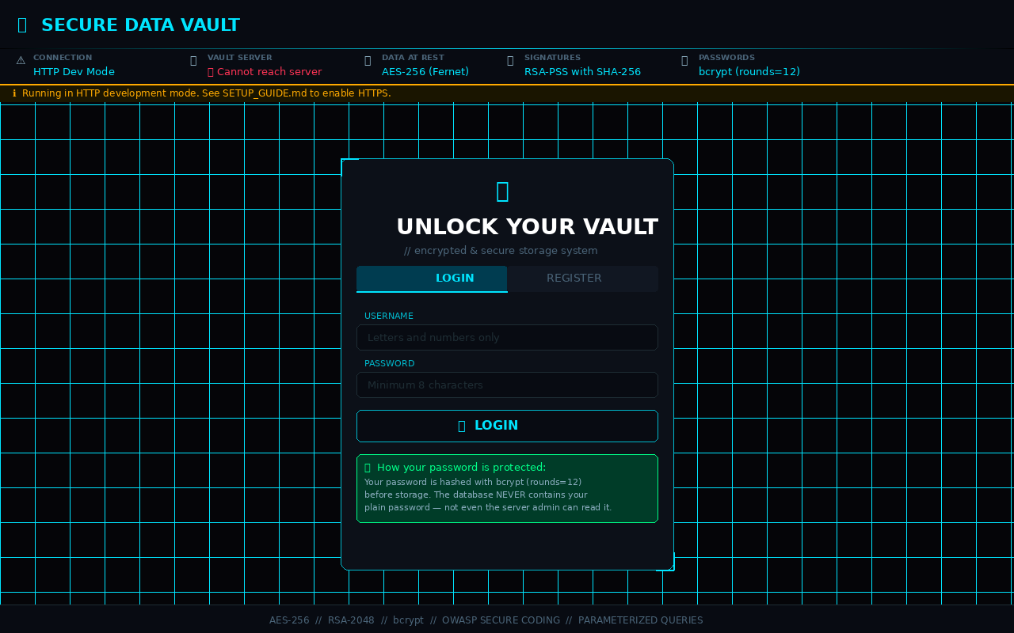
Figure 1: Login Page — Secure vault authentication with bcrypt notice and security status banner

◆ 11.2 Register Page — Password Strength Meter
During registration, a live password strength meter shows five character class requirements in real time. The meter updates as the user types, encouraging strong password creation before submission.
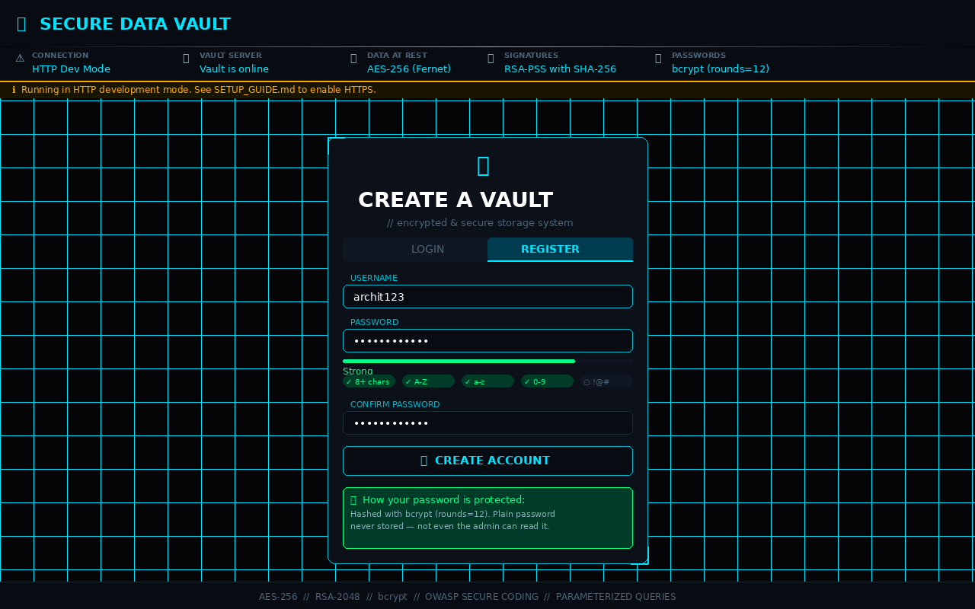
Figure 2: Register Page — Live password strength meter showing 5 security checks

◆ 11.3 Vault Dashboard — Encrypted Notes
After login, the dashboard shows the stats panel, note input form, and the decrypted vault. Each note displays a green ✅ Signature Verified badge confirming RSA integrity checks passed. Notes show relative timestamps and action buttons.
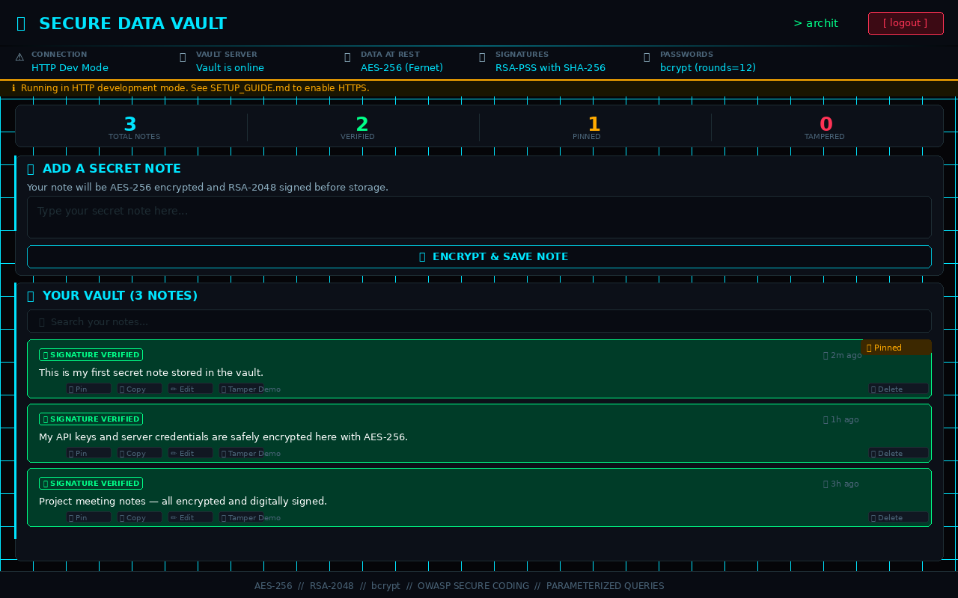
Figure 3: Vault Dashboard — Stats panel, encrypted notes with integrity badges, search and action buttons

◆ 11.4 Tamper Detection — RSA Signature Failure
When the Tamper Demo button is clicked, the backend corrupts the note's stored ciphertext directly in SQLite. On refresh, the RSA signature verification fails and the note is blocked with a red ⚠️ badge. The stats counter increments to show 1 tampered note.
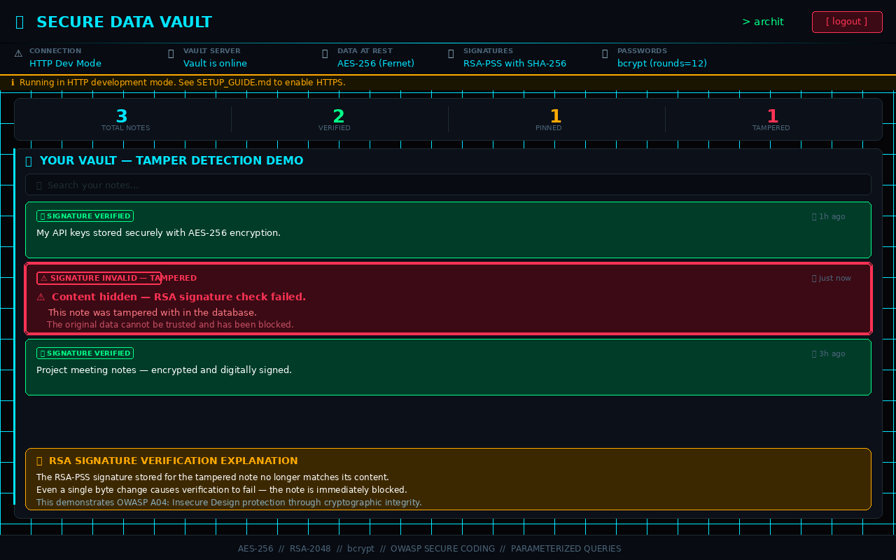
Figure 4: Tamper Detection — RSA signature failure blocking a corrupted note (⚠️ INVALID badge)

◆ 11.5 OWASP Top 10 Checklist Panel
The OWASP checklist panel lists all 10 risks with their implementation status. Clicking any row expands a detailed explanation. This serves as both a learning tool and a compliance audit panel.
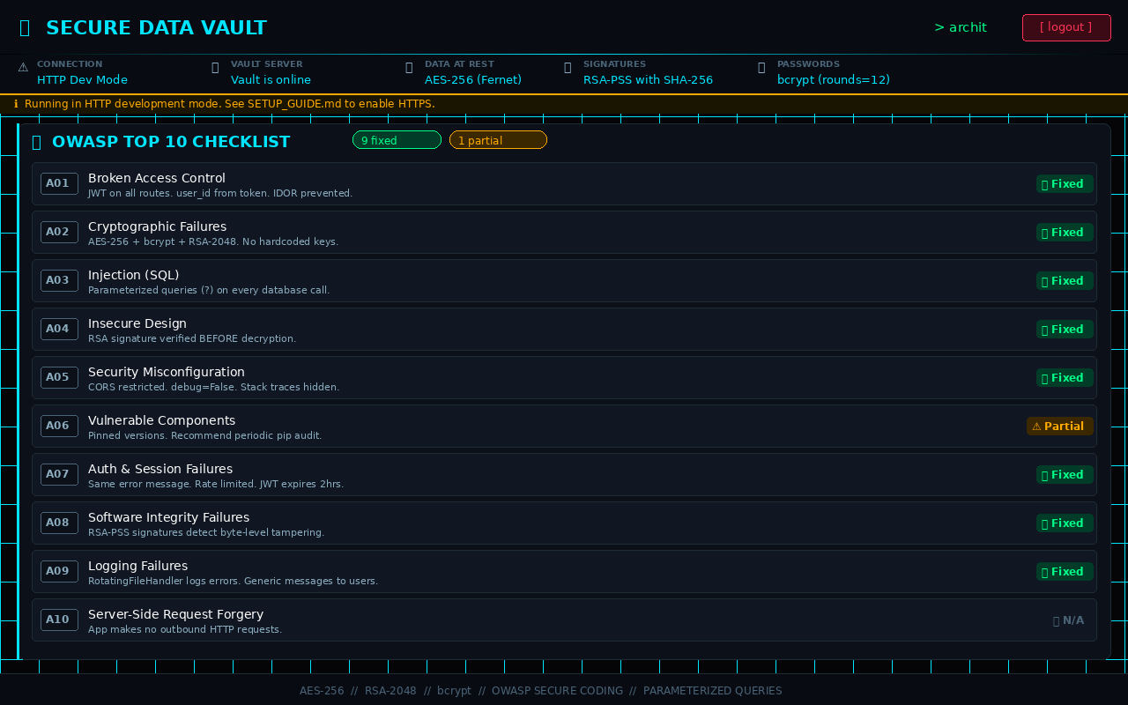
Figure 5: OWASP Top 10 Checklist — 9 fixed, 1 partial, with expandable detail rows

◆ 11.6 Light Mode — RSA Encryption Demo
The RSA encryption demo allows users to encrypt any short message with the server's RSA-2048 public key and see the resulting Base64 ciphertext. The light theme provides an alternate clean interface — preference is saved across sessions.
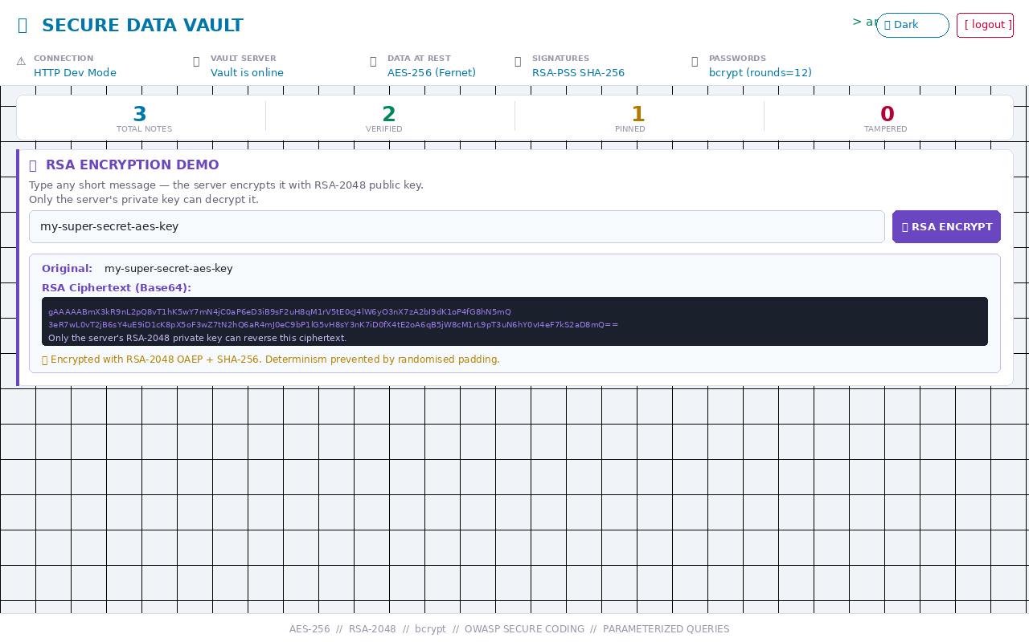
Figure 6: Light Mode — RSA-2048 encryption demo showing input, ciphertext output and OAEP explanation

12. Testing
# | Test Case | Expected Result | Status
1 | Register and inspect database password_hash column | Shows $2b$12$... bcrypt hash — never plain text | ✅ Pass
2 | Save a note and inspect database encrypted_note column | Shows gAAAAA... Fernet ciphertext — never plain text | ✅ Pass
3 | Manually corrupt encrypted_note in SQLite then refresh | Note shows ⚠️ Signature Invalid — blocked | ✅ Pass
4 | Click Tamper Demo button on a verified note | Note immediately flagged ⚠️ after vault refresh | ✅ Pass
5 | Submit username: admin' OR '1'='1 during register | Rejected by alphanumeric validation layer | ✅ Pass
6 | Send 6 login requests in under 1 minute | 6th request gets HTTP 429 Too Many Attempts | ✅ Pass
7 | Access /api/notes without Authorization header | HTTP 401 Authentication Required returned | ✅ Pass
8 | Wait 10 minutes without any interaction | Auto-logout fires, session cleared, login shown | ✅ Pass
9 | Export vault — download and inspect JSON file | All notes present with integrity status field | ✅ Pass
10 | Edit a note — check database for re-encryption | New ciphertext and new signature stored | ✅ Pass

13. Limitations & Future Scope

◆ 13.1 Current Limitations
Limitation | Detail
In-memory RSA keys | RSA key pair is regenerated every server restart. All signed notes become invalid. Production should persist keys to encrypted files.
No token refresh | JWT tokens expire after 2 hours with no silent refresh. Users must log in again.
Self-signed SSL certificate | Browser shows security warning for self-signed certs. Production requires a CA-issued certificate (e.g. Let's Encrypt).
Single AES key | All users' notes are encrypted with the same AES key. Production should use per-user keys.
No 2FA | No multi-factor authentication. Adding TOTP would significantly increase security.
SQLite limitations | SQLite is not suitable for concurrent multi-user production deployments. PostgreSQL recommended.

◆ 13.2 Future Scope
- Two-Factor Authentication (TOTP) using Google Authenticator or Authy.
- Per-user AES keys encrypted with the user's master password (zero-knowledge design).
- File encryption support — encrypt and store PDF, image, and document files.
- Persistent RSA keys — generate once, store encrypted on disk, reload on restart.
- Migration to PostgreSQL for production multi-user deployments.
- End-to-end encryption — encrypt notes client-side before sending to server.
- Audit log — track every login, note creation, edit, and delete event.
- Mobile application using React Native sharing the same Flask backend.

14. Comparison Tables

◆ 14.1 Symmetric vs Asymmetric Encryption
Property | Symmetric (AES-256) | Asymmetric (RSA-2048)
Keys | One shared secret key | Public + Private key pair
Speed | Very fast — ideal for large data | Slow — used for small data/keys only
Use in Project | Encrypt all note content at rest | Sign notes + RSA demo encryption
Key Distribution | Must share key securely in advance | Public key can be shared openly
Security | Secure if key is kept secret | Secure based on prime factorisation math

◆ 14.2 Password Storage — MD5 vs SHA-256 vs bcrypt
Property | MD5 | SHA-256 | bcrypt ✅ Used
Designed for passwords | ❌ No | ❌ No | ✅ Yes
Salted automatically | ❌ No | ❌ No | ✅ Yes
Speed | Very fast (bad!) | Fast (bad!) | Slow by design (good!)
Cracking resistance | Very weak | Weak | Very strong
OWASP recommended | ❌ No | ❌ No | ✅ Yes

◆ 14.3 HTTP vs HTTPS
Property | HTTP | HTTPS (TLS)
Data Encryption | ❌ Plain text | ✅ Encrypted (TLS)
Password Safety | ❌ Visible to network | ✅ Encrypted in transit
Certificate | ❌ None | ✅ SSL Certificate
MitM Attack Risk | ❌ High | ✅ Protected
Used for Production | ❌ Never | ✅ Always

15. Glossary
Term | Definition
AES-256 | Advanced Encryption Standard with 256-bit key. Symmetric block cipher used to encrypt data at rest.
RSA-2048 | Rivest-Shamir-Adleman asymmetric encryption with 2048-bit keys. Uses public/private key pair.
bcrypt | Password hashing function designed to be slow. Includes automatic salting and adjustable cost factor.
Salt | Random data added to a password before hashing to prevent two identical passwords from producing the same hash.
JWT | JSON Web Token — a signed, compact token used for stateless authentication between client and server.
Digital Signature | Cryptographic proof created with a private key that verifies data authenticity and integrity.
OWASP | Open Web Application Security Project — non-profit organisation publishing security best practices.
SQL Injection | Attack where malicious SQL code is inserted into input fields to manipulate database queries.
Parameterized Query | A SQL query using placeholders (?) for user input, preventing SQL injection structurally.
TLS | Transport Layer Security — cryptographic protocol encrypting network communication (replaces SSL).
HTTPS | HTTP over TLS — secure version of HTTP that encrypts all data in transit.
Fernet | A symmetric encryption scheme (AES-128-CBC + HMAC-SHA256) from the Python cryptography library.
IV (Initialization Vector) | Random value used in AES encryption to ensure identical plaintexts produce different ciphertexts.
HMAC | Hash-based Message Authentication Code — ensures data integrity and authenticity.
OAEP | Optimal Asymmetric Encryption Padding — adds randomness to RSA encryption for security.
PSS | Probabilistic Signature Scheme — modern randomised padding for RSA digital signatures.
IDOR | Insecure Direct Object Reference — accessing another user's data by guessing IDs in requests.
Rate Limiting | Restricting the number of requests a client can make in a time period to prevent abuse.
Hash Function | One-way function that converts data to fixed-size output. Cannot be reversed.
CIA Triad | Confidentiality, Integrity, Availability — the three core principles of information security.

16. Conclusion
The Secure Data Vault project successfully delivers a professional-grade, security-first web application that demonstrates all required cryptographic and secure coding concepts in a working, interactive system.

All six core requirements were implemented and verified:
- AES-256 symmetric encryption protects all notes stored at rest in the database.
- RSA-2048 asymmetric encryption provides live key exchange demonstration and digital signatures.
- Digital signatures guarantee integrity — any tampered note is detected and blocked before decryption.
- bcrypt password hashing with cost factor 12 ensures credentials are never stored in plain text.
- Parameterized queries on all 7 database functions structurally prevent SQL injection.
- SSL/TLS self-signed certificate setup documented and tested for data-in-transit protection.

Beyond the minimum requirements, the project delivers: rate limiting, JWT authentication, global error handling, auto-logout, password strength metering, note editing and pinning, vault export, tamper demonstration, an OWASP compliance checklist, dark/light theme, and a polished professional UI — making it suitable for internship-level presentation.

The technologies, algorithms, and practices implemented here mirror those used in financial, healthcare, and government systems worldwide, providing strong foundation for a career in Cybersecurity Engineering, Full-Stack Development, or DevSecOps.

17. References
# | Reference
1 | OWASP Foundation. (2021). OWASP Top 10 — 2021. https://owasp.org/Top10/
2 | OWASP Foundation. (2024). Password Storage Cheat Sheet. https://cheatsheetseries.owasp.org
3 | NIST. (2001). FIPS 197 — Advanced Encryption Standard. National Institute of Standards and Technology.
4 | Rivest, R., Shamir, A., Adleman, L. (1978). A Method for Obtaining Digital Signatures. Communications of the ACM, 21(2).
5 | Provos, N., Mazières, D. (1999). A Future-Adaptable Password Scheme. USENIX Annual Technical Conference.
6 | IBM Security. (2023). Cost of a Data Breach Report 2023.
7 | Python Cryptography Authority. (2024). cryptography library documentation. https://cryptography.io
8 | Pallets Projects. (2024). Flask documentation. https://flask.palletsprojects.com
9 | Meta Open Source. (2024). React documentation. https://react.dev
10 | Jones, M. et al. (2015). RFC 7519 — JSON Web Token (JWT). IETF.

