UNITED COLLEGE OF ENGINEERING AND RESEARCH

DEPARTMENT OF COMPUTER SCIENCE

NETWORK MONITORING AND SUSPICIOUS TRAFFIC DETECTION
Submitted By:
Archit Srivastava

Course: B.Tech
Submitted To:
Date: 28 March 2026

INDEX
S. No. | Topic | Page No.
1. | Title Page | 1
2. | Introduction to Network Monitoring | 2
3. | Tools Used | 3
4. | Network Capture Process | 4–6
5. | Screenshot of Packet Capture | 7–12
6. | Identified Protocols | 13–15
7. | Suspicious Traffic Analysis | 16
8. | Conclusion | 17

Introduction to Network Monitoring
Network monitoring is the process of capturing and analyzing network traffic to understand communication between devices. It helps in detecting unusual or suspicious activities such as unauthorized access, malware communication, or abnormal traffic patterns. Wireshark is a powerful tool used for packet analysis.

Tools Used
- Wireshark
- Nmap (optional)
- Linux Commands

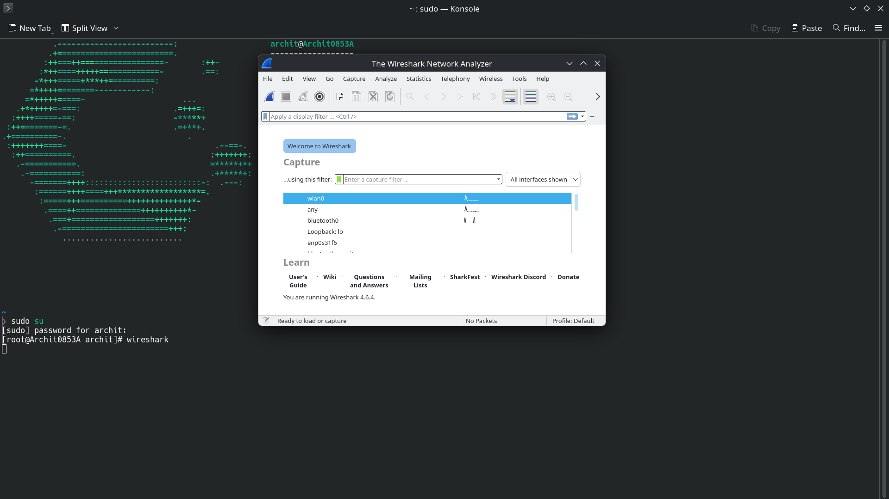
Figure :1-starting the wireshark

Network Capture Process
Wireshark was installed and the active Wi-Fi interface was selected. Traffic was captured for 10–15 minutes while browsing websites, watching videos, and performing searches. The captured packets were saved and analyzed.

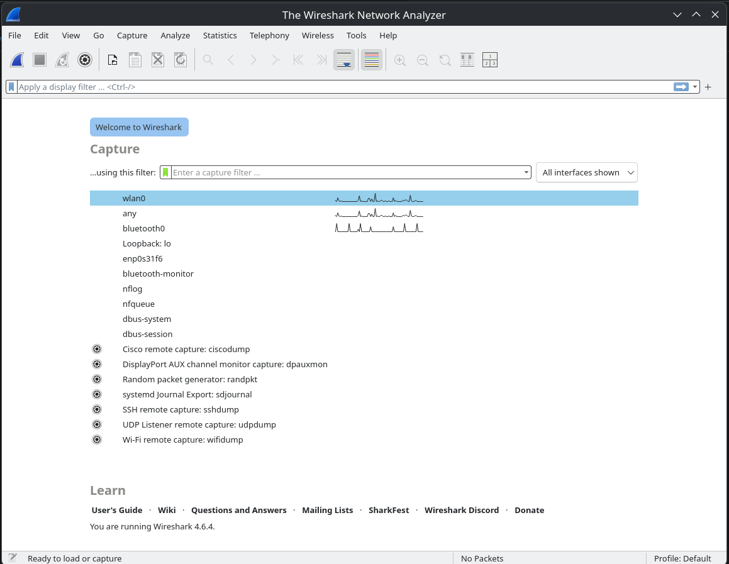
Figure :2-start capturing
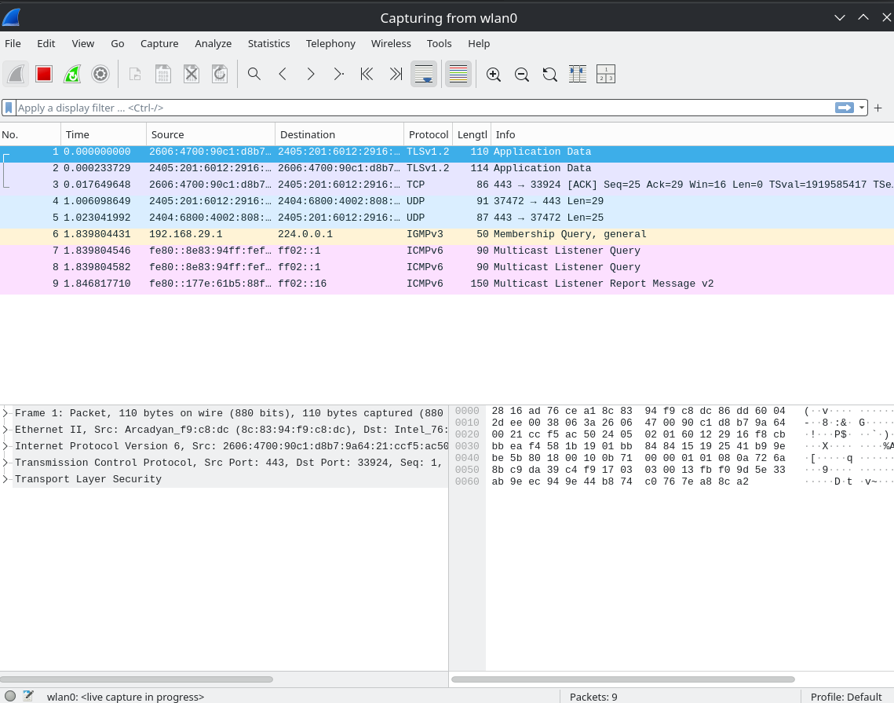
Figure :3-capturing start

During the packet capture process, different types of network activities were performed to generate diverse traffic. These included video streaming on YouTube, executing the ping command to generate ICMP packets, and downloading files from the internet. These activities helped in producing various types of network packets for analysis.

Figure :4-Video Streaming Activity (YouTube)

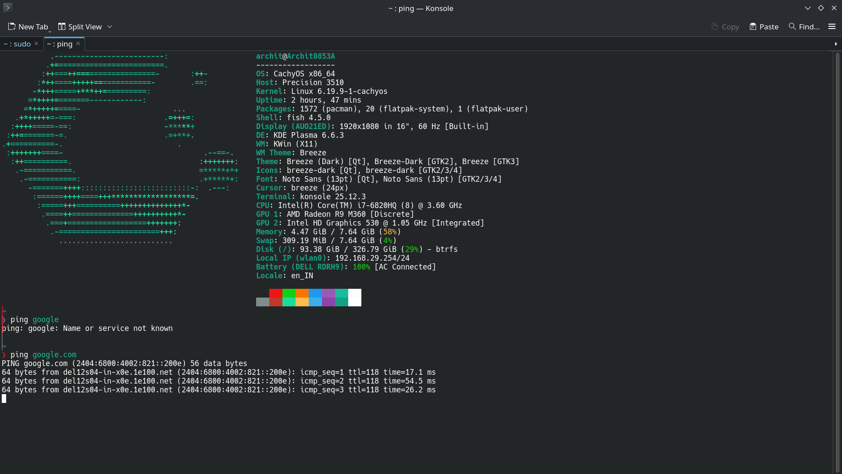
Figure :5-ICMP Traffic Generation using Ping Command

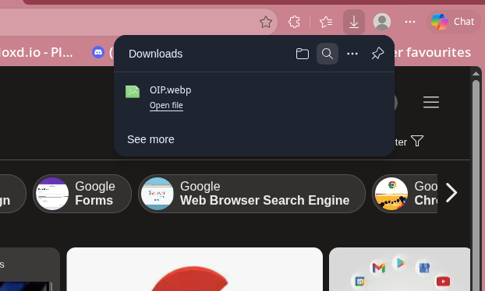
Figure :6-File Download Activity

Figure :7-mltiple site at same time

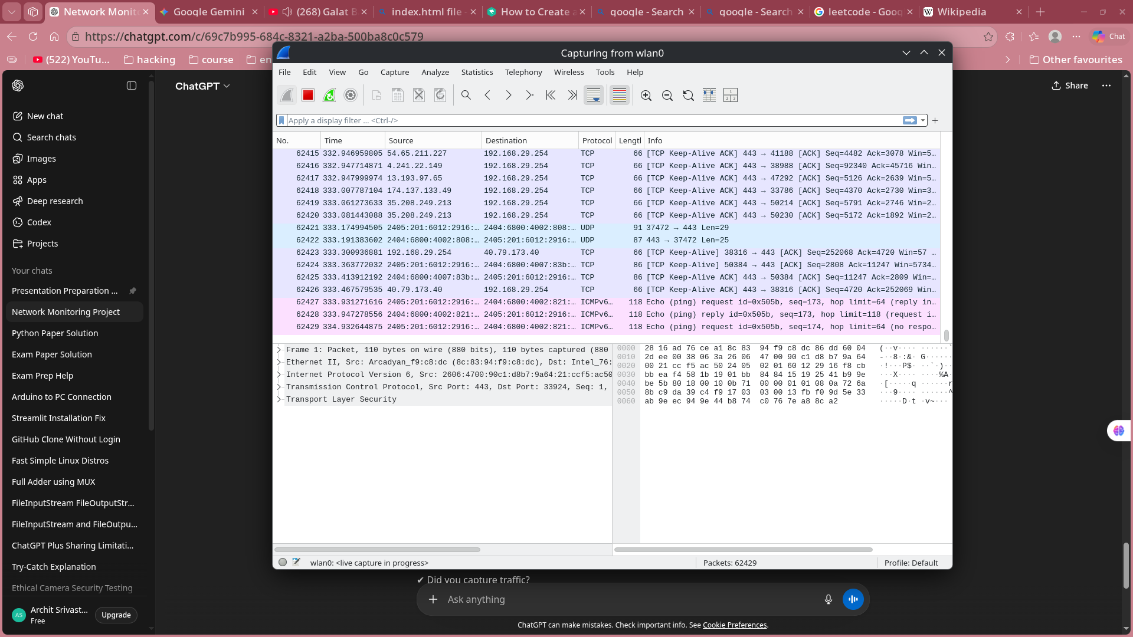
Figure :8-we capture so many packet(62429)

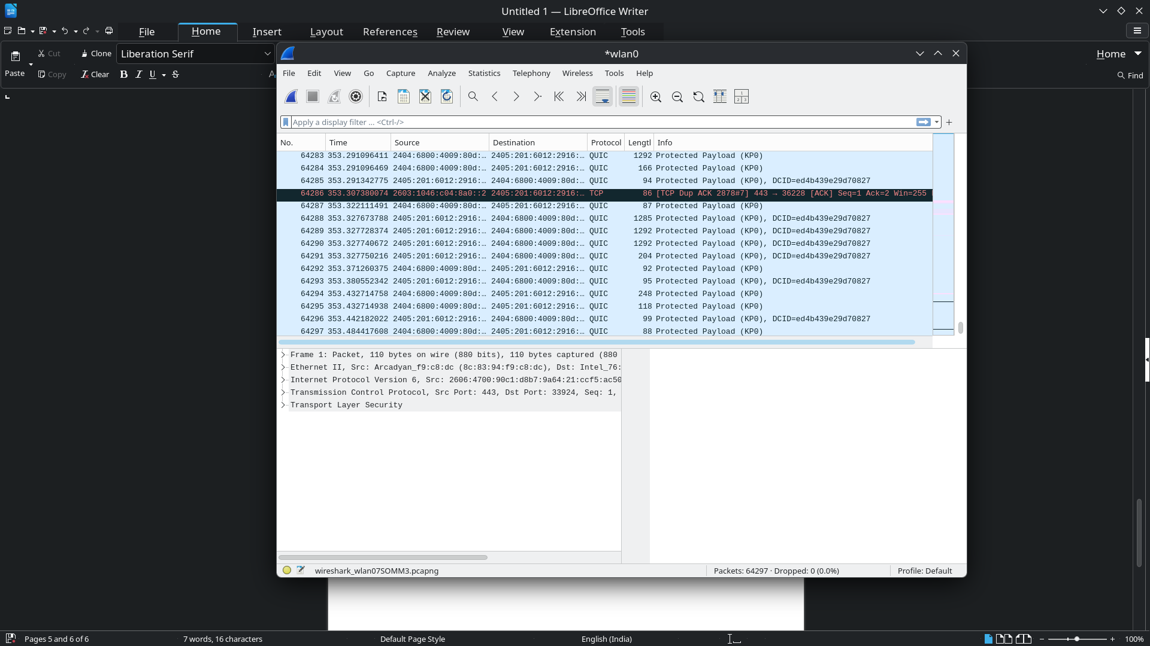
Figure :9-stop capturing

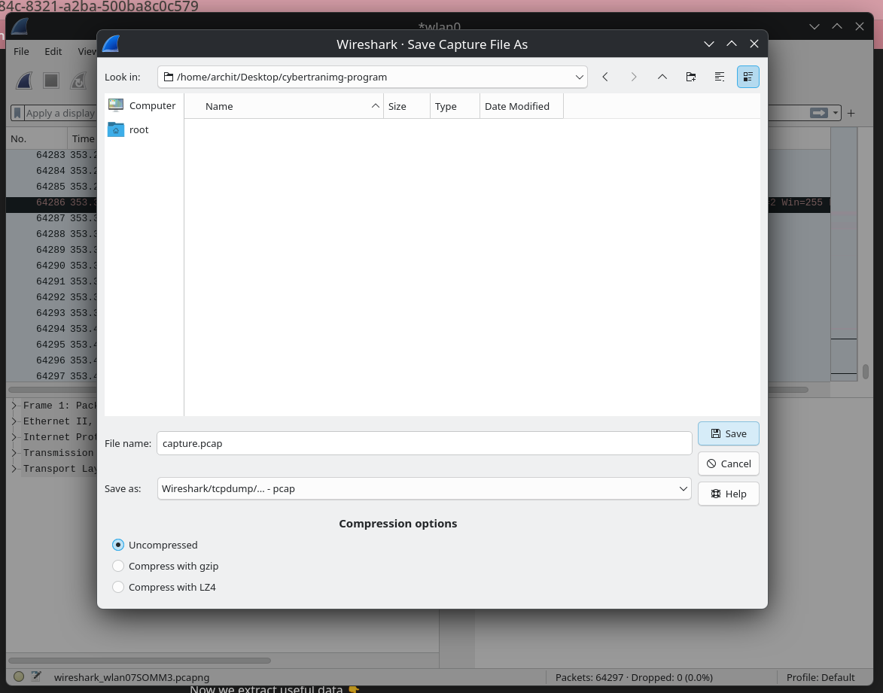
Figure :10-save the packet (capture.pcap)

Identified Protocols
Protocols observed include DNS, TCP, UDP, HTTPS, and ICMP. These represent normal communication between systems over the network.
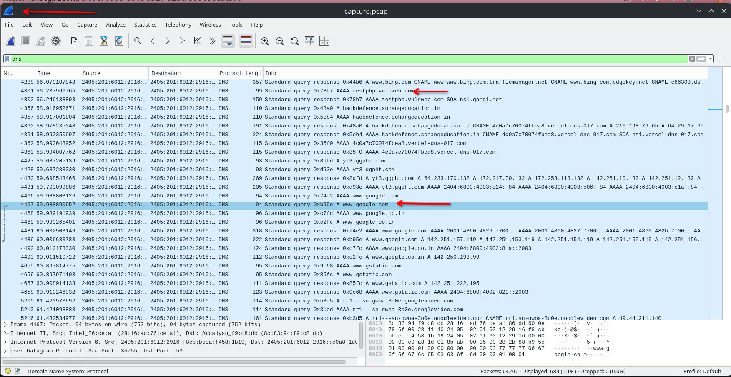
Figure :11-DNS Traffic Analysis

This screenshot displays filtered DNS packets using the “dns” filter in Wireshark. It shows domain name queries generated when accessing websites. DNS helps in resolving domain names into IP addresses.

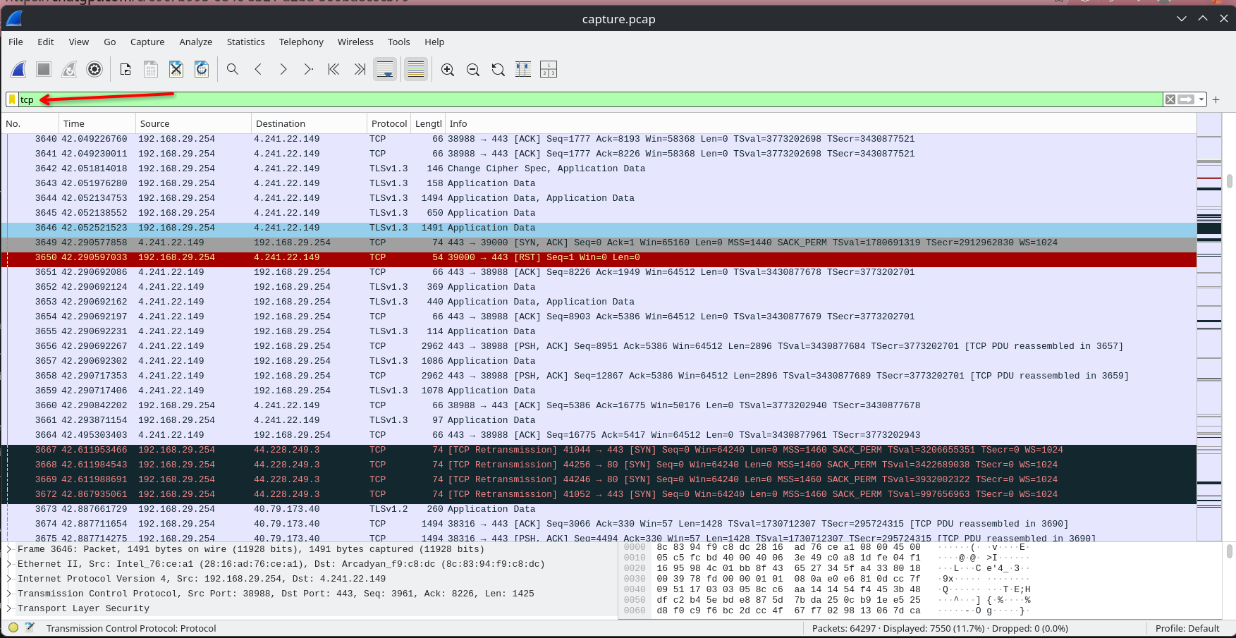
Figure :12-TCP Packets
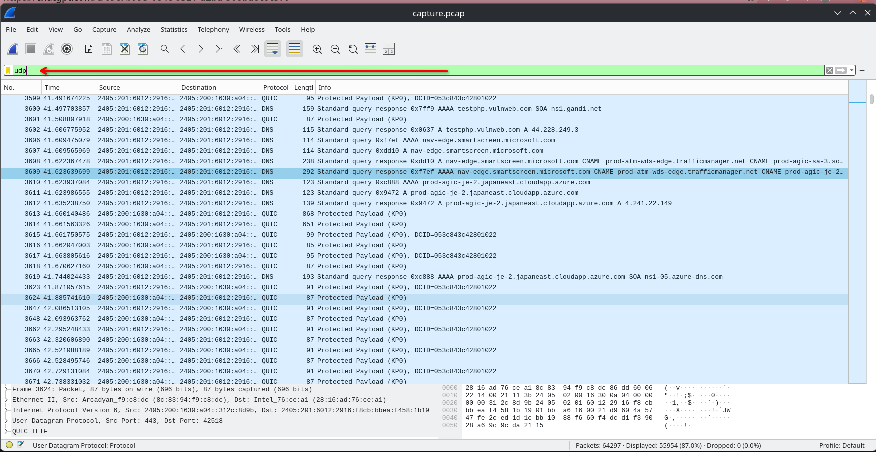
Figure :13-UDP
The screenshot shows TCP and UDP packets captured during the session. TCP ensures reliable communication, while UDP provides faster but less reliable transmission. These protocols areessential for network communication.

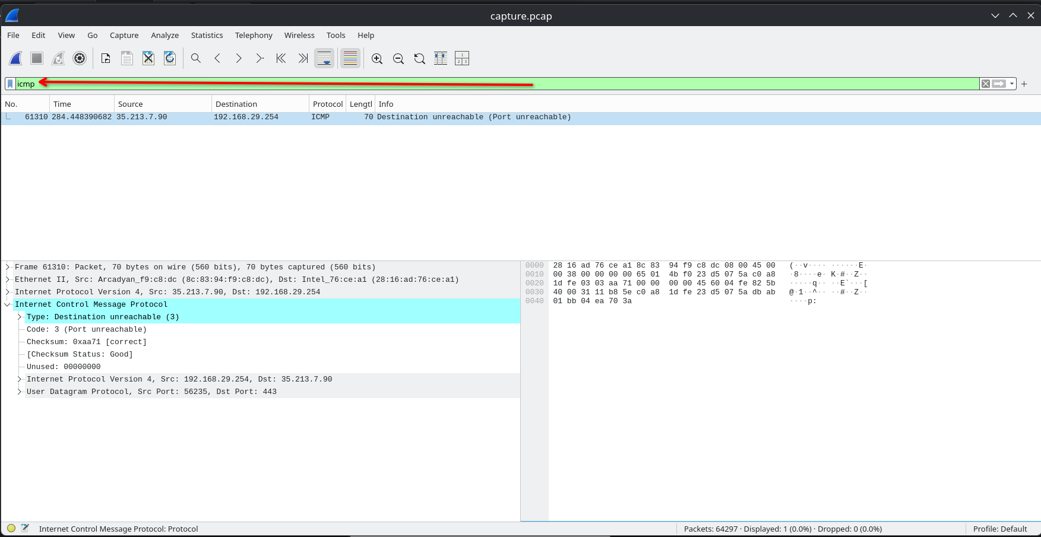
Figure :14-ICMP Packet Analysis
The screenshot shows ICMP packets captured using the “icmp” filter in Wireshark. These packets were generated using the ping command and are used to test network connectivity between the source and destination

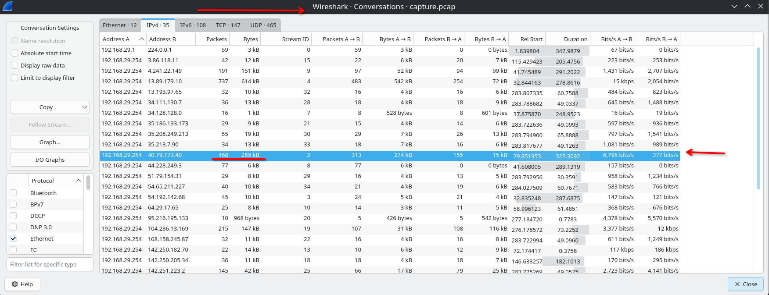
Figure :15-Network Statistics Analysis
This screenshot shows the statistics of captured packets, including communication between different IP addresses. It helps in identifying which devices are sending or receiving the most traffic.

Network Monitoring Architecture Diagram

This diagram illustrates how network traffic from the user’s device is captured using Wireshark. The captured packets are analyzed to identify different protocols and detect suspicious activity.
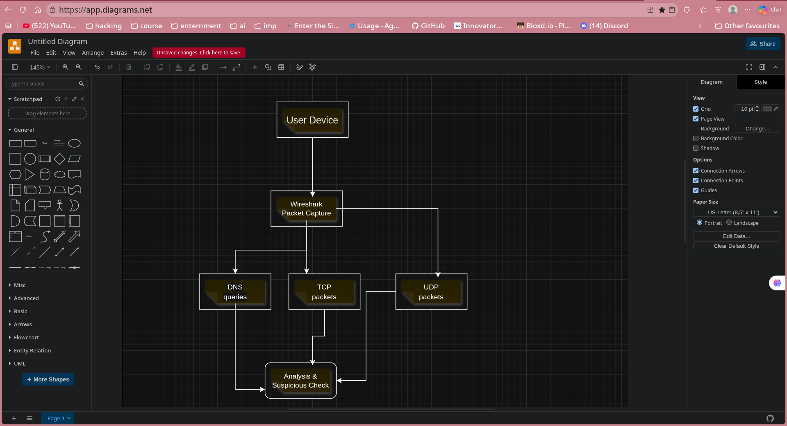
Figure :16-Network Monitoring Architecture Diagram

Packet Flow Diagram

This diagram represents the flow of data packets generated by user activities such as browsing or streaming. It shows how DNS requests, TCP connections, and data transfer occur and are captured by Wireshark.
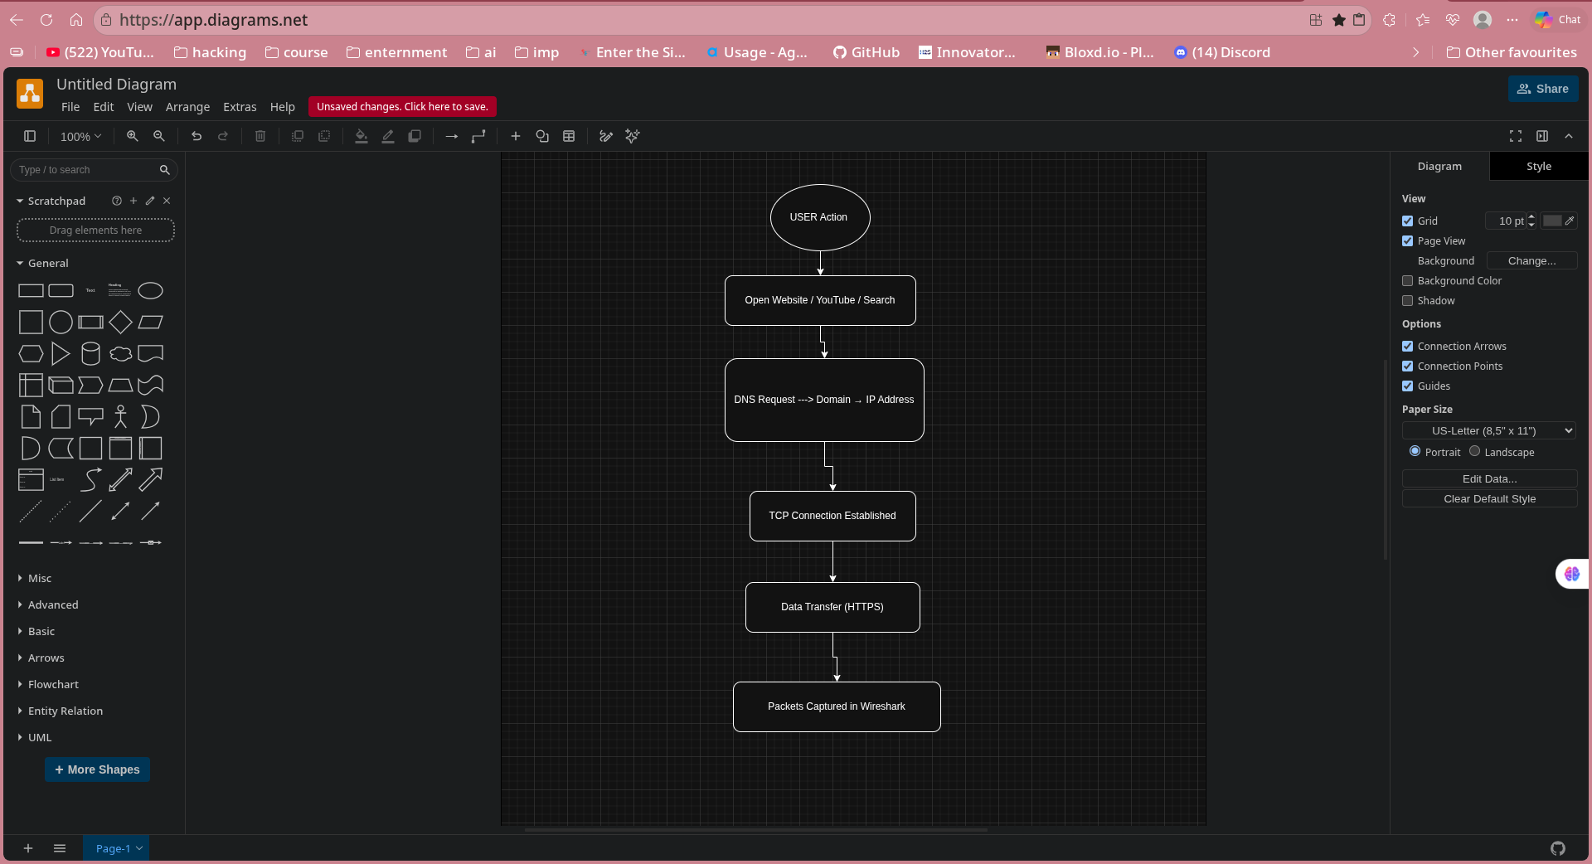
Figure :17-Packet Flow Diagram

Conclusion
The project demonstrated how network traffic can be analyzed using Wireshark. It helps in identifying protocols and detecting potential threats.

