IQ

SRI Systems, Inc.
[Type the company address]
[Type the phone number]
[Type the fax number]
[Pick the date]
Shoban Sriram
[A secrete guide to achieve a successful career in ITosphere]

Contents
OO Concepts 2
Design patterns 4
Frameworks 5
Java Core 6
Collection: 7
Thread: 9
JDBC 10
Hibernate (pure java ORM and persistence framework) 11
MVC 13
Spring 13
FindBug 15
Ruby 17
Struts 15
Tags 15
Web Related ( Servlets , JSP) 17
SOA 18
WebServices 18
RESTful 19
SOAP 20
jQuery (http://www.jquerybyexample.net/2013/07/latest-jquery-interview-questions-answers.html) 21
JSON 22
Puppet 23
Database 23
XML 26
Rails 27
JSF 27
HTML 5 27
EJB’s 27
JUnit 29
Maven 30
JBoss 30
Unix 30
Tomcat 30
Portlets (how are they different from Servlets) 31
Scrum 32
Agile: 32
Interview questions from the notes 33

OO Concepts

- Objects are the basic building blocks in OOPS. The real world objects have two characteristics: state and behavior. State is saved in variables and behavior is achieved through methods. Eg: Human object can have name, color, age, race, location etc and behavior like walking, sleeping, talking, eating etc.
- Procedural → Structured → Object Oriented → UML → Frameworks → Distributed computing (SOA) → Cloud computing, BigData or Hadoop one kind or process using DFS
- Data encapsulation, inheritance, polymorphism and abstraction are the main characteristics of OOP
- Encapsulation: Implies that the non-essential details of an object are hidden from the user and an access is provided to its essential details.
- Inheritance: OOP allows inheriting commonly used state and behavior from other classes. Enables to extend the functionality of an existing class.
- Abstraction: It refers to the attributes of an object that clearly demarcates it from other objects.
- Polymorphism: (overriding the methods defined in parent class, and making a call to them, classes, interfaces and abstract class. Passing a parent class attribute to a method. Public void walking(Animal animal) → walking.(cat) etc…
Polymorphism is nothing but assigning behavior or value in a subclass to something that was already declared in the parent class. Simply, polymorphism takes more than one form.
Dynamic binding: [Virtual functions, pure virtual functions (C++)]
Virtual Functions: We can use a single pointer variable to refer to the objects of different classes. Here we use the pointer to base class to refer to all the derived objects. But a base pointer even when it is made to contain the address of a derived class, always executes the function in the base class. The compiler simple ignores the contents of the pointer and chooses the member function that matches the types of the pointer. So to achieve real time polymorphism, we use ‘Virtual’ functions.
When we use the same function name in both the base and derived classes, the function in base class is declared as virtual using the keyword “virtual” preceding its normal declaration. When a function is made virtual, C++ determines which function to use at run time based on the type of object pointed to by the base pointer, rather than the type of pointer. Thus by making the base pointer to point to different objects, we can execute different versions of the virtual function.
Rules for virtual function:
- The virtual functions must be members of some class
- They cannot be static members
- They are accessed by using object pointers
- A virtual function can be a friend of another class
- A virtual function in a base class must be defined, even though it may not be used.
- The prototype of the base class version of a virtual function and all the derived class versions must be identical. If two functions with the same name have different prototype, C++ considers them as overloaded functions, and the virtual function mechanism is ignored.
- We cannot have virtual constructors, but we can have virtual destructors.
- While a base pointer can point to any type of the derived object, the reverse is not true.
- When a base pointer points to a derived class, incrementing or decrementing it will not make it to point to the next object of the derived class. It is incremental or decremented only relative to its base type. Therefore, we should not use this method to move the pointer to the next object.
- If a virtual function is defined in the base class, it need not be necessarily redefined in the derived class. In such cases, calls will invoke the base function.
Pure Virtual Function: It is normal practice to declare a function ‘Virtual; inside the base class and redefine it in the derived classes. The function inside the base class is seldom used for performing any task. It only serves as a placeholder. The function in the base class is declared empty. Such functions are called as do nothing function.
A “do-nothing” function may be defined as follows
Virtual void display()=0;
Such functions are called pure virtual functions. Classes having these functions are called abstract classes.
The main objective of an abstract base class is to provide some traits to the derived classes and to create a base pointer required for achieving runtime polymorphism. Abstract class is like Fruit, Flowers, Animal etc (each of these cannot have any properties for themselves but have to be extended by other classes like Apple, Orange, Rose etc)
- Object: It has a state and behavior. Associated with data
- Class: It is a blueprint or prototype from which objects are created
- Interface: It is a contract between the class and the outside world.
- Package: it is a namespace for organizing classes and interfaces in a logical manner.
- Modularity, Information hiding, code reuse, pluggablity and debugging ease
- Operator overload, method overloading, overwriting, overriding,

Cloud

- In Cloud we use resources and pay for it like utility companies.
- AWS is PAAS (Elastic Beanstalk) and also infrastructure service (IAAS)
- Elastic Beanstalk: EBS changes how developers push their apps into Amazon’s cloud. Developers upload the app and Elastic Beanstalk handles the deployment details of capacity provisioning, load balancing, auto-scaling and application health monitoring. EBS also gives the flexibility to developers to choose different solutions that are needed.
- Software as a service : gmail, google, SFDC
- PAAS:
- Gear is like a server, though it is not a server
- Cartridge:

Design patterns

- In programming, design patterns let you leverage the developer community's collective experience by sharing problems and solutions that benefit everyone. A design pattern must capture a problem's definition and context, a possible solution, and the solution's consequences.
- J2EE design patterns
  - Presentation Tier : Front Controller, Application Controller, CompositeView, ViewHelper, InterceptingFilter, DispatcherView, ServiceToWorker,
  - Business Tier: Application Service (New in 2), Business Object (New in 2), Business Delegate, Transfer Object, TransferObjectAssembler, SessionFacade, CompositeEntity, ValueObject, ValueObjectAssembler, Value list handler, service locator
  - Integration Tier: DAO, Service Activator, Domain Store (new in 2), Web Service Broker (new in 2)

- Elements of reusable object-oriented software: (Group of four design patterns)
  - Creational Patterns: Allow objects to be created in a system without having to identify a specific class type in the code. So we do not have to write large complex code to instantiate an object. It does this by having the subclass of the class create the objects. However, this can limit the type or number of objects that can be created within a system (Example database pooling, access control pooling etc)
Examples: Factory, Abstract Factory, Singleton, Builder, Prototype
  - Structural Patterns: Structural pattern allows creating system without rewriting or customizing the code. This provides the system with enhanced reusability and robust functionality.
Examples: Adapter, Bridge, Composite, Decorator, Façade, Flyweight, Proxy
  - Behavioral Patterns: Behavioral patterns influence how state and behavior flow through a system. By optimizing how state and behavior are transferred and modified, you can simplify, optimize and increase the maintainability of an application.
Chain-of-responsibility, Command, Interpreter, Iterator, Mediator, Memento, Observer, State, Strategy, Template method, Visitor
- Singleton: Ensures that the class has only one instance and provides a global point of access to that class. It ensures that all objects that use an instance of this class use the same instance. (mainly to solve coordination problem).
- Factory: createProduct, The factory method pattern intend to define an interface for creating an object but letting the subclass decide which class to instantiate. In other words, class differs instantiation to subclass. The factory method is also known as Virtual constructor. The client of the FM never needs to know the concrete class that has been instantiated and returned. Its clients has to know about the published abstract interface. Eg: EJBHome, EJBLocalHome, QueueConnectionfactory, javax.jms.TopicConnectionFactory, javax.net.ScoketFactory
- Abstract Factory: Create more than one type of a group of objects.
- Builder: Another way to create new objects
- Prototype:
- Adapter: Again access to a service with an incompatible interface
- Bridge: Decouples the function from the implementation.
- Composite: Often used with Chain of responsibility, Interpreter, Iterator, and visitor
- Decorator:
- Façade: Single interface, simplifying multiple interfaces in a subsystem
- Flyweight: Allows to utilize sharing to support large number of objects efficiently
- Visitor: Object that represents an operation that operates on elements of an object structure
- Proxy: Controlled access to a service is needed.
- Chain-Of-responsibility:
- Command: Separates invoker from performer. Example execute method in struts actionclass, main method in java etc : The command pattern encapsulates a request in an object, which enables to store the command, pass the command to a method, and return the command like any other object.
Benefits
  - Separates the object that invokes the operation from the one that knows how to perform it.
  - Its easy to add new commands, because you don’t have to change existing class
When to use
  - When we want to parameterize objects by an action to perform
  - When we specify, queue and execute request at different times
  - When we must support undo, logging or transactions.
- Interpreter: defines a grammar and interpreter that uses the grammar to interpret sentences.
- Iterator:
- Observer: A form of subscriber/publisher model
- State: Object appears to change class and alter its behavior
- Design patterns fall into two categories: general software development patterns and those patterns that identify specific J2EE challenges.
- Different relationships
  - Generalization: Inheritance (Is A) →
  - Aggregation: (Has A): the class is using other class so it has it as a member. ---<>
  - Association: Loosely coupled relationship ----
  - Realization: Interface (dependency) ----|>
  - Composition: Very strongly coupled relationship -----<>

Frameworks

Java New Features
- GC1 → improved GC first garbage collection
- Support for non-java language (java.lang.invoke)
- Main features added in 5
  - Generics
  - Annotations
  - concurrency
- Java 1.7
  - Improvement in try catch block where we can have the method kind of syntax and also catch multiple exceptions in the same catch block
  - Switch/case allows String values
  - Diamond operator when defining variables, we don’t have to mention on the right side.
  - Literals can have underscores
- 1.8

Java Core
- StringBuilder is faster than StringBuffer because it's not synchronized
- Externalizable is an Interface that extends Serializable Interface, and sends data into Streams in Compressed Format. It has two methods, writeExternal(ObjectOuput out) and readExternal(ObjectInput in)
- Final variables/methods cannot be changed, Finally(Exception block) and Finalize() to force clean the resource and it is not suggested to call, and it’s not guaranteed it will execute.
- Abstract class and Interfaces
  - Only public and abstract modifiers are allowed for methods in interfaces.
  - Variables are public static and final in an interface by default.
  - Difference between interface and abstract class: in abstract class you can have additional methods with different access modifiers and also have instance variables.
  - A class can implement multiple interfaces, but extend only one abstract class
- Polymorphism: One type of object, but base behavior executed/run. “one interface, multiple methods”. Polymorphism exists in three distinct forms in Java
  - Method overloading
  - Method overriding through inheritance
  - Method overriding through interface
- Overwrite: Something is to put something else in its place, replacing the behavior.
Override: something is to cause something else to operate instead of it harming or changing the thing overridden. This is polymorphism. (method can throw sub-exceptions not super, methods can be more narrower (only public, protected and default instance methods can be overridden), static methods can be overwritten.
Overload: Writing multiple methods with the same name but different return types or parameters.
- If you change the value of a static variable in a particular object, the value of that variable changes for all instances of that class. (static variables, methods are class variables and methods, static inner classes are not tied to their enclosing classes, static block gets executed first when VM is first started up, before instances of the class are created.
- public : Public class is visible in other packages, field is visible everywhere (class must be public too)
private : Private variables or methods may be used only by an instance of the same class that declares the variable or method, A private feature may only be accessed by the class that owns the feature.
protected : Is available to all classes in the same package and also available to all subclasses of the class that owns the protected feature.This access is provided even to subclasses that reside in a different package from the class that owns the protected feature.
default :What you get by default ie, without any access modifier (ie, public private or protected).It means that it is visible to all within a particular package
- enum is a special data type that enables for a variable to be a set of predefined constants.
- Downcast and upcast
  - Downcast: Object a = “Shoban” ; String s = (String) a;
  - Upcasting: String s = “Shoban”; Object o = (Object) s; //It is always legal to upcast. Object variable can hold any other variable.
- Annotations where introduced in Java 5, purpose of annotations is to attach additional information in the class or a meta-data of a class within the source code.
- Introspection: It is a technique in which the methods and variables of a java class can be programmatically determined at runtime.
- Garbage Collection: Every class inherits finalize() method from java.lang.Object, the finalize() method is called by garbage collector when it determines no more references to the object exists. Even though you force to recycle, there is no guarantee when all the objects will GC’d
- Constructors have same name as class, called only once during object creation, cannot return a value.
- Transient keyword indicates that the value of this member variable does not have to be serialized with the object. When the class will be de-serialized, this variable will be initialized with a default value of its data type.
- An inner class declared inside of a method can access local variable of this method if these variables are final.
- Wrapper class in java are wrapper around primitive data type.
- If you are overriding the method equals() of an object, you might need to consider overriding hashCode() method.
- Boarder layout is default for window, frame and dialog.

Collection: (Vector and array does not belong to collection)
- Vector Vs ArryaList : Vector is used in multithreading environment, vector doubles the size when it gets full. Arraylist is not threadsafe and it increases by half of its size. As Vector is synchronized there will be a performance hit.
- You can use Collections interface to synchronize any collection/list object
- Hashtable Vs HashMap: Hashtable is synchronized and HashMap is not, Hashtable does not allow null values in key or values, but HashMap allows null values as key (only one) and value. HashMap does not guarantee that the order of the map will remain constant over time.
- Hashtable (key-value pair): is a concrete implementation of a Dictionary. However java 2 reengineered hashtable so that it also implements the Map interface. Thus, Hashtable is now integrated into the collection framework. It is similar to HashMap, but is synchronized.
- Legacy classes are internally synchronized (Vector, Hashtable and Stack(extended from Vector).
- hashCode and equals method: hashCode methods helps to put all same objects that return the same value to put into one bucket, equals method then checks for objects within that bucket to see if same element is present. This is makes it very much efficient. Example: when you add objects (Cat, Dog, etc) to a hashMap, all Cats are in one bucket, all Dogs are in one bucket etc. When you check if a Cat ‘Sweet’ is present in a HashMap, it first gets the hashCode of Cat, uses this hashCode to get the bucket of Cat’s, then if the bucket is not empty, then uses the equals method to check if Cat ‘Sweet’ is present in the bucket. Does’
- Collection: Four interfaces in collection framework
  - Collection Interface: Enables to work with group of objects, it is at the top of the collections hierarchy
  - List: Extends Collection to handle sequences (list of objects)
  - Set: Extends Collection to handle sets, which must contain unique elements
  - Map: maps keys to values
We cannot add primitives
- List adds the method add (int, object) and addAll(int,Collection). These methods insert element at the specified index add(Object) & addAll(Collection) add at the end.
- Collection Classes
  - AbstractCollection: Implements most of the Collection Interfaces
  - AbstractList: Extends AbstractCollection and implements most of the List interface
  - AbstractSequencialList: Extends AbstractList for use by a collection that uses sequential rather than random access of its elements
  - LinkedList: Implements a lindked list by extending AbstractSequentialList
  - ArrayList: Implements a dynamic array by extending AbstractList
arrayList.remove(0) is slow as it needs to shift all other values, arraList.remove(arrayList.length-1) is fast. Performance is really slow if adding/deleting at the start of the list.
  - AbstractSet: Extends AbstractColletion and implements most of the Set interfaces
  - HashSet: Extends AbstractSet for use with a hashtable
  - TreeSet: Implements a set stored in a tree extends AbstractSet
- Factors on how to decide
- What you need the collection to do
- Are you using the fastest collection for your purposes(insertion/deletion, retrieval and traversal)
  - LISTS
    - Store lists of objects in ordered way
    - Duplicates are allowed
    - Can have null’s
    - Elements are indexed via an integer
    - Checking for particular item in list is slow
    - Looking an item up by index is fast
    - You can sort lists if you want to
    - If you want to add/remove items at end of the list use ArrayList
    - Add/remove else where in the list use LinkedList
  - SETS
    - Only store unique values in unordered way
    - Great for removing duplicates
    - Not indexed, unlike lists
    - Very fast to check if a particular object exists
    - hashCode() and equals() can be implemented for your purpose
    - does not allow null
  - MAPS: (HashMap, TreeMap and LinkedHashMap)
    - Key value pairs
    - Like lookup tables
    - Iterating our maps is slow
    - hashCode() and equals() can be implemented for your purpose
    - A map cannot contain duplicate keys: Each key can map to at most one value
- Tree (natural sort order), Linked(same order as added), Hash(no guarantee of order)
- Iterator or while loop, there is no difference between them.

Thread:
  - You cannot stop a thread, you can interrupt and also use wait method.
  - sleep() method waits for a particular duration of time, wait() methods waits indefinitely until notify() or notifyAll() method is called. When Sleep method is called, thread won’t start even if notify or notifyAll is called. Wait(), notify(), notifyAll() are methods of Object class, sleep() is in Thread class.
  - Synchronous block and Synchronous method:
    - Synchronous block: place locks for shorter periods than synchronized methods
    - Synchronous method: Locks the entire object.
  - Advantages: Concurrent operations,
  - States: New, Runnable, Running, Waiting/Blocked/Sleeping, Dead.
  - Synchronized keyword can be applied to static/non-static methods or a block. When applied for a method it locks the object, when applied for a static method it locks the class. The lock on the object and the lock on the class do not interfere with each other. It means, a thread accessing a synch non static method, then the other thread can access the synch static method at the same time but cannot access the synch non static method.
  - Volatile keyword: this is stored in main memory and multiple threads can access it. tracking when to end a loop in a multi-threaded application
  - Notify() wakes up the first thread that called wait(), notifyAll() will wakeup all threads that called wait() on the same object, but the highest priority thread will run first.
  - If run() method is directly invoked, the run() method runs in the existing thread and no new thread will be started. Start() has to be called for thread to be started.
  - Priority of the new thread will have the same priority of the thread that started.
  - Daemon threads run in the back ground, not used to run application code. Garbage collector is the daemon thread. Application does not wait for demon thread to end to exit the jvm.
  - Only methods can be synchronized, no variables or classes be synchronized.
  - While using multithreading, we should ensure that the main thread should end last or else the system will hang.
  - Deamon threads in the back ground. setDeamon(true) will make a thread deamon.
  - Threads have priority from 1 to 10. 1 lowest and 10 highest
  - Context-switching is the process of storing and restoring of CPU state so that Thread execution can be resumed from the same point at a later point of time. Context Switching is the essential feature for multitasking operating system and support for multi-threaded environment.
  - We can use Thread join() method to make sure all the threads created by the program is dead before finishing the main function. You can use thread.isAlive() method to check if the method is still running.
  - Sleep() and yield() methods are static so that programmers are not confused on which thread they are called on.

JDBC

- Steps in jdbc connection, register driver(load ), create connection, create statement, execute statement
- Common API’s: DriverManager, Driver, Connection, Statement, ResultSet, SQLException
- JDBC Driver types
  - JDBC-ODBC Bridge plus ODBC driver, also called Type 1: calls native code of the locally available ODBC driver. Used for development and testing purposes only.
  - Native-API, partly Java driver, also called Type 2: calls database vendor native library on a client side. This code then talks to database over network. Used when type 3 and type 4 are not available.
  - JDBC-Net, pure Java driver, also called Type 3 : the pure-java driver that talks with the server-side middleware that then talks to database. Used when multiple types of databases are used at the same time.
  - Native-protocol, pure Java driver, also called Type 4: the pure-java driver that uses database native protocol. Used for a specific type of database like oracle or MS SQL, Sybase etc.
- Type 4 is the fastest driver as it converts commands directly into vendor specific format.
- Dirty Read: When first transaction changes data, second transactions reads it but first transaction rolls back, then the second transaction that read is not valid anymore.
- Phantom Read:
- Non-Repeatable Reads:
- Types of ResultSet
  - TYPE_FORWARD_ONLY: The cursor can only move forward in the result set.
  - TYPE_SCROLL_INSENSITIVE: The cursor can scroll forwards and backwards, and the result set is not sensitive to changes made by others to the database that occur after the result set was created.
  - TYPE_SCROLL_SENSITIVE: The cursor can scroll forwards and backwards, and the result set is sensitive to changes made by others to the database that occur after the result set was created.
- Connection object is used to create all Statements.
- Statement: Create a Statement Object from the connection object. Any generic queries can be executed, for dynamic sql or for DDL work. Input is an sql statement.
- PreparedStatement: This object can be used to execute a compiled sql statement that has a predefined number of arguments to be passed. The performance is better. Inputs are parameters. It has only IN parameters
- CallableStatement: This interface is used to execute a stored procedure. It has IN, OUT and INOUT parameters.
- Isolation levels:

Hibernate (pure java ORM and persistence framework)
- Hibernate is a powerful, high performance object/relational persistence and query service. This lets the users to develop persistent classes following object-oriented principles such as association, inheritance, polymorphism, composition, and collections.
- ORM – Object Relational Mapping
- Open source, mapping of OO concepts to relational database using a process called object relational mapping.
- Hibernate uses few properties, such as query language specifications and connection pool, to define database properties and generate schemas.
- Isolation level:
- Advantages
  - Java developer need not worry about writing SQL queries. Clearly separates database access layer from business/UI layers.
  - Caching is built-in for better performance
  - Platform independence
  - Lazy loading improves performance (not needed everytime)
- Important conf files
  - Hibernate.cfg.xml configuration file
  - Mapping files *.hbm.xml for each table (used by conf class) [ORM is defined in these xml files]
- Important Hibernate classes
  - Session Interface
  - SessionFactory Interface
  - Configuration Interface
  - Transaction Interface
  - Query and Criteria Interface
- HibernateTemplate is a helper class which provides different methods for querying/retrieving data.
  - A Spring Template class simplifies interactions with Hibernate Session
  - Common functions are simplified to single method calls
  - Sessions are automatically closed
  - Exceptions are automatically caught and converted to runtime exceptions.
- Sorted collection is sorting collection by utilizing the sorting features provided by Java collection framework. If collection is not large, it will be more efficient way to sort this way.
- Ordered collection is sorting a collection by specifying the order-by clause for sorting, if collection is very large, it will be more efficient way to sort this way.
- Collection types in Hibernate are Bag, Set, List, Array and Map
- Hibernate proxy: Mapping of classes can be made into a proxy instead of a table. A proxy is returned when actually a load is called on a session. The proxy contains actual method to load the data. The proxy is created by default by Hibernate, for mapping a class to a file. The code to invoke JDBC is contained in this class.
- Lazy loading: Hibernate creates a proxy object to lazy load (We don’t fetch all the data for a particular object attributes. Proxy object is similar object that is created by hibernate. Example when you try to get Employee details it just gets employee details and not the associated list of users who reports to him etc.) FetchType.LAZY
- Eager loading: Hibernate loads all the data for every variable that this object has. (@ElementCollection(fetch=FetchType.EAGER)
- Concurrent update in Hibernate:
- Session.update() and session.lock():
- Dialect is needed to say hibernate what the database is (as all db’s are not same, some diff)
- Cache:
  - Hibernate has a default cache for all its queries. Like when we retrieve data for a User object, when we try to get the user again within the same session, returns the same object.
  - The second level cache(different sessions, applications, clusters): EHCache is configured in the .cfg.xml file with EHCAcheProvider class name. (Other type of second level cache is OSCache)
  - Not all entities are cached by default. We need to use annotation
@Entity
@Cacheable
@Cache(usage=CacheConcurrencyStrategy, [different types]) – to prevent dirty read
- Transient, persistent and detached objects:
  - Transient objects do not have association with the database and session objects. They are simple objects and not persisted to the database. Once the last reference is lost, that means the object itself is lost. And ofcourse, garbage collected. The commits and rollbacks will have no effects on these objects. They can become into persistent objects through the save method calls of Session object.
Eg: UserDetails user = new UserDetails();
User.setUserName(“Test user”);
  - Hibernate takes up then it is called persistence.
Eg: Session.save(user);
User.setUserName(“Update user”);
  - Detached object have corresponding entries in the database. These are persistent and not connected to the Session object. These objects have the synchronized data with the database when the session was closed. Since then, the change may be done in the database which makes this object stale. The detached object can be reattached after certain time to another oject in order to become persistent again.
Eg: session.close();
User.setUserName(“Update user after session close”); //will not update.
- Get() and load(): get is returns null if the object is not found. Load throws an exception if no value.

MVC

ehache
- Ehcache is used for aching your web page.
- You can configure ehcache by having a separate xml file ehache and define the cache configuration. Refer that in your web.xml file for all of your view’s, may be a jsp file etc like footer.jsp etc

Spring
- Main APIs used in Zimmer.com
  - ReloadableResourceBundleMessageSource – messages (cacheseconds 60)
  - JndiObjectFactoryBean – for jdbc connection pooling
  - Hibernate - LocalSessionFactorBean , HibernateTransactionManager,
  - JavaMailSenderImpl
  - Dwr – Direct Web Remoting - SimpleUrlHandlerMapping : creates javascripts that can be used to communicate with server components and vice versa.
  - Security – md5 spring security feature

- Spring
  - IoC or Dependency Injection. Use the XML file to inject properties into the spring factory for creating objects. You can make changes to the XML, without any changes to object to create different objects for the purpose. There are three ways we can achieve dependency injection, but in Spring, there are two ways you can inject the dependency, using properties and through construction. Interface injection is another ways of achieving IoC. Client object class will not use the new keyword for creating the beans.
  - Is very flexible with many technologies like JSP, velocity, XML, PDF etc
  - Spring supports RESTful URL’s
  - Annotation based configuration or XML configuration
  - IoC or dependency injection based.
  - Front Controller (Dispatcher Servlet). Request first hits this component
  - HandlerMapper
  - Configuration
    - Spring3 (DispatcherServlet) in web.xml
    - Spring3-service.xml (customized) – Details of bean wiring.
    - Spring3-servlet.xml – config the annotation bean (name is from web.xml plus servlet.xml)
  - Annotations
    - @Controller → Class level, tells spring framework that it can handle some requests
    - @RequestMapping → Can be used at the class level or method level, Map a particular url for a method. Arguments are
      - URL[] → can handle multiple urls
      - HTTP method[] → GET, POST, DELETE, TRACE, OPTIONS, HEAD, PUT. Default is GET.
      - Params[] → pass parameters eg. ‘myname=guest’
      - Headers[]→
- Example:
@Controller
@RequestMapping(“/student/*”)
Public class StudentController{
@RequestMapping(“add”,method=RequestMethod.POST)
Public String addStudent(){} - /appcontext/student/add – forwards to the return string
@RequestMapping(“delete”,method=RequestMethod.GET)
Public String deleteStudent(){} - /appcontext/student/delete
@RequestMapping(“details”) default is handled by GET
Public String studentDetails(){} - /appcontext/student/details

- You can also plug with other MVC frameworks like struts.
- Spring is a light weight inversion of control and aspect-oriented container framework
- IoC or dependency injection can be implemented in two ways in spring
  - Configuring this via XML
  - Using Annotations
- Two ways of using is dependency injection are
  - Constructor (usually used)
  - Setter method
- Pros and Cons:
  - Pros:Loosely coupled, increases testability,
  - Cons: Increase code complexity, complicate debugging and code flow is not clear at first.
- Struts is tightly coupled and spring is loosely coupled
- Spring is a container of beans.
- Different modules in Spring are
  - Core Spring framework:
  - Web :
  - AOP: Very powerful tool to achieve dynamic way of introducing additional functionality
  - DAO:
  - ORM:
  - MVC:
  - Spring Context:
Struts framework is part of Spring framework.
In Spring, if you don’t have a form, you don’t need a form controller. This is the major difference to Struts.
Spring Web MVC allows you to use any object as a command or form object.
Advantages of Spring MVC over Struts MVC
- There is a clear separation between Models, Views and Controllers in Spring
- Springs MVC is very versatile and flexible based on interfaces, but struts forces Actions and Form object into concrete inheritance.
Spring provides both interceptors and controllers:

- Bean scope
  - Singleton: Scope a single bean definition to a single object instance per Spring IoC container.
  - Prototype: Scopes a single bean definition to any number of object instances.
  - Request: Scopes a single bean definition to the lifecycle of a single HTTP request: that is each and every HTTP request will have its own instance of a bean created off the back of a single bean definition. Only valid in the context of a web-aware Spring Application Context.
  - Session: Scopes a single bean definition to the lifecycle of a HTTP Session. Only valid in the context of a web-aware Spring ApplicationContext.
  - Global Session: Scopes a single bean definition to the lifecycle of a global HTTP Session. Typically only valid when used in a portlet context. Only valid in the context of a web-aware Spring ApplicationContext.

Struts
- Struts is based on Model 2 MVC design paradigm, having flexible control layer based on standard technologies like java servlets, JavaBeans, ResourceBundles , XML as well as various Jakarta common packages. It has its own controller component and integrates with other technologies to provide the Model and the View. For Model, Struts can interact with standard data access technologies, like JDBC and EJB, Hibernate etc. For View, Struts work well with JSP’s, including JSTL, tiles, JSF etc
- Struts framework makes it much easier to design scalable, reliable web applications with Java
- ActionServlet plays the controller part in Jakarta Struts framework.
- Message Resource Definitions files can be added to the struts-config.xml file through <message-resources/> tag.
- ActionClass is part of the Model and is a wrapper around the business logic. Action class allows to work on the HttpRequest, has to be extended and overwrite the execute() method. The return type of the execute() method is ActionForward which is used by struts framework to forward the request.
- ActionForm is a JavaBean that maintains the session state for web application and it is automatically populated on the server side with the data entered in the form on client side.
- DynaValidatorForm can be used to validate user data on server side.
- Validator-rules.xml and validation.xml files are two xml files related with validation applied to Form bean, it can be on client side or server side.
- <html:errors/> can be used to display all the errors
- <html:javascript> when added in the jsp file generates the client side validation scripts, in validation.xml we need to add <html:javascript formName=”abc” dynamicJavascript=\”true\” staticJavascript=”\true\” />
- Difference between MVC 1 and MVC 2
MVC1 | MVC2
Just has two components (Jsp has all the display and business logic) | Has three components, controller which gets the request, and passes to the Action which handles the business logic and is the model object. JSP is purely for visual

Java Performance Tools
- JProbe (Quest):
- Jconsol: java tool to check on memory consuption

FindBug

- Different types
  - Scariest
    - High confidence
      - (strName.trim() , This value has to be assigned back to string attribute, strName = strName.trim())
    - Normal confidence
  - Scary

  - Troubling
    - High confidence
    - Normal confidence (variables not used, null check not valid )
  - Of Concern
    - High confidence (Accessing static method on instance object, unreferenced variable, Exception caught when not thrown, )
    - Normal confidence
- Lot of Very Confusing to have methods of names (names having mixed uppercase ower case, variables reused, .
- Integrated with Ant and when run it will show the errors and also creates an XML file with all the error codes.
- Bad Practice, Correctness, Malicious code vulnerability, Multithreaded correctness, Performance, Security, Dodgy Code,

- 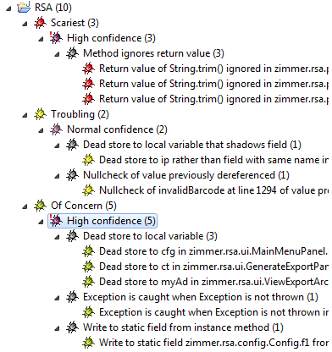

Ruby
- Interpreted language, more flexible, but performance is not its greatest strengths
- module “ABC” → like a package/namespace (Cannot use ‘<’ inherited or instantiated ), but can have methods, attributes etc and can be extended using key word ‘extend’ . Thus module’s provide a mechanism for multiple inheritance via mix-ins.
module First_Module
def method_1
puts “This is method 1 in First Module”
end
end
class First_Class < String
extend First_Module
end

First_Class.method_1 →prints This is method 1 in First Module

- access modifiers are public, protected (other objects of same class) and private (within the context of the same object).
- class abc < String ( ‘<’ is used to extend to a class)
- Polymorphism: Ruby is duck typing, changes objects dynamically based on the methods called. To achieve polymorphism in ruby, objects does not have to be in the inheritance hierarchy.
- Last statement of the method is a return (can also use return keyword), returns arrays.
- initialize() is used as a constructor
- you can create a proc (method) and assign it to a variable and reuse it.
- To through exception using keyword “raise” eg: raise “The value is less than 10”
- Ruby is strongly (dynamically) typed language, language processor checks during run time (5+”five”) gives error. Does not give error until execution.
- Fixnum is for integer, String class for string, Float class for 5.1,
- class Account
attr_accessor acctNum
def getDetails
puts “Account Number is “
puts acctNum
end
end
- Kernel methods like puts (puts or Kernel.puts “This is also optional but unnecessary”
- everything in ruby is objects
- you can have attributes, methods without a class
- variable names can contain letters, numbers and ‘_’ , case sensitive, should start with letter
- Ruby operators == , !=, <, > , if weight == 120 , unless age < 18 (if not greater than 18)
- looping – 4.times {puts “Hi”} , 3.upto(7) {puts “hi”}, 15.downto(12) {puts “hi”} , 0.step(15,5){|x| puts x} , d.to_f (changes the type to float)
- final variables (if you start a variable name with uppercase letter its constant, eg Pi = 3.14159), but this still changes the value. Ruby throws an warning message
- using #{} within a string. This will actually get the value of variables
- 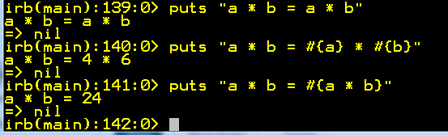
- arrFruits = [“Apple”,”Orange”,”Grapes”,”Banana”] , arrFruits.push(“PineApple”) , arrFruits.pop → removes last item , arrFruits.each {|x| puts x}, arrFruits.include?(“Apple”)
- "434-()2343".match(/[a-z]/) or "434-()2343" =~ (/[a-z]/)
- commas are not allowed in numbers, underscores are eg: 100_000_000
- erb stands for embedded ruby (was in puppet code)
- Similarities with Java
  - Memory is managed via a garbage collector
  - Objects are strongly typed
  - There are public, private and protected methods
  - Has rdoc very similar to javadoc that generate the docs.
  - Variables are passed by reference (values themselves are references)
  - Try catch → java , begin rescue → Ruby
- Differences
  - Ruby call stack is very less compared to java call stack. Eg: database access call: 28 to 37 for ruby (6 layers), java is 50+ (11 layers)
  - It is an interpreted language and so you don’t compile it. Hence ruby is a dynamic type checking, where in issues in the code show-up when we try to run/execute.
  - Everything is an object including numbers like 1, 2, etc
  - There is no static type checking.
  - Variable names are just labels, they don’t have a type associated with them. Variables just spring-up to different types based on the value assigned.
  - There is no casting, but you can change the objects to different objects like to_float etc
  - There are misin’s instead of interfaces
  - == and equals are handled differently in java and ruby, == is used to check the contents in ruby (in java .equals) and equals is used to check if two objects are same (== in java)
  - In Ruby, new is like a property instead of a keyword.
  - Last statement in a method is a return
  - Class name and file name need not be same
  - Ruby automatically converts the data type if a number is a big number, but in java over/underflow happens.
  - Uses nil instead of null
  - Super can be called anywhere, but in java it should be the first line
  - Strings are mutable in ruby and immutable in java. Use symbols in ruby to make strings immutable.
- Symbols: Type of variables much like string :symbol
- Advanced Ruby
  - Operator overloading is possible. (you can overwrite == , + , to_s etc) all these signs are methods
  - array[] , array << “abc” This is how you add to array using << symbol
  - Space ship operator <=> (sorting is so easy array.sort! {|a,b| a <=> b } → descending , array.sort! { |a,b| b <=> a}
  - Self, super, def initialize,
  - Attr_attribute (internally creates instance variable, setter and getter) , attr_reader (creates instance variable, getter) , attr_writer (creates instance variable, setter)
  - Declare class variables like @@ids (with two at signs)
  - Parallel assignment eg: a, b = 10, 20
  - Even number release are actual release, odd number releases are experimental.
  - Creating abstract class is not possible, but the same functionality can be achieved by creating a kind of abstract method as below
def get_db_name
raise 'this method should be overriden and return the db name'
end
or
class A
def initialize
raise 'Doh! You are trying to instantiate an abstract class!'
end
end

class B < A
def initialize
end
end

  - Sort and reverse will leave the original array untouched, you need to use sort! And reverse! To make changes to the original array.
  - Conditional statements
    - array.include?(id)
foo_bar_123 | Local variables |  | Methods ending in ‘?’ return Boolean results  -empty?,zero?,include?,eql?,member?,success?,  stoped?,any?,all?
@foo @trucks @_123 @Cat | Instance variables |  | Methods ending in ‘!’ are possible dangerous  map!, sort!, reject!
@@foo @@car @@dog | Class variables |  | list.each do |x|  #do something with x  end
Cow COW | Constants |  | list.each_with_index do |x,i|  end
$rails $a $_123 $Horse | Global variables |  | Control Flow: &&, and , case text when
Math::PI | Module Constants |  | Duck Typing: no is a relationship, String and Array behave same way
1 2 3_000 1_123 | Integers and bignums |  | Exception: raise, rescue, ensure, retry
1.0 2.0 | Floating point numbers
Math::min(x) | Module Functions
:symbol :”A-Symbol” | Symbols (Singletons)
/^[Rx]egexp/ | Regular Expressions
[1, “1”,:one] | Array
{:one ➔1, :two ➔2} | Hash

Rails
- http://www.railsinstaller.org/
- rails new sample
- comes with a default server ‘WEBbrick’
- go to your apps director ‘samples’ and run rails server or rails s
- http://download.aptana.com/tools/radrails/plugin/install/radrails-bundle → Eclipse plugin
- ABCController < ApplicationController (extend ApplicationController)
- Three main parts
  - Active Record: A class library that provides an ORM over a plain old RDBMS
Eg: class Student < ActiveRecord::Base
  - Action
- 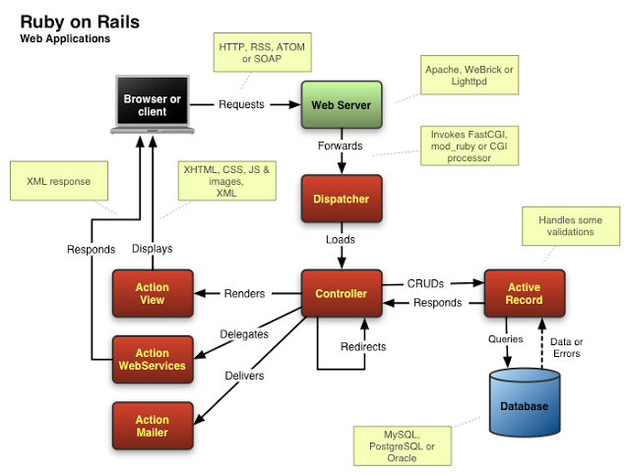

Python
- Interpreted language, more flexible, simple, easy to read syntax, open source
- Object oriented language
- 99% cross platform, open source, has interactive shell, easy to embed and extend
- Automatic modules namespaces
- Case sensitive, type-less, whitespace matters, #comments the line, no multi-line comments

VMWare

Puppet
- Default port 8140, puppet client runs every 30 mins
- Puppet –noop , puppet –-t
- package / file / service if you can do this, you can do a lot.
- Centralized configuration tool which is used to automate administration tasks. Puppet Agent (Client) sends request to Puppet Master(Server) and Puppet Master Push configuration on Agent.
- Manifest in Puppet are the files in which the client configuration is specified
- Whatever the manifest we defined in modules, can call or include into other manifests. Which makes it easier to manage Manifests as it helps to push specific manifests on specific Node or Agent.
- Steps to configuration
  - Install puppet client/server on client and server machines
  - Configure the host in puppet client to add puppet server m/c
  - Check the ownership of the “/var/lib/puppet” folder where the puppet configuration is loaded. Use the ‘chown’ command to assign puppet user
  - Run puppetd –test on client
  - Access puppet server with root access
  - Check for certificates on the server using puppetca –list
  - Sign the certificate by running command puppetca --sign puppet-client-name
  - Check on client to see if you can connect server. It should be able to access the server.
  - On server, create a new puppet policy file may be like a site.pp file in the manifest folder

node default{
package { ‘nmap’: ensure => installed,
}
file { ‘etc/motd’ :
source => ‘puppet:///files/motd’,
}
package{ ‘openssh’:
ensure => installed,
}
file { ‘etc/sshd_config’:
source => ‘puppet:///files/sshd_config’,
notify => Service[‘sshd’],
require => Package[‘openssh’],
}

service{ ‘sshd’ :
ensure => running,
enable => true,
hasstatus => true,
hasrestart => true,
}
}

  - After creating this file you need to restart the puppet master using command “rcpuppetmasterd restart”
  - Currently puppet client is running on the client if not use command “rcpuppet start” to start the service.
  - Look at the log ‘tail /var/log/puppet/puppet.log’ – “rcpuppet stop” to see the log file
  - You can check now the sshd permissions that is disabled as configured earlier…(changing sshd configuration is not in the steps)
- /var/lib/puppet/ssl/ca/signed → certificates are stored here
- Sometime you need to write manifests on conditional experession based on agent specific data which is available through Facter. Facter provides information like Kernel version,Dist release, IP Address, CPU info and etc.You can defined your facter also.
- etckeeper-commit-post: In this configuration file you can define command and scripts which executes after pushing configuration on Agent
- Etckeeper-commit-pre: In this configuration file you can define command and scripts which executes before pushing configuration on Agent
- By default Puppet Agent request to Puppet Master after a periodic time which known as “runinterval”. Puppet Kick is a utility which allows you to trigger Puppet Agent from Puppet Master.
- Puppet dashboard is that it can automatically receive reporting information from the clients and store it in a MySQL DB for easy retrieval. To do this, we need to move a script and set a couple of things in the puppet.conf on the server. In etc/puppet-dashboard/lib/puppet there exists a script called Puppet_dashboard.rb. We need to copy this to $libdir/puppet/reports directory.
- Dashboard is a web application that provides both external node classification and report processing. It is a component of puppet enterprise.
- Dashboard 2.0 is cool, it has improved to REST API access, runs on both Ruby 1.8.7 and 1.93, bug fixes, UI tweaks, updated to Rails 3.2 with many gem updates.
- PuppetDB provides an API for retrieving reports going forward Dashboard will use this API

Linux
- Sudo → super user do.
- Root → is the highest level of user
- In Ubuntu you cannot login as root, to prevent hackers or other treats , so you login as a normal user and then sudo.
- Man ping, use q to quit the man pages.
- Tasksel → to install any package easily.

Tags
- Custom tags provide the same functionality as java bean components. However unlike javabean components which must first be declared and then accessed using get and set methods, custom tags work with a page by obtaining initialization information through parameters defined when the tag is created custom tags have access to the web container and all the objects available to JSP page. Custom tags can modify the generated response. Custom tags can aslo be nested within one another, allowing for complex interactions with a JSP page.

Web Related ( Servlets , JSP)
- Servlets
  - Servlets are a programmatic tool and are best suited for low level application functions that don’t require frequent modification.
    - Well suited for dynamically generating binary data such as images or a new content type
    - Extending a web server functionality. (When extending the servlet class if we need to overwrite the init() method, we need to call super.init() as it is not a do nothing function.
    - doGet(), doPost(), doPut(), doDelete(), doHead(), doTrace(),
    - destroy() method is a do nothing method, so need not call super.
  - Single Threaded models are thread safe servlets.
- JSP
  - In jsp we use include for static file and jsp:include for dynamic files
- Clustering is used for
  - Load balancing
    - Random
    - Round Robin
    - Weight based
    - Parameter based
  - Failover
- Internationalization: It is a process of preparing an application to support various languages.
- Localization: is the process of adapting an internationalized application to support a specific language or locale. A locale is a language or subset of a language that includes both regional and language specific information.
- Custom tags: Provide the same functionality as java beans components. However unlike java Bean components which must first be declared and then accessed using get and set methods. Custom tags work with a page by obtaining initialization information through parameters defined when the tag is created. Custom tags have access to the web container and all the objects available to jsp pages. Custom tags can modify the generated response. Custom tags can also be nested within on another, allowing for complex interactions with a jsp page.

SOA
- Approach to deploy a software application employing loosely coupled services, standard interfaces/protocols, cross-platform and seamless.
- When designing SOA you need to think about long term, use right technology, factor in the business, consider service design.
- SOA Architecture
  - SOA Work flow : allows us to define a work flow using services in the SOA registry. (orchestrating services)
  - Service Broker: reads the work flow and takes the services from SOA registry and ties them together. Service brokers are middleware like EAI.
  - SOA Registry: is like a reference database of services. It describes what each service does, where they are located and how they can communicate. It’s a central reference of meta-data for services. (WSDL)
  - SOA supervisor :
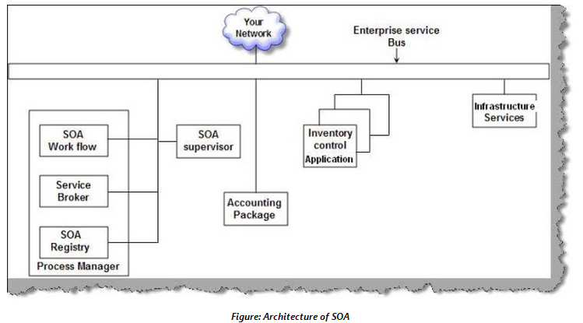
- SOA = Service and Message
- 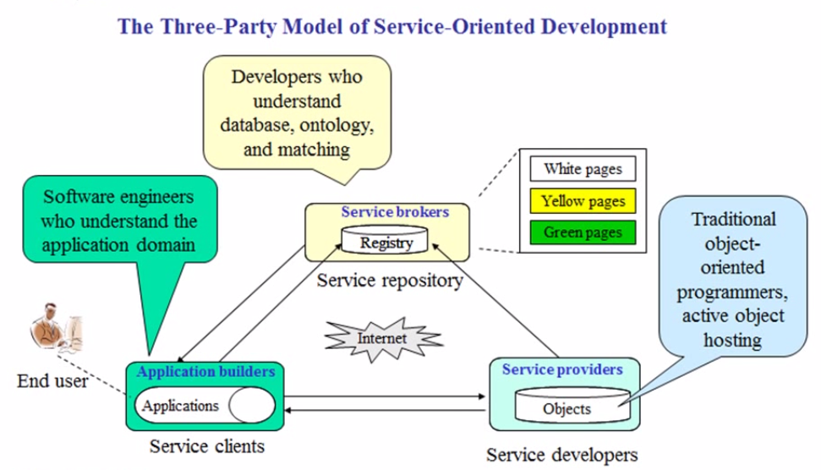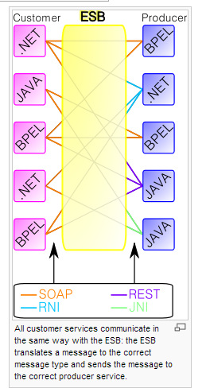
- An ESB (Enterprise Service Bus) is a software architecture model used for designing and implementing communications between mutually interacting software applications in a service Oriented architecture. As a software architectural model for distributed computing it is a specialty variant of the more general client server model and promotes agility and flexibility with regards to communications between applications. Its primary use is in EAI of heterogeneous and complex landscapes.
- 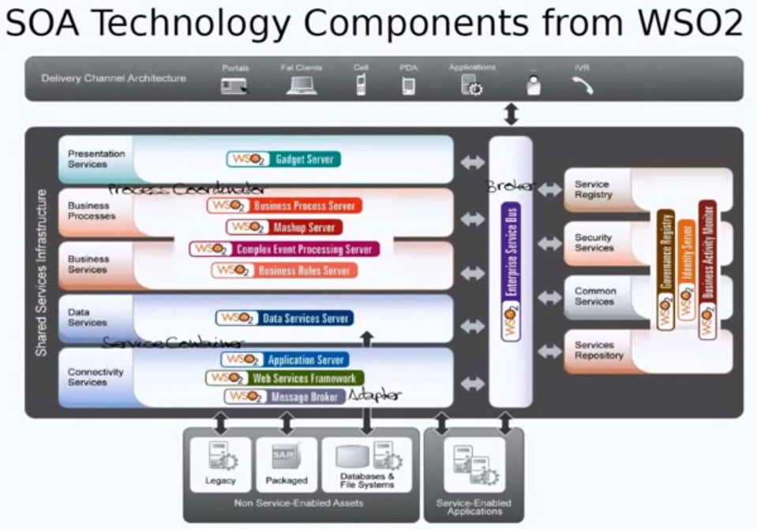
- SOA is an architecture for building loosely coupled services which act like black boxes and can be orchestrated to achieve a specific functionality by linking together
- Service
  - Should be self-contained and communicate using messages
  - Should be to self-define themselves
  - Should be maintained in a repository where we can find them (UDDI). SOA registry where we can get the services.
  - We should be able to orchestrate services
- Message
  - formats should be standard and cross platform
  - should be able to communicate asynchronously, reliably and in a secure way
  - should be able to describe and discover a services in a standard manner (WSDL)

WebServices
- Different Jars
  - Apache Axis2: WSDL2Java or Java2WSDL,
  - JAX-WS: Is a annotation based support model for developing web services. This replaces JAX-RPC. Uses JAXB 2.0 API for binding technology for mapping between java objects and XML documents.
  - JAXB: JAXB is an XML to Java binding technology that supports transformation between schema and java objects, between XML instance documents and Java object instances.
- WSDL→Java (top down approach), Java → WSDL (bottom up approach)
- URL, MediaType are important attributes to set
- Service First → Java code & then WSDL (Bottom up approach)
- Contract First → WSDL and then java code. (Top down approach) – We still write a throw away java class interface. Once we get the xml and then tweak it as we need and lock it down. Then update the java class as per the WSDL. This is how it is done in real time scenario.
- SEI → Service endpoint interface . This is the class that transfers data to XML. This is a generated code.
- WSDL, UDDI, SOAP, SEI
- Different operations: one-way, request-response, solicit-response, notification
- Wsimport tool to generate the stubs.
- Main components of webservices: XML, SOAP, UDDI, WSDL
- Annotations help in keeping the names same no matter the changes in the underlying method/class names
- Defining Types: (@SOAPBinding(style=Style.RPC/DOCUMENT))
  - There are two types (Style.DOCUMENT and Style.RPC) Default is DOCUMENT
  - RPC is not remote procedure call, it’s a style.
  - Advantages of document type are to validate, in RPC you cannot validate.
- 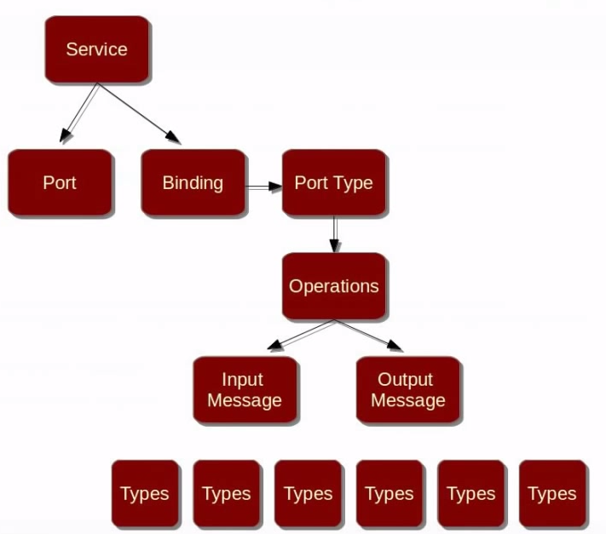
- Having a separate interface will help to decouple. So every implementation class will have an interface and all annotations specified in that interface. This is service EPI.
- Only one annotation has to be specified in the implementation class which is
endpointInterface="org.shoban.javabrains.ProductCatalogInterface"

RESTful

- REST stands for Representational State Transfer.
- There is no RFC, no standards, uses patterns for implementations. (should have a good way of naming rest services, short meaningful …etc) The main challenge is to do it properly and the best way to expose the methods. Producing REST service is more difficult due to no standards or RFC. Consuming is not as difficult. Resources: methods should be Coarse Grained and not fine grained. Nouns and not Verbs.

- Advantages
  - Scalability – heterogeneous systems can interact with each other
  - Generality – system to system interactions
  - Independence – very independent
  - Letency (Caching) -
  - Security – https specification
  - Encapsulation –
- Services are implemented using servlets methods and so called directly from client using uri. Hence its faster than SOAP as it does not have to traverse the XML file.
- RESTful services are completely stateless
- Restful services provides a good caching infrastructure over HTTP GET method(if data the web service is returning is not altered frequently and not dynamic in nature.)
- REST is particularly useful for restricted profile devices such as mobile phones and PDA’s or tablets for which the overhead of additional parameters like the headers and other SOAP elements are less.
- REST services are easy to integrate with the existing websites and are exposed through XML.
- No interoperability.
- Light weight and faster result and simple transaction (CRUD operations) is needed
- GET,PUT,POST,DELETE,HEAD
GET → Read, DELETE → Delete, HEAD → Headers, no body, PUT and POST → create/update
- PUT for create (identifier is known by the client)
- PUT for update if full replacement (Idempotent)
- POST for create on a parent resource (201 return code created, with location of where it has created)
- POST for update on instance resource. (200 return code ok) (NOT Idempotent)
- MediaType → this makes the server/client how to interpret objects like (html, xml, plain, json etc). Format Specification + parsing rules, Request: Accept header, Response: Content – type header
- Design:
  - Base URL , smallest url possible
  - Versioning: Don’t break the existing clients,

SOAP

- Apache Axis is an implementation of the SOAP
- JAXB is used by the java code that is generated from the WSDL
- JAXP
- WSDL contains and describes the common set of rules to define the messages, binding, operations and location of web service.
- SOAP represents the information exchange mechanism between the three main actors in the webservices model
  - A web service provider
  - A web service requester
  - A web service Broker
- It is based on XML documents and is designed to be simple and extensible.
- SOAP is defined by W3C specifications
- It is also independent of actual web services implementation and therefore allows interoperability between web services implantation on different platforms and OS
- SOAP Web services (such as JAX-WS) are useful in handling asynchronous processing and invocation.
- SOAP supports several protocols and technologies, including WSDL, XSD’s, SOAP, WS-Addressing
- Used for complex implementation.

SOAP Vs REST

SOAP | REST
Exposes OPERATIONS which represent LOGIC | Exposes RESOURCES which represent DATA.
Uses HTTP POST | HTTP Verbs (GET,PUT,POST,DELETE) for CRUD operations
SOAP is XML based messaging protocol. XML data only. | REST is not a protocol but an architectural style, and multiple data formats
SOAP has standard specification | REST has none
SOAP uses interfaces and named operations to expose business logic. SOAP calls are made to business logic. | REST messages should be self-contained and should help consumer in controlling the interactions between provider and consumer(examples links in the message to decide the next course of action)
SOAP has specifications for stateful implementation. Asynchronous messaging. | REST follows stateless model. Emphasis on simple point-to-point communication over HTTP
SOAP has a separate specification for security | REST does work on HTTPS and no other specs
Strong Typing.
Eg: switchCategory() | Eg: getUser()
 | REST can be consumed by any client, allows better support for browser clients due to its support for JSON, Ajax, javascript
ACID transactions over a service. Provides two phase commit (WS-AutomicTransaction) | It is’nt ACID complaint. Does not provide two phase commit
SOAP supports WS-Security which adds more enterprise security features | REST supports SSL (as SOAP also does), but no special security
SOAP has a successful/retry logic built in and provides end to end reliability even through SOAP intermediaries | REST does’nt have a standard messaging system and expects clients to deal with communication failures by retrying.
SOAP is OLDI | REST is safe..are’nt all get operations safe?

USES
SOAP | REST
Enterprise services | Web Services
 | Limited bandwidth (smaller message size)
SOAP based reads cannot be cached | REST based reads can be cached. Performs and scales better

MongoDB
- Horizontal scalability and spread across multiple physical systems

- Setting up…download, create folder /data/db , start mongod.exe and start mongo.exe. use ‘db’ as you created db folder. Eg: db.user.insert({name:”Shoban”,lastname:”Sriram”}) , db.user.find({name:”shoban”})
db.users.update(
{ age: { $gt: 18 } },
{ $set: { status: "A" } },
{ multi: true }
)

- Creates JSON style documents
- JSON-style documents with dynamic schemas offer simplicity and power
- Mirror across LANs and WANs for scale and peace of mind, Scale horizontally without compromising functionality
- In MongoDB, the primary key is automatically set to the_id field

Node.js

- Clolud based javascript library resides and owned by google servers

jQuery (http://www.jquerybyexample.net/2013/07/latest-jquery-interview-questions-answers.html)
- JQuery is fast, lightweight and feature rich client side javascript library/framework which helps in travers HTML DOM, make animations, add Ajax interaction, manipulate the page content, change the style and provide cool UI effects.
- JQuery is a client side javaScript library and greatly simplifies javascript programming
- Cross browser support, easy to learn and expand, AJAX capability, large pool of built-in methods, tons of plug-ins
- Moved css complexity to javascript

- $ is used for the elements and # is used for the id’s.
- Example
$(document).ready(function(){
$(“p”).click(function(){
$(this).hide();
});
$(“h1”).click(function(){
$(“h2”).hide(1000);
});
}); //$ sign can be replaced by JQuery, but for simplicity we use $
- JQuery does not follow W3C recommendations, but is used in every other website
- The starting statement is $(document).ready(function(){, there could be multiple of those statements.
- Comes in two versions production and development. (production is minimized)
- Advantages of using CDN (Google, Microsoft, JQuery) will reduce load on our servers
- To find html elements in JQuery we use selectors, name, #ID, .Class, *, multiple elements, attribute selector.

JSON
- Advantages are
  - Easy to read and write (Simplicity,Readability,Scalability,Flexibility)
  - Fast and compact
  - Ideal for ordered lists or key/value pairs
  - Maps perfectly to most programming language with mutable arrays and dictionaries.

- Supported objects are array’s [1,b,c,…] and key/value pairs {“key”:”value”,”key2”:”value2”}
Value can be string, number, object, array, true/false or null. This helps to build so much data.
- This structure is similar to what PHP(Phyton) supports.
- Use:
  - export/import data where “live reading” is not necessary
  - To configure menus or tools
  - To define production assets
  - To store settings for scripts
  - To create attribute mapping files
  - To store any key/value data
- Jsonlint.com can be used to validate json format.
- Phyton has json methods that can be used to read/write/update/delete contents in json object. It’s like parsing XML file.
- Jackson is like XML Parser, you can use to create java files (pojos) out of .json file and use it in java for creation/updation etc. (bug in Jackson, Boolean should create methods with getABC() instead of isABC() , the other bug is with data type byte[]

Database
- Normalization is a process of organizing data in a database more efficiently, and it is done to make sure that connections and dependencies between data make sense, and to get rid of redundant data.
- Normalization is a technique used to simplify data structures by establishing relationships between data items and removing unnecessary data items.
  - First Normal Form: 1NF removes all repeating groups, so that record is of fixed length. Data groups are decomposed into two-dimensional records. The fields of record have simple atomic values
Employee Name | Dept Name | Child Name | Date of Birst | Sex

1NF
Employee Name | Department Name |  | Employee Name | Child Name | Date of Birth | Sex

  - Second Normal Form: A relation is in 2NF if and only if it is in 1NF and every non-key items are fully dependent on the primary key.

Eg: A supplier related with particular city, sends the products to the company, when each city is having some status. Here city names and status are repeated. To convert into 2NF we have to create functional dependencies like
Supplier Code | Status | City | Product code | Quantity

-------- Status
Supplier Code -----
-------- City

Here status and city are repeating so you can get those into a separate table and reference with a new supplier code.
Supplier Code | Status | City
New_Supplier_Code1

Supplier Code | Product code | Quantity

  - Third Normal Form: A relation is in 3NF if and only I fit is in 2NF and every non-key item is non-transitively dependent on the primary key. Here transitive dependencies are removed from a record design.
Transitive: Being or relating to a relation with the property that if the relation holds between a first element and a second and between the second element and a third, it holds between the first and third elements.
Extending the example in 2NF
Supplier status and city status are made separate tables
Supplier Code | Status

Status | City

- Fact tables are primary tables of database which track the progress of a certain process or activity.
- Constraints are used to prevent the database from losing internal and external integrity. The types are check, not null, unique, primary key and foreign key.
- Different types of Joins
  - INNER : Returns all the rows in both the tables where ‘ON’ clause matches (Select * from emp_tbl e inner join tbl_location L ON E.location – L.location
(Inner part of the Venn diagram)
  - LEFT and RIGHT OUTER JOIN :
    - Left: All records from left table and the matching records from the right table.
    - Right:All records from right table and the matching records from the left table.
  - FULL OUTER JOIN :
    - Full Outer Join: returns all rows in both tables and also the matching records in both the tables (All red)
    - Full outer Join (not matching records): Can be used to get only records that don’t match using a where clause (where A.key is null and B.key is null)
  - CROSS JOIN: Cross join returns the cartesian product. It returns rows which combine each row from first table with each row from the second table. (not in below diagram)

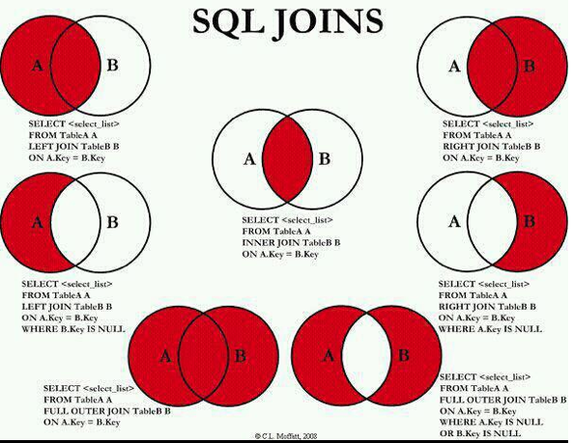

- Candidate Key
- Alternate key
- Index and its benefits
- Union and union all
- Intersections
- Views
- Cursors
- Triggers
- Isolation levels
Isolation Levels for JDBC | Isolation Levels for SQL | Oracle |  | SQL
READ_UNCOMMITTED (ANSI level 0) | UR, DIRTY READ, READ UNCOMMITTED | Yes |  | Yes
READ_COMMITTED (ANSI level 1) | CS, CURSOR STABILITY, READ COMMITTED | Yes |  | Yes
REPEATABLE_READ (ANSI level 2) | RS | Yes |  | Yes
SERIALIZABLE (ANSI level 3) | RR, REPEATABLE READ, SERIALIZABLE | Yes |  | Yes
SNAPSHOT |  |  |  | Yes

- Clustered and non-clustered index
  - A clustered index determines the order in which the rows of a table are stored on disk. Advantage is it is faster, disadvantage is when an update happens. (Similar to ArrayList). There can be only one clustered index for a table.
  - For a non-clustered index, data storage is scattered on the disk. It takes extra effort to collect the data, but the updates will be faster. There can be multiple non-cluster indexes on a table.

- MYSQL
  - Default port 3306
  - List of users from mysql (select * from mysql.user)
  - Alter table table_name drop column_name (delete column)
- Oracle
  - Uses CLOB and BLOB object types for large object types.
  - BPC is a bulk copy tool.
  - First number is the major db release number, second db maintainence release number, third application server release number, fourth component specific release number, fifth platform specific release number

XML

- Namespace provides a means to distinguish one XML vocabulary from another, which allows us to create richer documents by combining multiple vocabularies into one document type.
- XPath describes a querying language for addressing parts of an XML document. This allows applications to ask for a specific piece of an XML document, instead of having to always deal with one large “chunk” of information. Eg: to get all the last names from a document.
- XLink & XPointer: Liinking in XML is divided into two parts
  - XLink: defines a standard way of creating hyperliniks in XML documents
  - XPointer: Allows the hyperlink to point to more specific parts (fragments) in the XML document.
- We use SAX where time and resources are important, usually for reading. DOM is used for reading and writing XML.
- XSD: Schema is an extension to DTD
  - In schemas we can define more data types (Date, Decimal, Integer, String, Time, Boolean)
  - We can format the date
  - We can validate the data (enumeration, length, maxExclusive, maxInclusive, maxLength, minExclusive, minInclusive, minLenth, pattern, totalDigits, whitespace etc)
  - Indicators:
    - Order Indicators (All, Choice, sequence)
    - Occurrence indicators (maxOccurs, minOccurs)
    - Group Indicators (groupName, attrGroupName)
- A well-formed XML is nested properly, attribute value must be within quotes, elements are case sensitive, all elements must be closed, must have only one unique root element.

Rails

JSF

HTML 5
- It is an improvement of HTML 4.01 + XHTML 1.0 + DOM Level 2 HTML
- Instead of <div id=”header”> you use <header> elements. Similarly for footer, nav, article, section, aside
- 10 most important new elements are color, date, datetime-local, email, phone, time, url, range, number, search
- HTML 5 is a new standard for HTML whose main target is to deliver everything without need to any additional plugins like flash, Silverlight, etc
- HTML 5 do not need a DTD as it does not use SGML or XHTML. Just use <@DOCTYPE html>
- SGML → XML → XHTML , SGML → HTML. But HTML 5 is completely new,
- New elements, attributes, CSS3 support, 2 D/3D graphics, local storage, local SQL db
- Support to multimedia for Audio and Video
- Browser does not recognize extra spaces or lines , only <br> can insert more lines
- Heading elements are from H1 (big) to H6 (smaller).
- Relative address is local, absolute address is full path
- Audio tag <audio src =”abc.mp3” controls>Does not support </audio>, other way is <audio controls><source src= “/../abc.mp3” type=”audio/mpeg”> < …type=”audio/ogg”></audio>. Video element is the same as audio with type=”video/mp4” or “video/ogg”>
- Other attributes apart from controls are autoplay, loop,

JavaScript/Ajax/JQuery
- The ready event occurs after the HTML document has been loaded, while the onload event occurs later, when all content (e.g. images) also has been loaded.
- The onload event is a standard event in the DOM, while the ready event is specific to jQuery. The purpose of the ready event is that it should occur as early as possible after the document has loaded, so that code that adds funcionality to the elements in the page doesn't have to wait for all content to load.

EJB’s
http://www.tutorialspoint.com/ejb/index.htm

- What is Entity Bean and Session Bean
Entity Beans are long lived, they exists across client sessions, are shared by multiple clients and remain alive even after a restart of the server or other failure. Session beans are generally tied to the lifetime of a given client session.
- What are transaction attributes
EJB provides an approach called declarative transaction management. In DTM the author of the bean can specify what type of transaction support the bean requires. When the bean is deployed, the container reds the deployment descriptor associated with that particular EJB bean and automatically provides the necessary transaction support.
- What are different transaction attributes (Container managed Transactions)
Transaction Type | If Transaction exists | If Transaction not exists
Required | Uses the same transaction | Creates a new transaction
Requires new | Creates new transaction | Creates a new transaction
Not supported | Does not use the transaction | Does not create
Supports | Uses the same transaction | Does not create
Mandatory | Uses same transaction | Throws exception

- In Bean Managed transaction, developer manages the life cycle of transaction states. (start, commit)
- What are the services provided by container
  - Support for transaction management
  - Support for multiple instances
  - Support for persistence
  - Support for security (ACL)
  - Concurrency
  - Networking
  - Messaging
  - Deploy time customization

- A bean managed persistence can have container managed transaction
- ejbActivate() , ejbLoad(), ejbPassivate(), ejbRemove(), ejbStore(), setEntityContext(), unsetEntityContext()
- TWO Phase commit: The usual approach used to manage transactions in a distributed environment is called two-phase commit. In two phase commit, a transaction co-ordinator governs the actions of several transactions processors. In the first phase the transaction co-ordinator tells each transaction processor to prepare the transactions “preparing the transaction” generally involves writing the desired updates to a transaction log file. Each transaction processor attempts to prepare its portion of the transactio, responding to the transaction co-ordinator with a “vote-commit” if it succeds, or a ‘vote-rollback” if it fails. If a transaction co-ordinator receives even one vote for roll-back, it must inform all of the other participants to roll back their transactions. If the transaction co-ordinator receives only votes for commit, it adds an entry to its own log indicating that the transaction should be commited and notifies each participant that it should commit the transaction. Each participant then writes its changes to permanent storage and reports back to the transaction co-ordinator that it has finished. When the transaction co-ordinator receives this notification from all participants, it clears its own log.
- ACID
  - Atomic : If any of work item fails, the complete unit is considered failed
  - Consistency: A transaction should keep the system in consistent
  - Isolated: Each transaction executes independently of any other transaction
  - Durable: Transaction should survive system failure if it has been executed or committed.
- User JNDI to initialize the InitialContext obect and then lookup the EJB.
- Most of the frameworks like spring, hibernate etc are light weight when compared with EJB’s, but providing the same features
- EJB 3 eliminates the need to describe configuration data in configuration XML files.
- Stateless session beans as opposed to plain java classes
  - Utilize portability characteristics of session beans which are made possible by the enterprise java platform
  - Built-in transaction support
  - Built-in failover mechanism
  - Platform and vendor neutral
  - Scalability

JUnit

- JUnit is a testing framework for java programming language. It is written in java and is open source unit testing software.
- Important features
  - Open source framework
  - Provides annotation to identify the test methods
    - Annotations are like meta tags that can be applied to class or methods. It gives information about test methods. Which methods are going to run before and after all the methods, which methods or class will be ignore during execution.
@Test, @Before, @After, @Ignore, @BeforeClass, @AfterClass, @Runwith(Suite.class), @SuiteClasses({}), @Parameters, @RumWith(Parameterized.class) and @Rule
  - Provides assertions for testing expected results
  - Provides Test runners for running tests
  - JUnit tests can run automatically and they check their own results and provide immediate feedback
  - JUnit test can be organized into test Suits containing test cases and even other test suites
  - It has a nice color code to display test results (like green and red).
  - It has plugins to generate reports.
  - JUnit code can be separated out when building the final executing bundle.
- Known input and expected output is what is tested
- Very useful when the development is spread across multiple teams and locations
- System.out.println() is not a good way as this takes lot of additional code embedded into the real code.
- assert() is deprecated as assert is a keyword in Java (assertTrue() etc are new methods)
- set %JUNIT_HOME% and test by running java org.junit.test.TestAll
- Testing components that run on J2EE Containter (EJB’s, servlets etc) , we need to refactoring J2EE components to delegate functionality to other objects that don’t have to be run in a J2EE container will improve the design and testability of the software. Cactus is an open source software that can be used to test server side components.
- Main classes – Asset (list of assert methods), TestCase , TestResult, TestSuite
- Unit testing is at the entity level (class or method) to check if it works as per the requirements
- Do not use the test-case constructor to setup a test case (As finding the exception thrown is difficult)
- Don’t assume the order in which tests within a test case run
- Avoid writing test cases with side effects
- Call a superclass’s setup() and teardown() methods when subclassing
- Do not load data from hard-coded locations on a filesystem
- With JUnit you can setup Mock services for testing. EasyMock works by implementing the proxy pattern. When you create a mock object, it creates a proxy object that takes the place of the real object. The proxy object gets it's definition from the interface you pass when creating the mock

Maven

- Common problems and activities (It has a very elegant solution for each of the four functionalities)
  - Multiple jars (spring.jar, hibernate.jar, etc) → Miss out some jars which Maven helps
  - Dependencies and versions → dependencies on versions
  - Project structure → web app we have proper folders, libraries
  - Building, publishing and deploying → using ant we write build scripts
- Mvn –version , mvn compile
- Pom.xml (This has all the configuration and the dependency jar files)
- Maven Repository : Archetype Info (type of project) and Dependency Info (depending jars)
- Maven first checks the local repository and then goes online to check for other dependencies
- Phases: Validate, compile, test, package, install and deploy

JBoss

- Sd

Unix

- Find. –print 2>/dev/null | xargs grep –il ‘xxx’
- Find . –name ‘abc.txt’

Tomcat

- Components: Catalina (container), Jasper(JSP engine), Coyote(Http connector)
- Catalina is tomcats servlet container that implements sunmicrosystems specification for servlets and JSP’s.
- Jasper is tomcats JSP engine that converts JSP’s into servlets. At runtime, Jasper detects the changes to JSP files and recompiles them.
- Coyote is tomcat’s http connector components that supports http 1.1 protocol for the web server.
- Clustering support (jdk 1.5 and above)
- Tomcat 7.0 supports servlet 3.0 and JSP 2.2 specs. Does not support EJB, but can be enabled by OpenEJB

Portlets (how are they different from Servlets)
- Servlets can render complete web pages, whereas portlets renders html fragments. These fragments are aggregated by the portal into a complete web page.
- The content type of JSR 168 portlets can be only cHTML, XHTML, WML. It does not support other content types.
- Portlets are not allowed to generate HTML code that contains tags such as body, frame, frameset, head, html, or title.
- A Portlet unlike a servlet doesn’t have URL attached to it so it cannot be accessed directly. Access is only through the portal page which holds the portlet.
- Portlets can be provided with controls to manipulate its window states or portlet modes.
- Multiple instances of a single portlet can be placed onto the same page.
- Portlets support persistent configuration and customization, profile information.
- Portlets can have two types of request viz. render request and action request.
- Portlets have two scopes within session; application scope for communication across portlets and portlet scope for intra portlet communication.
- Portlet cannot set the character set encoding of the response nor can it set the HTTP response headers.
- Portlets doesn’t have access to request URL. So it cannot access the query parameters appended to the URL. Portlets cannot set cookies.
- Typical methods of Portlet API are doView(), doEdit(), doHelp() and processAction() while those of servlet are doService(), doPost(), doGet().

Apache Camel
- Supports 120 different technologies like ftp, http, file, smpt etc and you can write your own component.
- A very simple syntax for which every technology you use
- Inbuilt unit test case support
- You can use DSL (domain specific language) like java, groovy, xml, or scala
- Can be deployed as standalone, web container(tomcat), application server(websphere, weblogic), spring container, cloud, OSGi
- Open source, scalability, error handling, transaction, monitoring, tooling, and commercial support.

Mule Plugin support in eclipse

Amazon S3 Connector (Mule 3.5+) 2.6.1.201310021452
Amazon SQS Connector (Mule 3.5+) 2.2.3.201310021502
CMIS Connector (Mule 3.5+) 1.2.1.201312061751
Facebook Connector (Mule 3.5+) 2.3.1.201310021508
Google Calendars Cloud Connector Mule Studio Extension 1.1.1.201312061726
Google Calendars Connector (Mule 3.5+) 1.2.3.201312061705
Google Contacts Cloud Connector Mule Studio Extension 1.1.1.201312061727
Google Contacts Connector (Mule 3.5+) 1.2.3.201312061707
Google Spreadsheets Connector (Mule 3.5+) 1.2.3.201312061708
Google Tasks Connector (Mule 3.5+) 1.2.3.201312061710
Magento Connector (Mule 3.5+) 2.1.0.201310021448
Mongo DB Connector (Mule 3.5+) 3.4.2.201402071847
Mule Amazon SQS Connector Mule Studio Extension 2.4.3.201310021717
Mule CMIS Connector Mule Studio Extension 1.13.0.201312171441
Mule Facebook Connector Mule Studio Extension 2.2.0.201304081316
Mule Google Spreadsheet Cloud Connector Mule Studio Extension 1.1.1.201312061729
Mule Google Tasks Connector Mule Studio Extension 1.1.1.201312061731
Mule Magento Connector Mule Studio Extension 2.0.0.201304081301
Mule Mongo Connector Mule Studio Extension 3.4.3.201402071916
Mule S3 Connector Mule Studio Extension 2.6.0.201309181935
Mule Salesforce Connector (Mule 3.5+) 5.4.4.201401131840
Mule Salesforce Connector Mule Studio Extension 5.3.5.201311271823
Mule Twilio Connector Mule Studio Extension 1.4.0.201212071208
Mule Twitter Connector Mule Studio Extension 3.0.0.201306191435
Twitter Connector (Mule 3.5+) 3.0.1.201310021459
MuleStudio
CloudHub Mule Runtime (Dec 2013) 3.5.0.201312051904
Data Mapper Designer 3.5.0.201401281959
Mule Studio Core Components 3.5.0.201402101917
MuleSoft Enterprise Java Connector for SAP (3.4+) 3.5.0.201312201335
MuleSoft Enterprise Java Connector for SAP (3.5+) 3.5.0.201312201335

Scrum
- Scrum is one of the many iterative and incremental agile software development method (IID).
- Product back log: User stories, use cases, wish list
- Break down the product back log into sprints. Business will prioritize the use cases that needs to be part of each sprint’s . Sprint is the basic unit of development.
- Each iteration has planning, requirements analysis, design, coding, unit testing and acceptance testing when a working product is demonstrated to the users/business.
- Goal of sprint is to get it to ship ready state.
- Burn down chart (use cases vs sprints or remaining effort vs time), shows the day by day amount of work completed. It helps to
  - Calculate Completed date
  - Actual velocity and what it takes to complete it on time or on track
  - Data comes from the each user story. The estimation comes from the developers who use different estimation techniques.
- Daily scrum: It is an standup meeting where everyone comes with an update of the task
- Scrum retrospective meeting, where we review and lessons learnt and proceed for the next sprint
- There are 6 types of meetings in scrum,
  - Daily scrum: Standup or backlog grooming
  - Story time
  - Scrum of scrums
  - Sprint planning
  - Sprint review
  - Sprint retrospective

Agile:
- Agile is an incremental and iterative way of project implementation.

DevOps:
- 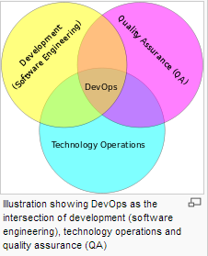.

AWS:
- IAAS (Infrastructure as a service), more than just hardware virtualization, hardware and services, web based management consol, REST API
- Regions, (AZ) Availability zone, Edge Locations. Regions are conceptual(not physical), AZ are physical where the hardware exits, edge locations a smaller physical servers run DNS servers, cloud form. (something like Akamai kind of experience)
- You pay as you go and as you use. No contract, some services are completely free, you can buy a server for an hour, bid for a server, etc send an email to 1/10,000 cent.
- Core AWS Services for Java Developers
  - EC2 and EBS (EC2 for processing and EBS for storage like a hard drive)
  - AMI’s is a snapshot of existing computer. You can clone the image and up and running.
  - SDK is really powerful to manage resources,
  - EC2 can be used for webserver, app server, db server
  - Relational Database: MySQL, Oracle, SQL Server. Automated backups, live replication for fail-over support (different regions or AZ), provision DBs from your browser
  - S3(Simple Storage Service): images, resumes, documents etc. Cloud based file storage, simple API to CRUD files, unlimited capacity, excellent for static web content, move BLOBS from RDBMS to S3. If the site is static, then everything can be done using S3
  - SimpleDB good for smaller amounts of structured data, 10GB limit per table, use in combination with S3.
  - DynamoDB hosted on SSD, no size or request limitations, pay for performance.
  - Monitoring (H & S) : CloudWatch, flexible notification through SNS(simple notification service)
  - Load Balancing: ELB,
  - Auto Scaling service: works with cloudWatch and ELB and automatically provision additional EC2 instances when load increases. Shutdown instances when load decreases, pre-emptive scaling(holiday sales), monitor health of EC2 instances
  - Java and AWS: provides full API to manage AWS services from Java, also to use services from within java application(upload a file in S3, publish a services etc). Eclipse integration (AWS explorer), Maven integration.
  - CloudFormation helps in creating a blueprint for development environment. Developer and I want oct 2013 environment, self-serve hardware, guarantee everyone’s environment is same, work with more than one development setup, no more scared demo environments, continuous integration opportunities.
  - AWS at Testing Time: self served
- Advanced AWS Services
  - PaaS w/ Elastic Beanstalk:
    - Bundles up services provided by EC2, S3, CloudWatch, Auto Scaling and ELB
    - Browser based provisioning of production ready environments and java web apps
    - Often requires no modification to existing code, supports live hot-swappign for app upgrades, can use other AWS services for apps, can be extended through low-level system access
  - Messaging w/ SNS and SQS:
  - Business Process Management w/SWF
  - Caching w/ElasticCache
  - Big Data w/Elastic Map Reduce
  - Content Delivery Network(CDN) w/CloudFront: Serve static content from edge locations, clients routed to closest edge location, streaming content etc like Akamai
- Other services
  - Route 53: DNS
  - CloudSearch: search within application
  - Glacier: File archiving services
  - VPC
  - Direct Connect
  - FPS

OpenStack(RedHat):
- Components: Identity, dashboard, orchestration, metering, object storage, image service, block storage, networking and compute. There are currently nine components and there are more to come.
- Identity(keystone): Tenants (group of users), users, roles, tokens, services.
User → (ReST API) (Token (authenticate and keeps a token), Identity(LDAP(users/passwords)) , Services(Flat files, or db)) → All can use a rdbms
You can scale keystone horizontally.
- Dashboard: Web UI, Selfservice UI, from Horizon UI all details are displayed, memory, networking,
- Orchestration(Heat): AMQP, consumes all other openstack APIs, important concept: template defined stacks.
- Metering(Ceilometer): The foundation of billing or charge back systems. Concepts: Meters, Compute pollster, Central pollster, Event Listener, Collectors.
- OpenStack Object Storage(Swift): Accounts, Containers, Object, Ring
- OpenStack Image Service(Glance): Images, Metadata, Storage Backends
- Block Storage (Cinder): Volumes, snapshots, storage backups.
- OpenStack Networking (Quntam) : Networks, routers, subnets, ports, vendor plugins
- OpenStack Compute also called Nova: instances/servers, flavors/instance types, virt drivers, OpenStack API’s and EC2 API’s.

OpenShift(RedHat):
- Develop: Use web console, Eclipse IDE, or command-line to create a new application and OpenShift will spin up a gear where that application will run.
- When you create your application, you also select from your choise of programming language, database, or other services via OpenShift cartridges.
- Code and push: OpenShift uses git for managing code inside of the platform. Simply perform a “git push” to deploy your code to your application.
- Build: Build, test, publish. automatically. OpenShift automates the process with other tools such as Maven(Java builds), Jenkins(CI), and Apache(HTTP).
- Scale: OpenShift automates application scaling. Using an HA-Proxy software load-balancer, OpenShift will horizontally scale the application with increasing load.

CloudForms(RedHat):
- CloudForms 3 is a software that manages cloud, including open stack, and is therefore a complimentary to open stack and other infrastructure platforms, such as VMware vSphere, red hat enterprise Virtualization and AWS.
- CloudForms 3 is a cloud management platform
- 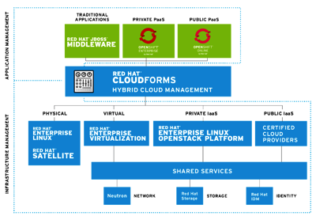

Interview questions from the notes

- What is the advantage of using ClassForName() instead of instantiating and registering
- How do you insert two rows with single insert statement
- How do you check if a database is running on a sun solaris m/c from your system (Check for processes)
- What is redundancy in database, give example
- How do you return more than one value in java methods (Arrays etc)
- When you write a query, how do you say that is the most efficient way
- What design pattersn did you use in your project
- How do you prevent two clients accessing the same row in the database using entity beans
- What is prepared statement
- What is callable statement
- How is aggregation represented
- Single threaded model in servlet → Thread safe?
- What specifications a java class should satisfy to say it to be a java bean
- Difference between weblogic 5.1, 6.0 and 6.1 and 7.0
- What is LDAP used for
- Why do we go for BPM when CPM allows multiple features (performance, CMP is not fully matured)
- How can you crash JVM or the server
- What is proxy pattern
- What is data structure
- What is JIntegra
- What is SXD,DTDs
- Where do you use SAX or DOM
- What is singleton pattern
- What is Façade pattern
- What is a pattern
- What is RUP
- What is analysis in design
- What is struts
- If a language is to be told as a pure OO language then what specifications should it satisfy
- Why do we cast object, can we cast child class to a parent class
- What is the purpose of using session bean instead of simple class
- How do you evaluate the time for an usecase and what are the different methods(Matrixs)
- What did you learn from this project
- Why do you need remote and home interface

