进程试图

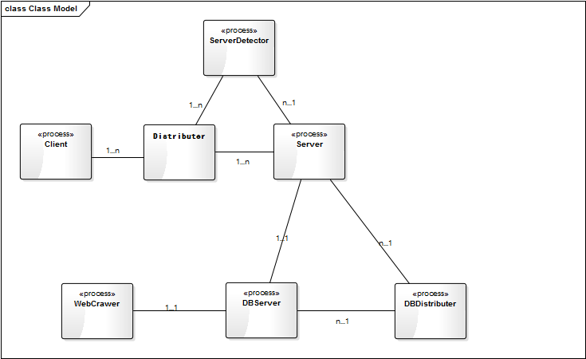

FunctionSequence描述

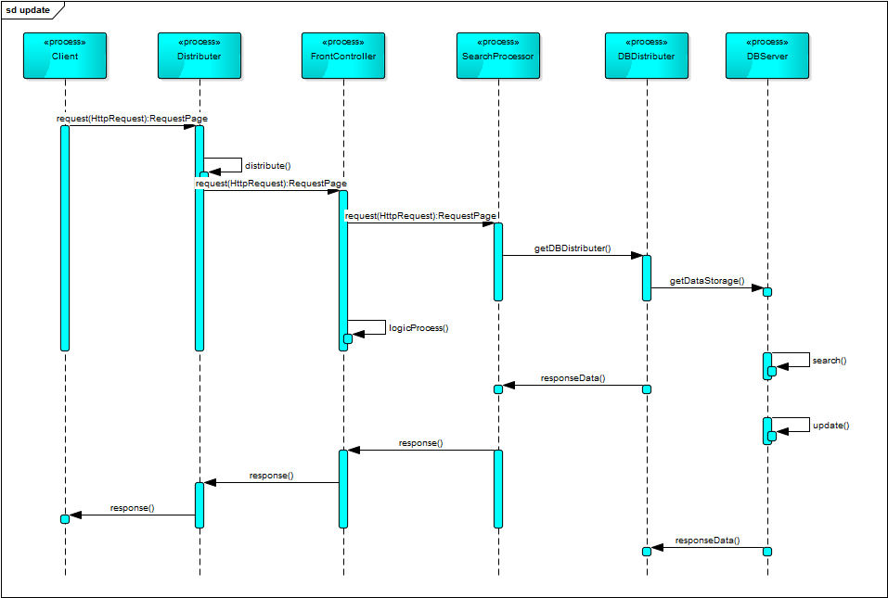

FunctionSequence接口描述

|  |  |
| --- | --- |
| **发送进程** | **Client** |
| **发送端口** | request |
| **通信方式** | Http协议通信 |
| **通信描述** | 发送请求 |
| **接口进程／接口** | Distributer.distributer() |

|  |  |
| --- | --- |
| **发送进程** | **Distributer** |
| **发送端口** | request |
| **通信方式** | Http协议通信 |
| **通信描述** | 分派请求 |
| **接口进程／接口** | FrontController.request() |

|  |  |
| --- | --- |
| **发送进程** | **FrontController** |
| **发送端口** | request |
| **通信方式** | Http协议通信 |
| **通信描述** | 搜索请求 |
| **接口进程／接口** | SearchProcessor.getDBDistributer() |

|  |  |
| --- | --- |
| **发送进程** | **SearchProcessor** |
| **发送端口** | getDBDistributer |
| **通信方式** | Procedure Call |
| **通信描述** | 请求得到数据库分配 |
| **接口进程／接口** | DBDistributer.responseData() |

|  |  |
| --- | --- |
| **发送进程** | **DBDistributer** |
| **发送端口** | getDataStorage |
| **通信方式** | Procedure Call |
| **通信描述** | 请求获得数据存储 |
| **接口进程／接口** | DBServer.responseData() |

MonitorProcess描述

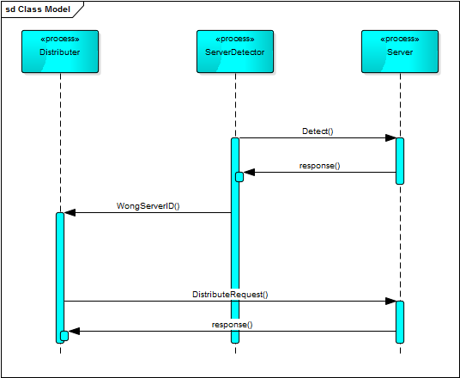

MonitorProcess接口描述

|  |  |
| --- | --- |
| **发送进程** | **ServerDetector** |
| **发送端口** | WrongServerID |
| **通信方式** | Procedure Call |
| **通信描述** | 发送错误的服务器ID |
| **接口进程／接口** | Distributer.DistributerRequest() |

|  |  |
| --- | --- |
| **发送进程** | **ServerDetector** |
| **发送端口** | Detect |
| **通信方式** | Procedure Call |
| **通信描述** | 请求识别 |
| **接口进程／接口** | Server.response() |

WebCrawler描述

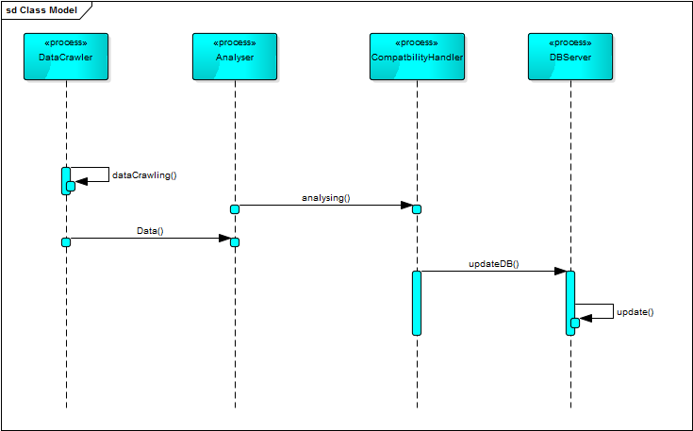

WebCrawler接口描述

|  |  |
| --- | --- |
| **发送进程** | **DataCrawler** |
| **发送端口** | initDB |
| **通信方式** | Remote Procedure Call |
| **通信描述** | 初始化数据库 |
| **接口进程／接口** | DBServer.initResponse() |

|  |  |
| --- | --- |
| **发送进程** | **DataCrawler** |
| **发送端口** | Data |
| **通信方式** | Remote Procedure Call |
| **通信描述** | 传送数据 |
| **接口进程／接口** | Analyser.analysing() |

|  |  |
| --- | --- |
| **发送进程** | **Analyser** |
| **发送端口** | Analysing |
| **通信方式** | Remote Procedure Call |
| **通信描述** | 分析数据 |
| **接口进程／接口** | CompatbilityHandler.updateDB() |

|  |  |
| --- | --- |
| **发送进程** | **CompatbilityHandler** |
| **发送端口** | updateDB |
| **通信方式** | Remote Procedure Call |
| **通信描述** | 更新数据库 |
| **接口进程／接口** | DBServer.updateResponse() |