Name : Kallem Architha Batch : Z-13-12 Project: Cyber Threat Intelligence
Email : archithareddykallem@gmail.com

Assignment

1) Python Note Book link:
https://colab.research.google.com/drive/1Dk1Ts86HYrQ08KqPYld0g8hSUqZtg_Xe?usp=sharing

2) Working Code with OutPuts:

Code:
import json
import requests

url = "https://raw.githubusercontent.com/mitre/cti/master/enterprise-attack/enterprise-attack.json"

response = requests.get(url)
data = response.json()
print("File is Loaded Successfully")
print(type(data))
print(len(data))
print(data.keys())
#print(data["objects"])

print("-------------------------------------------------------------------")

techniques=[]
for obj in data["objects"]:
if(obj.get("type")=="attack-pattern"):
techniques.append(obj)
print(techniques)

print("-------------------------------------------------------------------")

def threat_score(techniques):
result=[]
scored = []

for tech in techniques:
score = 5

name = tech.get("name", "").lower()

if "credential" in tech["name"].lower():
score += 3
if "execution" in tech["name"].lower():
score += 2
if "privilege" in tech["name"].lower():
score += 3
if "persistence" in tech["name"].lower():
score += 2
if "lateral" in tech["name"].lower():
score += 2
description = tech.get("description", "").lower()

if "administrator" in description:
score += 2
if "remote" in description:
score += 2
if "bypass" in description:
score += 2
if "stealth" in description:
score += 1

result=[name, score]
scored.append(result)

return scored

scored_techniques = threat_score(techniques)
print(scored_techniques[:5])

print("-------------------------------------------------------------------")

scored_techniques.sort(key=lambda x: x[1], reverse=True)
for name, score in scored_techniques[:10]:
print(f"{name} — Score: {score}")

print("-------------------------------------------------------------------")

for name, score in scored_techniques[:20]:
if(score>=8.9):
print(name)

Outputs:
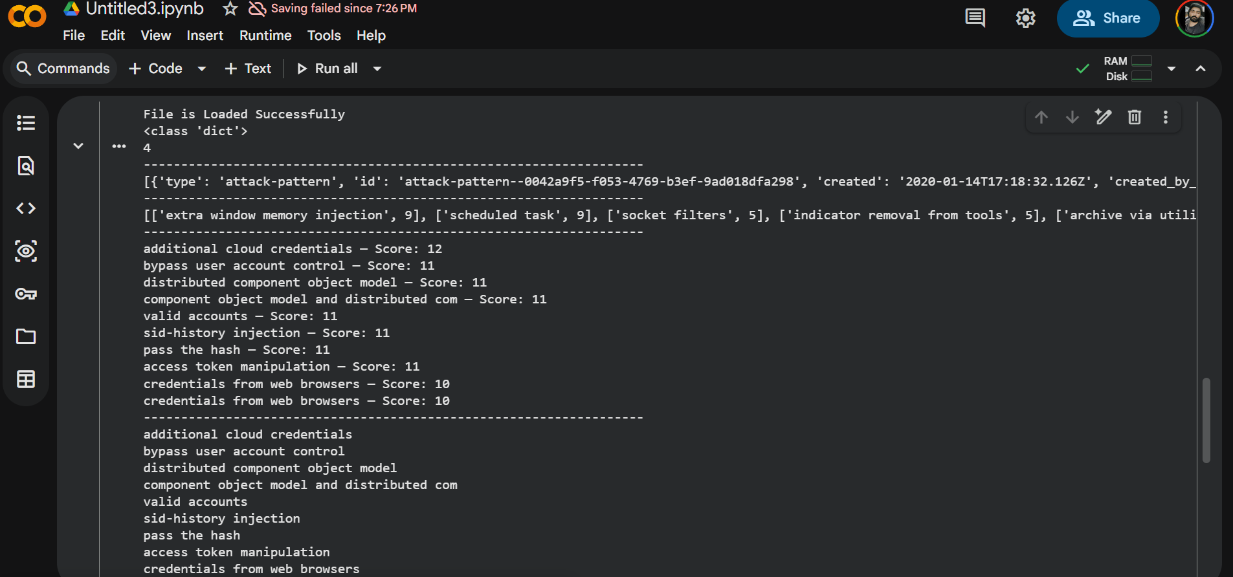

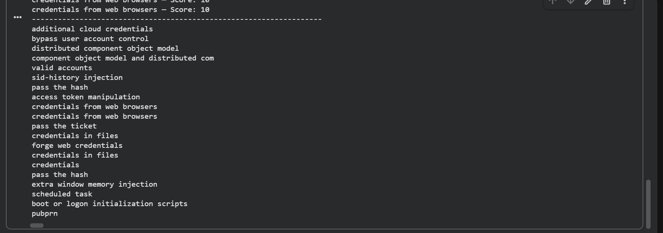

3) Explanation: scoring system help a cybersecurity analyst prioritize threats by converting a very large and complex dataset into ranked risk list through giving scores based on conditions and rules provided.

