Mini-Assigment 1: Player Stage Start Guide

Matthew J. Urffer

CS-528

Notes:

For some reason, using the screen shot method from the GUI create images that were all black. I then decided to just take screen shots.

# Exercise 1:

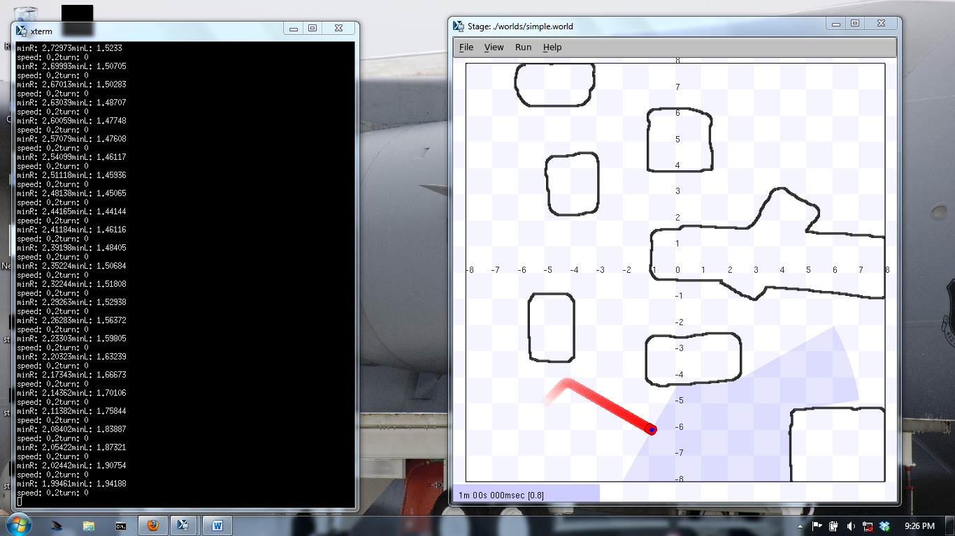

# Exercise 2:

Randomwalk –

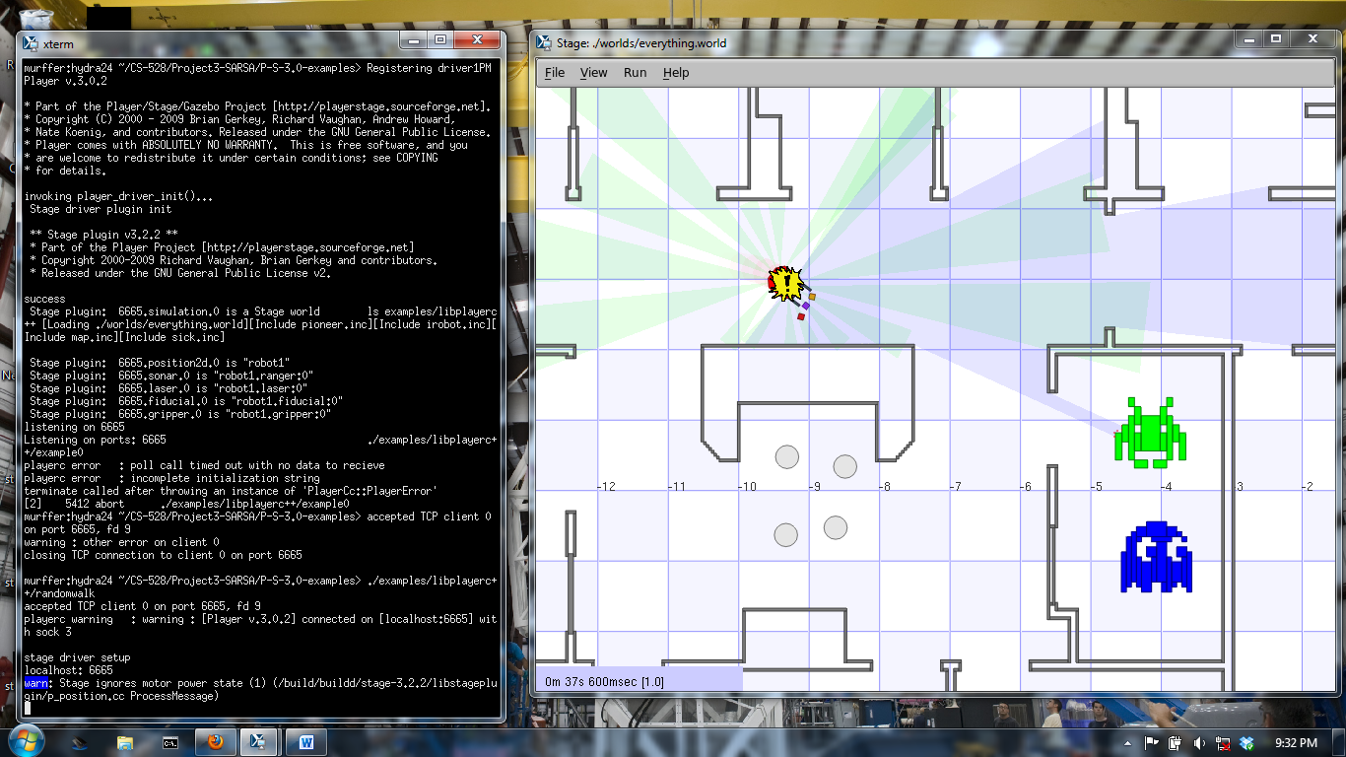

goto –

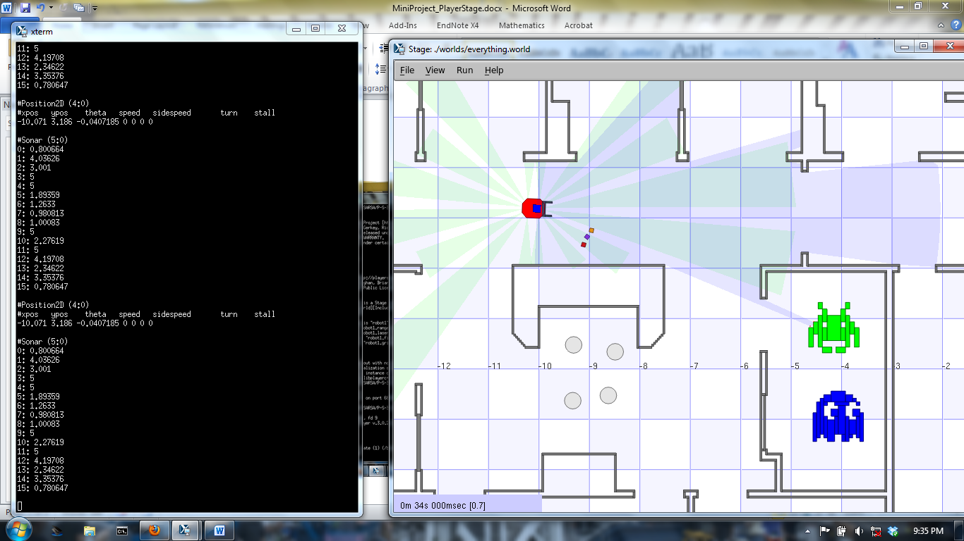

# Exercise 3:

randomwalk.cc

The first few lines provide the setup for the robot (using a laser or sonar). After completion, the robot is started to move. It then runs into the first small obstacles (I guess below the lasers?) so it never enters the control loop.

# Exercise 4:

everything.cfg

The first block of everything.cfg defines a world (geometry) by calling the world configuration file. The second block (and proceeding commented blocks) are constructors for different types of robots. The exact calling card is available in the manual and is not reproduced here.

# Exercise 5:

Everything.world

Everything.world is the rendering engine of the simulation. It defines the word size / resolution, and what world map should be used. It then goes on to define objects in the world (as well as what they can do, such a being picked up) as well as several Pioneer robot objects.

# Exercise 6:

