**CSC 573 – Internet Protocols**

**Project 1**

**Archit Kwatra – 200316390**

Please note: The below instructions are for windows machine. Also, there are some libraries required which were pre-included with the python on windows. I have mentioned the one which I had to install. Please feel free to install other required libraries in case there is an error.

Requirements:

* Python 3.6 or above
* pytz library for time zone information (separately installed)

The project directory has 4 main folders:

* server – Folder for the server and its components
* client1 – First peer/client
* client2 – Second peer/client
* client3 – Third peer/client

Steps for testing (run the first 4 commands on different terminal windows) -:

1. Go the server folder and run the command “python server.py”. You will see the below terminal state after running the above command.

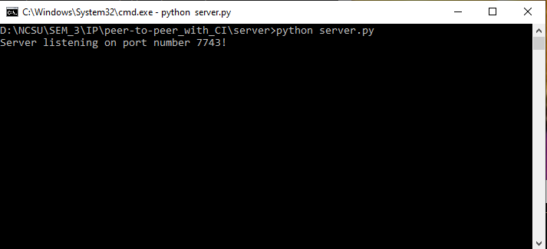

1. Go to client1 folder and run the command “python client1.py”, type y and press enter. You will see the below terminal state after running the above command.

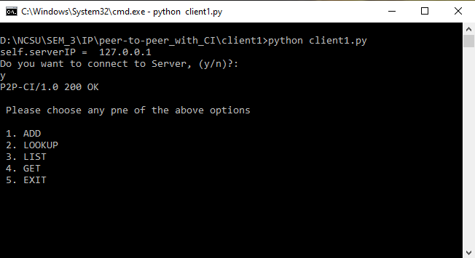

1. Go to client2 folder and run the command “python client2.py”, type y and press enter. The output will be very much same as the one in step 2
2. Go to client3 folder and run the command “python client3.py”, type y and press enter. The output will be very much same as the one in step 2 (This client testing is not necessary, and you can skip this if you want to. 2 clients/peers are enough for testing purposes)
3. Now, press 1 in client1 and hit enter. It will as you to enter the RFC number you wish to add Once you type the RFC number and press enter, it will ask you to enter the RFC title. Type the required information and hit enter. The RFC will be added to the current RFC list. Below are the output snapshot examples for reference.

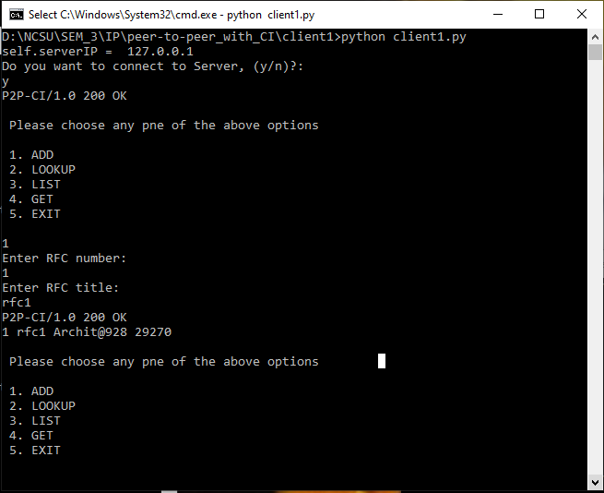

1. You can now check all the added RFCs by typing 3 and hitting enter. For adding RFCs from other peers, you can follow the same steps from their respective terminals.
2. For an RFC lookup, press 2 and hit enter. It will ask you the RFC number and display the RFC information if it is available with any other of the peers, otherwise it will display the required message. Please see the below snapshot for your reference.

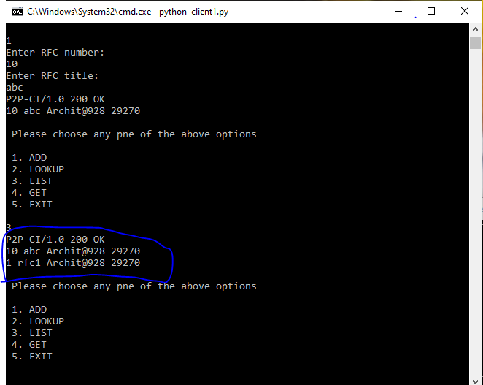

1. To download an RFC from any peer, type 4 and hit enter. It will ask you the RFC number. If the RFC will be available with any of the peers, it will download it, otherwise, it will display an error. Once downloaded, it will add the RFC from that peer to the RFC list as well automatically. Please see the below snapshot for reference.

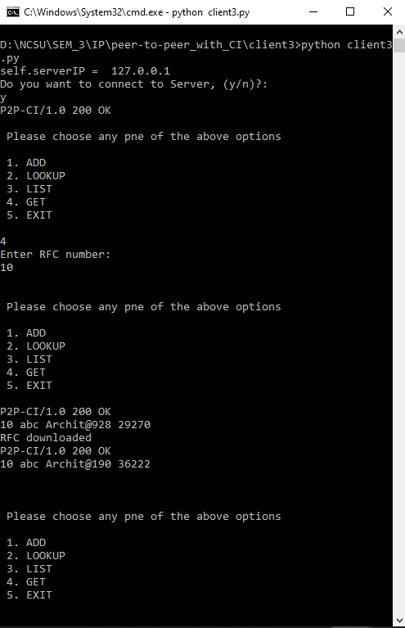

1. Press 5 and hit enter to exit. All the information for the RFC will be automatically removed from the lists.

REF:

1. <https://en.wikipedia.org/wiki/Peer-to-peer_file_sharing>
2. <http://www.cloudbus.org/papers/P2PbasedContentSharing.pdf>
3. <http://www.stackoverflow.com>
4. <https://medium.com/@amannagpal4/how-to-create-your-own-decentralized-file-sharing-service-using-python-2e00005bdc4a>