DAA Lab Practicals
Assignment
Archit Nitin Latkar
1MS18CS027
CSE IV A

1)Write an algorithm and program for Kruskals Algorithm and attach required
snapshots.

Algorithm:Kruskal’s Algorithm(G,c)

Sort edges in ascending order of cost.
Initially T=∅
for each edge e=(v,w):
If there is currently no path from v to w in (V,T) then:
Add e to T
Program -

import java.util.*;
public class Kruskal {
static int V;
static int[] parent= new int[V];
static int INF=Integer.MAX_VALUE;

static int find(int i){
while(i!=parent[i]){
i=parent[i];
}
return i;
}

static void union(int i,int j){
int a=find(i);
int b=find(j);
parent[a]=b;
}
static void kruskal(int[][] cost){
int minCost=0;
for(int i=0;i<V;i++){
parent[i]=i;
}
int edge_count=0;
while(edge_count<V-1){
int min=INF;
int a=-1,b=-1;
for(int i=0;i<V;i++){
for(int j=0;j<V;j++){
if(find(i)!=find(j) && cost[i][j]<min){
min = cost[i][j];
a = i;
b = j;
}
}
}
union(a,b);
edge_count++;
System.out.println("Adding Edge "+a+" "+b+" "+min);
minCost+=min;
}
System.out.println("Cost of mst: "+minCost);
}
public static void main(String args[]){
Scanner sc=new Scanner(System.in);
System.out.println("How many nodes?");
V=sc.nextInt();
int[][] cost=new int[V][V];
for(int i=0;i<V;i++){
cost[i][i]=INF;
for(int j=i+1;j<V;j++){
System.out.print("Weight of edge "+i+" "+j+"//-1 if no edge : ");
int x=sc.nextInt();
if(x == -1){
cost[i][j]=cost[j][i]=INF;
continue;
}
}
}
long t1=System.nanoTime();
kruskal(cost);
long t2=System.nanoTime();
System.out.println("Execution time: "+(t2-t1));
}
}

Output -
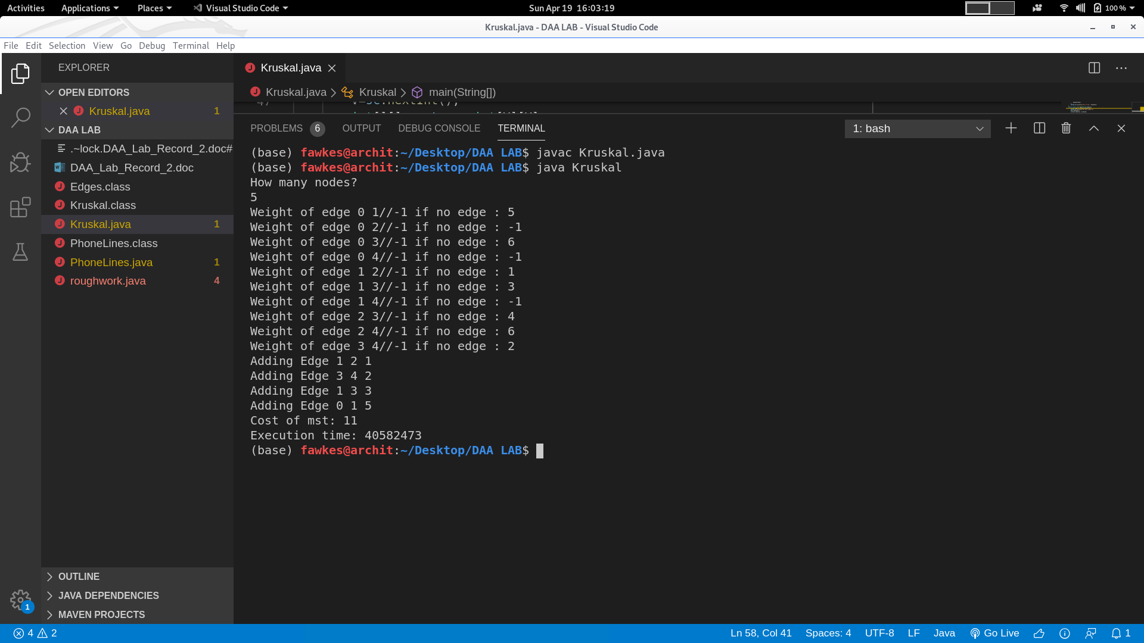

2)Write an algorithm and program for Prim’s Algorithm.

ALGORITHM: PRIM’S ALGORITHM(Cost):
Initially S={s} and T=∅
While S!=V :
Select node v which is not there in S and which has an edge into S
and for which attachment cost is minimum.
Add v to S
Add edge e to T
EndWhile
Return T

Java Program -

import java.util.*;

public class Prims {
static int V;
static int INF = Integer.MAX_VALUE;
static int[] predecessor = new int[100];
static int[] weight = new int[100];
static boolean[] status = new boolean[100];
static final boolean TEMP = false;static final boolean PERM = true;
static void prims(int[][] cost){
int c,v;
int edgesintree=0;
int wtTree=0;
for(int i=0;i<V;i++){
predecessor[i]=-1;
status[i]=TEMP;
weight[i] = INF;
}

int root=0;
weight[root]=0;

while(true){
c = tempVertexMin();
if(c == -1){
System.out.println("Weight of MST is: "+wtTree); return;
}
status[c]=PERM;
if(c!=root){
edgesintree++;
wtTree+=weight[c];
System.out.println("Adding edge "+predecessor[c]+" "+c);
}
for(int i=0;i<V;i++){
if(cost[i][c]<weight[i] && status[i]==TEMP){
weight[i]=cost[i][c];
predecessor[i]=c;
}
}
}

}

static int tempVertexMin(){
int min = INF;
int x=-1;
for(int i=0;i<V;i++){
if(status[i]==TEMP && weight[i]<min){
min = weight[i];
x=i;
}
}
return x;
}

public static void main(String args[]){
Scanner sc = new Scanner(System.in);
System.out.println("How many nodes?");
V=sc.nextInt();
int[][] cost = new int[V][V];
for(int i=0;i<V;i++){
cost[i][i]=INF;
for(int j=i+1;j<V;j++){
System.out.print("Weight of edge "+i+" "+j+" //-1 if no edge: ");
int x = sc.nextInt();
if(x == -1){
cost[i][j]=cost[j][i]=INF; continue;
}
cost[i][j]=cost[j][i]=x;
}
}
prims(cost);
}

}

Output -

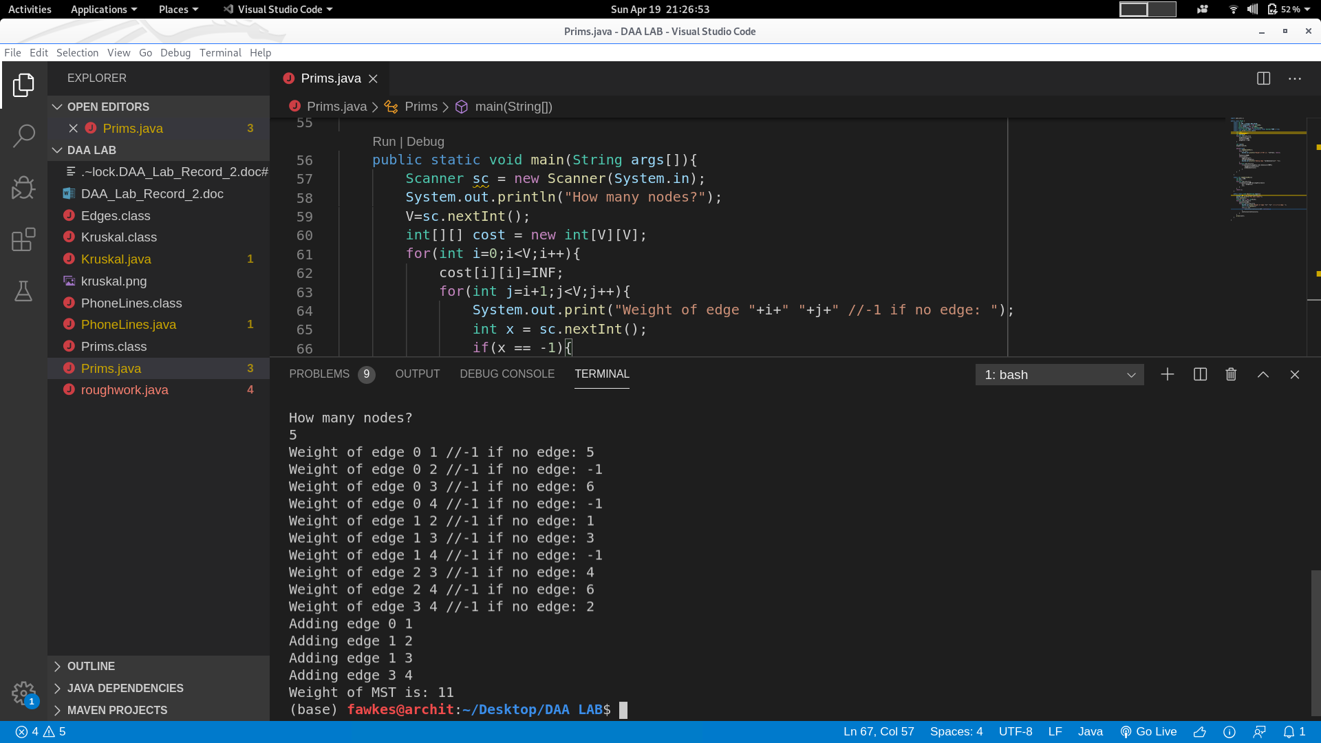

3)Write an algorithm and program for Dijkstra’s Algorithm.

Algorithm Dijkstra’s Algorithm:
Let S be a set of explored nodes.
For each u in S, we store distance d(u)
Initially S={s} and d(s) = 0
While S != V:
Select node v which is not in S and has an edge in S for which d’(v) = min d(u) +le is as small as possible
Add v to S and define d(v) = d’(v)
EndWhile

Java Code -

import java.util.*;
public class Dijkstra {
static int V;
static final int INF = Integer.MAX_VALUE;
static int[] predecessor = new int[100];
static boolean[] visited = new boolean[100];
static int[] distance = new int[100];
public static void main(){
Scanner sc = new Scanner(System.in);
System.out.println("How many nodes?");
V = sc.nextInt();
int[][] cost = new int[V][V];
for(int i=0;i<V;i++){
cost[i][i] = INF;
for(int j=i+1;j<V;j++){
int x;
System.out.print("Enter Weight of edge "+i+" "+j+"//-1 if non-existent: ");
x=sc.nextInt();
if(x == -1){
cost[i][j]=cost[j][i]=INF; continue;
}
cost[i][j]=cost[j][i] = x;
}
}
distance = cost[0];
distance[0] = 0;
visited[0] = true;
int nextNode = 0;
for(int i=0;i<V;i++){
int min = INF;
for(int j=0;j<V;j++){
if(min > distance[j] && !visited[j]){
min = distance[j];
nextNode = j;
}
}
visited[nextNode] = true;
for(int j=0;j<V;j++){
if(!visited[j]){
if(min+cost[nextNode][j] < distance[j]){
distance[j] = min + cost[nextNode][j];
predecessor[j] = nextNode;
}
}
}
}
System.out.println("distance array: ");
for(int i=0;i<V;i++){
System.out.print(distance[i]+" ");
}
System.out.println("\nPrinting paths:");
for(int i=0;i<V;i++){
int j=i;
System.out.print(i+"<-");
do{
j=predecessor[j];
System.out.print(j+"<-");

}while(j!=0);
System.out.println();
}

}
}

Output -
