
RAMAIAH
Institute of
Technology

nology

Certificate

This report is submitted for the evaluation of Assignment component for the subject "DATA COMMUNICATION" with the subject code CS44 during the term Jan-May 2020.

Submitted by

1MS18CS001 A Manoj
1MS18CS006 Abhishek V Tangod 1MS18CS013 Akash Hegde
1MS18CS027 Archit Nitin Latkar

Signature of Faculty

DEPARTMENT OF COMPUTER SCIENCE & ENGINEERING
RAMAIAH INSTITUTE OF TECHNOLOGY
(Autonomous Institute, Affiliated to VTU)
BANGALORE-560054
www.msrit.edu

Jan-May 2020

TABLE OF CONTENTS:

SI No. | Content | Page No.
1 | Problem Statement
2 | Theory  - Attenuation  - Noise and SNR  - Distortion  - Latency  - Throughput  - Bandwidth  - Capacity using Nyquist Formula  - Capacity using Shannon Formula
3 | Code in C++
4 | Output screenshots

1. PROBLEM STATEMENT-

WAP that calculates noise based on attenuation, distortion and noise. Also calculate bandwidth based on either nyquist or shannon, latency & throughput. For Nyquist channel capacity input the number of signal levels to calculate bandwidth and for Shannon capacity, input SNR aNd Bandwidth.

2. THEORY

- Attenuation -
Attenuation means a loss of energy
When a signal ( simple or composite ) travels through a
medium, it loses some of its energy in overcoming the
resistance of the medium.
Formula for attenuation is given as -
dB = 10 log 10 (P2 /P1) where P2 is power of signal after transmission and P1 is power or signal before transmission.

- Noise and SNR -
Undesirable signal that gets added between transmitter and reciever is called Noise.
Noise can be measured using the Signal To Noise Ratio which is defined as the ratio of signal power to noise power.

- Distortion -
This occurs when signal elements at reciever have different phase than that at the sender. The shape of the signal changes. The effect of distortion can be included in noise by taking into consideration the distortion level. The new factor is called Signal To Noise+Distortion ratio and is calculated as :
SNDR = 10*log10((s+n+d)/(n+d))

- Latency -
It is defined as the time delay between the time of sending and receiving the signal. There are 4 types of delays namely -
1) Popagation Delay – The time required by the message to travel through the connection medium.
It is calculated as distance between source and destination times the signal speed.
2) Transmission Delay – It is the time difference between the arrival of the first bit of data and the last unit of data ie. the time required for transmission of entire message.
3) Queueing Time – Packets in routers have to wait for sometime before they are processed. This time is called as Queueing time.
4) Processing Time – Some time is required to process a packet and this time is called as Processing time.
Delay is given by the sum of all these latency.

- Bandwidth -
It is the maximum rate at which data can be transferred through a channel. For analog data it is measured in Hz and for digital data it is measured in bits per second.
Formulae discussed under Nyquist and Shannon capacity.

- Throughput -
It is a measure of how fast can data be actually sent through a channel. Throughput maybe equal to or less than the actual bandwidth. It is also measured in Hz for analog signals and bps for digital signals.

- Capacity Of Channel using Nyquist Formula -
For a noiseless channel, the capacity can be measured by the Nyquist formula which is stated as -
BitRate = 2*Bandwidth*log2(L) where L is the number of levels used in the communication system.

- Capacity Of Channel using Shannon’s Formula -
Shannon’s formula gives the data rate by taking into account the SNR of the channel. The formula is:
Capacity = Bandwidth*log2(1+SNR)
*From the Nyquist and Shannon formulae we can find the bandwidth of channels.

3. CODE IN C++

Main Driver Code

#include<iostream>
#include<bits/stdc++.h>
#include<cmath>
#include "shannonCapacity.h"
#include "bandwidth.h"
#include "Attenuation.h"

using namespace std;

int main(){
cout<<"This is a program that can calculate latency, throughput, bandwidth, capacity, attenuation and noise\n";
int choice;
while(true){
cout<<"Select choice function according to the number\n";
cout<<"1. Attenuation\t2. Noise SNR and Distortion\n3. Latency\t4. Throughput\n5. Bandwidth\t6.Channel capacity Using Nyquist Formula\n7.Channel Capacity using Shannon's Formula\t8. End\n";
cin>>choice;
switch(choice){
case 1: attenuation();cout<<endl;
break;
case 2: noise();cout<<endl;
break;
case 3: latency();cout<<endl;
break;
case 4: throughput();cout<<endl;
break;
case 5: bandwidth();cout<<endl;
break;
case 6: nyquist();cout<<endl;
break;
case 7: shannonCapacity();cout<<endl;
break;
case 8: cout<<"Ending Program\n";exit(0);
default: cout<<"Invalid choice...Please try again\n";
}
}
return 0;
}

FUNCTION FOR BANDWIDTH

void bandwidth()
{ cout<<"Calculate Bandwidth for?\n1.Noiseless Channel(Nyquist Bit Rate)\n2.Noisy Channel(Shannon's Capacity')\n";
ll n;cin>>n;
if(n==1)
{
// Noiseless Channel: Nyquist Bit Rate
// Bitrate = 2 * Bandwidth * log2(L)
// Bandwidth is Bandwidth of the channel
// BitRate is the bit rate in bits per second (Maximum Bitrate)

ll levels,bitrate;
cout<<"Enter the Bitrate of the Noiseless Channel in bps\n";
cin>>bitrate;

cout<<"Enter the number of signal levels in the signal that noiseless channel is transmitting\n";
cin>>levels;

ll bw = (bitrate / ((float)2.0 * log2(levels)));

cout<<"Bandwidth: "<<bw<<" Hz\n";

}
else if(n == 2)
{ ll capacity,SNR;
cout<<"Enter the Capacity of the Noisy Channel in bps : ";
cin>>capacity;
cout<<"Enter the SNR (signal-to-noise ratio) value : ";
cin>>SNR;
float bw = capacity/((float) log2(1+SNR));
cout<<"Bandwidth of the noisy channel is : "<<bw<<" Hz"<<endl;
}
else
{
cout<<"Error:Invalid Input\nOnly 1 and 2 are allowed\n";
}
}

FUNCTION FOR LATENCY

void latency()
{
//Defines how long it takes for an entire message to completely
//arrive at the destination from the time the first bit is sent out
//from the source
// Latency = propagation time + transmission time + queuing time + processing delay
//propagation time
ll dist,prop_speed=(2.4 * 1e8);
cout<<"What is the distance between source and destination in km?\n";
cin>>dist;
cout<<"What is the propagation speed in m/s? (2.4 * 10^8 m/s -> light speed)\n";
cin>>prop_speed;
float prop_time = ((dist * 1000)/((float) prop_speed));
cout<<"Propagation Time : "<<prop_time*1000.0<<" ms"<<endl;
//transmission time
float tr_time,msg_size;
ll bw;
cout<<"Enter the message size in kbyte : ";
cin>>msg_size;
cout<<"Enter the Bandwidth of the channel in Gbps: ";
cin>>bw;
tr_time = ((msg_size*1000*8)/((float)(bw * 1e9)));
cout<<"Transmission time : "<<(tr_time*1000.0)<<" ms\n";
//queuing time
float q_time,prc_delay;
cout<<"Enter the Queuing time and processing delay of the network in ms :\n";
cin>>q_time>>prc_delay;
cout<<"--------------------------------------------------------------------------------\n";
cout<<"Queuing time : "<<q_time<<" ms\n";
cout<<"Processing delay : "<<prc_delay<<" ms\n";
cout<<"Transmission time : "<<(tr_time*1000.0)<<" ms\n";
cout<<"Propagation Time : "<<prop_time*1000.0<<" ms"<<endl;
cout<<"Latency = propagation time + transmission time + queuing time + processing delay\n";
cout<<"--------------------------------------------------------------------------------\n";
float latency = tr_time*1000.0 + prop_time*1000.0 + q_time + prc_delay;
cout<<"Latency = "<<latency<<" ms\n";
cout<<"--------------------------------------------------------------------------------\n";
}

FUNCTION FOR THROUGHPUT

void throughput()
{
//Measure of how fast we can actually send data through a
//network

cout<<"Enter the Bandwidth (in Mbps) of the network\n";
ll bw;cin>>bw;
cout<<"Enter the actual data that can be passed through this link, in frames per minute\n";
ll fpm;cin>>fpm;
cout<<"Enter average number of bits in each frame\n";
ll bits;cin>>bits;
float thpt = ((fpm*bits)/((float)60.0));
cout<<"Actual Bandwidth of the network : "<<bw<<" Mbps"<<endl;
cout<<"Throughput : "<<(thpt/(float)1e6)<<" Mbps"<<endl;

}

FUNCTION FOR ATTENUATION

void attenuation(){
double p1,p2;
cout<<"Enter initial and final power for Calculating Attenuation: "<<endl;
cin>>p1>>p2;
double db = log10(p2/p1)*10;
if(db<0)
cout<<"The Attenuation is "<<(int)db<<" dB"<<endl;
else
cout<<"The Amplification is "<<(int)db<<" dB"<<endl;
}

FUNCTIONS FOR NOISE AND DISTORTION

void noise(){
double sig,noi;
cout<<"Enter Signal Power and Noise Power to Calc SNR and SNR(db) { in mW } : "<<endl;
cin>>sig>>noi;
cout<<"The SNR is "<<(sig/noi)<<endl;
cout<<"The SNR(db) is "<<10*(log10(sig/noi))<<endl;
cout<<"Do you want to calculate noise with distortion as well? y/n"<<endl;
char choice;
cin>>choice;
if(choice=='y' || choice == 'Y')
printsndr(sig,noi);
else return;
}
void printsndr(double s,double n){
int d;
cout<<"Enter Distortion level to calculate SNDR : "<<endl;
cin>>d;
cout<<"The SNDR is "<<10*log10((s+n+d)/(n+d))<<"dB"<<endl;
}

FUNCTION FOR NYQUIST FORMULA

void nyquist()
{
float b,l;
cout<<"bandwidth in kHz"<<endl;
cin>>b;
cout<<"enter number of levels"<<endl;
cin>>l;
float r=2*b*log2(l);
cout<<"the bandwidth of the channel is "<<r<<"kbps "<<endl;

return ;
}

FUNCTION FOR SHANNON FORMULA

void shannonCapacity(){
double SNR,BW,Capacity;
cout<<"This is a function to calculate capacity according to Shannon capacity\n";
cout<<"Enter SNR (Signal To Noise Ratio): ";
cin>>SNR;
cout<<"Enter Bandwith(in KHz): ";
cin>>BW;
Capacity = BW*log2(1+SNR);
cout<<"Capacity of channel: "<<Capacity<<"kbps"<<endl;
return;
}

4.OUTPUT

This output has been taken after running all functions -

This is a program that can calculate latency, throughput, bandwidth, capacity, attenuation and noise
Select choice function according to the number
1. Attenuation 2. Noise SNR and Distortion
3. Latency 4. Throughput
5. Bandwidth 6.Channel capacity Using Nyquist Formula
7.Channel Capacity using Shannon's Formula 8. End
1
Enter initial and final power for Calculating Attenuation:
30 10
The Attenuation is -4 dB

Select choice function according to the number
1. Attenuation 2. Noise SNR and Distortion
3. Latency 4. Throughput
5. Bandwidth 6.Channel capacity Using Nyquist Formula
7.Channel Capacity using Shannon's Formula 8. End
2
Enter Signal Power and Noise Power to Calc SNR and SNR(db) { in mW } :
400 300
The SNR is 1.33333
The SNR(db) is 1.24939
Do you want to calculate noise with distortion as well? y/n
y
Enter Distortion level to calculate SNDR :
60
The SNDR is 3.24511dB

Select choice function according to the number
1. Attenuation 2. Noise SNR and Distortion
3. Latency 4. Throughput
5. Bandwidth 6.Channel capacity Using Nyquist Formula
7.Channel Capacity using Shannon's Formula 8. End
3
What is the distance between source and destination in km?
12000
What is the propagation speed in m/s? (2.4 * 10^8 m/s -> light speed)
240000000
Propagation Time : 50 ms
Enter the message size in kbyte : 10
Enter the Bandwidth of the channel in Gbps: 3
Transmission time : 0.0266667 ms
Enter the Queuing time and processing delay of the network in ms :
7 3
--------------------------------------------------------------------------------
Queuing time : 7 ms
Processing delay : 3 ms
Transmission time : 0.0266667 ms
Propagation Time : 50 ms
Latency = propagation time + transmission time + queuing time + processing delay
--------------------------------------------------------------------------------
Latency = 60.0267 ms
--------------------------------------------------------------------------------

Select choice function according to the number
1. Attenuation 2. Noise SNR and Distortion
3. Latency 4. Throughput
5. Bandwidth 6.Channel capacity Using Nyquist Formula
7.Channel Capacity using Shannon's Formula 8. End
4
Enter the Bandwidth (in Mbps) of the network
5
Enter the actual data that can be passed through this link, in frames per minute
60
Enter average number of bits in each frame
8
Actual Bandwidth of the network : 5 Mbps
Throughput : 8e-06 Mbps

Select choice function according to the number
1. Attenuation 2. Noise SNR and Distortion
3. Latency 4. Throughput
5. Bandwidth 6.Channel capacity Using Nyquist Formula
7.Channel Capacity using Shannon's Formula 8. End
5
Calculate Bandwidth for?
1.Noiseless Channel(Nyquist Bit Rate)
2.Noisy Channel(Shannon's Capacity')
1
Enter the Bitrate of the Noiseless Channel in bps
1024
Enter the number of signal levels in the signal that noiseless channel is transmitting
8
Bandwidth: 170 Hz

Select choice function according to the number
1. Attenuation 2. Noise SNR and Distortion
3. Latency 4. Throughput
5. Bandwidth 6.Channel capacity Using Nyquist Formula
7.Channel Capacity using Shannon's Formula 8. End
6
bandwidth in kHz
5
enter number of levels
16
the bandwidth of the channel is 40kbps

Select choice function according to the number
1. Attenuation 2. Noise SNR and Distortion
3. Latency 4. Throughput
5. Bandwidth 6.Channel capacity Using Nyquist Formula
7.Channel Capacity using Shannon's Formula 8. End
7
This is a function to calculate capacity according to Shannon capacity
Enter SNR (Signal To Noise Ratio): 0.5
Enter Bandwith(in KHz): 5
Capacity of channel: 2.92481kbps

Select choice function according to the number
1. Attenuation 2. Noise SNR and Distortion
3. Latency 4. Throughput
5. Bandwidth 6.Channel capacity Using Nyquist Formula
7.Channel Capacity using Shannon's Formula 8. End
8
Ending Program

Screenshots of Outputs –

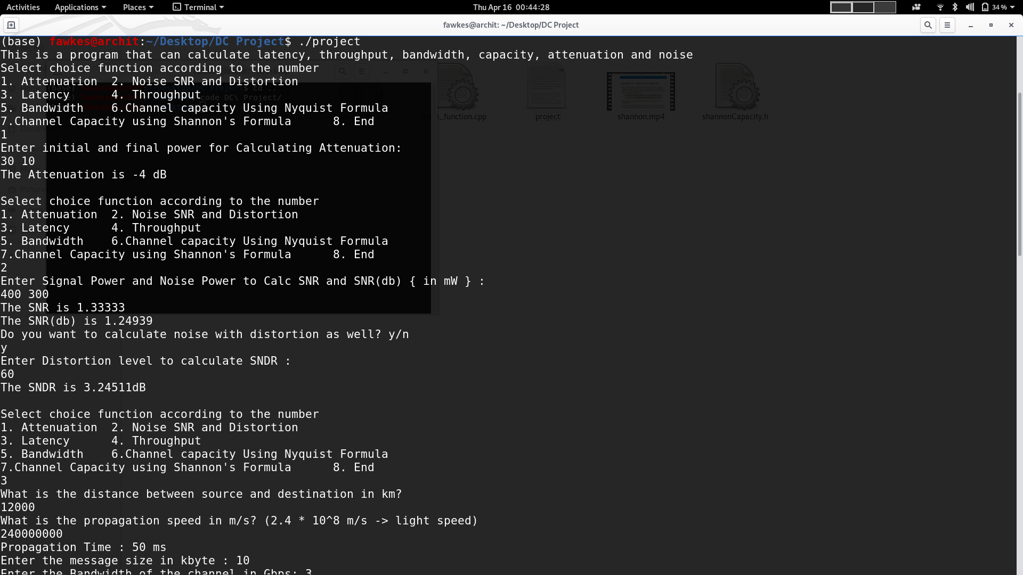Figure 1: Output Part1
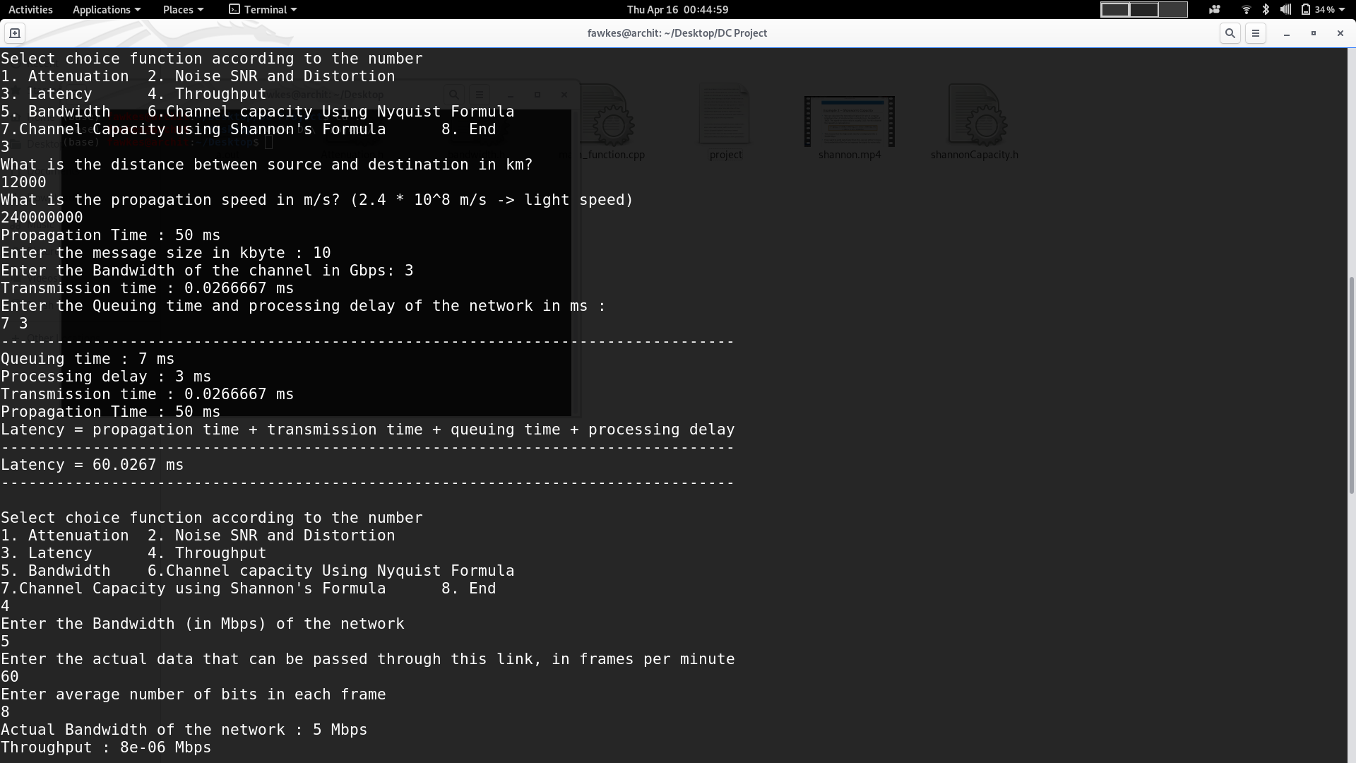Figure 2: Output part2
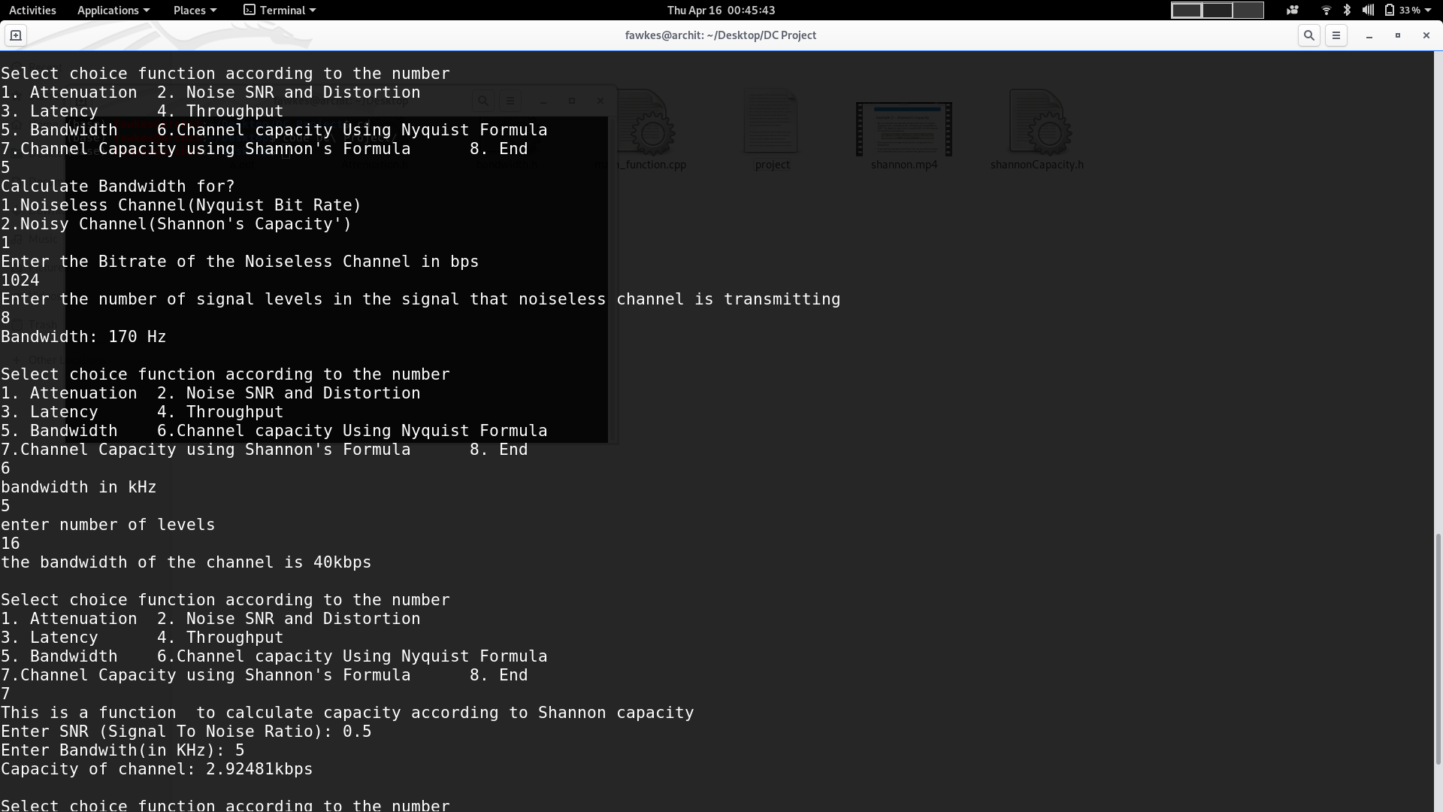Figure 3: Output part3
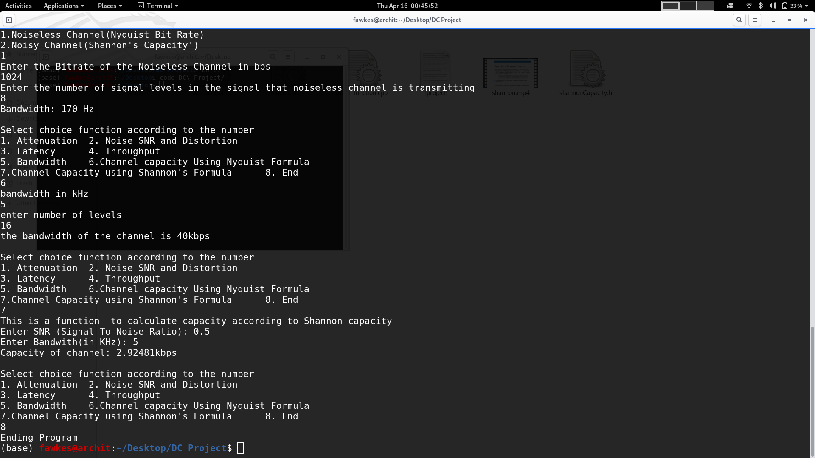Figure 4: Output part4

