Comparison of Prim’s algorithm for finding Minimum Spanning Tree with and without parallel processing

A Manoj, Abhishek V Tangod, Archit Nitin Latkar
( Usn: 1MS18CS001, 1MS18CS006, 1MS18CS027)

Abstract:

Keywords- OpenMP, Parallel Downloading, parallelism, Minimum Spanning Tree

I. Introduction
Most computers today have multiple cores in their CPU. The number has gone from 2 to 64 in just 15 years. Parallel processing has become the norm not just in cloud computing and high end applications but also for home computers. It has led to significant performance improvements in user experience. Programmers can make use of multi core architecture through some programming paradigms such as threads. Many programming languages now support parallelism and some such as Golang are built around it. In C/C++, we can use OpenMP to parallelise processing. OpenMP contains a set of directives that instruct the compiler to execute sections of code on different threads.

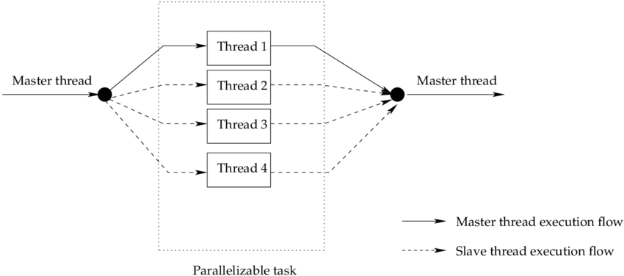

Fig 1. OpenMp threading flow

A Spanning tree of a graph is a tree that contains all the nodes of the graph and a subset of edges such that there is no cycle. A “Minimum Spanning Tree” (MST) is a spanning tree whose sum of the weights of the edges is minimum. It finds applications in many areas where graphs are involved such as network optimisation, pipelines and electricity grid, social networks and even indirectly in the fields of machine learning, face recognition etc. hence optimising a method to find one can greatly speed up computations. There are majorly two algorithms that are popular - Prim’s algorithm and Kruskal’s algorithm. In this paper we compare the performance of Prim’s algorithm implemented for single core and a multi core architecture.

II. Literature Survey
OpenMP is a shared-memory multiprocessing Application Program Inference (API) . It provides easy development of shared memory parallel programs. It provides a set of compiler directives for us to create threads, on top of pthreads manage the shared memory and synchronise the operations. The programs are compiled into multithreaded programs and the communications between threads is very systematic as threads share the same memory address space. A set of libraries is provided by the runtime as it maintains a thread pool as well [1]. To switch between sequential and parallel sections, which follow the fork/join model it uses a block-structured approach . A single thread is split into a number of threads at the entry of a parallel block, and a new sequential thread is started when all the split threads have finished . A fine-grained control over the threads is allowed by the directives[2]. Willy Zwaenepoel, Y.Charlie Hu, Honghui Lu, and Alan L Cox (1999), implemented OpenMP on a network of shared memory multiprocessors. The programmer relies on a single, standard shared-memory API for parallelization within a multiprocessor and between multiprocessors. John Bircsak, Zarka Cvetanovic, Peter Craig, Jonathan Harris, RaeLyn Crowell, Carl D. Offner and C. Alexander Nelson (2000), in their paper, describes extensions to OpenMP that implement data placement features needed for Non-Uniform Memory Access (NUMA) architectures. It is required that a programmer controls the placement of data in memory and the placement of computations that operate on that data in order to write efficient parallel programs for NUMA architectures, which have characteristics of both shared-memory and distributed-memory architectures. When computations occur on processors that have fast access to the data optimal performance is obtained . OpenMP does not by itself address these issues. It is supported on various platforms like LINUX, Windows and UNIX and various languages like C, C++, and Fortran [2]. Some of the advantages of OpenMP are 1) The compiler takes care of transforming the sequential code into parallel code according to the directives, therefore OpenMP is much easier to use[2]. 2) Without serious understanding of the multithreading mechanism, the programmer can write multithreaded programs [1].

III. Method

1. Prim’s Algorithm

2. Implementation in C++ (Serial)

3. Scope for parallelism
Prim's algorithm starts with the single node and explores all the adjacent nodes with all the connecting edges at every step. The edges with the minimal weights causing no cycles in the graph got selected. So during adding next node in the set, by finding minimum weight edge in parallel over all adjacent nodes that are to be explored, but updating minimum weight in critical section. Also the distributing the iterations among threads using parallel static schedules while updating key.
4. Implementation of parallelism in C++

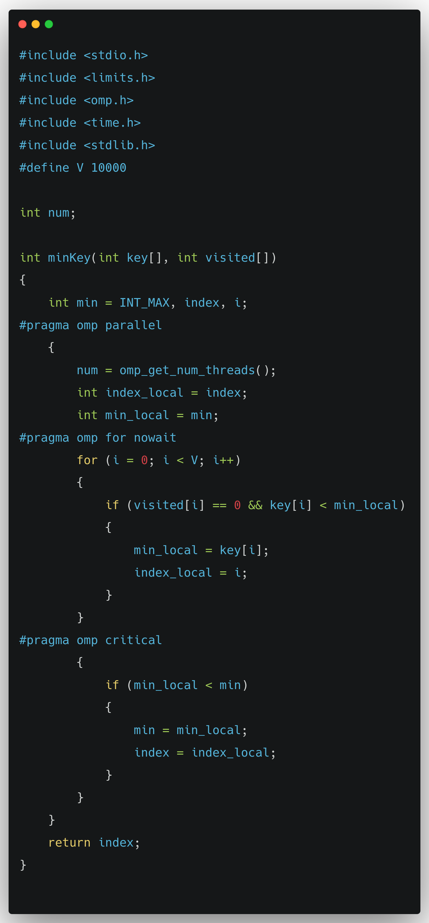
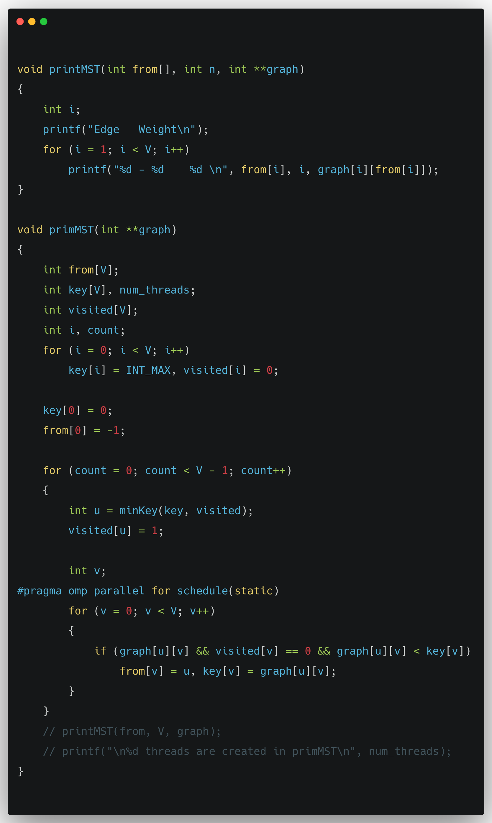

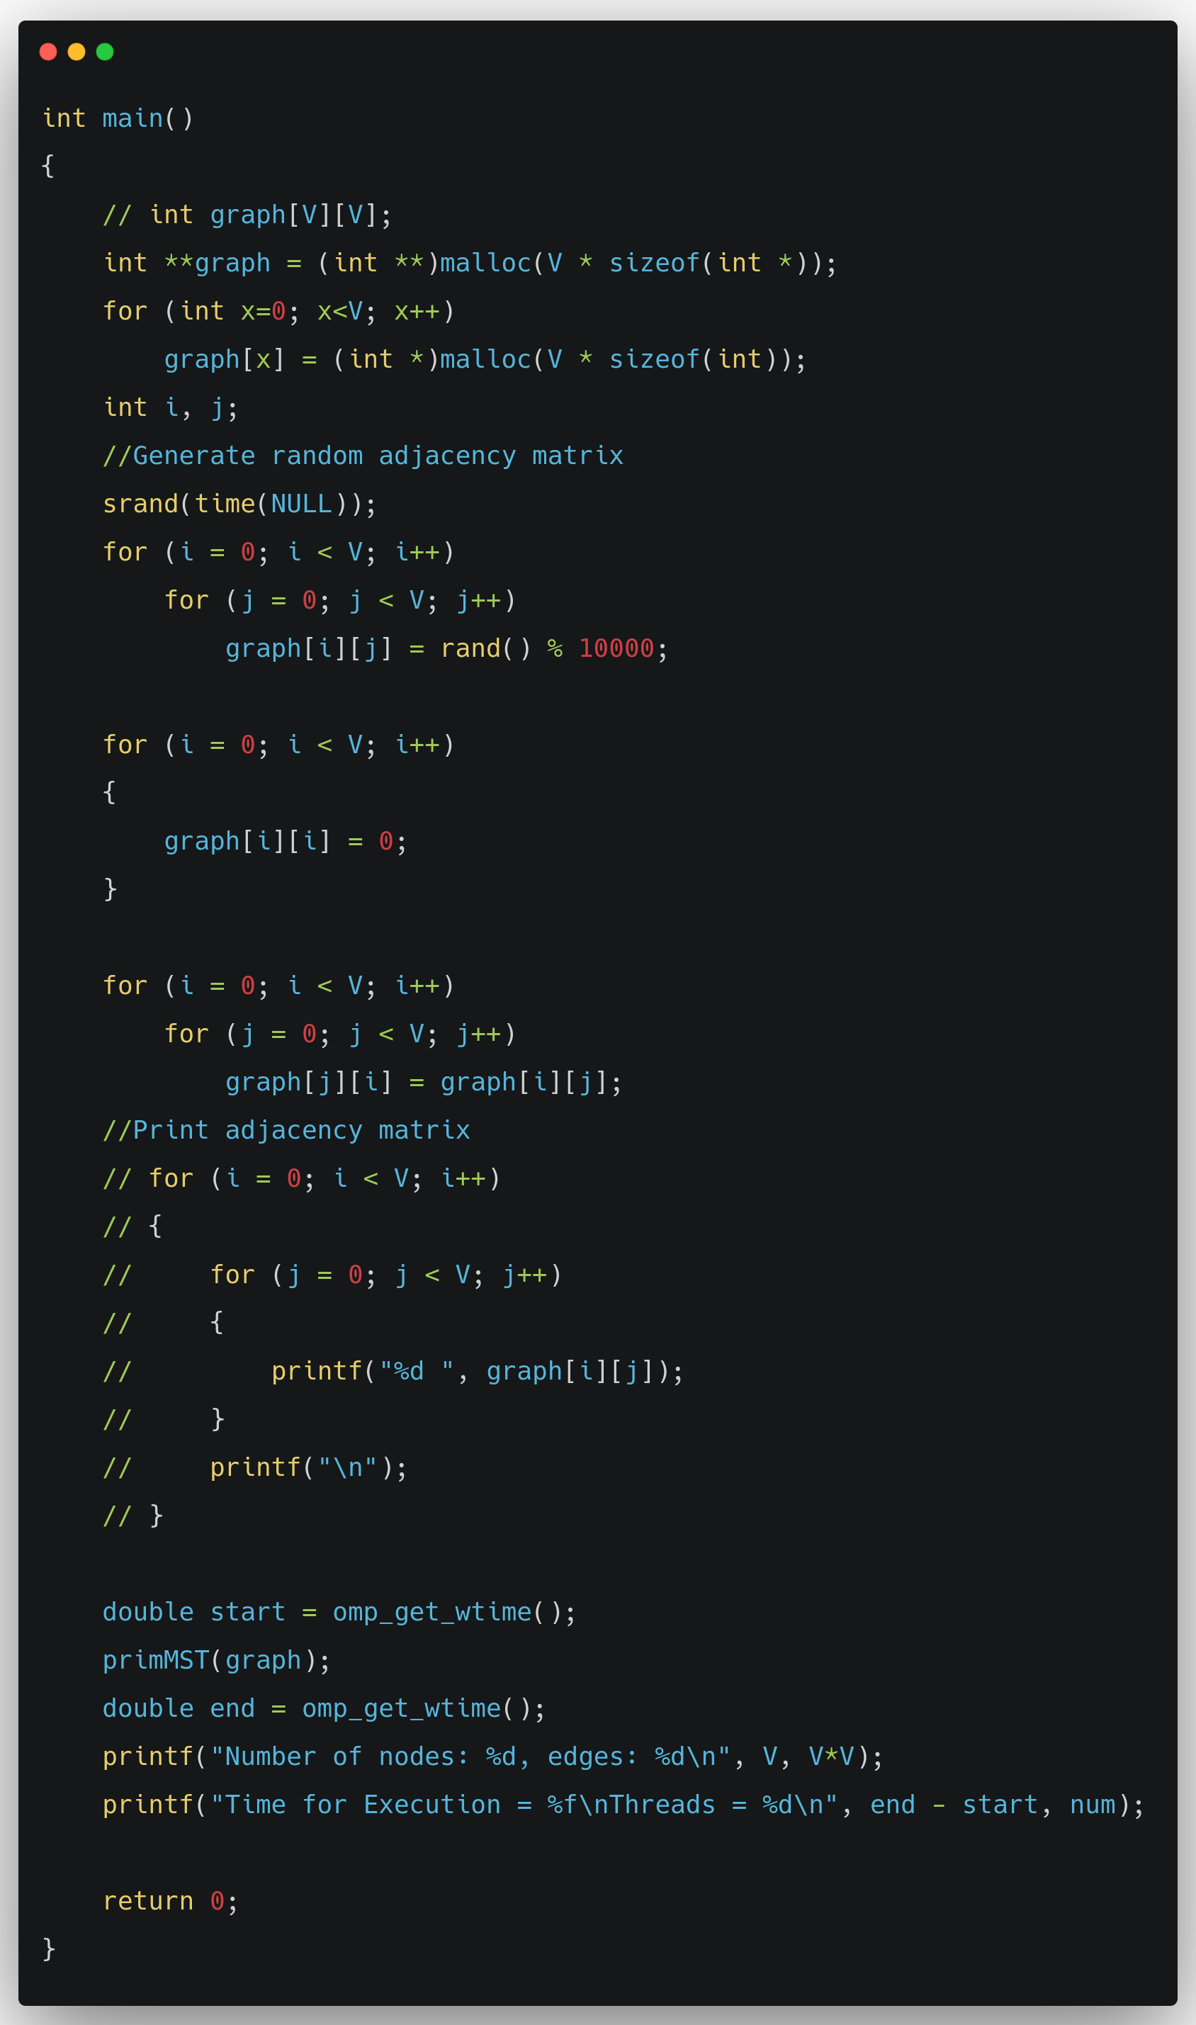

III. Results
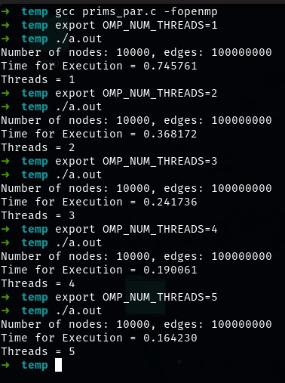

Fig 1. Result of serial and parallel execution of Prims algorithm in Seconds
(Thread=1 means, serial execution)

From the above output we can infer that in serial mode ( with thread =1) and 1e4 nodes, 1e8 edges it took 0.745761 seconds to build a minimum spanning tree using Prims algorithm, but in parallel, the time went on reducing exponentially, with Thread =2, almost reduced to half 0.368172, with Threads = 3, 0.241736s and so on.
(The results are obtained by running this on AMD Ryzen 7 5700u processor (8 cores, 16 threads))

References:
[1] OpenMP Architecture Review Board, ―OpenMP Application Program Interface,‖ 2008, http://www.openmp.org/mp-documents/spec30.pdf.
[2] B. Barney, Introduction to Parallel Computing, Lawrence Livermore National Laboratory, 2007, https://computing.llnl.gov/tutorials/parallel_comp/ .
[3] R. Awari, "Parallelization of shortest path algorithm using OpenMP and MPI," 2017 International Conference on I-SMAC (IoT in Social, Mobile, Analytics and Cloud) (I-SMAC), 2017, pp. 304-309, doi: 10.1109/I-SMAC.2017.8058360.
[4] Parallel Programming with OpenMP in C | by Samir Huseynzade | Medium
[5] Sharma, Sanjay. (2012). Performance Analysis of Parallel Algorithms on Multi-core System using OpenMP. International Journal of Computer Science, Engineering and Information Technology. 2. 55-64. 10.5121/ijcseit.2012.2506.

