RETAIL SALES & PROFIT INTELLIGENCE STUDIO

Year 3, Sem V Computer Engineering
Business Intelligence and Analytics

By

Vamshi Pottabatini 60004240029
Archit Prabhu 60004240228
Harshit Pandya 60004240079

Guide:

Dr. Kiran Bhowmick
Contents
- Introduction
- Data collection / Data description
- Data pre-processing
- Mining models / analytics (Prediction/regression/classification etc)
- Results
- Visualization (Charts/plots)
- Conclusion

1. Introduction
Retail companies record thousands of sales transactions, but raw data does not show where the business makes or loses money. This project applies Business Intelligence and data-mining techniques to retail sales data to find profit drivers, loss-making products, customer groups and return patterns, and presents the results on an interactive dashboard.
Objectives:
- Clean and prepare the sales data for analysis.
- Measure business performance using KPIs.
- Predict profit, loss-making orders and future sales, and segment customers.
- Visualize the results and build a dashboard for decision-making.
Tools: Python, pandas, scikit-learn, Matplotlib, Seaborn, Plotly, Streamlit.

2. Data collection / Data description
The dataset used is the official Sample - Superstore dataset from Tableau Public (public.tableau.com/app/learn/sample-data). It contains the sales of a fictitious retail company in the United States and Canada from January 2023 to December 2026.
Sheet | Rows | Description
Orders | 10,194 | One row per order line (21 columns)
Returns | 296 | Order IDs that were returned
People | 4 | Regional manager of each region

Column(s) | Description
Order ID, Order Date, Ship Date, Ship Mode | Order and shipping details
Customer ID, Customer Name, Segment | Customer details (Consumer, Corporate, Home Office)
Country/Region, City, State/Province, Postal Code, Region | Location
Product ID, Category, Sub-Category, Product Name | Product details
Sales, Quantity, Discount, Profit | Sales value (USD), units, discount rate, profit/loss (USD)

The data has 5,111 orders, 804 customers, 1,862 products, 3 categories, 17 sub-categories and 4 regions.

3. Data pre-processing
- Column names: standardised (Country/Region to Country, State/Province to State).
- Missing values: none found.
- Duplicates: 2 duplicate rows removed (10,194 to 10,192 rows).
- Data types: dates converted to datetime; 438 US postal codes corrected by restoring the leading zero.
- Validity checks: no ship date before order date, no zero/negative sales or quantity, all discounts between 0 and 1. The 1,900 rows with negative profit were kept as valid losses.
- Outliers: 1,183 sales and 1,913 profit outliers flagged using the IQR method (not removed).
- Data integration: the Returns and People sheets were joined to the orders on Order ID and Region.
- Feature engineering: Year, Month, Quarter, Ship Days, Profit Margin %, Discount Band, Is Loss, Is Returned and Sales x Discount.

4. Mining models / analytics
4.1 Descriptive analytics
KPIs (total sales, profit, profit margin, orders, average order value and return rate) were calculated and analysed by category, region, segment, discount band and time.
4.2 Regression - predicting profit
Linear Regression and Random Forest were trained to predict the profit of an order line using Sales, Quantity, Discount, Sales x Discount, Category, Sub-Category, Region, Segment and Ship Mode (80/20 train-test split and 5-fold cross-validation).
4.3 Classification - predicting loss-making orders
Logistic Regression and Decision Tree (max depth 5) were trained to predict whether an order line makes a loss (Profit < 0), using the same features and a stratified 80/20 split.
4.4 Clustering - customer segmentation
Customers were grouped with K-Means (k = 4, chosen by the elbow method) on Recency, Frequency and Monetary (RFM) values.
4.5 Forecasting - monthly sales
A Linear Regression model with trend and month-of-year features was compared with a seasonal naive baseline. The last 12 months were used as the test set.

5. Results
Key performance indicators
Total Sales | Total Profit | Profit Margin | Orders | Avg Order Value | Return Rate
$2,326,154 | $292,273 | 12.6% | 5,111 | $455 | 5.8%

Regression
Model | R2 (test) | R2 (5-fold CV) | MAE ($)
Linear Regression | 0.80 | 0.62 | 35.45
Random Forest | 0.67 | 0.59 | 19.54

Classification
Model | Accuracy | Precision | Recall | F1
Logistic Regression | 0.94 | 0.94 | 0.72 | 0.82
Decision Tree | 0.95 | 0.96 | 0.76 | 0.85

Clustering
Segment | Customers | Avg orders | Avg sales ($)
Champions | 249 | 8.9 | 4,887
Loyal | 202 | 6.8 | 2,683
Potential | 262 | 5.0 | 2,021
Low Value | 91 | 2.5 | 417

Forecasting
Model | MAE ($) | MAPE
Seasonal Naive | 15,793 | 24.4%
Linear Regression | 11,380 | 17.6%

Key findings
- Technology has the highest sales and profit (17.4% margin); Furniture has only a 2.6% margin.
- Tables, Bookcases and Supplies are loss-making sub-categories; 302 products make a loss.
- Discounts above 20% give negative margins (-15.3% for 21-40% and -77.4% for 41-80%).
- West is the most profitable region and Central the least.
- The West region has a 15.1% return rate, about three times the other regions (3.9% - 5.0%).
- Sales peak in November, December and September.

6. Visualization (Charts/plots)
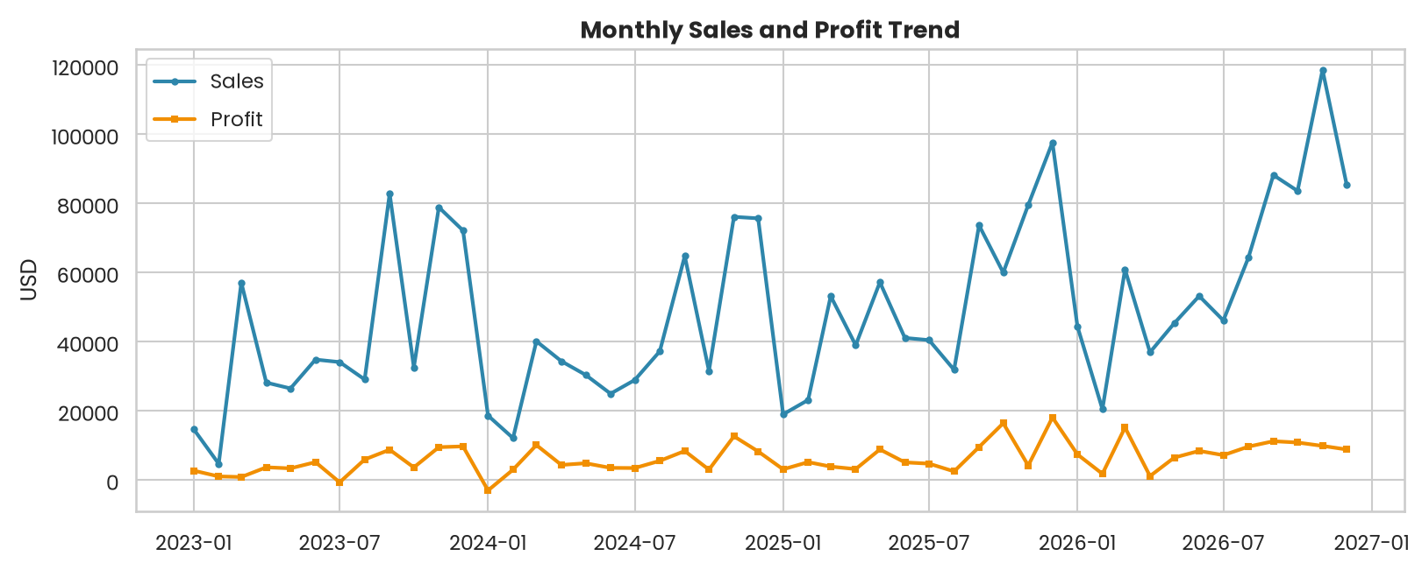
Figure 1: Monthly sales and profit trend
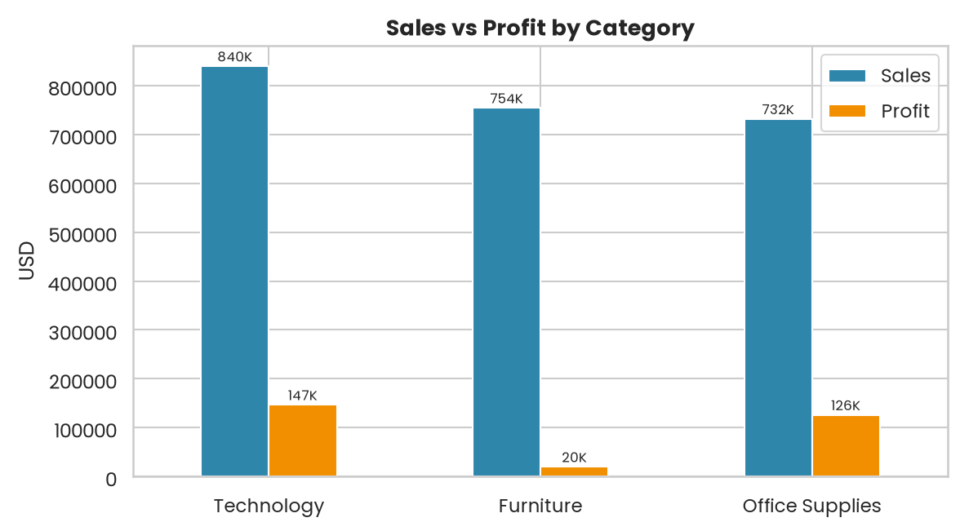
Figure 2: Sales vs profit by category
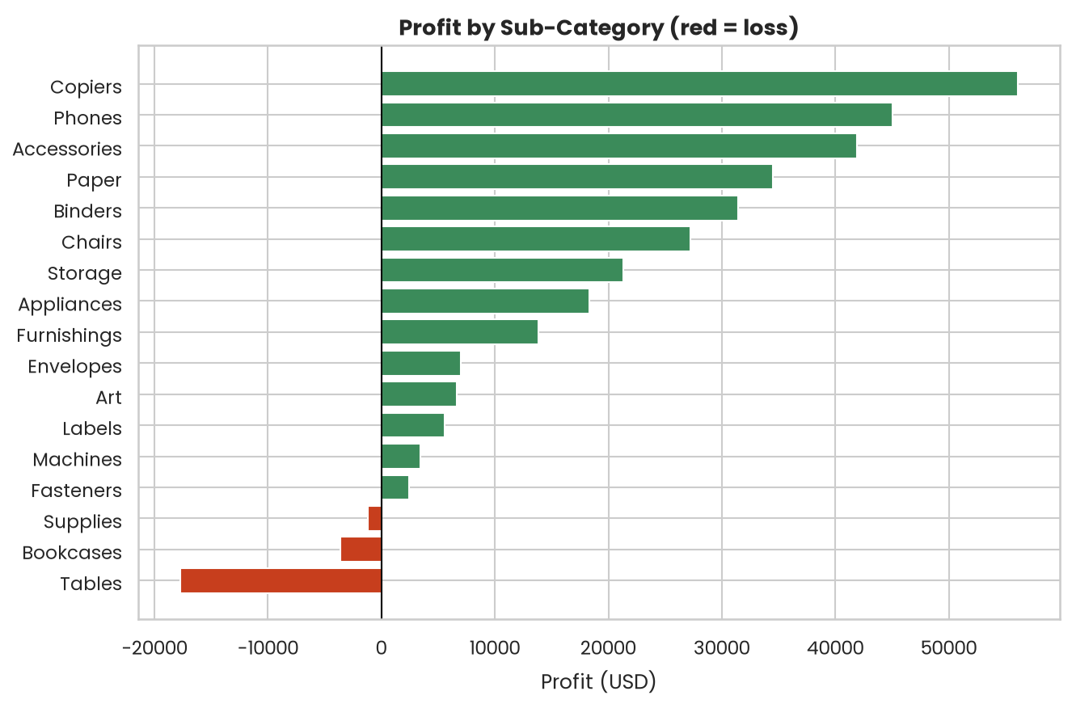
Figure 3: Profit by sub-category
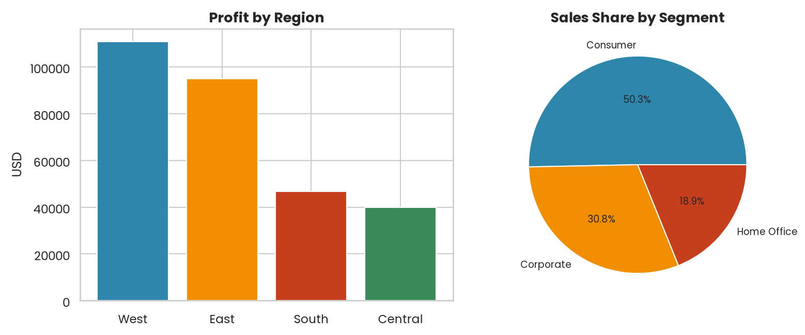
Figure 4: Profit by region and sales share by segment
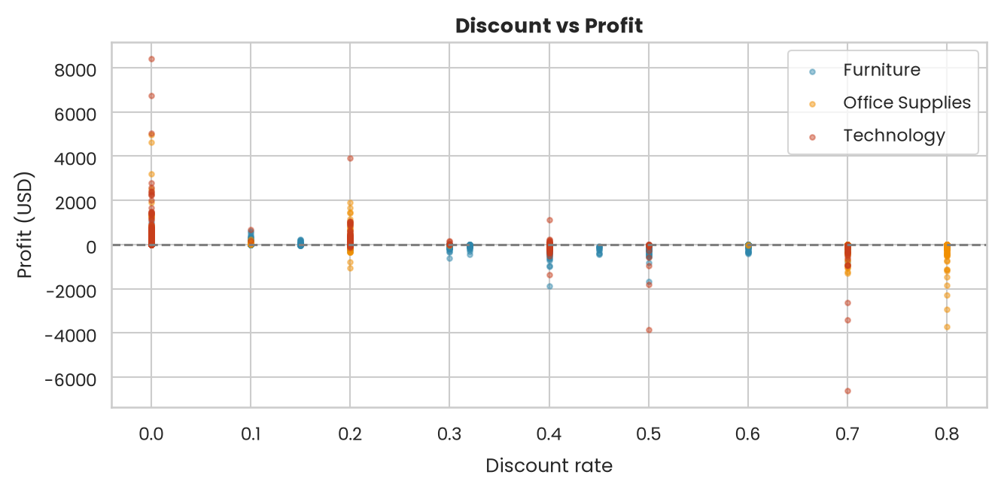
Figure 5: Discount vs profit
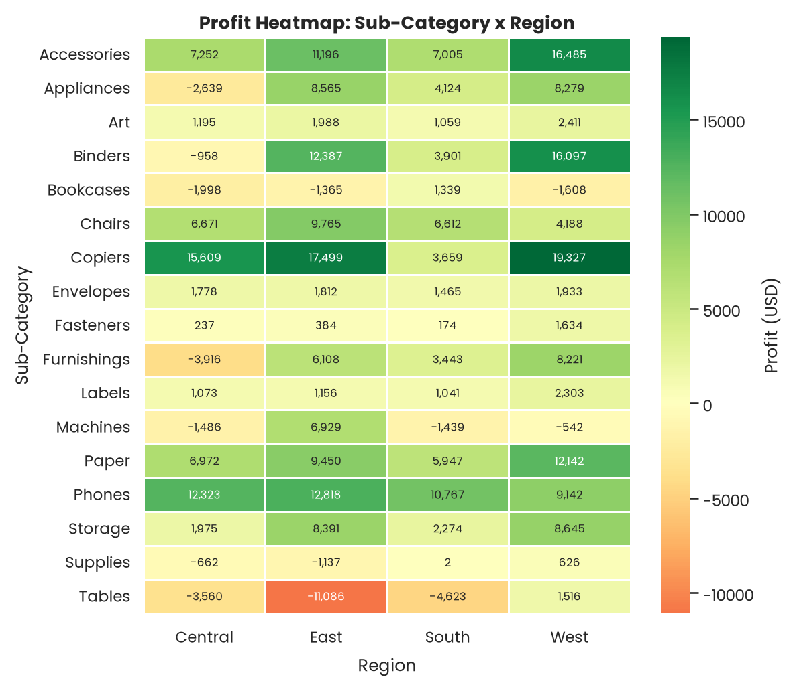
Figure 6: Profit heatmap by sub-category and region
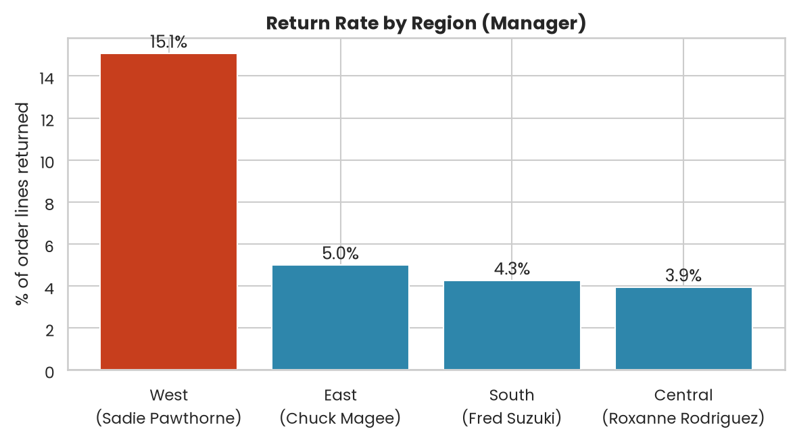
Figure 7: Return rate by region
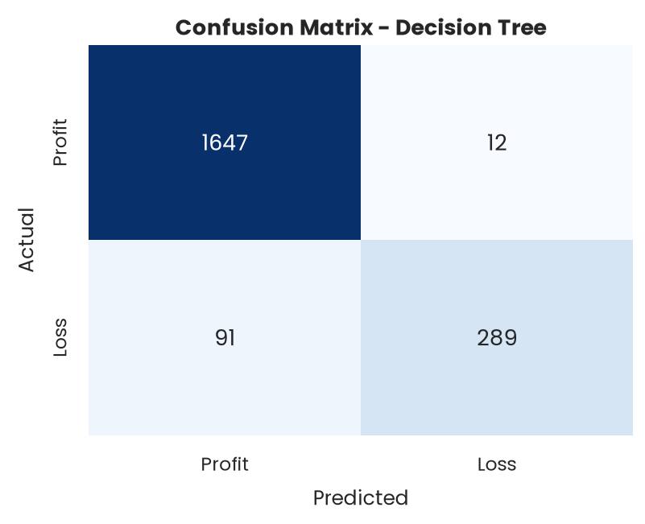
Figure 8: Confusion matrix of the Decision Tree
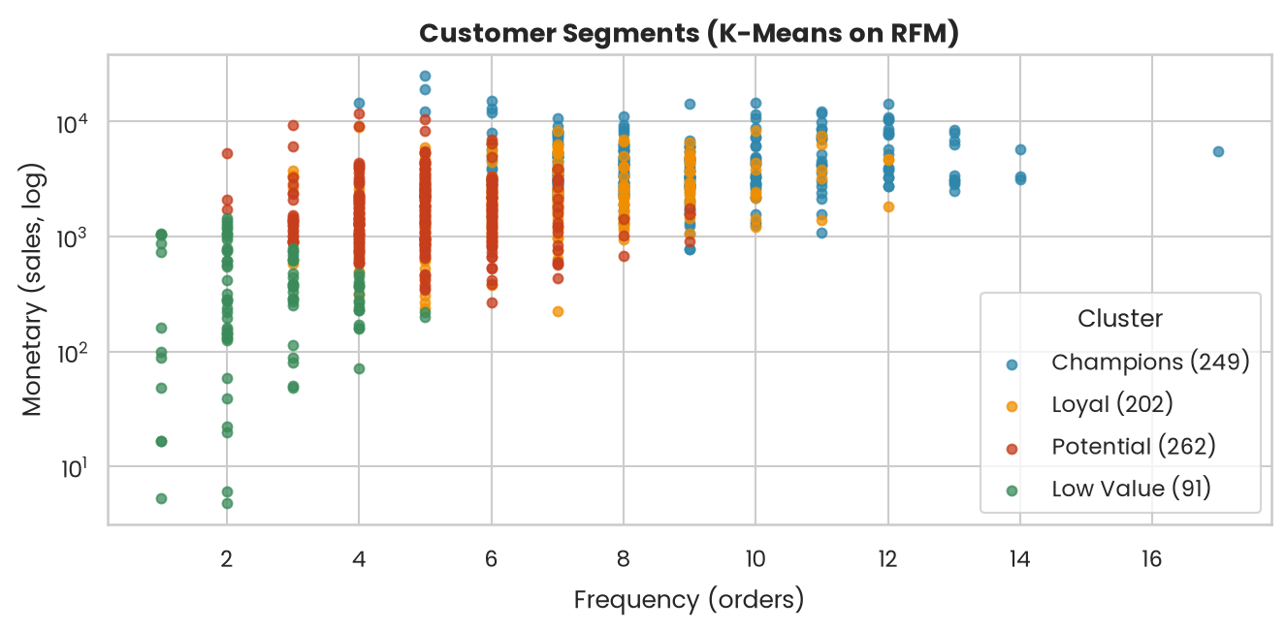
Figure 9: Customer segments (K-Means)
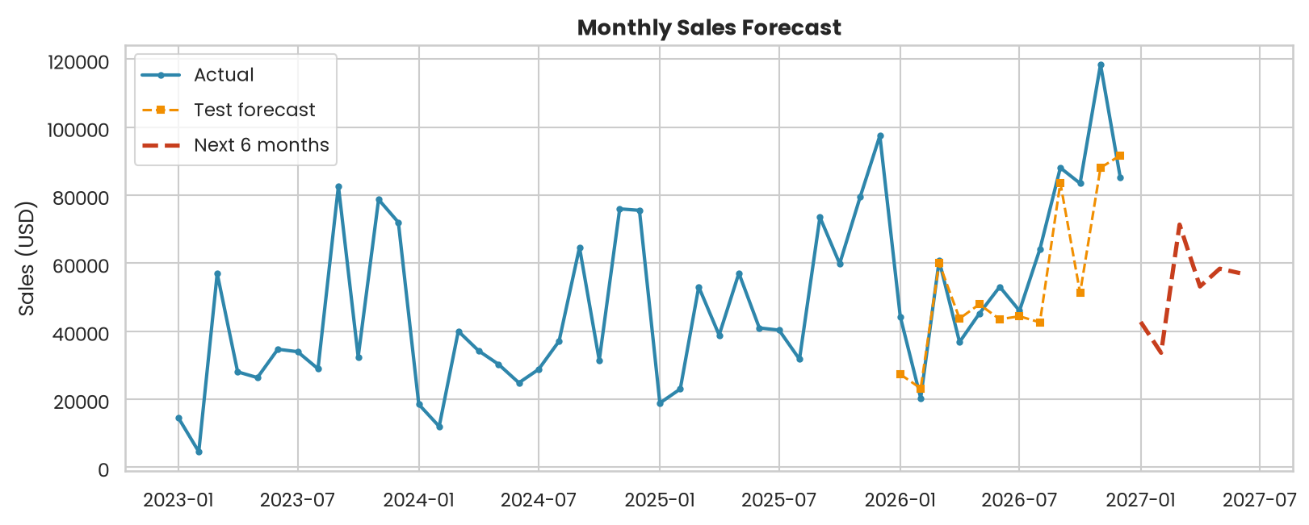
Figure 10: Monthly sales forecast

7. Conclusion
A complete Business Intelligence workflow (data collection, pre-processing, analytics, data mining and visualization) was applied to the Superstore retail data, with the results shown on an interactive dashboard.
- The Decision Tree predicted loss-making orders with 95% accuracy, and Linear Regression gave the best profit prediction (R2 = 0.80).
- High discounts are strongly linked to losses, so discounts above 20% should be limited.
- Loss-making products such as Tables and Bookcases need price or cost review.
- Champion and Loyal customers should be targeted for retention.
- The high return rate in the West region should be investigated.

