

Functional Safety Concept Lane Assistance

**Document Version: [1.0]**

**Template Version 1.0, Released on 2017-06-21**



# Document history

|  |  |  |  |
| --- | --- | --- | --- |
| Date | Version | Editor | Description |
| 27/11/2018 | 1 | Archit Rastogi | First pass |
|  |  |  |  |
|  |  |  |  |
|  |  |  |  |
|  |  |  |  |

# Table of Contents

Document history

Table of Contents

Purpose of the Functional Safety Concept

Inputs to the Functional Safety Analysis

Safety goals from the Hazard Analysis and Risk Assessment

Preliminary Architecture

Description of architecture elements

Functional Safety Concept

Functional Safety Analysis

Functional Safety Requirements

Refinement of the System Architecture

Allocation of Functional Safety Requirements to Architecture Elements

Warning and Degradation Concept

# Purpose of the Functional Safety Concept

Functional Safety concept documents the high-level functional safety requirements identified from functional safety goals. These requirements are then allocated to the relevant parts of the system. Verification and validation for all the requirements is also documented. From the result of functional safety concept, technical requirements are derived at a later stage.

# Inputs to the Functional Safety Concept

## Safety goals from the Hazard Analysis and Risk Assessment

|  |  |
| --- | --- |
| **ID** | **Safety Goal** |
| Safety_Goal_01 | The oscillating steering torque from the Lane Departure Warning function shall be limited. |
| Safety_Goal_02 | The Lane Keeping Assistance function shall be time limited, and additional steering torque shall end after a given time interval so the driver cannot misuse the system for autonomous |

## Preliminary Architecture

### https://d17h27t6h515a5.cloudfront.net/topher/2017/July/5976aa23_02-advanced-driver-assistance-system-architecture-02-1/02-advanced-driver-assistance-system-architecture-02-1.png

### Description of architecture elements

|  |  |
| --- | --- |
| **Element** | **Description** |
| Camera Sensor | Captures Image and provides the data to the Camera ECU |
| Camera Sensor ECU | Processes the images to calculate the car position with respect to lane lines |
| Car Display | Provides display warnings and status to the driver |
| Car Display ECU | Generates the warning signals based on input from Camera Sensor ECU and EPS ECU |
| Driver Steering Torque Sensor | Measures the steering torque applied by the driver |
| Electronic Power Steering ECU | Process the input from Driver Steering Torque sensor and Camera sensor ECU and provides the final torque based on the appropriate Lane Assistance functionality |
| Motor | Applies the final torque received from Electronic Power Steering ECU to steering wheel |

# Functional Safety Concept

The functional safety concept consists of:

* Functional safety analysis
* Functional safety requirements
* Functional safety architecture
* Warning and degradation concept

## Functional Safety Analysis

|  |  |  |  |
| --- | --- | --- | --- |
| **Malfunction ID** | **Main Function of the Item Related to Safety Goal Violations** | **Guidewords (NO, WRONG, EARLY, LATE, MORE, LESS)** | **Resulting Malfunction** |
| Malfunction_01 | Lane Departure Warning (LDW) function shall apply an oscillating steering torque to provide the driver a haptic feedback | MORE | The lane departure warning function applies an oscillating torque with very high torque amplitude (above limit) |
| Malfunction_02 | Lane Departure Warning (LDW) function shall apply an oscillating steering torque to provide the driver a haptic feedback | MORE | The lane departure warning function applies an oscillating torque with very high torque frequency (above limit) |
| Malfunction_03 | Lane Keeping Assistance (LKA) function shall apply the steering torque when active in order to stay in ego lane | NO | The lane keeping assistance function is not limited in time duration which leads to misuse as an autonomous driving function |

## 

## Functional Safety Requirements

Lane Departure Warning (LDW) Requirements:

|  |  |  |  |  |
| --- | --- | --- | --- | --- |
| **ID** | **Functional Safety Requirement** | **ASIL** | **Fault Tolerant Time Interval** | **Safe State** |
| Functional  Safety  Requirement  01-01 | the lane keeping item shall ensure that the lane departure oscillating torque amplitude is below Max_Torque_Amplitude | C | 50ms | Vibration Torque Amplitude below  Max_Torque_Amplitude |
| Functional  Safety  Requirement  01-02 | The lane keeping item shall ensure that the lane departure oscillating torque frequency is below Max_Torque_Frequency | C | 50ms | Vibration Torque frequency below Max_Torque_Frequency |

Lane Departure Warning (LDW) Verification and Validation Acceptance Criteria:

|  |  |  |
| --- | --- | --- |
| **ID** | **Validation Acceptance**  **Criteria and Method** | **Verification Acceptance**  **Criteria and Method** |
| Functional  Safety  Requirement  01-01 | Validate Max_Torque_Amplitude chosen is appropriate for different drivers | Verify when the torque amplitude crosses the limit, the lane assistance output is set to zero within the 50 ms fault tolerant time interval |
| Functional  Safety  Requirement  01-02 | Validate Max_Torque_Frequency chosen is appropriate for different drivers | when the torque frequency crosses the limit, the lane assistance output is set to zero within the 50 ms fault tolerant time interval |

Lane Keeping Assistance (LKA) Requirements:

|  |  |  |  |  |
| --- | --- | --- | --- | --- |
| **ID** | **Functional Safety Requirement** | **ASIL** | **Fault Tolerant Time Interval** | **Safe State** |
| Functional  Safety  Requirement  02-01 | the electronic power steering ECU shall ensure that the lane keeping assistance torque is applied for only Max_Duration | B | 500ms | Lane Keeping Assistance Torque is zero |

Lane Keeping Assistance (LKA) Verification and Validation Acceptance Criteria:

|  |  |  |
| --- | --- | --- |
| **ID** | **Validation Acceptance**  **Criteria and Method** | **Verification Acceptance**  **Criteria and Method** |
| Functional  Safety  Requirement  02-01 | Validate that the Max_duration value chosen is appropriate for not allowing drivers to take their hands off the wheel | Verify that the functionality turns off if LKA exceeds MAX_DURATION |

## 

## Refinement of the System Architecture

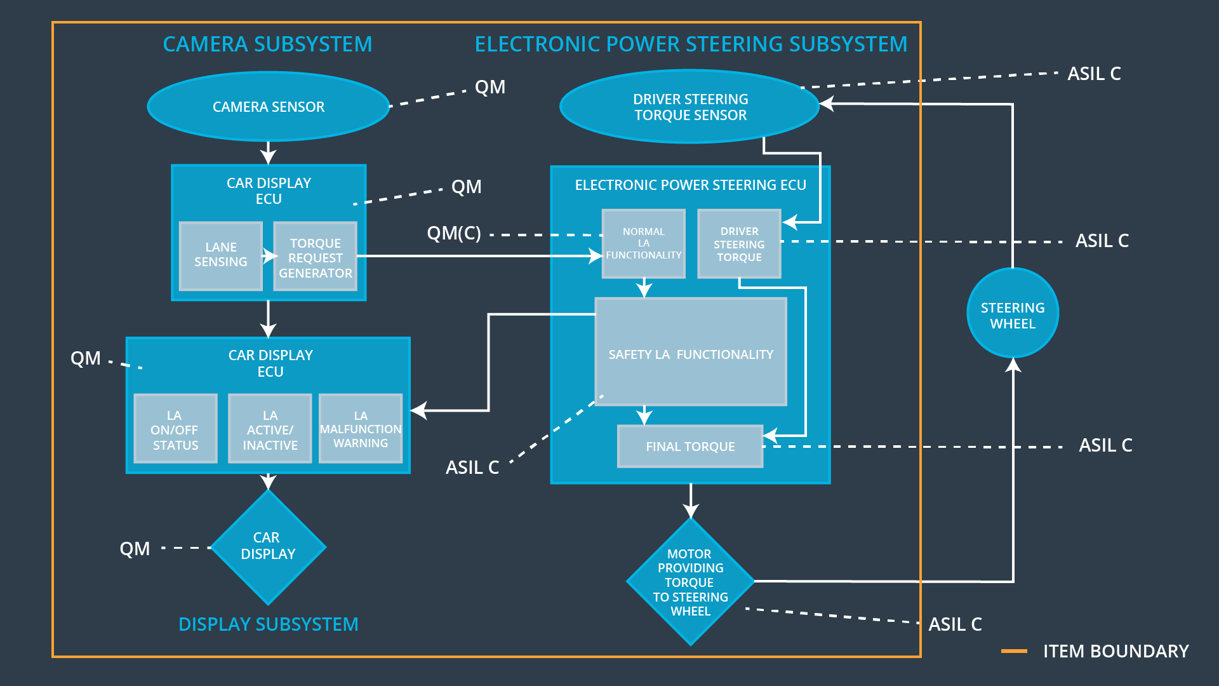

## Allocation of Functional Safety Requirements to Architecture Elements

|  |  |  |  |  |
| --- | --- | --- | --- | --- |
| **ID** | **Functional Safety Requirement** | **Electronic Power Steering ECU** | **Camera ECU** | **Car Display ECU** |
| Functional  Safety  Requirement  01-01 | The lane keeping item shall ensure that the lane departure oscillating torque amplitude is below Max_Torque_Amplitude | **X** |  |  |
| Functional  Safety  Requirement  01-02 | The lane keeping item shall ensure that the lane departure oscillating torque frequency is below Max_Torque_Frequency | **X** |  |  |
| Functional  Safety  Requirement  02-01 | the electronic power steering ECU shall ensure that the lane keeping assistance torque is applied for only Max_Duration | **X** |  |  |

## Warning and Degradation Concept

|  |  |  |  |  |
| --- | --- | --- | --- | --- |
| **ID** | **Degradation Mode** | **Trigger for Degradation Mode** | **Safe State invoked?** | **Driver Warning** |
| WDC-01 | System off | Malfunction 01, 02 | Yes | Warning on Car Display |
| WDC-02 | System off | Malfunction 03 | Yes | Warning on Car Display |