

Technical Safety Concept Lane Assistance

**Document Version: [1.0]**

**Template Version 1.0, Released on 2017-06-21**



# Document history

|  |  |  |  |
| --- | --- | --- | --- |
| Date | Version | Editor | Description |
| 27/11/2018 | 1.0 | Archit Rastogi | First pass |
|  |  |  |  |
|  |  |  |  |
|  |  |  |  |
|  |  |  |  |

# 

# Table of Contents

Document history

Table of Contents

Purpose of the Technical Safety Concept

Inputs to the Technical Safety Concept

Functional Safety Requirements

Refined System Architecture from Functional Safety Concept

Functional overview of architecture elements

Technical Safety Concept

Technical Safety Requirements

Refinement of the System Architecture

Allocation of Technical Safety Requirements to Architecture Elements

Warning and Degradation Concept

# Purpose of the Technical Safety Concept

Technical safety concept involves:

* Turning functional safety requirements into technical safety requirements
* Allocating technical safety requirements to the system architecture

# Inputs to the Technical Safety Concept

## Functional Safety Requirements

|  |  |  |  |  |
| --- | --- | --- | --- | --- |
| **ID** | **Functional Safety Requirement** | **ASIL** | **Fault Tolerant Time Interval** | **Safe State** |
| Functional  Safety  Requirement  01-01 | the lane keeping item shall ensure that the lane departure oscillating torque amplitude is below Max_Torque_Amplitude | C | 50ms | Vibration Torque Amplitude below  Max_Torque_Amplitude |
| Functional  Safety  Requirement  01-02 | The lane keeping item shall ensure that the lane departure oscillating torque frequency is below Max_Torque_Frequency | C | 50ms | Vibration Torque frequency below Max_Torque_Frequency |
| Functional  Safety  Requirement  02-01 | the electronic power steering ECU shall ensure that the lane keeping assistance torque is applied for only Max_Duration | B | 500ms | Lane Keeping Assistance Torque is zero |

## Refined System Architecture from Functional Safety Concept

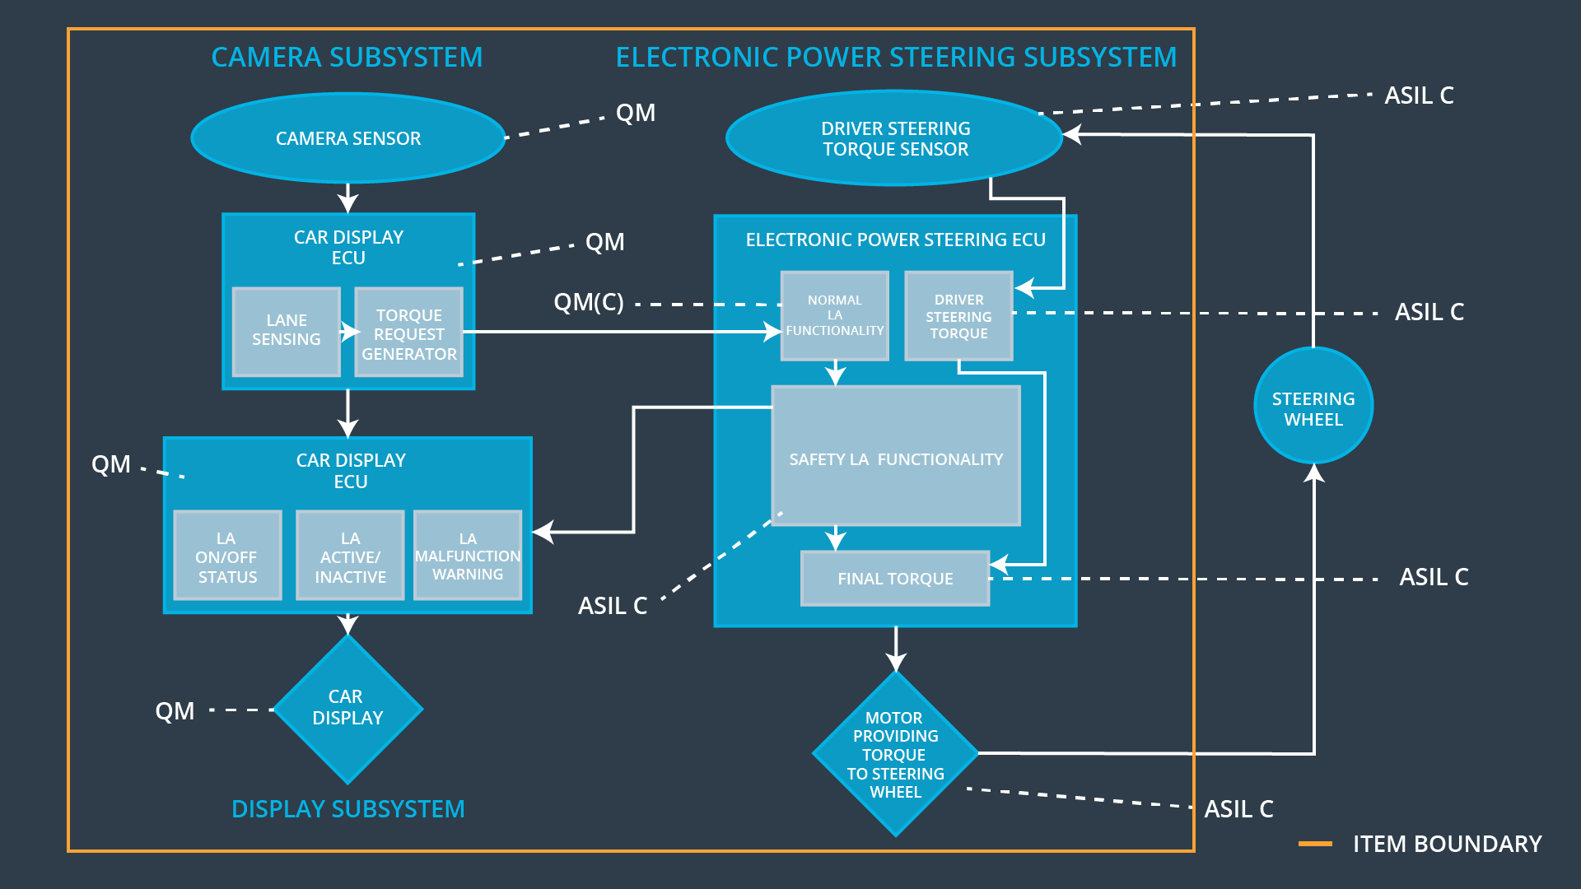

### 

### Functional overview of architecture elements

|  |  |
| --- | --- |
| **Element** | **Description** |
| Camera Sensor | Captures Image and provides the data to the Camera ECU |
| Camera Sensor ECU - Lane Sensing | Detects Lane line from the images |
| Camera Sensor ECU - Torque request generator | Generates torque request based on the lane lines and position of vehicle to be sent to EPS ECU |
| Car Display | Show warning to the driver |
| Car Display ECU - Lane Assistance On/Off Status | Indicates if the LA functionality is off or on |
| Car Display ECU - Lane Assistant Active/Inactive | Indicates if the LA functionality is active/ inactive based on lane detection |
| Car Display ECU - Lane Assistance malfunction warning | Indicates any malfunction in the LA system |
| Driver Steering Torque Sensor | Measures the steering torque applied by the driver |
| Electronic Power Steering (EPS) ECU - Driver Steering Torque | Process input from Driver Steering Torque Sensor |
| EPS ECU - Normal Lane Assistance Functionality | Receives Camera Sensor Torque request and pass it to safety lane assistance functionality module |
| EPS ECU - Lane Departure Warning Safety Functionality | Ensures if the LDW is working properly and the functional safety requirements are met |
| EPS ECU - Lane Keeping Assistant Safety Functionality | Ensures if the LKA is working properly and the functional safety requirements are met |
| EPS ECU - Final Torque | Combines the torque request from LDW, LKA and also the driver steering torque and send it to the motor |
| Motor | Applies the final torque received from Electronic Power Steering ECU to steering wheel |

# Technical Safety Concept

## Technical Safety Requirements

**Lane Departure Warning (LDW) Requirements:**

Functional Safety Requirement 01-01 with its associated system elements

(derived in the functional safety concept)

|  |  |  |  |  |
| --- | --- | --- | --- | --- |
| **ID** | **Functional Safety Requirement** | **Electronic Power Steering ECU** | **Camera ECU** | **Car Display ECU** |
| Functional  Safety  Requirement  01-01 | The lane keeping item shall ensure that the lane departure oscillating torque amplitude is below Max_Torque_Amplitude | X |  |  |

Technical Safety Requirements related to Functional Safety Requirement 01-01 are:

|  |  |  |  |  |  |
| --- | --- | --- | --- | --- | --- |
| **ID** | **Technical Safety Requirement** | **ASIL** | **Fault Tolerant Time Interval** | **Architecture Allocation** | **Safe State** |
| Technical  Safety  Requirement  01 | The LDW safety component shall ensure that the amplitude of the 'LDW_Torque_Request' sent to the 'Final electronic power steering Torque' component is below 'Max_Torque_Amplitude. | C | 50ms | LDW Safety | LDW_Torque_Request Amplitude to be set to zero |
| Technical  Safety  Requirement  02 | As soon as the LDW function deactivates the LDW feature, the 'LDW Safety' software block shall send a signal to the car display ECU to turn on a warning light. | C | 50ms | LDW Safety | LDW_Torque_Request Amplitude to be set to zero |
| Technical  Safety  Requirement  03 | As soon as a failure is detected by the LDW function, it shall deactivate the LDW feature and the 'LDW_Torque_Request' shall be set to zero. | C | 50ms | LDW Safety | LDW_Torque_Request Amplitude to be set to zero |
| Technical  Safety  Requirement  04 | The validity and integrity of the data transmission for 'LDW_Torque_Request' signal shall be ensured. | C | 50ms | Data Transmission and Integrity | LDW_Torque_Request Amplitude to be set to zero |
| Technical  Safety  Requirement  05 | Memory test shall be conducted at start up of the EPS ECU to check for any faults in memory. | A | Ignition Cycle | Memory Test | LDW_Torque_Request Amplitude to be set to zero |

Functional Safety Requirement 01-2 with its associated system elements

(derived in the functional safety concept)

|  |  |  |  |  |
| --- | --- | --- | --- | --- |
| **ID** | **Functional Safety Requirement** | **Electronic Power Steering ECU** | **Camera ECU** | **Car Display ECU** |
| Functional  Safety  Requirement  01-02 | The lane keeping item shall ensure that the lane departure oscillating torque frequency is below Max_Torque_Frequency | X |  |  |

Technical Safety Requirements related to Functional Safety Requirement 01-02 are:

|  |  |  |  |  |  |
| --- | --- | --- | --- | --- | --- |
| **ID** | **Technical Safety Requirement** | **ASIL** | **Fault Tolerant Time Interval** | **Architecture Allocation** | **Safe State** |
| Technical  Safety  Requirement  01 | The LDW safety component shall ensure that the frequency of the 'LDW_Torque_Request' sent to the 'Final electronic power steering Torque' component is below 'Max_Torque_Frequency | C | 50ms | LDW Safety | LDW_Torque_Request Frequency to be set to zero |
| Technical  Safety  Requirement  02 | As soon as the LDW function deactivates the LDW feature, the 'LDW Safety' software block shall send a signal to the car display ECU to turn on a warning light. | C | 50ms | LDW Safety | LDW_Torque_Request Frequency to be set to zero |
| Technical  Safety  Requirement  03 | As soon as a failure is detected by the LDW function, it shall deactivate the LDW feature and the 'LDW_Torque_Request' shall be set to zero. | C | 50ms | LDW Safety | LDW_Torque_Request Frequency to be set to zero |
| Technical  Safety  Requirement  04 | The validity and integrity of the data transmission for 'LDW_Torque_Request' signal shall be ensured. | C | 50ms | Data Transmission and Integrity | LDW_Torque_Request Frequency to be set to zero |
| Technical  Safety  Requirement  05 | Memory test shall be conducted at start up of the EPS ECU to check for any faults in memory. | A | Ignition Cycle | Memory Test | LDW_Torque_Request Frequency to be set to zero |

**Lane Keeping Assistance (LKA) Requirements:**

Functional Safety Requirement 02-1 with its associated system elements

(derived in the functional safety concept)

|  |  |  |  |  |
| --- | --- | --- | --- | --- |
| **ID** | **Functional Safety Requirement** | **Electronic Power Steering ECU** | **Camera ECU** | **Car Display ECU** |
| Functional  Safety  Requirement  02-01 | The lane keeping item shall ensure that the lane keeping assistance torque is applied for only Max_Duration | X |  |  |

Technical Safety Requirements related to Functional Safety Requirement 02-01 are:

|  |  |  |  |  |  |
| --- | --- | --- | --- | --- | --- |
| **ID** | **Technical Safety Requirement** | **ASIL** | **Fault Tolerant Time Interval** | **Allocation to Architecture** | **Safe State** |
| Technical  Safety  Requirement  01 | The LKA safety component shall ensure that the 'LDW_Torque_Request' is sent to the 'Final electronic power steering Torque' component only for 'Max_Duration’ | B | 500ms | LKA Safety | LKA_Torque_Request to be set to zero |
| Technical  Safety  Requirement  02 | As soon as the LKA function deactivates the LKA feature, the 'LKA Safety' software block shall send a signal to the car display ECU to turn on a warning light. | B | 500ms | LKA Safety | LKA_Torque_Request to be set to zero |
| Technical  Safety  Requirement  03 | As soon as a failure is detected by the LKA function, it shall deactivate the LKA feature and the 'LKA_Torque_Request' shall be set to zero. | B | 500ms | LKA Safety | LKA_Torque_Request to be set to zero |
| Technical  Safety  Requirement  04 | The validity and integrity of the data transmission for 'LKA_Torque_Request' signal shall be ensured. | B | 500ms | Data Transmission and Integrity | LKA_Torque_Request to be set to zero |
| Technical  Safety  Requirement  05 | Memory test shall be conducted at start up of the EPS ECU to check for any faults in memory. | A | Ignition Cycle | Memory Test | LKA_Torque_Request to be set to zero |

## Refinement of the System Architecture

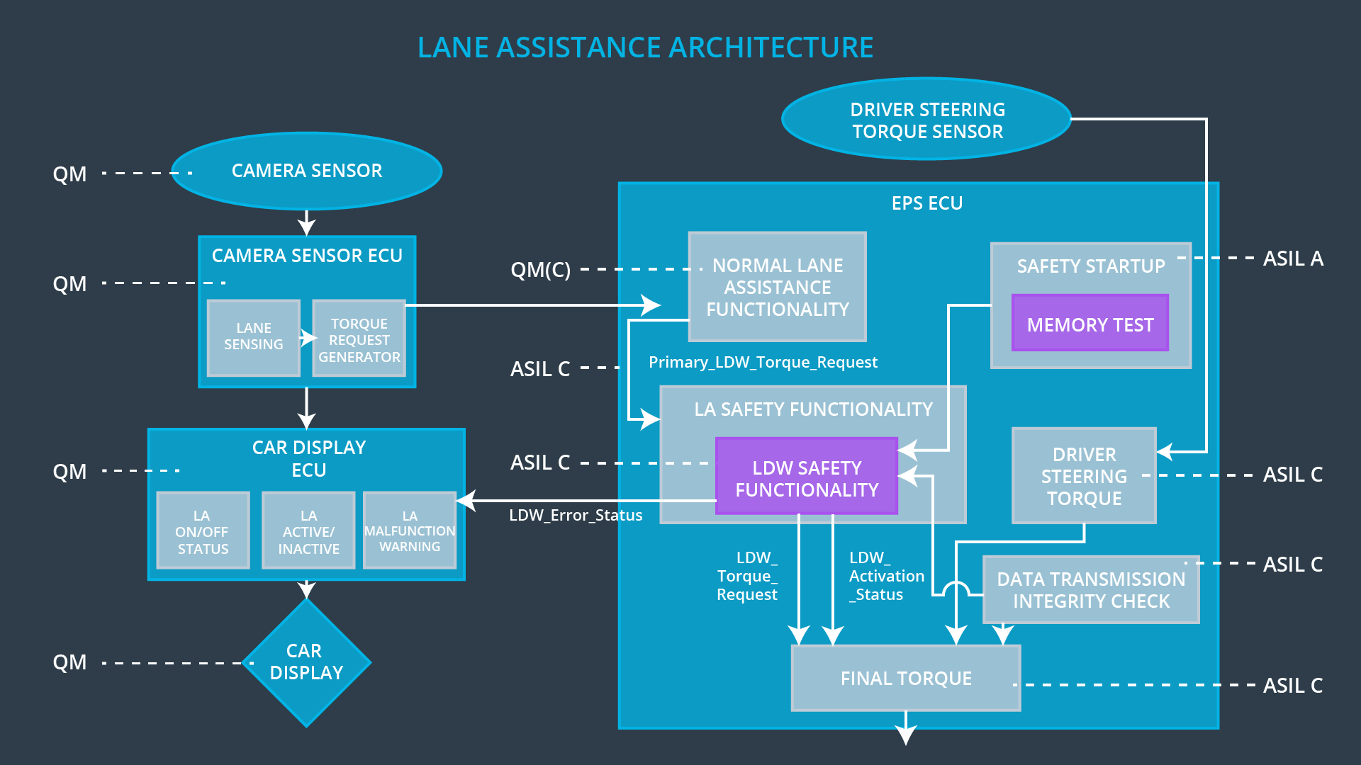

## Allocation of Technical Safety Requirements to Architecture Elements

All technical safety requirements are allocated to the Electronic Power Steering ECU

## Warning and Degradation Concept

|  |  |  |  |  |
| --- | --- | --- | --- | --- |
| **ID** | **Degradation Mode** | **Trigger for Degradation Mode** | **Safe State invoked?** | **Driver Warning** |
| WDC-01 | System off | Malfunction 01, 02 | Yes | Warning on Car Display |
| WDC-02 | System off | Malfunction 03 | Yes | Warning on Car Display |