|  |  |
| --- | --- |
|  |  |



**United Overseas Bank Limited**

NETS QR

Functional Specifications

Version DRAFT 0.1

Date: 05/06/2017 12:52

Document Control

**Document Author(s):** Archit Sharma

**Document Approver(s):**

|  |  |  |
| --- | --- | --- |
| Approver Name | Role | Approved Date |
|  |  |  |
|  |  |  |
|  |  |  |

**Document Reviewer(s):**

|  |  |  |
| --- | --- | --- |
| Reviewer Name | Role | Reviewed Date |
|  |  |  |

**NOTE:** All Approvers and Reviewers are considered required unless explicitly listed as optional.

**Version History:**

The Document Author is authorised to make the following types of changes to the document without requiring that the document be re-approved:

* Editorial, formatting, and spelling
* Clarifications

To request a change to this document, contact the Document Author or Owner. Changes to this document are summarized in the following table in reverse chronological order.

|  |  |  |  |
| --- | --- | --- | --- |
| Revision | Date | Updated By | Change Description |
| V 0.1 | 15/06/2017 | Archit Sharma | Initial Draft |
|  |  |  |  |
|  |  |  |  |
|  |  |  |  |
|  |  |  |  |

**Document Source:**

The latest version of this controlled document is stored in the below share point.

Table of Contents

Document Control 2

Table of Contents 3

1. Introduction 4

1.1. Document Purpose 4

1.2. Document Scope 4

1.3. Out of Scope 4

2. Functional Specifications 5

2.1. Quick Pay – Normal Flow 5

2.1.1. Description 5

2.1.2. Pre-Conditions 5

2.1.3. Screens & Navigation 5

2.1.4. Fields and Actions 8

2.1.5. Processing Rules 11

2.1.6. Assumptions and Dependencies 12

2.1.7. Exclusions 12

2.2. Alternative Flow - Recipient Not Registered 13

2.2.1. Description 13

2.2.2. Pre-Conditions 13

2.2.3. Screens 13

2.2.4. Fields and Actions 16

2.2.5. Processing Rules 17

2.2.6. Assumptions and Dependencies 17

2.2.7. Exclusions 17

3. Security & Control Requirements 23

4. Alerts 24

5. Testing Scenarios 25

6. Appendix 26

6.1. Terminology/Glossary 26

6.2. References 27

6.2.1. Special Characters 27

6.2.2. PIB FRS 28

6.2.3. CAS FRS 28

7. Sign Off 29

# Introduction

## Document Purpose

The purpose of the NETS QR Payment is to extend cashless payment options to all market segments. One such option is to enable those whose phones do not have NFC to pay by scanning a QR code on terminals with the camera.

.

## Document Scope

NETS QR Payment functionality for Mighty will include the following modules:

| **No** | **Functionality** | **Description** |
| --- | --- | --- |
|  | Bill Payment for First Time Users  ( Ideal Flow) | Users have to first set up fingerprint ID before being allowed to make payment |
|  | Bill Payments for Returning Users | Users have already Set Up fingerprint ID and can directly go to making payments |

## Out of Scope

The following modules have been covered in the CAS FRS and are note covered in this document:

1. Funds transfer to Added Payee
2. CAS Registration
3. Manage CAS

# Functional Specifications

## First Time Users

### Description

This functionality allows the user to register for a fingerprint lD and accept terms and conditions before allowing them to make a payment using NETS QR code

### Pre-Conditions

1. User must have latest Mighty 6.0 App on smart phone.

### Screens & Navigation

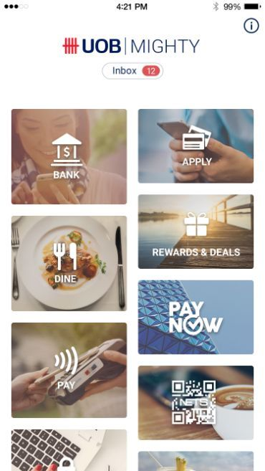 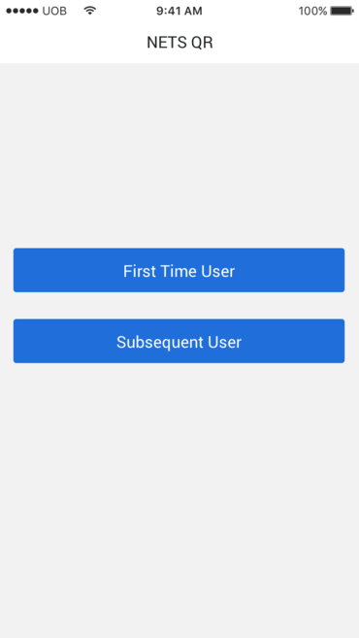

**NETS QR- First Time User**

**Mighty 6.0 Home Screen**

**1 FA Signing**

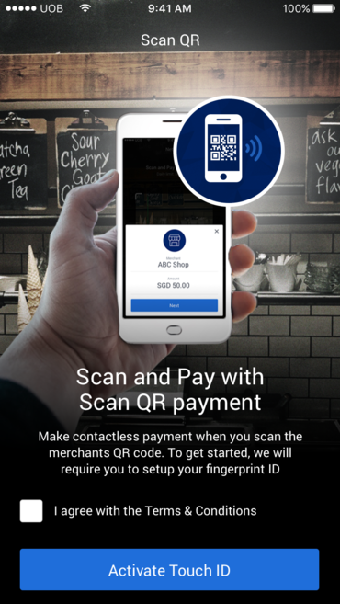 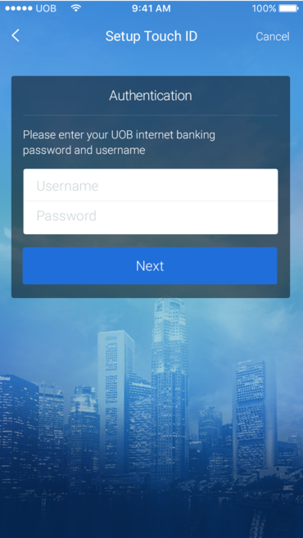

**1FA Login**

**Set Up NETS QR Payment**

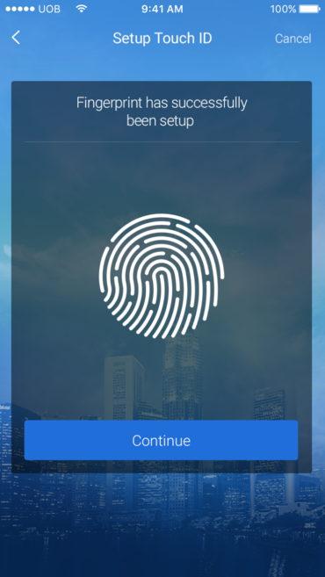 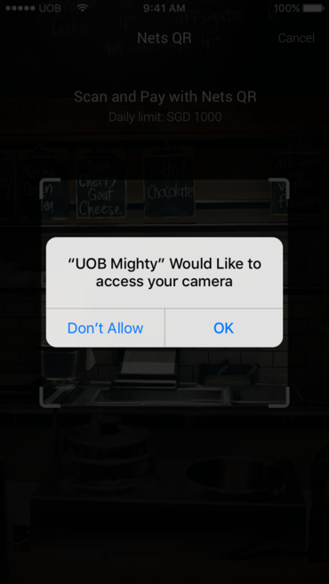

**Camera Access Permission**

**Fingerprint Set Up**

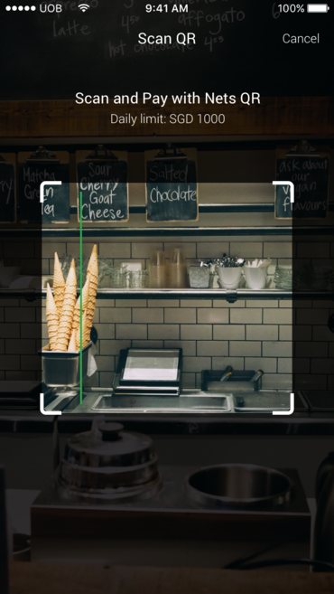 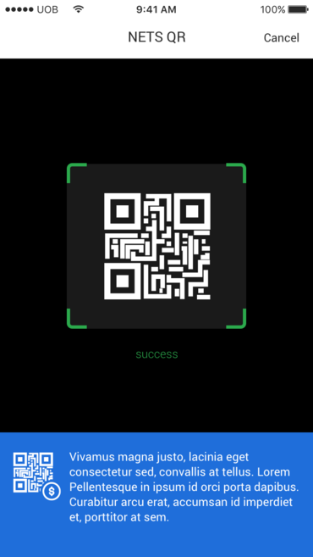

**Scan and Pay**

**Scan and Pay**

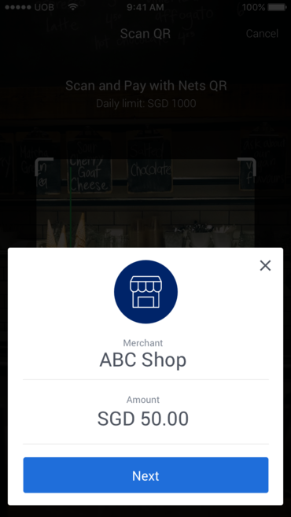 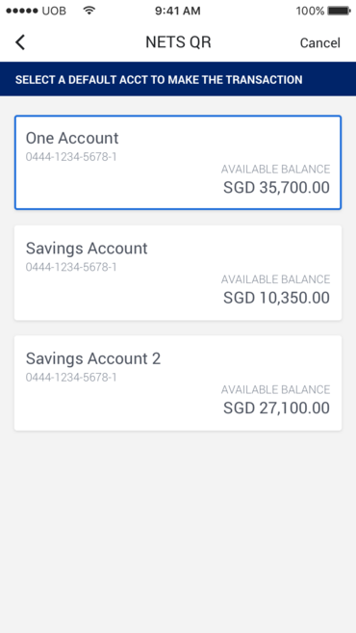

**From**

**Scanning Success**

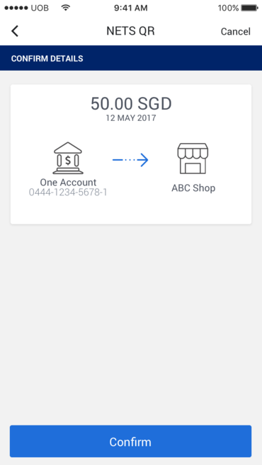 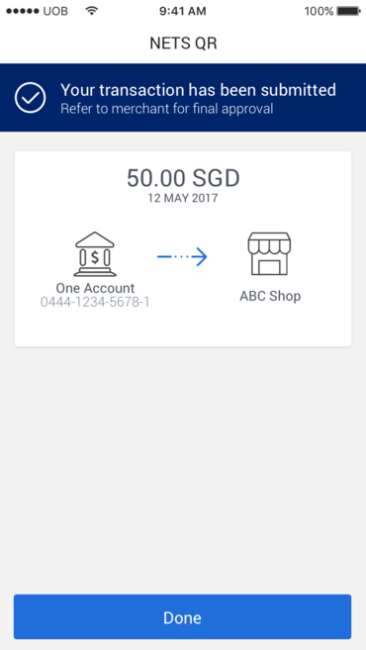

**Acknowledgement**

**Confirmation**

### Fields and Actions

#### Fields

| **S/N** | **Field** | **I/O** | **M** | **Type & Size, Label, Maintainable** | **Description** | **Validation Rules/Remarks** | |
| --- | --- | --- | --- | --- | --- | --- | --- |
| **Set Up NETS QR Payment** | | | | | | | |
|  | Terms and Conditions | I | M | Checkbox | User must accept Terms and Conditions before being allowed to proceed | |  |
| **Sign in** | | | | | | | |
|  | Username | I | M | Textbox(16) | Username to sign in into Mighty | | No validation |
|  | Password | I | M | Textbox | Enter Password | | All existing password validations shall be followed. |
| **Scanning Success** | | | | | | | |
|  | Merchant | O | M | Display Field |  | | As retrieved from QR code |
|  | Amount | O | M | Display Field |  | | As retrieved from QR code |
| **From** | | | | | | | |
|  | From Account | I | O | Account Cards | List of all the eligible accounts |  | |
| **Confirm Details** | | | | | | | |
|  | Amount | O |  | Display Field |  | As retrieved from QR code | |
|  | From Account | O |  | Display Field |  |  | |
|  | Merchant | O |  | Display Field |  | As retrieved from QR code | |
|  | Date | O |  | Display Field |  |  | |
| **Acknowledge** | | | | | | | |
|  | Amount | O |  | Display Field |  | As retrieved from QR code | |
|  | From Account | O |  | Display Field |  |  | |
|  | Merchant | O |  | Display Field |  | As retrieved from QR code | |
|  | Date | O |  | Display Field |  |  | |

#### Actions

| **S/N** | **Action Name** | **Type** | **User Action** | **System Response** | **Validation Rules/Remarks** |
| --- | --- | --- | --- | --- | --- |
| **Mighty 6.0 Landing Screen** | | | | | |
|  | NETS QR Payment Tile | Linked Icon | Touch | Open First Time /Subsequent User Screen |  |
| **First Time /Subsequent User** | | | | | |
|  | First Time User | Button | Click | System navigates to set up NETS QR payment screen |  |
|  | Subsequent User | Button | Click | Please refer to Section 2.2 for more details |  |
| **Set Up NETS QR Payment** | | | | | |
|  | Activate Touch ID | Button | Click | System navigates to 1FA Login Screen | Button is disabled until terms and conditions are accepted. |
| **1FA** | | | | | |
|  | Sign In | Button | Click/Touch | 1. System validates credentials | User validation |
| **Fingerprint Set Up** | | | | | |
|  | Fingerprint |  | Touch | System records users fingerprints and sets up Fingerprint ID following existing process as per XXXX |  |
| **Camera Permission** | | | | | |
|  | Ok | Button | Click | Systems navigates to San and Pay Screen |  |
|  | Don’t Allow | Button | Click | Systems ends the flow as user cannot proceed without granting camera permission to the app |  |
| **Scanning Success** | | | | | |
|  | Next | Button | Click | System navigates to From account screens |  |
| **Confirm Details** | | | | | |
|  | Done | Button | Click | System navigates to acknowledgement screen |  |
| **Acknowledgement** | | | | | |
|  | Done | Button | Click | System Navigates to Mighty 6.0 landing screen |  |

### Processing Rules

1. Validate all pre-conditions are met before allowing customer to perform the transaction

.

### Assumptions and Dependencies

### Exclusions

## Subsequent Users

### Description

This functionality allows the user already registered to make a payment using NETS QR code.

### Pre-Conditions

1. User must have latest Mighty 6.0 App on smart phone.

### Screens & Navigation

 

**NETS QR- Subsequent User**

**Mighty 6.0 Home Screen**



**Scan & Pay**

 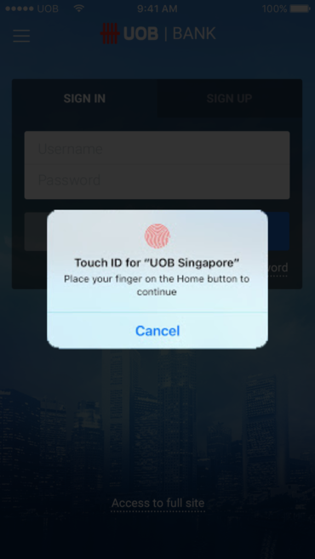

**1FA Login-Touch ID**

**Scanning Success**

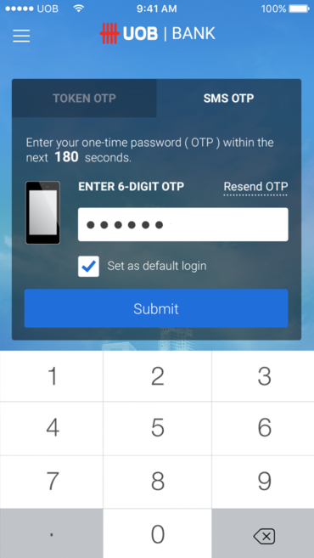

**2FA Login**

**1FA Login**

**From**

**Scanning Success**

** **

**Acknowledgement**

**Confirmation**

### Fields and Actions

#### Fields

| **S/N** | **Field** | **I/O** | **M** | **Type & Size, Label, Maintainable** | **Description** | **Validation Rules/Remarks** | |
| --- | --- | --- | --- | --- | --- | --- | --- |
| **Scanning Success** | | | | | | | |
|  | Merchant | O | M | Display Field |  | | As retrieved from QR code |
|  | Amount | O | M | Display Field |  | | As retrieved from QR code |
| **OTP** | | | | | | | |
|  | OTP | I | O | Num(6) |  | As per existing OTP rules | |
| **Confirm Details** | | | | | | | |
|  | Amount | O |  | Display Field |  | As retrieved from QR code | |
|  | From Account | O |  | Display Field |  |  | |
|  | Merchant | O |  | Display Field |  | As retrieved from QR code | |
|  | Date | O |  | Display Field |  |  | |
| **Acknowledge** | | | | | | | |
|  | Amount | O |  | Display Field |  | As retrieved from QR code | |
|  | From Account | O |  | Display Field |  |  | |
|  | Merchant | O |  | Display Field |  | As retrieved from QR code | |
|  | Date | O |  | Display Field |  |  | |

#### Actions

| **S/N** | **Action Name** | **Type** | **User Action** | **System Response** | **Validation Rules/Remarks** |
| --- | --- | --- | --- | --- | --- |
| **Mighty 6.0 Landing Screen** | | | | | |
|  | NETS QR Payment Tile | Linked Icon | Touch | Open First Time /Subsequent User Screen |  |
| **First Time /Subsequent User** | | | | | |
|  | First Time User | Button | Click | Please refer to Section 2.1 for more details |  |
|  | Subsequent User | Button | Click | System navigates to the Scan and Pay screen |  |
| **Scanning Success** | | | | | |
|  | Next | Button | Click | System navigates to From account screens |  |
| **1FA** | | | | | |
|  | Sign In |  | Click/Touch | System validates credentials using Touch ID | User validation |
| **2FA** | | | | | |
|  | Submit | Button | Click | System performs 2FA validation using Mighty Secure / Token/SMS OTP |  |
| **Confirm Details** | | | | | |
|  | Done | Button | Click | System navigates to acknowledgement screen |  |
| **Acknowledgement** | | | | | |
|  | Done | Button | Click | System Navigates to Mighty 6.0 landing screen |  |

### Processing Rules

1. Validate all pre-conditions are met before allowing customer to perform the transaction

.

### Assumptions and Dependencies

### Exclusions

# Security & Control Requirements

# Alerts

Alert messages are configured in PIB. Mighty will only invoke alert message based on flow.

| **Function** | **Alert Scenario** | **Alert Type** | **SMS Message** | **Email Message** |
| --- | --- | --- | --- | --- |

# Testing Scenarios

The following scenarios are essential and must be tested.

|  |  |  |  |
| --- | --- | --- | --- |
| S/N | Functional Area | Scenario Description | Remarks |
| 1. 7. | Funds Transfer | Sender (Registered with CAS and Mighty Secure) performs One Time Funds transfer to Mobile Number (Recipient also registered with CAS) | Normal Flow |
| 1. 8. | Funds Transfer | Sender (Not Registered with CAS) performs One Time Funds transfer to Mobile Number (Recipient registered with CAS) | Alternate Flow |
| 1. 9. | Funds Transfer | Sender (Registered with CAS) performs One Time Funds transfer to Mobile Number (Recipient not registered with CAS) | Alternate Flow |
|  | Funds Transfer | Sender (Without Mighty Secure) performs One Time Funds transfer to Mobile Number (Recipient registered with CAS) | Alternate Flow |
|  |  |  |  |
|  |  |  |  |

# Appendix

## Terminology/Glossary

|  |  |
| --- | --- |
| Term/Acronym | **Description** |
| Proxy | Refers to Mobile Number/FIN/NRIC used for funds transfer in place of Bank Account Number |
| OTP | One time Pin |
| DR | Disaster Recovery |
| DIT | Developer Integration Test |
| SIT | System Integration Test |
| UAT | User Acceptance Test |
| PAT | Product Acceptance Test |
| BU | Business Unit |
| BTS | Business Technology Services |

## References

# Sign Off

We confirm that we have reviewed and accepted the Mighty Central Addressing Scheme Functional Specifications Version 0.0.07 dated 22-Mar-17 subject to the following qualifications/conditions (if any):

______________________________________________________________________________

**User Acceptance & Sign Off**

|  |  |  |  |
| --- | --- | --- | --- |
| Name/Designation | User Division / Department | Signature | Date |
|  |  |  |  |
|  |  |  |  |
|  |  |  |  |
|  |  |  |  |
|  |  |  |  |
|  |  |  |  |
|  |  |  |  |
|  |  |  |  |