Township Construction Scheduling & Drone Monitoring Report
Prepared for: Software Development Team (Construction Monitoring Module)

1. Introduction
This report defines the construction stages of a township project for the purpose of developing a drone-based construction scheduling and monitoring software. The proposed system is intended to utilize periodic orthomosaic drone imagery to compare planned versus actual site progress, identify construction milestones automatically, generate progress reports, and support project managers in day-to-day decision-making.
The township has been divided into five components: Residential, Commercial, Open Spaces, Amenities, and Club House. Each component follows its own construction sequence, allowing the software to track progress independently for each component as well as collectively at the overall township level. The construction timeline has been organized into six stages, detailed below.

2. Township Components
The following components have been identified for independent progress tracking:
- Residential — vertical housing construction, tracked by floor count (G+ levels).
- Commercial — retail/commercial block construction, tracked by initiation and completion.
- Open Spaces — landscaping, gardens, and common outdoor areas.
- Amenities — shared facility infrastructure within the township.
- Club House — recreational/community building construction.

3. Stage-wise Construction Breakdown

Stage 1: Site Preparation
Primary Components: Residential
This stage covers barren land development, site preparation, layout marking, and finalization of the floor plan. No vertical construction has begun; the focus is on preparing the site for foundation work.
Drone Monitoring Objective: Identify physical land-clearing and layout changes from orthomosaic imagery, confirm site preparation completion percentage, and flag any delay against the planned start date.

Stage 2: Foundation & Structural Base
Primary Components: Residential
This stage covers foundation laying, column erection, slab casting, and parking area construction for the residential blocks. This forms the structural base on which vertical floor construction will proceed.
Drone Monitoring Objective: Detect foundation and column progress from imagery, estimate percentage completion of the structural base, and compare against the planned schedule.

Stage 3: Residential Rise & Commercial Start
Primary Components: Residential & Commercial
Residential construction reaches G+3 floors, while commercial construction is initiated in parallel. This marks the point where two components are being tracked simultaneously.
Drone Monitoring Objective: Track residential floor-count progression to G+3 and detect the onset of commercial construction activity from imagery; flag any lag in either component.

Stage 4: Residential Rise & Commercial Completion
Primary Components: Residential & Commercial
Residential construction reaches G+6 floors, and commercial construction is completed at this stage.
Drone Monitoring Objective: Confirm G+6 floor completion for residential and verify commercial completion through imagery-based structural comparison against the completed-stage reference.

Stage 5: Residential Rise & Amenity Initiation
Primary Components: Residential, Open Spaces, Amenities & Club House
Residential construction reaches G+10 floors. In parallel, construction of Open Spaces, Amenities, and the Club House is initiated.
Drone Monitoring Objective: Track residential floor progression to G+10 and detect initiation activity across Open Spaces, Amenities, and Club House zones from orthomosaic imagery.

Stage 6: Residential Completion & Amenity Completion
Primary Components: Residential, Open Spaces, Amenities & Club House
Residential construction reaches its final height of G+15 floors. Open Spaces, Amenities, and Club House construction are completed at this stage, marking substantial completion of the township.
Drone Monitoring Objective: Confirm final residential floor count (G+15) and verify completion of Open Spaces, Amenities, and Club House through final imagery comparison; generate the overall township completion report.

4. Professional Stage Matrix
The table below summarizes all six stages across township components, for direct reference by the development team when structuring the software's stage-tracking logic and database schema.
Stage | Residential | Commercial | Open Spaces / Amenities / Club House | Key Milestone
Stage 1 | Barren land, site preparation, floor plan finalization | — | — | Site mobilization
Stage 2 | Foundation, columns, slabs, parking construction | — | — | Structural base complete
Stage 3 | G+3 floor completion | Initiation of construction | — | Commercial works begin
Stage 4 | G+6 floor completion | Completion of construction | — | Commercial works complete
Stage 5 | G+10 floor completion | — | Initiation of construction | Amenity works begin
Stage 6 | G+15 floor completion | — | Completion of construction | Township substantially complete

5. Scheduling Bar Chart (Gantt View)
The chart below presents an indicative scheduling bar chart (Gantt view) mapping each township component against the six construction stages on a common timeline. Durations shown are illustrative placeholders (three months per stage, 18 months total) — actual dates should be substituted from the approved project schedule once available. This is the structure the software's schedule/timeline module should replicate, with each bar editable per component.
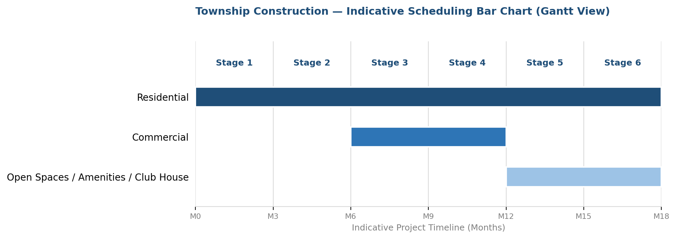

6. Work Progress Indicators
Two complementary visualizations are proposed for tracking work progress within the software: a component-wise progress curve showing cumulative completion percentage across stages, and a dashboard-style progress indicator giving a snapshot view at any given survey date. Both are illustrative — actual percentages will be computed by the software from orthomosaic image analysis at each survey.
6.1 Component-wise Progress Curve

6.2 Dashboard Progress Indicators
The example below illustrates how progress indicators could appear on the software dashboard for a survey captured during Stage 3, with Residential at 45% and Commercial at 40% completion, while Open Spaces, Amenities, and Club House have not yet started.

