- System Overview
- System Architecture Overview

- Neural Nexus is a state-of-the-art AI diagnostic platform designed to assist clinicians in the detection, classification, and reporting of brain tumors from MRI scans. The system follows a decoupled architecture with a high-performance Python backend and a cinematic, interactive React frontend.
- 1. AI Diagnostic Core (Backend)Engine: Built with FastAPI, the backend orchestrates the diagnostic pipeline.
- Model Architecture: Uses a custom-trained EfficientNet-V2-S / ResNet-50 CNN, optimized for high-accuracy classification across four primary classes: Glioma, Meningioma, Pituitary, and No Tumor.
- Interpretability (Grad-CAM): Implements Gradient-weighted Class Activation Mapping to generate visual heatmaps, highlighting the specific regions in the MRI scan that drove the AI's classification decision.
- Clinical Narrative (BioMistral): Integrates the BioMistral LLM to transform raw diagnostic telemetry and risk metrics into human-readable clinical narratives and risk assessments.
- Reporting: Automatically generates dynamic, clinician-ready PDF reports using fpdf2.
- 2. Clinical HUD & Visualization (Frontend)Framework: Developed using React and Vite, prioritizing a high-density, "Mission Control" aesthetic.
- Cross-Modality Viewer: Supports multiple diagnostic views:RAW: The original MRI input.ENHANCED: CLAHE-processed image for better contrast.
- GRAD-CAM: Heatmap overlay at varying intensities.
- SPLIT-VIEW: Interactive wipe separator for side-by-side comparison
- Spatial Copilot (3D Brain): An interactive 3D model powered by React Three Fiber (Three.js). It maps the 2D tumor location from the scan into a 3D coordinate system, providing anatomical context for the detection.
- Dynamic Telemetry: Real-time HUD displaying confidence scores, classification results, and clinical risk assessments.
- Deployment & Scalability
Frontend:https://neural-nexus-git-feature-un-e2e0e7-purvansh-s-projects-3c13a221.vercel.app/
Backed :https://huggingface.co/spaces/purvansh01/neural-nexus-backend
- Infrastructure: The backend is designed for containerized deployment (e.g., Hugging Face Spaces via Docker), while the frontend is optimized for edge deployment (e.g., Vercel).

- Dashboard :
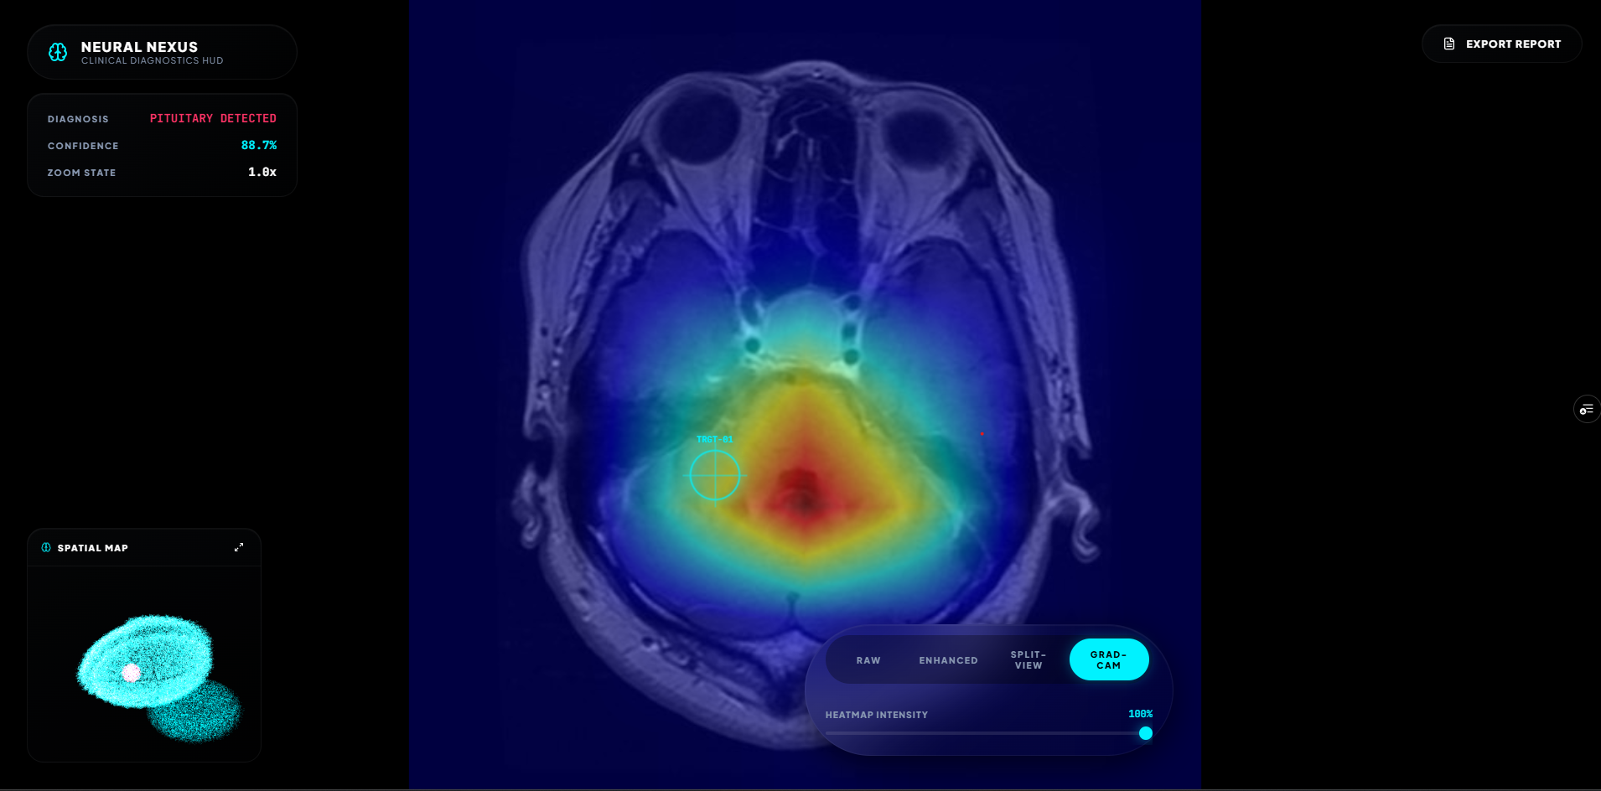

- System Generated Tumor Report
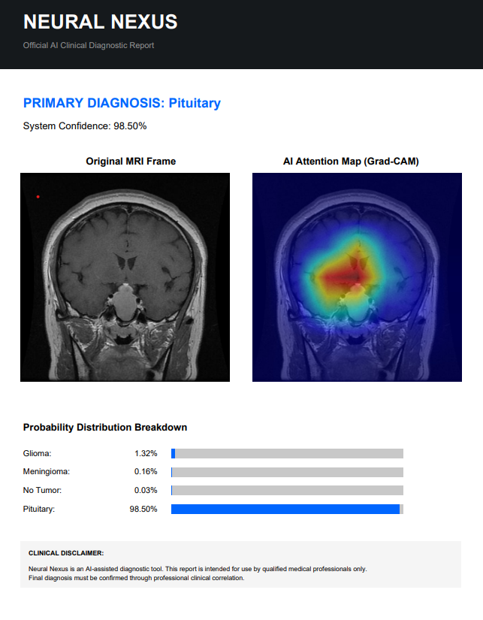

- ML-Model :
ResNet50 (Residual Network with 50 layers) is a landmark Convolutional Neural Network (CNN) architecture that popularized the concept of "Skip Connections."

1. The Problem: Degradation of Accuracy
In traditional "plain" networks, as you add more layers, accuracy reaches a peak and then starts degrading rapidly. This isn't just overfitting; it's a mathematical problem where the "gradient" (signal for learning) disappears as it travels back through 50+ layers—known as the Vanishing Gradient Problem.

2. The Core Solution: Residual Blocks (Skip Connections)
ResNet50 introduces Identity Shortcut Connections.

Instead of forcing the network to learn the entire transformation (the whole MRI feature), each block only learns the "Residual" (the difference/error).
. The input is added back to the output of the convolutional layers $F(x)$.
Significance: This allows the model to be much deeper while remaining easy to train. If a layer is useless, the network can simply "skip" it by setting to zero.
3. The Bottleneck Architecture (Efficiency)
To keep the model computationally light, ResNet50 uses Bottleneck Blocks. Each block has three layers:

1x1 Conv: Reduces the number of input filters (the "bottleneck").
3x3 Conv: Performs the actual spatial feature extraction.
1x1 Conv: Expands the number of filters back to the original size.
Evaluation Point: This allows the model to have 25.6 Million parameters—a huge capacity for learning, but efficient enough to run on standard GPUs.
4. Stage-by-Stage Breakdown
Stage Description Purpose
Stage 0 7x7 Conv + MaxPool Quickly reduces image size to extract basic shapes (skull borders).
Stage 1 - 4 50 Convolutional Layers 4 stages of residual blocks that extract increasingly complex "semantic" features (tumor density, texture, and location).
Global Average Pooling Averages features (7x7 -> 1x1) Converts spatial 2D data into a 2048-dimensional feature vector.
FC Head Fully Connected Layer Maps those 2048 features to our 4 tumor classes.
5. Technical Rationale for your Project
Feature Reusability: Because of skip connections, earlier low-level features (basic shapes) are preserved and available for later layers (complex tumor diagnosis).
Stability: It provides a stable "Loss Surface," which is why our model reached 91% accuracy without "exploding" or "vanishing" during training.
Global Average Pooling: We used GAP instead of standard Flattening because it reduces the number of parameters and makes the model less prone to overfitting on specific image positions.
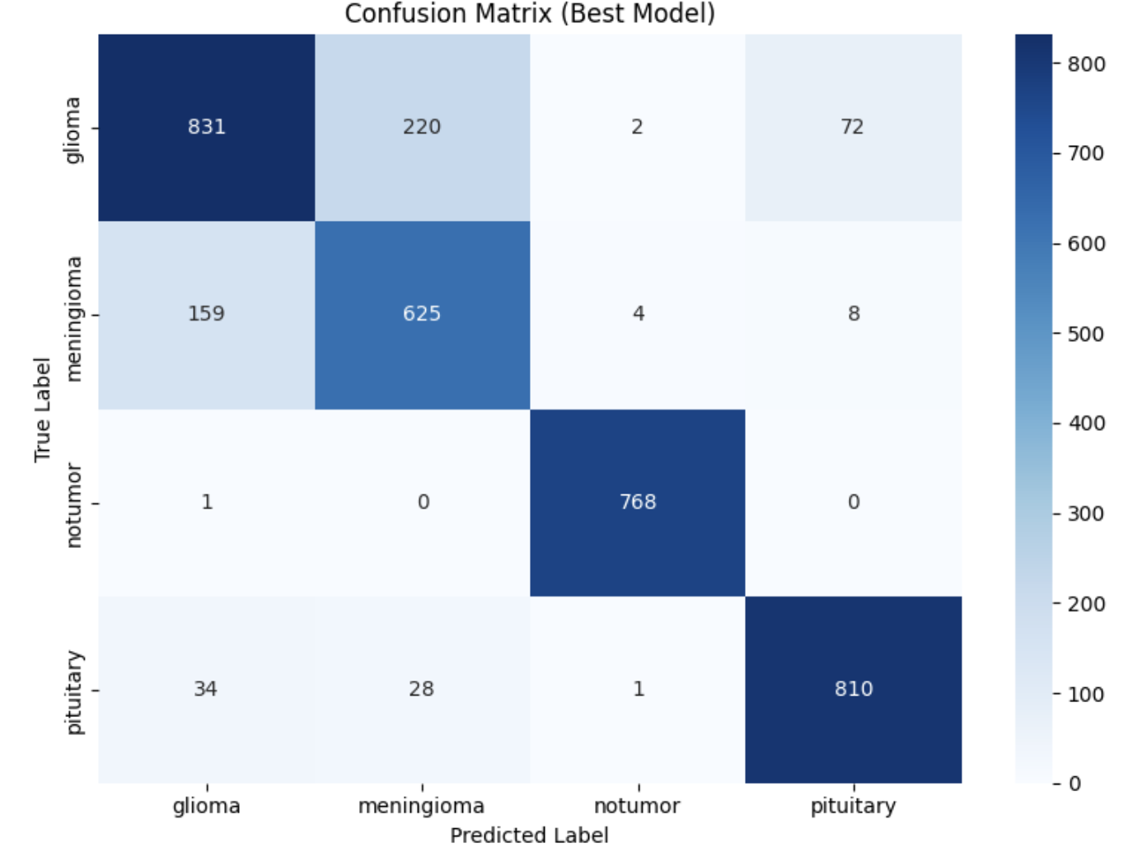
- Grad-Cam View
