***Washington Mutual, San Francisco, CA Jan 06 – Jul 07***

***Business Analyst***

## *Project Description: FOREX- Foreign Exchange Trading System Application*

This project was in the Cash Management division. The project Foreign Exchange Trading System Application was the enhancement of the trading system that Washington Mutual Bank used for foreign currency exchange for UK, Canada, and AUS etc.

***Responsibilities:***

* Elicited and **gathered business requirements through brainstorming and prototyping**.
* Conducted feasibility study and **performed GAP and Impact analysis for the proposed state**.
* Conducted **JAD sessions** to allow different stakeholders to communicate their perspective with each other, resolve any issues and come to an agreement quickly.
* Created **use case scenarios** and **documented workflow and business processes**.
* Prepared **Business Requirement Document (BRD) and Functional Specification Document (FSD).**
* Facilitating use case requirements sessions to elaborate requirements and business processes into technical **UML** specifications.
* Implemented the project around **AGILE** methodology.
* Assisted the Project Manager with creating detailed project plans and also in developing, scheduling and tracking project timelines.
* Created mock up screens using **Dreamweaver** for the UI designer.
* Collaborated with the QA team to **ensure adequate testing on software, maintained quality procedures, and ensured that appropriate documentation was in place**.
* **Conducted peer review meetings periodically** to keep track of the project’s milestones.

***Environment:*** UML,MS Visio, Rational Rose, Quality Center 9.0, Java, J2EE.

**Who were your customers?**

I worked on an application called WMForex (Forex Trading System) which was used by WAMU customers. These customers could be retail customers or could be wholesale customers.

**Tell me about this application?**

Washington Mutual Foreign Exchange was an Internet-based foreign exchange trading and transaction reporting application which allowed users to initiate, approve and report on all foreign exchange and foreign currency account (FCA) transactions from a single source.

This application used to give real time updates on Foreign Currency Exchange rates. Customers can maintain standard wire instructions. E.g., a customer Joe Blow may have standard wire payment instructions that whenever he sells FOREX, don’t credit his WAMU account but send the proceeds to a Swiss account. Site of-course was an HTTPS site with 128 bit encryption.

Clients could easily:

* Settle transactions automatically to the user’s WAMU account (or a non Wamu account).
* Obtain real-time exchange rates and execute Spot and Forward contracts.
* Maintain foreign currency accounts with WAMU Bank and access the account using WMForex with the ability to withdraw money from the account to send foreign payments.

Alok’s attempt at understanding this application: Macys is a wholesale customer of WaMu. Macys has 20M dollars in their DDA account. Macys is worried about sliding dollar value. Macys investment advisors tell Macys Finance department “You should convert half of your liquid money into EUROS”. Macys Finance Manager will login to WMForex and initiate a spot conversion of 10M dollars into Euros. Before doing this, the WMForex application will tell the Finance Manager, “You will get 7,300,000 Euros if you go through this transaction”. And, in addition, “we will also charge you a 0.1% conversion fee ($10,000) for this”. Macys Finance Manager will go ahead. Conversion of funds happen. Now, Macy’s online Forex account statement shows the latest holdings of Macys.

10M USD

7.3M Euros

Another use of this application: Macys is buying clothes from clothes merchants in India. Macys has to pay (send a wire transfer of 10 lakh rupees to India) the merchant. Again, Macys Finance Manager has the capability of sending money to any country in the world (except Iran, Cuba and North Korea: Because they are “embargoed” countries) using this application (WMForex).

**What was WaMu doing before this application was developed? How was WaMu helping its customers with their Forex needs?**

This process was manual. A banker dedicated to each business was doing these services for wholesale customers. There was already a Forex application that was in the bank. But, this application was “inside facing” by which I mean only bank employees could use this. This project involved “opening up” this Forex application to empower our wholesale customers conduct their own Forex Transactions.

**Where was the Forex information (exchange information) coming from?**

Bloomberg: Wamu must have a currency converter page like this:

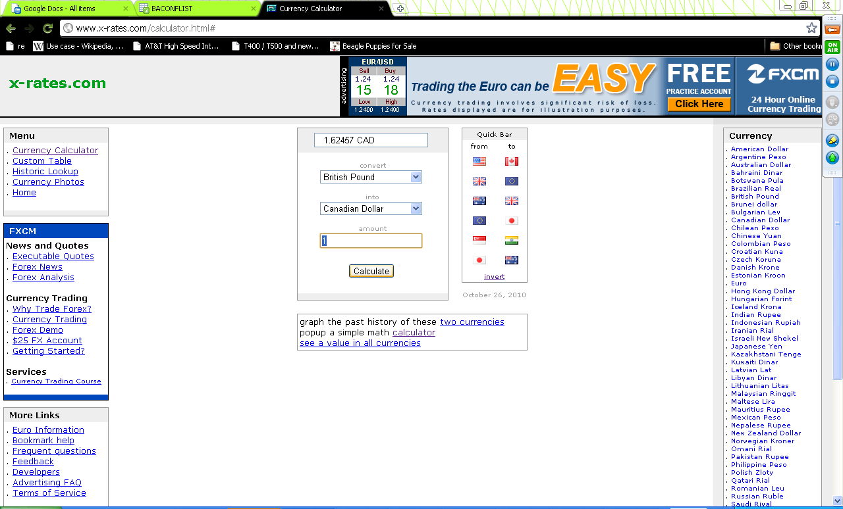

Where was currency exchange rate information coming from? Bloomberg Financial Network. How was this information coming to Wamu from Bloomberg? This data transfer used to happen with XML over HTTPS (So, we were using Web services). Why would Bloomberg give this information to Wamu? In exchange of fees? How much do you think, if you have to take a guess, WaMu pays Bloomberg for each currency exchange rate request. 0.5 cents.

**How did you make sure security of the application?**

* Using https (Hackers can still sniff the internet packets and intercept the passwords but cannot decipher the password (because it is encrypted);
* The clients that we have (companies) could give different levels of access to its employees. So, the CEO/CFO/COO level people had no trading limitations but say the HR Manager had restricted accounts which needed approval from C level executives beyond a certain amount. I was responsible for setting up this roles and limitations matrix! As such, our application was a RBAC application. (Role Based Access Control Application).
* Session management. Log out a user session after 15 minutes of inactivity.
* Introducing the concept of SiteKey (so as to prevent Phishing)

(These security enhancements above do not take care of the fraud that could happen if a customer’s password gets compromised (e.g. a thief gets to know a customer’s password).

The enhancement below can deal with compromised password too.

* Having a SecurId token mechanism so that in addition to username and password, one more constantly changing passcode is also required.

## What is the foreign exchange market?

Market in which foreign currencies are bought and sold and exchange rates between currencies are determined. (Source: SmartMoney)

In [finance](http://en.wikipedia.org/wiki/Finance), the **exchange rates** (also known as the **foreign-exchange rate**, **forex rate** or **FX rate**) between two [currencies](http://en.wikipedia.org/wiki/Currency) specify how much one currency is worth in terms of the other. It is the value of a foreign nation’s currency in terms of the home nation’s currency.[[1]](http://en.wikipedia.org/wiki/Exchange_rate#cite_note-0) For example an exchange rate of 91 [Japanese yen](http://en.wikipedia.org/wiki/Japanese_yen) (JPY, ¥) to the [United States dollar](http://en.wikipedia.org/wiki/United_States_dollar) (USD, $) means that JPY 91 is worth the same as USD 1. The [foreign exchange market](http://en.wikipedia.org/wiki/Foreign_exchange_market) is one of the largest markets in the world. By some estimates, about 3.2 trillion USD worth of currency changes hands every day.

**Exchange rate**

The **spot exchange rate** refers to the current exchange rate. The **forward exchange rate** refers to an exchange rate that is quoted and traded today but for delivery and payment on a specific future date.

**FOREX- Foreign Exchange Trading System Application**

This project was in the Cash Management division. The project Foreign Exchange Trading System Application was the enhancement of the trading system that Washington Mutual Bank used for foreign currency exchange for UK, Canada, and AUS etc.

**About WM Forex**

Allows clients to easily and securely obtain real-time exchange rates and execute Spot, Forward, and Windows (Time Option) contracts, and settle transaction automatically to user's WAMU account over the Internet. Clients also have the ability to access their foreign currency accounts held with WAMU Bank, which includes the ability to withdraw money from the account to send foreign payments.

WAMU Bank Foreign Exchange (WMForex) is a secure, Internet-based foreign exchange trading and transactions reporting system which allows users to initiate, approve, and report on all foreign exchange and foreign currency account (FCA) transactions from a single source.

**Features and Benefits**

**Real-time Pricing**

* WMForex provides real-time foreign exchange rates for spot, forward, time options including cross-currency trades.
* All transactions can be initiated right from your desk, eliminating the need to phone the bank for wire payments.

**Standard Instructions**

* WMForex allows users to maintain a database of standard payment instructions.
* Multiple users in instructions per currency can be maintained and are accessible via a simple drop-down box.

**Administration and Security**

* WMForex allows companies to specify the access level of each user. Companies can have discretion regarding users' trading limitations.
* Multiple users in several locations can have different authority levels related to initiating, settling, and authorizing FX and FCA transactions.
* WMForex utilizes state-of-the art security features, including 128-bit encryption.

**Reporting**

* Current and historical reporting functionality provide a complete snapshot of your company's foreign activity with WAMU Bank - for payments executed online or verbally with our foreign exchange trading desk.
* Print instant PDF confirmations of your international payments.

**How did you make sure security of the application?**

* https; the clients that we have (companies) could give different levels of access to its employees. So, the CEO/CFO/COO level people had no trading limitations but say the HR Manager had restricted accounts which needed approval from C level executives beyond a certain amount. I was responsible for setting up this roles and limitations matrix!

**How did you make sure security of the application?**

https; the clients that we have (companies) could give different levels of access to its employees. So, the CEO/CFO/COO level people had no trading limitations but say the HR Manager had restricted accounts which needed approval from C level executives beyond a certain amount. I was responsible for setting up this roles and limitations matrix!

**Tell me about your Washington Mutual LOCKBOX project?**

When I was working with WAMU, since I was a part of the wholesale division, I was exposed to a lot of projects that I helped out in.

One of the projects that I was involved with was moving from manual lockbox to a digital lockbox (In a manual lockbox service, WAMU used to send information about the checks received at WAMU on behalf of the wholesale customer in form of a hard copies of checks that were couriered over). In this project, we converted this manual process to an electronic process where company sees images in 2 hours of WAMU receiving it. I was involved in a project where the accounting department of the wholesale customer would receive electronic notification of activity on their account and that causes the wholesale customer to login to our lockbox reporting site to download the latest lockbox activity on their account. Staff doing processing reduced from 4 ppl (8 hrs/day) to 2 ppl (4hrs/day). One major benefit of this project was for the wholesale customer to see the images of the checks received on the lockbox reporting web site.

**Q: What is your experience with exchange rates?**

The foreign exchange rate between two currencies specifies how much one currency is worth in terms of the other. These rates, comes into the picture when one is trying to either buy or sell foreign currency.

There is no unified or centrally cleared market for the majority of FX trades, and there is very little cross-border regulation. Due to the over-the-counter (OTC) nature of currency markets, there are rather a number of interconnected marketplaces, where different currencies instruments are traded. This implies that there is not a single exchange rate but rather a number of different rates (prices), depending on what bank or market maker is trading, and where it is.

Due to London's dominance in the market, a particular currency's quoted price is usually the London market price. A joint venture of the Chicago Mercantile Exchange and Reuters, called Fxmarketspace opened in 2007 and aspired but failed to the role of a central market clearing mechanism.