**Informatica Architecture:**

Power Center Client Tools

* Designer
  + Source Analyzer
  + Target Designer
  + Mapping Designer
* Workflow Manager
* Workflow Monitor

Integrations Service

(Extract data from the source, apply transformation and load data to the target)

Fetches Data

Repository Service

Fetches Data

Power Center Repository

(Relational DB which stores all the metadata created in Power Center)

* Contains information to extract, transform and load data.
* Contains Permissions and privileges

Repository Manager

(This will help you to add a repository)

Administer

Power Center Administration Console

**Source definitions:** Definitions of database objects such as tables, views, synonyms, or files that provide source data.

**Target definitions:** Definitions of database objects or files that contain the target data.

**Mappings:** A set of source and target definitions along with transformations containing business logic that you build into the transformation. These are the instructions that the Integration Service uses to transform and move data.

* You create mappings to read data from relational tables, transform the data, and write the transformed data to relational tables. The Power Center Client uses ODBC drivers to connect to the relational tables

**Reusable transformations:** Transformations that you use in multiple mappings.

**Mapplets:** A set of transformations that you use in multiple mappings.

**Sessions and Workflows:** Sessions and workflows store information about how and when the Integration Service moves data. A workflow is a set of instructions that describes how and when to run tasks related to extracting, transforming, and loading data. A session is a type of task that you can put in a workflow. Each session corresponds to a single mapping.

* A session is a set of instructions that tells the Integration Service how to move data from sources to targets. A session is a task, similar to other tasks available in the Workflow Manager. You create a session for each mapping that you want the Integration Service to run. The Integration Service uses the instructions configured in the session and mapping to move data from sources to targets.
* A workflow is a set of instructions that tells the Integration Service how to execute tasks, such as sessions, email notifications, and shell commands. You create a workflow for sessions you want the Integration Service to run. You can include multiple sessions in a workflow to run sessions in parallel or sequentially. The Integration Service uses the instructions configured in the workflow to run sessions and other tasks.
* You create and maintain tasks and workflows in the Workflow Manager

**BCBSM EDW Architecture**

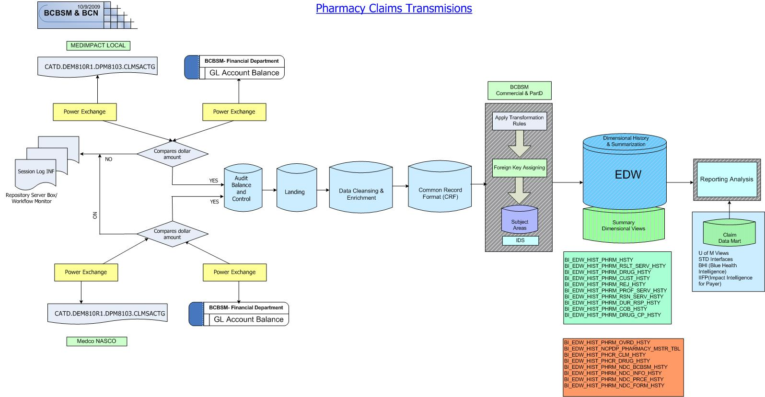

**IDS Primary Keying**

* Unique Surrogate (primary) keys are generated for each unique record in every table in IDS except small reference tables.
* The surrogate key will be based on the natural key for the table. The natural key could be one or more fields.

**IDS Foreign Keying and Stubbing**

If the foreign key lookup fails, a STUB record will be created in the master key table with the natural key on it and a surrogate key assigned.

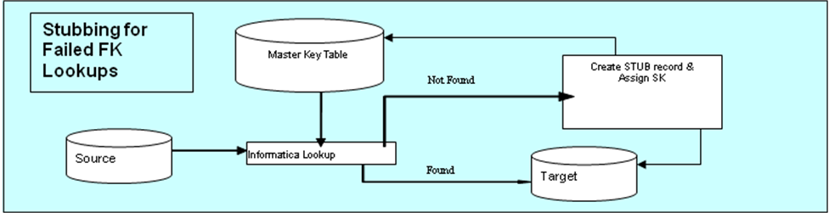

**Common Record Format (CRF) Example**

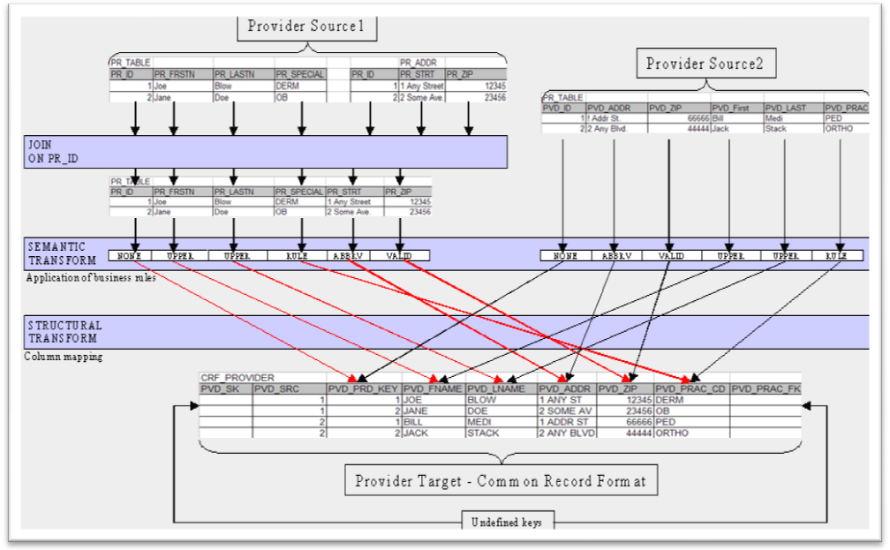

**References:**

<http://www.informatica.com/videos/demos/6920_warehousing/index.html>

<http://www.robdavispe.com/free2/software-qa-testing-test-tester-2213.html>  
<http://en.wikipedia.org/wiki/Data_integration>  
  
<http://www.learnbi.com/bi_data.htm> ------- this is amazing  
<http://it.toolbox.com/wiki/index.php/Data_Warehouse_Concepts#Staging_Area> ------- this is amazing  
  
<http://www.bipminstitute.com/data-warehouse/etl-transformation-design.php>  
  
<http://www.stylusstudio.com/tutorials/data_integration_tutorials.html>  
  
<http://articles.techrepublic.com.com/5100-10878_11-5029912.html?tag=rbxccnbtr1>  
  
<http://www.altova.com/videos.asp?type=0&video=mapforce>

Once you have studied the following reference this will be more helpful to dig to the details;

<http://trainovation.com/main/index>

<http://it.toolbox.com/wiki/index.php/What_is_lookup_transformation_in_informatica%3f>