Health Management Associates, Inc, Lancaster, PA (Healthcare Domain) Jan 2006 – Oct 2006

Project Manager/Sr. Business Analyst

Project: EMR and EPM Management System
Health Management Associates, Inc. is a premier operator of acute care hospitals primarily in the southeast and southwest areas of non-urban America. The Project was to enhance and integrate Commercial off the shelf (COTS) web based Electronic Health Record (EHR) NextGen 5.5 Software system and provide a better approach to documentation than conventional, paper based system. This software system increased access, eliminated illegible handwriting related errors, improved quality of care and security, reduced documentation expense and mitigate malpractice liabilities. The main features in this software include Powerful Search, Virtual Sticky Notes, Encounter based documentation and Template texts. Specialty modules include Cardiology, Gastroenterology, General Medicine, Pain Management, OB-GYN and Pediatrics.

Environment: Oracle, J2EE, MS Visio, Microsoft Project, Excel, Word, HP Quality Center, Business Object 6.5
Responsibilities:
- Proactively communicate and conducted interviews with Physicians, Office Manager and Billers and gathered, analyzed and documented their information needs and functional requirements and deliver the following artifacts as needed: SRS (Software Requirements Specifications), BRD (Business Requirements Document), Use Cases, User Stories.
- Responsible for interacting with client for requirements gathering, analyzing requirements, and creating detailed specifications.
- Analyzed plan requirements and then contributed further defining the plan requirements with their Project Manager. Observed the compliance of the requirements with federal and state government regulations Medicaid, Medicare, and accreditation body requirements.
- Captured KPI metrics data at every stage in the work flow engine which later utilized to perform extensive ETL (extract, load and transform) actions and prepare reports using Business Objects 6.5.
- Maintained and enhanced NextGen Electronic Medical Records (EMR), Electronic Practice Management (EPM), and Imaging Control System (ICS) software.
- Gathered knowledge on HL7, HIPAA rules and regulations.
- Successfully refined and implemented new and inherited projects for specialties or practices where the NextGen KBM could not meet the client's needs or workflow.
- Implemented Surescripts, Patient Education, Medical Necessity, and other Medicare incentives.
- Successfully refined and implemented new and inherited projects for specialties or practices where the NextGen KBM could not meet the client's needs or workflow.
- Involved in ETL processes to load data from Flat files, MS Access and MS Excel spreadsheet into the target Oracle database by applying business logic on transformation mapping for inserting and updating records when loaded.
- Designed, test, and customized EMR templates, documents and crystal reports.
- Created documents using Documents Builder for templates.
- Installed and setup Interlink Electronics e-pad for electronic signature on documents.
- Edit/Add new information using File Maintenance.
- Recommended changes for system design, methods, procedures, policies and workflows affecting Medicare/Medicaid claims processing in compliance with government compliant processes like HIPAA / EDI formats and accredited standards like ANSI.
- Developed and executed SQL queries on claim records to validate reporting data.
- Created and executed SQL Queries.
- Designed and documented Test Cases according to the application requirements using Quality Center.
- Coordinated and attended meetings to review these specifications with the Quality Assurance Manager, Business Systems Analysts, RUP Engineers, Project Manager & others on the team.
- Worked closely with the development team to communicate client requirements
- Reviewed Test Cases for EDI transactions and executed them in Quality Center testing environment.
- Participated in the bug review meetings, Updated requirement document as per business user feedback and change in functionality of the application.
- Assisted client in developing content and training materials; recommended enhancements and identified new business requirements ensuring appropriate documentation.
- Trained providers, administrators, and staff on implementation and use of NextGen’s EHR and EPM.
- Worked effectively with physicians, nurses, and engineers to solve problems related to EMR, EPM, and ICS to make software more user-friendly to staff and doctors.
- Developed RFP/RFI documentation for IT infrastructure vendor selection process; SOW, and SOP.
- Acted as liaison between the group and the Supplier (NextGen) till the end of the successful implementation of the product.

Project Summary:
HMA became increasingly time and labor-intensive as a result of its continued reliance on a paper-based medical record system. Existing documentation methods were not adequately supporting the clinic’s evaluation and management (E&M) coding.

As a Service Contract Business Analyst I was working with the Contract and Legal Team of Health Management Associates and was involved in creating Request for Proposal (RFP) and Request for Information (RFI) to filter the vendor for a successful implementation of the Electronic Medical Record (EMR) and Enterprise Practice Management system (EPM).

Finding an integrated solution for maximum impact
After its initial rounds of research on electronic medical record (EMR) and enterprise practice management (EPM) solutions, I was responsible to find the correct vendor for this and after much deliberation we chose NextGen EMR and EPM system so it could help improve organizational efficiencies and enable its staff to provide better patient care.

I also played a major role in order to make sure that system was compliant with the standards like HL7, XML, and Https etc and there was a seamless integration of patient data between practice’s information systems and other healthcare entities.

What is the difference between Medicaid and Medicare?
Medicare and Medicaid are both government-sponsored programs designed to help cover healthcare costs.
Medicare
Medicare is a federal program attached to Social Security. Medicare is available to all U.S. citizens 65 years of age or older and it also covers people with certain disabilities. It is available regardless of income. The four-part program includes:
- Part A: Hospitalization coverage.
- Part B: Medical insurance.
- Part C: Privately purchased supplemental insurance that provides additional services and through which all Medicare services offered by Part A and Part B can be accessed.
- Part D: Prescription drug coverage.
Medicaid
Medicaid is a joint federal and state program that helps low-income individuals and families pay for the costs associated with medical and long-term custodial care.
Unlike Medicare, which is available to everyone, Medicaid has strict eligibility requirements. The rules vary by state (beyond the basics set forth in the federal guidelines), but the program is designed to help the poor, so many states require Medicaid recipients to have no more than a few thousand dollars in liquid assets to participate in the program. There are also income restrictions. For example, in the state of New York, the 2007 monthly income limit for an individual is less than $700 per month. In Alabama, that amount was $643.
- http://www.investopedia.com/articles/pf/07/medicare-vs-medicaid.asp
- http://www.medicare.gov/Publications/Pubs/pdf/11306.pdf
What is the difference between EMR and EHR?
EMR: The electronic record of health-related information on an individual that is created, gathered, managed, and consulted by licensed clinicians and staff from a single organization who are involved in the individual’s health and care.
An EMR is a more silo record of a single diagnosis or treatment, most likely used by a specialist.
EHR: The aggregate electronic record of health-related information on an individual that is created and gathered cumulatively across more than one health care organization and is managed and consulted by licensed clinicians and staff involved in the individual’s health and care.
An EHR will provide a more comprehensive view into a patient’s health and history by pulling information from other systems, providing clinical decision support and alerting providers to health maintenance requirements.
What is Continuity of Care Document (CCD) and Continuity of Care Record (CCR)?
The purpose of the CCD is to provide an overall summary of a patient’s care. In contrast to the CCR, which is a snapshot in time of relevant medical information or specific condition, the CCD is a compilation of medical data used to create an historical record of received care.
CCR standard is a published, open, Extensible Markup Language (XML)-based standard to exchange relevant current and past patient history between clinical applications. CCR is not a historical document containing physician notes, transfer information or a discharge summary.
A typical scenario of use might look something like this:
A patient has a test performed at a lab. The lab generates an HL7 V3 ORU (Result Message) message and sends it to an EMR system. The EMR then generates a CCD for the patient, which is either sent electronically to the provider or printed out for the patient to carry to the next point of care.
In this scenario, the lab results are transferred in a way that prevents loss of meaning or errors in interpretation, while at the same time working within the context of the EHR. The CCD functions well as part of the comprehensive personal health record. At the same time, it maintains universal compatibility among providers to share vital patient information – in this instance test results – in the most accurate and efficient manner possible.
In another scenario, a physician uses CCD to enter free-form text about a patient visit alongside the standardized information such as demographics or lab results. This is an advantage over other standards – like CCR – which do not allow narrative text. In this situation, specific information that is important for continued care of the patient – and that would otherwise not be conveyed – is now available to the receiving physician.
Gap analysis or conformance checking for HL7 messages,
It is a logical process used to determine whether a message from one particular medical device or application is compatible to the standard HL7 messaging format, or a custom format, adopted by another device or application.
Cardinality
Cardinality represents the minimum and maximum number of values that can exist inside a given element of a message. The HL7 messaging standard allows cardinality, where elements can be either optional or required, and either singleton (non-repeating) or repeating.
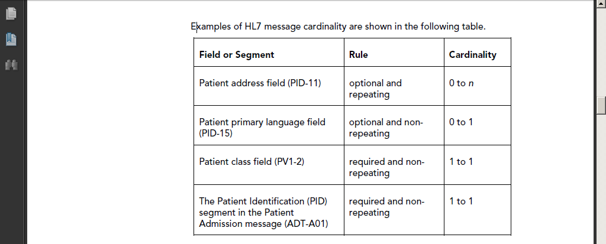
How Does Cardinality Cause Nonconformance?
When looking at cardinality, it would seem to provide enough flexibility to be followed by all systems. However, this is an area that frequently causes nonconformance. The following example shows one way this can happen.
One development team (team 1) may implement the cardinality of the Patient Address Field (PID-11) exactly as the standard says. Therefore, they would allow zero to infinite patient addresses (cardinality of 0 to n).
Another development team (team 2), may require one patient address but only allow one (cardinality 1 to 1). Team 2, in this example, is not HL7 compliant.
If the application developed by team 1 sends a message to team 2’s application without a patient address, the application from team 2 would not accept it, even though the message is HL7 compliant.
Several items will need to be checked for conformance to the HL7 standard used:
- Cardinality within fields or segments
- HL7 version features used by both the sending and receiving entity
- Customization and/or misinterpretation of the HL7 standard
- Differences in message formats
How direct EMR will help an Imaging Center Facility?
Before scenario: A patient’s physician states that a radiological exam is needed, so the physician checks the appropriate boxes on the paper requisition and hands it to the patient. The patient goes to the imaging facility and hands the request to the front desk. While waiting for the exam, the patient completes a form with demographic and medical information.

After the exam is completed, the imaging center may produce a copy of the images for the patient to deliver back to the physician. The patient report also may be delivered through another method, such as a fax.

After Scenario: Turn this process outside in. Imagine: The patient’s physician states that a radiological exam is needed, so the physician enters the order into an EMR system and electronically sends the patient information and order to a selected imaging center. The imaging center calls the patient to schedule a time for the exam. The patient arrives. After the exam is completed, the patient report, radiologist interpretation and corresponding images (via PDF or Web-based PACS) are sent electronically to the referring physician’s EMR. The physician reviews the patient’s report in their EMR system and calls the patient for consultation.

The latter process delivers a better experience for the patient as well as increases the patient’s confidence in the accuracy of the information being exchanged. Manual steps are removed from the process, and the overall experience exceeds the patient’s expectations.

Claims and Medical Billing Process
http://en.wikipedia.org/wiki/Medical_billing_(United_States)

