Contents - Expect Great Things
Project: 2
Can you describe the project in-detail? What were some of the problems you identified and what solution were recommended? 3
Project 1: Kohls.com Measurement Project (was released on August 2006) 3
Project 2: Checkout Module Integration. (Was released on December 5th 2005) 4
What was your role in the team? 4
What were your target demographics? 5
What were some of your Marketing efforts? 5
What were some of your marketing action items? 5
What is a wireframe? 6
What is an HTML prototype? 6
Cost per click (CPC)? 6
Click-through rate? 6
Pay per click? 7
Where were you living while your stay in WI? 7
Address: 7
References 8

Project:
Kohl’s Corporate Office, Milwaukee, WI Oct 2005 – Oct 2006
Business Data Analyst
Project: Kohls.com

Kohl’s Corporation is one of the biggest retail companies in US. Kohl's stores and its ecommerce site Kohls.com feature nationally recognized brand-name merchandise, exclusive labels, and private-branded goods. The purpose of the project was to redesign its ecommerce site Kohls.com with new features and a clean navigation of the site. The project also involved a complete revamp of the site search, zoom features and its shopping lifecycle.
Environment: RUP Methodology, Business Objects XIR2, Oracle 10g, J2EE v 1.3, Rational Rose, Rational Requisite Pro, Clear Quest, Microsoft FrontPage

Responsibilities:
- Contributed ideas towards building the company’s core business and marketing plan; implemented them into the business and functional requirements of the platform.
- Made project plans using MS Project.
- Facilitated JAD sessions with the business team and technology team.
- Generate daily, weekly and summary reporting and performance insights for the following programs: event performance for tab, including Advertised vs. non-advertised sales, Power Hours, Early Birds, BOGO and like-themed events.
- Conducted Previews and User Acceptance Test (UAT) sessions with the marketing team.
- Involved in In-Depth Research to gather requirements from Kohls.com users to improve the Online Shopping experience.
- Produce different levels of prototypes to aid the design and usability testing process: interactive HTML prototypes, and wireframes.
- Developed strategies and processes to reduce access time by optimizing the landing pages using Google’s Adwords and Google Analytics to drive market penetration.
- Created dashboards, metrics, analytics, goals, alerts using Business Objects XI enterprise edition to streamline processes and procedure.
- Created Real time statistics available to Upper Management – via “Dashboards”.
- Building templates and dashboards for customized views of the data specific to each group and line of business.
- Conducted a web-metrics study and devised plans and budgets for CPC, CTR, PPC.
- Trained Customer Support staff and updated them about Kohls.com latest features.
- Devised extensive E-mail marketing campaigns regularly & kept a track of positive as well as negative feedback for improvisation.

Can you describe the project in-detail? What were some of the problems you identified and what solution were recommended?

Project 1: Kohls.com Measurement Project (was released on August 2006)
Project Purpose: The purpose of the project was to provide customers an enhanced online experience through strategically designed features, such as improved search functionality, user-friendly site navigation, and to launch web store of its popular brands. And also to make sure that the site’s interactive design aligns with Kohl’s branding and positioning, ensuring that consumers will have the same branded experience whether shopping in-store or online.
Problems: One of the significant learning’s from the study, that were observed are as follows
- The site’s search functionality was not performing up to visitor expectations.
Solution: The solution to the problem was to implement a parametric search capability within the result. By which I mean that the search results were made more specific for users so that they can find exactly what they were looking for by
- Category,
- Brand,
- Price,
- Color
- And Size.
This also included larger product images, and adding zoom functionality for a product. By doing this it not only enhanced the effectiveness of the search function but also created an impact on visit success for all visitor groups.

- One of the other problems that we were facing was that our popular brands did not have an online presence.
Solution: The solution to the problem was to launch micro-sites that would be accessible from its own web site (Kohls.com). For example, a web store is implemented for its very popular in-store brand Simply Vera Vera Wang and Elle. In addition to that,
- It will advertise its popular brands (like Simply Vera Vera Wang, Elle, Dockers, Arrow and many more) on the home page of Kohls.com
- It will promote online shopping with a Deal of the Day feature on its web site home page offering Internet only discounts and with occasional free shipping deals.
- Not only that, but it lets those customers who might be interested watch its television commercials online.

Project 2: Checkout Module Integration. (Was released on December 5th 2005)
One of the other projects that I was involved in was to improve the abandoned Checkout process within ecommerce site Kohls.com.
Project Purpose: The purpose of the project was to improve shopping lifecycle, from browsing to choosing to buy, by integrating the Allurent’s Checkout Module and also to increase our online sales by providing customers retail level of customer interaction.
Responsibilities:
In the past, the whole checkout process was really frustrating for a customer for Example It not only required the customer to register with Kohls.com before checkout but also required to enter the information (Like Billing Information, Shipping Information etc) again and again for its every purchase. And there were some technical and design issues that were also observed and needs to be resolved.
I was responsible for the following task,
- To gather requirements and metrics like demographics, visit intent, visit success, conversion rate etc from various team and to provide solutions of how we can quantify the numbers.
- To understand how Allurent’s Flash based Checkout module was working and how it will integrate with Kohls.com website.
At Present, by doing an in-depth analysis on the Allurent’s Checkout Module I was able to point some key features that Allurent will offer to ecommerce site Kohls.com. Some of them were
- To break the checkout process into a 5 stage process, Billing & Shipping, Gift Options, Payment, Place Order and Success.
- To display a red alert when an item is skipped or does not contain the correct data.
- To give an option to the customer to Edit Your Shopping Bag
- To give an option to the customer to Continue Shopping etc

What was your role in the team?
As a part of the Creative Solutions Marketing Group, my job as a Business Data Analyst was to work hand in hand with different teams (Marketing Team, Business Team and the Technology Team) and act as liaison by providing them with inputs regarding business requirements, test plan/scenarios, designing the web based interface, and conducting JAD sessions with individual teams and collectively as well. In addition to that, I was also responsible in identifying strategies of how to improve our E-business presence.
(The primary purpose is to focus, on understanding why your visitors have come to our site, then on identifying the barriers to success and removing them.)

What were your target demographics?
Kohl's core customers are married women ages 25 to 54 shopping for themselves, their families, and their homes. Kohl's sees an opportunity to capture more share of wallet among empty nesters ages 45 to 54 and single women ages 25 to 34.

What were some of your Marketing efforts?
It was to introduce several new contemporary apparel brands on Kohls.com to capture more share also among young girls, young men. And it also added the beauty section on its ecommerce site Kohls.com. Some of the featuring brands were;
- Daisy Fuentes in women's career and activewear,
- everGirl (by Nickelodeon) in young girls,
- Urban Pipeline in young men's,
- And Candie's in juniors and young girls.
- And it also included the launch of Chaps (by Ralph Lauren) in men's career and casual sportswear.
- It also added the beauty tab on its website Kohls.com featuring the four exclusive cosmetics brands -- American Beauty, Flirt!, Good Skin, and Grassroots (all by Estée Lauder). By direct mail, digital advertising and e-mail for its holiday marketing program.

What were some of your marketing action items?
- A campaign was designed to showcase Kohl's as a one-stop shopping destination for shoppers looking to get the most for their money during a challenging economic environment. Gifts were highlighted throughout via brightly wrapped boxes and taglines such as “Gifts that fit your budget beautifully.”
- We implemented a Gift Card Center featuring two kiosks. For the first time, customers will be able to redeem e-gift cards — gift cards that can be bought, given and printed online — in Kohl's stores and online at Kohls.com. Also, customers will be able to purchase gift cards from other retailers, including Best Buy, Apple iTunes and Barnes & Noble.
- One of the strategies for the holiday program was to make use of frequent sales events beginning in November and aggressive discounts on popular merchandise earlier in the season.
- Online, Kohl's will take over the home pages of popular online sites including AOL, MSN and Yahoo.
- We send e-mail to our customers throughout the season offering gift ideas, sneak peeks at upcoming sales and shipping offers.
- Via the mail, we offered charged card holders a 23 special savings days.

What is your experience with Microsoft CRM?
We used this tool as a centralized source to maintain customer information. It enables the sales force to collaborate and share valuable information, such as customer profiles, sales and competitive sales data, affiliations, targeting and segmentation information that results in stronger relationships with customers and increased productivity for our brands.
In your Kohl’s Project you said that you Responsible for preparing financial reporting, cost accounting, budgeting, and financial forecasting. Can you describe in detail?
Well, as a BA, many times I have had to come up with Budget estimates for a particular enhancement (or sets of enhancements). I would use MS Access to come up with a high and low estimates on a quarter by quarter basis for our development resources, QA, operations, hardware costs, hardware depreciation, software licenses, travel budgets as well as training. I would then present these findings of budget on a professional power point presentation for the senior executives. This is all in response to the initial estimate of a software project. Along the way, I also had to track the accuracy of this initial budget estimation to make sure that we are roughly spending the same money per month as we had planned because our Finance department used to get very upset if the actual expenditure is not in line with the expected expenditure per month.
Describe your resume from the perspective of Data analysis?
In my professional experience as a Business Data Analyst I have dealt with data in almost all of my projects where at times I was responsible to do data analysis, gather requirements to design a database structure with the DBA team, data integration, write SQL queries to do QA testing and validation of the application.

- Another example, when I was working for Kohl’s as a Business Marketing analyst I was involved with data to understand the consumer buying behavior and generate weekly, daily and monthly reports using MS Excel to understand the sales target we achieved during a particular month.
- I have also used tools like Business Objects to generate reports for upper management to gauge and understand our core MVC (Most Valued Customers) customers and send them weekly coupons and lowest sales prices on our product line as a Marketing initiative. And also create an opportunity for the demographics among empty nesters that are within the age group of 45 to 54 and single women ages 25 to 34.
- In addition, I have also used MS Excel to generate reports to understand how a consumer navigates to the ecommerce site Kohl.com and was able to improvise the ecommerce site with the problems it was facing in its web sales like search functionality, the checkout process and the overall look and feel.

What is a wireframe?
A wireframe is a grayscale block diagram that illustrates the overall navigation and the blocks of elements such as content, functionality, etc. that will go on the screen. It does not contain pictures and doesn't necessarily need to link to anything. It just demonstrates what elements a web page or application screen will contain and roughly where they might go--although the location can change. It does not include visual design.
An HTML wireframe is created in HTML using an html editor such as Axure or Dreamweaver. A flat wireframe is created using a program such as InDesign, PowerPoint, or Visio and does not have interactive components, but is a flat image of the elements on the screen

What is an HTML prototype?
An interactive HTML prototype goes a step further by linking navigation on an HTML wireframe to other wireframes representing subsequent screens, filling in content as needed, and adding mock functionality such as drop-down menus and fields that don't tie into any backend. This prototype does not represent any visual design other than simple layout.

Cost per click (CPC)?
It is the amount of money an advertiser pays search engines and other Internet publishers for a single click on its advertisement that brings one visitor to its website.

Click-through rate?
Click-through rate or CTR is a way of measuring the success of an online advertising campaign. A CTR is obtained by dividing the number of users who clicked on an ad on a web page by the number of times the ad was delivered (impressions). For example, if a banner ad was delivered 100 times (impressions delivered) and one person clicked on it (clicks recorded), then the resulting CTR would be 1 percent.

Pay per click?
Pay per click (PPC) is an Internet advertising model used on search engines, advertising networks, and content sites, such as blogs, in which advertisers pay their host only when their ad is clicked. With search engines, advertisers typically bid on keyword phrases relevant to their target market. Content sites commonly charge a fixed price per click rather than use a bidding system.
Websites that utilize PPC ads will display an advertisement when a keyword query matches an advertiser's keyword list, or when a content site displays relevant content. Such advertisements are called sponsored links or sponsored ads, and appear adjacent to or above organic results on search engine results pages, or anywhere a web developer chooses on a content site.
Although many PPC providers exist, Google AdWords, Yahoo! Search Marketing, and Microsoft adCenter are the three largest network operators, and all three operate under a bid-based model. Cost per click (CPC) varies depending on the search engine and the level of competition for a particular keyword.

Where were you living while your stay in WI?

Address:
Arbor Ridge Apartments
7960 North 107th Street,
MILWAUKEE, WI 53224

Corporate Address:
Kohl's Department Stores
N56 W17000 Ridgewood Drive
Menomonee Falls, WI 53051
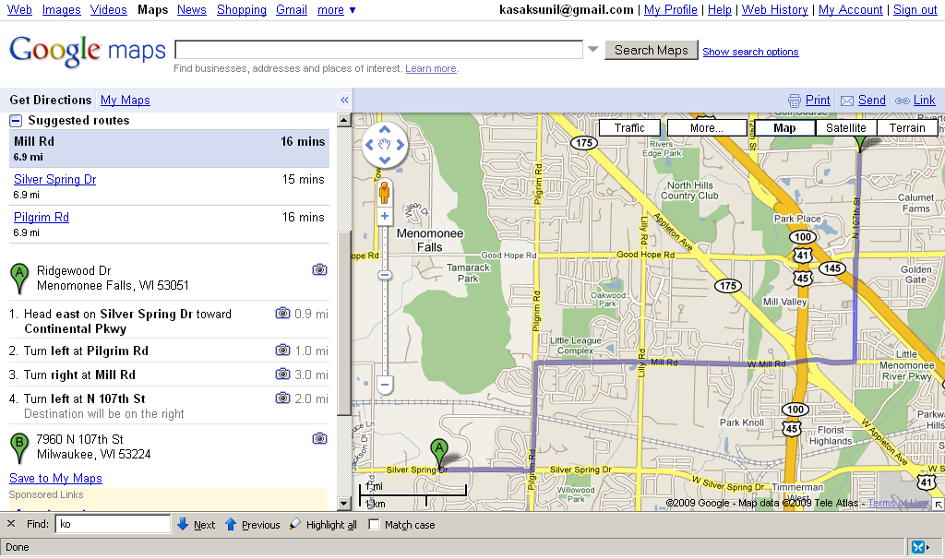

References
- http://www.boxesandarrows.com/view/html_wireframes_and_prototypes_all_gain_and_no_pain

