Contents
Can you describe the Project in detail? 3
Business Context Diagram 5
What were some of the key challenges you dealt with? 6
What was your role in the Change Control Board? 6
How were the files transmitted from the Patient to the Database? 7
What were your final deliverables? 7
Which platform was the application tested? 7
Who was your end user? 7
What is HIPAA? 7
What was the goal of HIPAA? 7
What was your involvement with HIPAA? 8
What does The Privacy Rule Protects “PHI”? 8
References for HIPAA: 8
What is HL7? 8
The Name "Health Level-7" 9
V3 Messaging 9
References for HL7: 9
What is FDA Regulations (21 CFR 820)? 9
21 CFR Parts 820- This is a Medical Device Regulation 9
How do you perform internal audits? 9
What is an FDA CAPA? 10
Where were you living while your stay in MA? 10
Were there any critical bugs that were unresolved? 11
How did you perform data analysis? Was the product tested with some sample data and how did you analyze the results? 11
What was your UAT experience with this project? 12

Project:
Philips Medical System, Andover, MA Nov 2006 – March 2008
Sr. Business Process Analyst
Project: ECG Data Management System

Philips is a world leader in healthcare, lifestyle and lighting, Philips integrates technologies and design into people-centric solutions. The purpose of the project is to manage ECG across the enterprise. The concept initiated to design TraceMasterVue, a data management system that automate the process, storage and distribution of ECG. TraceMasterVue provides the software tools to analyze, view, edit, and compare ECG records; plus generate, manage, and distribute reports in various formats to meet specific needs.

Environment: RUP Methodology, Telelogic DOORS 8.3, MS Project, Bugzilla, MS Visio, MS SQL Server, Wireframe V1.2, Win CVS, ASP.net , C#

Responsibilities:
- Conducted requirements analysis and facilitated Joint Application Development (JAD) sessions.
- Followed a structured approach to organize requirements into logical groupings of essential business processes, business rules, information needs, and ensured that none of the critical requirements go unnoticed.
- Assisted with detailed project planning by contributing and creating project definition documents, business requirements documents (BRD), and functional requirements documents (FSD).
- Created Traceability Matrix for use cases with use case drawings, diagrams and test criteria’s to help the testing tem to understand the requirement testing parameters.
- Active member of Change Control Board (CCB) and regulated the gaps in the requirements.
- Developed timelines for project delivery, and managed projects and resources to successful completion using MS Project.
- Performed data analysis and coordinated with DBA team to create data models for new application and the interface initiative.
- Actively participated in almost all the phases of SDLC beginning from requirement until implementation and user training and training manuals.
- Created weekly BA/QA team status reports for management team and Program office (PMO).
- Supported QA team in creating test cases to test the functionality of the new and enhanced application, performed User Acceptance Testing (UAT).
- Facilitate user training for new application and created user manual for new application and enhanced application.
- Ensured that all the expected regulatory standards as per 21 CFR and HIPAA compliant are met.

Can you describe the Project in detail?
The project involved designing a Remote ECG Data Management System i.e. TraceMasterVue to capture electrocardiogram (ECG) data for diagnosing cardiac rhythm. The system provides ECG data to physicians in a timely manner for evaluating the underlying cause.
TraceMasterVue is a web based application that was designed in ASP.net framework using C# as the programming language. Using the web application, the medical assistant will enter the Patient information (Details of the patient like name, gender, DOB, medical conditions, insurance information) and assign a Physician (using a drop down list of physicians), a unique ILR (Implantable Loop Recorder) number and a unique PDM (Patient Diagnostic Manager) number to the patient’s record. In the backend, Patient record is created and information is stored in the database i.e. MS SQL Server. This application is then used by the medical assistant to set up a time/date for Out Patient surgery.
High Definition Implantable Loop Recorder (HD-ILR) continuously monitors the electrical activity of the heart. This device is implanted in the patient’s upper left chest. The loop recorder’s weighs approximately 19.8 grams and has a 28-month battery life.

The Personal Diagnostic Manager (PDM), which the patient carries in a pocket or purse, retrieves ECG data from the HD-ILR when a patient experiences symptoms, or daily in the absence of symptoms.

How the PDM works?
The PDM has 2 modes:
- Physician Mode
The physician inserts the programming key (this is a Plastic key and should not be used by the patient), after insertion the PDM is in Physician mode. At that point, physician will set the following parameters;
- Two parameters – high and low heart rates – provide monitoring criteria.
- Select different languages for physician and patient use. (like English, Spanish , French etc)
- Patient Mode
After the physician removes the key, it is ready for patient use.

The Base Station A Bluetooth®-enabled modem that links to the Monitoring Center, transmits data from the PDM to a secure database over a standard (analog) telephone line, and includes a power supply, a telephone cord, and a telephone line Y-adapter. ECG data collected by the PDM is transmitted wirelessly and automatically to the Base Station which sends the data securely to the Monitoring Center.

Business Context Diagram
2
Patient
Wireless Transmit ECG Data
Receive Data from ILR
Implant ILR
Patient Diagnostic Manager (PDM)
Base Station
3
4
Signals
Signals
ILR (Implantable Loop Recorder)

6: ECG Files will be stored

Web Server
IIS

SOAP, XML
Database
IIS

Proxy Server
Stores Data
5
7
Retrieves Data
1: Medical Assistant enter Patient Info and Physician uses Trace Master Vue to pull the information.
Trace Master Vue
(Web Interface)
Physician Reports

Medical Assistant
Physician

Operating distance:
PDM to HD-ILR 2.0 m (6.6 ft)
PDM to Base Station 9.1 m (30.0 ft)
Steps:
- Gather ECG Data: ILR (Implantable Loop Recorder) remotely monitors the electrical activity of the heart. The device is implanted in the patient’s upper left chest by performing a surgical procedure. ILR captures data in three ways;
    - When a patient has a symptom
    - When the heart rate exceeds the limit programmed by the Physician
    - Periodically to monitor the Patients condition
- Transmit ECG Data: Patient carries the PDM in a pocket or a purse; PDM retrieves the ECG data from the ILR when a patient triggers a symptom. Physician will program the PDM for the data to be collected from the ILR.
- Base Station: Base station is placed in patient home and connected via phone line or a cable. ECG data collected from the PDM is wirelessly transmitted to the Monitoring Service Company for data analysis.
- Reporting ECG Data to Technicians: After receiving ECG Data Technicians analyze the data, create reports and send the data to the Physicians for patient diagnostic.

What were some of the key challenges you dealt with?
Some of the Key challenges that we faced were;
- Integration of all the modules i.e. Web Client, Proxy Server, Web Server and the Data Manager making sure that all the modules communicate with each other.

What was your role in the Change Control Board?
In the Deployment Phase of the project, the customer proposed a requirement change for the Web Client module. As a Business Analyst my role was to gather the requested change and propose the change to the Change Control Board.
For example,
- One of the requirements that weren’t discussed initially in the requirements gathering phase was that once a patient record is created and an ILR and a PDM have been assigned to the patient, there must be a time limit by which the patient’s surgery must be scheduled. This is because these devices are very expensive and we cannot just block them with patients who come in for an initial consultation diagnostic but never come back for their scheduled surgery. The CCR (Change Control Request) proposed by the business team was to escalate assigned but un-used ILRs and PDMs to the physician so that they can follow up with their patient and if patient has changed their mind about this operation, provide the physician a way to “release” the unique ILRs and PDMs back to the pool of available devices.
- Another was to filter the Patient records by First Name, Last Name and the ILR.

How were the files transmitted from the Patient to the Database?
ECG data file that was retrieve from the PDM from an ILR is wirelessly transmitted by a Base Station to a Proxy Server and then to the IIS Web Server using XML based SOAP protocol. The data is then stored in the Database.
- Why do you need a Proxy Server?
A Proxy Server was required to enable a secure transmission of the ECG data in a timely fashion.
- What is SOAP? (Simple Object Access Protocol)
SOAP is an XML based protocol for accessing a Web Service
(Web services use XML to code and to decode data, and SOAP to transport it.)

What were your final deliverables?
The final deliverable was;
- The Project Definition document, BRD, FSD
- In addition to the above, RTM, Verification Summary report and the Anomaly report were also the deliverables.

Which platform was the application tested?
The application was tested on Windows XP OS and Vista machine.

Who was your end user?
This product was designed by Philips Medical System and is used by patient for diagnosing cardiac rhythm.

What is HIPAA?
HIPAA is Health Insurance Portability and Accountability Act. (http://en.wikipedia.org/wiki/Health_Insurance_Portability_and_Accountability_Act)
The U.S. Department of Health and Human Services (“HHS”) issued the Privacy Rule to implement the requirement of the Health Insurance Portability and Accountability Act of 1996 (“HIPAA”).

What was the goal of HIPAA?
- Create a uniform “floor” for privacy protection
- State laws could be more protective
- Increase patient rights and inform people of their rights

What was your involvement with HIPAA?
As a part of my job was to make sure, no real patient records should go into QA environment. Because when test data is difficult to produce from scratch, many companies route to downloading data from production databases into QA environment.
I had to sit with the Chief Information Security Officer (or their team) to understand what data needs to be masked (like SSN, DOB, Address, CC Number etc.) before we could download production data into QA (or staging). This exercise, though very bureaucratic helps companies not get sued for breach of privacy. As these are against HIPAA “Privacy” rules.

What does The Privacy Rule Protects “PHI”?
- What is “Protected Health Information”?
  - Name, photograph, date of birth
  - Social Security Number
  - Finger prints, health status, diagnosis
  - Admission date, medical record number
  - Address, telephone number, FAX, e-mail
  - Health information from record
- Individually identifiable information
- Health information about a patient
- Demographic information
- In any form: written
- Oral or electronic

References for HIPAA:
- http://www.healthcare.philips.com/main/support/productsecurity/privacy_rule.wpd
- http://www.hhs.gov/ocr/privacy/hipaa/understanding/summary/privacysummary.pdf
- Power Point Presentation: ..\HIPAA\PRIVACY_RULE.ppt

What is HL7?
Health Level Seven (HL7), is an all-volunteer, not-for-profit organization involved in development of international healthcare standards.
HL7 and its members provide a framework for the exchange, integration, sharing and retrieval of electronic health information.

The Name "Health Level-7"
The name "Health Level-7" is a reference to the seventh "application" layer of the ISO OSI Reference model. The name indicates that HL7 focuses on application layer protocols for the health care domain, independent of lower layers.

V3 Messaging
The HL7 version 3 messaging standard defines a series of electronic messages (called interactions) to support any and all healthcare workflows. HL7 v3 messages are based on an XML encoding syntax.

References for HL7:
- http://www.pbgh.org/programs/documents/LabDemoFinalReportAttach3.pdf

What is FDA Regulations (21 CFR 820)?
21 CFR Parts 820- This is a Medical Device Regulation
FDA introduced 21 CFR Part 11 for rules on the use of electronic records, electronic signatures.
The General Principles of Software Validation verification as “Software verification provides objective evidence that the design outputs of a particular phase of the software development life cycle meet all of the specified requirements for that phase.”
It also defines Validation as “Confirmation by examination and provision of objective evidence that software specifications conform to user needs and intended uses, and that the particular requirements implemented through software can be consistently fulfilled”
Verification - Are we building the right product
Validation - was the product built right (this can ONLY be confirmed by User Acceptance test of intended use)

How do you perform internal audits?
Intent of audit is to see if a company has a process that is compliant with FDA regulations/guidelines. An audit would be done to see if the company is following that process. This can be done by looking @ what is called 'objective evidence' of the process being followed.
Objective Evidence – It is a standard approach to represent the objective evidence of what the organization intend to do (for example, product specification, procedures, training course curricula and blank forms etc) “records” would be what the organization has done (for example, attendances sheet from training programs, completed forms , and inspection and monitoring data)

What is an FDA CAPA?
Corrective Action – Event that has happened in the past
A company will fix a problem in their business process; say a customer complaint or product return, after the problem has occurred. This is typically product or event focused. Then the company will look at what they've done and say, "Well if we revise our shop router or procedure, this will not happen again." They will label this second phase as Preventive Action.
So in this example the systemic action taken is the revision of the shop router or procedure. This is Corrective Action.
Preventive Action – To prevent an event to happen in the future
Preventive Action activities must stand alone and not focus on past events. For example: Company XYZ has a Preventive Maintenance management program that requires manual data entry. It is working fine and there have not been any problems. However, it takes a lot of time to manage and does have a high potential for error or lost records. XYZ decides to purchase Preventive Maintenance software to manage this activity. Since the purchase is not based on problems that have happened and is focused on process control or making an improvement to the QMS, it is a Preventive Action.
Corrective and Preventive Actions are key elements to a Quality Management System (QMS) that is focused on Continual Improvement and Customer Satisfaction
http://wiki.answers.com/Q/What_is_an_FDA_CAPA

Where were you living while your stay in MA?
Apartment:
Windsor Green
311 Lowell Street,
Andover, MA 01810

Corporate Address:
Philips Medical Systems
3000 Minuteman Road
Andover, MA 01810-1099
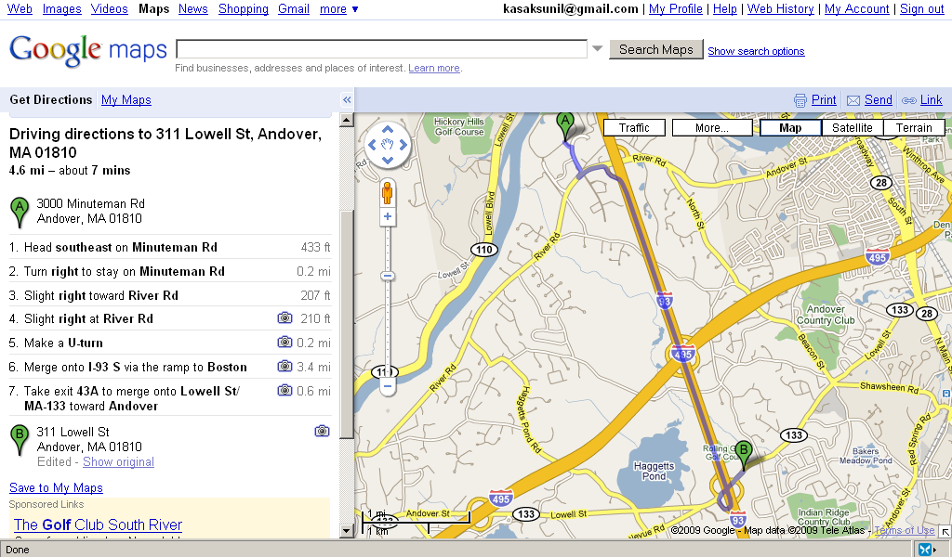

Were there any critical bugs that were unresolved?
No critical bugs were unresolved but there were few enhancements that were still in open state. Like a functionality to filter records with the Patient First Name and Last Name for example. As this was one of the critical applications for Philips I and one of the QA engineer were responsible to make sure that the application was fully tested for its intended use from both the business and quality aspect of the application.

How did you perform data analysis? Was the product tested with some sample data and how did you analyze the results?
I wrote some SQL scripts to populate the sample data to test the different modules/functionality of the product.
For example, 10 patient records were created and a Physician, a unique ILR number and a unique PDM number were assigned to the patient record. After implanting the ILR through an outpatient surgery to a patient, that particular ILR and the PDM should not be available from the front end of the application for use by other patient.
I would just use the SQL client to write some simple queries like
Select a.PatientFN, a.PatientLN, b.PDMModel, c.ILRModel
From Patienttbl a, PDMtbl b, ILRtbl c
Where a.PatientID = 1;

Another example, if a patient record is deleted using the TraceMasterVue i.e. front end that particular record is not completely deleted from the database but only the Delete column flag is disabled. This is very important so that we can maintain Medical History for that particular patient.

So I would check this by writing a simple query;
Select * from Patienttbl a
Where a.PatientID = 1;

How would you transfer flat files between different databases?
  - For example when I was working as a Business Process Analyst with Philips Medical System, our QA team needed test database. At times, I created a sample .txt file (Flat File with Comma Separate Values) with made up patient data so that we can provide test data to the testing team. At times, we also tapped into production database to get production data and insert it into QA database but only after masking some specific fields (like SSN, DOB, Address, CC Number etc.) before we could download production data into QA environment for testing of the application “Remote ECG Data Management System”.
  - Using the Bulk Insert command we were able to transfer the Comma Separated Value file into MS SQL Server QA Database environment.

