WRITE-UP: BofA

Bank of America, San Francisco, CA
Mar 2009 - Present
Business Analyst
Project: Security Enhancement for Automatic Bill Payment through ACH Payment Gateway for BofA’s Corporate Clients
The project involved enhancing the payment gateway with extra security measures; a technology-driven approach for online banking. The important features included were, secured authorization processing and enhancements of automatic bill pay options.

Responsibilities:
- Elicited with business teams, technology teams and quality assurance members to gather, document and communicate system requirements effectively.
- Designed UML diagrams using Rational Rose and MS Visio, for better understanding of business processes.
- Conducted user interviews, surveys and created presentations of business process for requirements gathering, analysis, and design.
- Created Wireframes using Dreamweaver and MS Visio, to effectively communicate the user-interface platforms to the system teams.
- Collaborated with technical staff and subject matter experts to establish the technical vision of projects and analyze tradeoffs between performance and usability.
- Initiated JAD sessions for design and documentation of the Functional Specification Document (FSD) and made sure that all the requirements were implemented into functionality or a feature within the system by means of Requirements Traceability Matrix (RTM).
- Interacted with system developers to clarify questions and resolve discrepancies in Business Requirement Documents (BRD).
- Worked closely with both development and testing teams to improve quality of the application by actively participating in regression analysis and User Acceptance Testing (UAT).
- Managed scope change effectively with business modules in mind, thus accommodating reasonable requests from business teams.

Environment: Rational Rose, Telelogic Doors, MS Visio, Adobe Photoshop, MS Excel, MS Access, Oracle, UML and RUP.

LOCATION

555 California Avenue, SFO, CA

Montegomery BART

PROJECT

Security Enhancement for Automatic Bill Payment through ACH Payment Gateway - Corporate Clients

Automatic Bill Pay is the process by which BofA’s clients pay their vendors on a pre-defined date. BofA’s options for their corporate clients are:
- Pay fixed amount every month on a specified date to vendors.
- Pay full amount to vendors (E bill: Electronic Bill, when amount varies every month, the vendor sends a bill directly to BofA and the bank of behalf of it’s clients pays the amount to the vendors.
- Make Minimum payments to vendors.

Security Enhancements Done: SCOPE
1. Age out passwords of clients every 6 months (Good discussion about whether this is too much vs. the security of the account).
2. 128 bit SSL encryption.
3. Passowrd strength is analyzed and suggested by the system if it is Strong,
Medium or Low.
- Database back-up security, all back-ups are encrypted for data protection.
- Not allow passwords to be reused until they are at least “10 times old”.

An example of an ER Model and how a BA can tell if an ER Model serves the business purposes (business requirements) of a customer – Wholesale customer ACH Online Bill Pay?

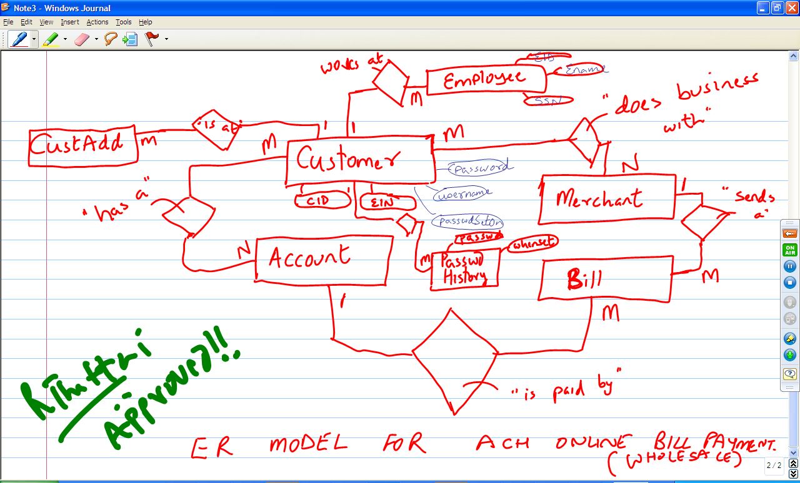

CLIENTS : Nokia, Cisco Systems, E Bay, Macys, JC Penny to name a few.

DURATION: Jan 2009 - Present (17 months)

TEAM: BA - 7, QA - 5, DA - 2, Dev - 7, PM - 1 (Total 22)

DUTIES: System Design Document(SDD), UML, RTM, JAD sessions, Satnd-up meetings, UAT, Wireframes, Triple constraint trade-offs, Bug Triaging, Liaison between fuctional and technical teams, GAP Analysis, Change Management.

GAP ANALYSIS
AS-IS
Online Bill Pay already in place with very good security features. But the demands of the security features have to change as per market situations. Hence to avoid security breach from hackers and phishers, BofA had to add more features to assure security to customers.
TO-BE
Enhancements to existing security features were planned.
1. Age out passwords of clients every 6 months.
2. 128 bit SSL encription.
3. Password strength is analyzed and suggested by the system if it is Strong, Medium or Low.
4. Database back-up security, all back-ups are encrypted for data protection.
5. Strengthening of site key image and phrases by making the customer add more than one image and phrase.

REQUIREMENTS GATHERING TOOL:
Rational Doors

BIGGEST CHALLENGE FACED IN THE PROJECT:
The effort to secure the Database back up was grossly underestimated. The project was supposed to got extended by 2 months. ?????????????????

MAJOR CONTRIBUTION:
???????

ORGANIZATION SET-UP:
Dynamic

How did you handle conflicts on job?
There was a major conflict between the business teams and technical teams about the need for the 128 bit encryption. The technical teams did not feel the need for it as the bill pay security that BofA offered was good enough. But since we were dealing with corporate clients, the business teams wanted to give them more than what they had. I as a BA had to intervene to reason out the two sides of the coin to promote a healthy discussion.

How did you use doors?
Doors is a document management system and I created several documents and managed them effectively on the application like, System Design Document(SDD), RTM. I linked requirements documents to test cases for traceability purposes. I created several modules, objects and attribute for each requirement.

What other functions did you perform on the job?
JAD sessions, Satnd-up meetings, UAT, Wireframes, Triple constraint trade-offs, Bug Triaging, Liaison between fuctional and technical teams, GAP Analysis, Change Management, UML
Tell me about your last project with Bank of America and if you have rolled out the project or if you are still on it?
I am still with BofA and will be rolling the project in a week’s time. I ma working as a BA dealing with security enhancement projects for automatic bill pay for corporate clients of BofA.
Online Bill Pay is already in place with good security features for corporate clients of BofA. This is a very important BU for the corporation as we deal with vendors of major corps like Nokia, Cisco Systems, E Bay, Macys, JC Penny to name a few. Enhancements are needed because of the changing demands of security in this volatile market. Hence to avoid security breach from hackers and phishers, BofA had to add more features to reassure protection to its customers.

Enhancements to existing security features that were are working on are:
1. Age out passwords of clients every 6 months.
2. 128 bit SSL encription.
3. Passowrd strength is analyzed and suggested by the system if it is Strong, Medium or Low.
4. Database back-up security, all back-ups are encrypted for data protection.
5. Strenghthening of site key image and phrases by making the customer add more than one image and phrase.
Do you have any Web Channel Management experience? Where have you done it?
What sales experience do you have in the past? Have you worked with Internet Services Groups before?
Can I talk about my GAP and MACYS experience?????????
WCM manages the sales capabilities on the public site and Product Applications. How do you think you can tackle this as a BA and what do you think will be your role in it?
Can I have some ideas about my current projects?
What is your opinion and experience on the RUP environment and how do you deal with it?
RUP stands for rational Unified Process. It is an iterative SDLC which means that is believes that a project should be developed in iterations. The advantage of having an iterative SDLC is that it makes the project more flexible, scope changes can be handled easily, risks are identified earlier.
I have actively worked in a RUP environment in my last two projects at BofA and JPMC. RUP is the SDLC I like the most and feel is the most effective. I have also worked in other hybrid environments like waterfall, agile/ SCRUM, but RUP is my favorite for the reason that the atmosphere is highly dynamic, efficient and fast-paced. There are frequent releases and the opportunity for scope change is higher. As a BA there is a constant need for interaction with the other team members and keep all the members of the business teams and technical teams in the loop. The whole RUP atmosphere is so fluid and buzzing with activity that the 4 phases in RUP like Inception, Elaboration, Construction and Transition are not clearly demarcated but provide excellent results.
What are the other sub-projects you used?

