SUBIECT 2018_1

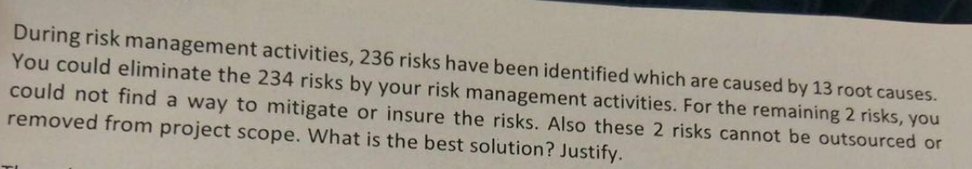
Remain 2 risks.
The risks are threats so the methods to deal with them are : avoidance, reduction (mitigation), transfer (send them to someone else to deal with them) and acceptance (accept the risk, plan accordingly and come with a contingency plan, “Plan B”).

The 2 risks can’t be outsourced => can’t be transferred.
The 2 risks can’t be removed => can’t be avoided or mitigated
The only option left is to accept them and prepare for the situation in which that risk does something bad to your project, have a Plan B.

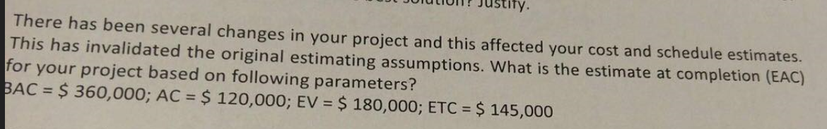
EAC = ?
BAC = 360.000
AC = 120.000
EV = 180.000
ETC = 145.000

Our original estimation has been invalidated => we are in the situation in which :
EAC = actuals to date + new estimate for remaining work
EAC = AC + ETC.
- EAC = 120.000 + 145.000 = 265.000 $



The organization structure is Strong Matrix Organization because in this one the Project Manager has the following responsibilities:
- Decide what has to be done
- Decide the deadline for the tasks
- Manage the budged of the tasks (how much money)
- Check how well has been the project implemented (how good is it)

SUBIECT 2018_2

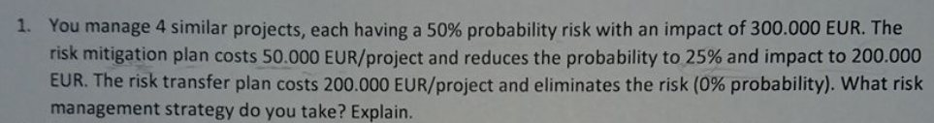
Risk prob = 50%
Risk impact = 300.000
- Risk EXPOSURE = 4 * 50% * 300.000 = 600.000

Risk probability if mitigated = 25%
Risk impact if mitigated = 200.000
Risk mitigation plan = 50.000
- Risk EXPOSURE = 4 * (50.000 + 25% * 200.000) = 400.000

Risk transfer plan = 200.000
Risk probability if transferred = 0%
- Risk EXPOSURE = 4 * (200.000 + 0) = 800.000

Provided these calculations, I would personally choose the risk mitigation strategy because it implies the least amount of resources (money) and the risk probability is quite low (25%).
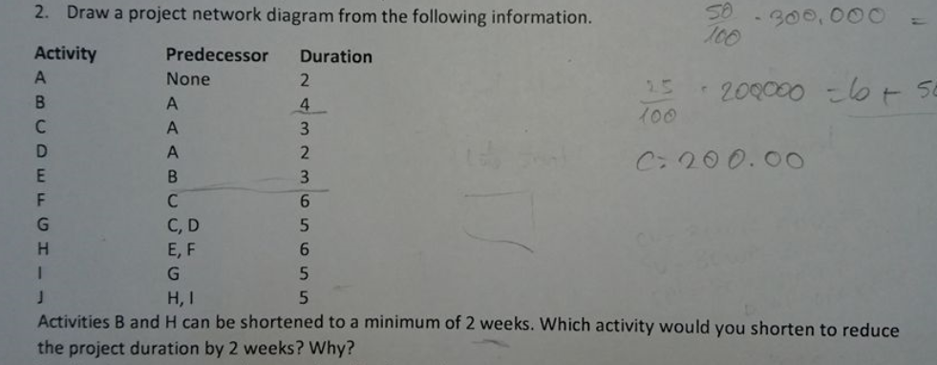
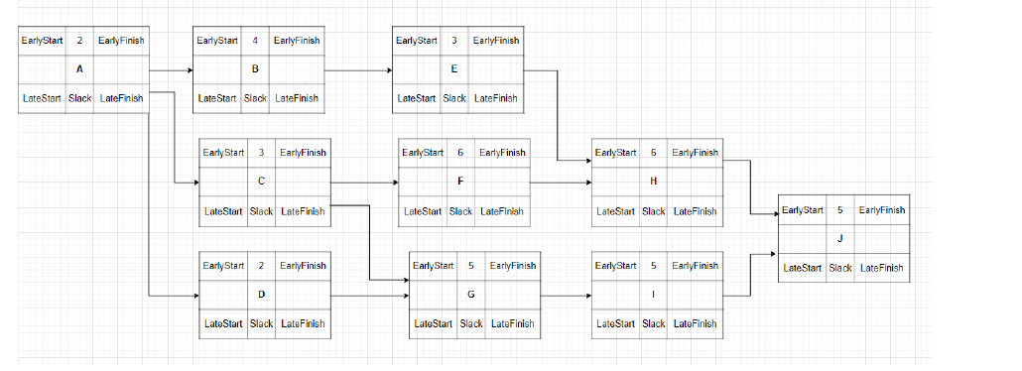 A B E H J = 2 + 4 + 3 + 6 + 5 = 20
A C F H J = 2 + 3 + 6 + 6 + 5 = 22 => critical path
A C G I J = 2 + 3 + 5 + 5 + 5 = 20
A D G I J = 2 + 2 + 5 + 5 + 5 = 19
To reduce the project duration, reduce activity H duration since it is on the critical path

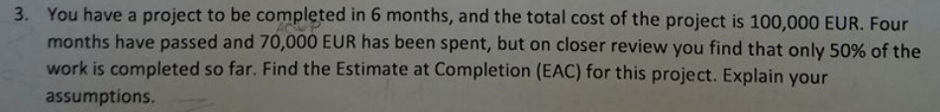
Project time = 6 months
Project cost = 100.000 => BAC = 100.000
4 months passed -> 70.000 spent , 50% work done
EAC = ?

EAC = AC + (BAC – BCWP)/CPI -> because the I consider that current variances are typical of future variances.
AC = ACWP = 70.000
BAC = 100.000
BCWP = 50% * 100.000 = 50.000
CPI = BCWP / ACWP = 50.000 / 70.000 = 0.714
- EAC = 70.000 + (100.000 – 50.000) * 0.714 = 140.000

SMART =
a. Specific
  - b. Measurable (the accuracy)
  - c. Achievable
  - d. Relevant
  - e. Time-bound

- By 28/02/2021 adapt the framework to detect roughly 70-80% of obstacles in field of view and mark them with cuboids.
- By 28/04/2021 detect 80% of stop signs and semaphores and implement semnalization to user by alert messages.
- By 28/05/2021 write 75% of the thesis project in Latex.

SUBIECT 2018_3
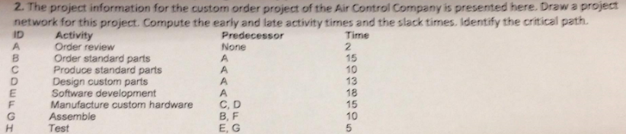
Paths:
A B G H = 2 + 15 + 10 + 5 = 32
A C F G H =2 + 10 + 15 + 10 + 5 = 42
A D F G H = 2 + 13 + 15 + 10 +5 = 45 => CRITICAL PATH45
A E H = 2 + 18 + 5 = 25

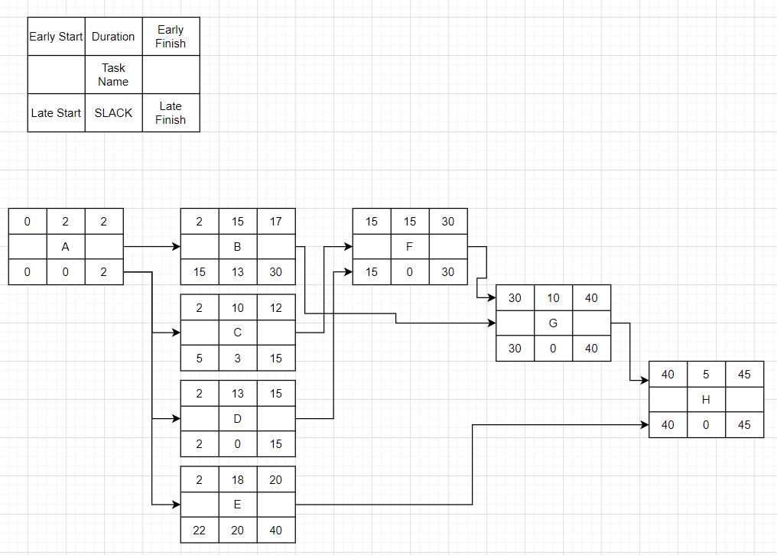

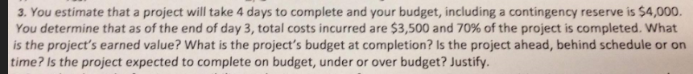
4 days to complete, budget = 4000.
Day 3, 3500 cost, 70% done
EV = ?
BAC/EAC = ???
Ahead/behind or on time ?
On budget, under, over ?
BAC = 4000
ACWP = 3500
EV = BCWP = 70% * BAC = 70% * 4000 = 2800
CPI = BCWP / ACWP = 2800 / 3500 = 0.8
To compute EAC, we can consider the fact that the work will keep this pace so the variations are typical.
- EAC = ACWP + (BAC – BCWP) / CPI
- EAC = 3500 + (4000 – 2800) / 0.8
- EAC = 3500 + 1500 = 5000
CPI < 1 => OVER BUDGET
4 days ….. 100%
3 days ….. 70%
3 / 4 = 0.75
70 / 100 = 0.70
- Behind schedule

Mitigation – money on training for example so the people working at this could know more and so design the system so the components would integrate perfectly
Contingency - back up plan, keep the money until you really need to use them => if risk happens invest something and solve the issue by some refactoring or some kind of work-around
Transfer – assign the task to somebody else or some third party

SUBIECT 2018_4
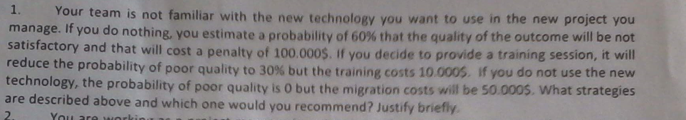
- Do noting -> accept the risk
60% not satisfactory, penalty = 100.000
EXPOSURE = 60% * 100.000 = 60.000
- Training session -> mitigation
30% not satisfactory, penalty 100.000, training cost = 10.000
EXPOSURE = 10.000 + 30% * 100.000 = 40.000
- Not use the new technology -> transfer
0%, migration costs = 50.000
EXPOSURE = 50.000 + 0 = 50.000

Choose the training session approach because it costs less and also helps the team develop their skills in that new technology (maybe in the future they will need this)

As a PM in a strong matrix your authority is moderate to high, you have a high responsible for the project’s budget, schedule, the project team relationships and resource allocation.

3.4.5
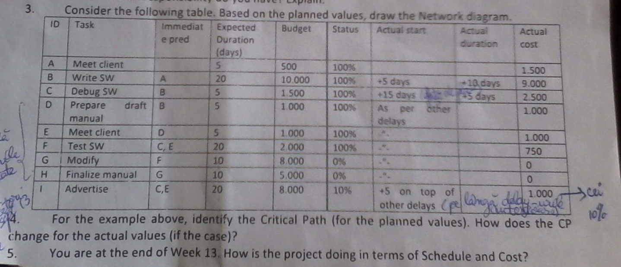
Critical path :
A B D E F G H = 5+20+5+5+20+10+10=75
Considering planned values:
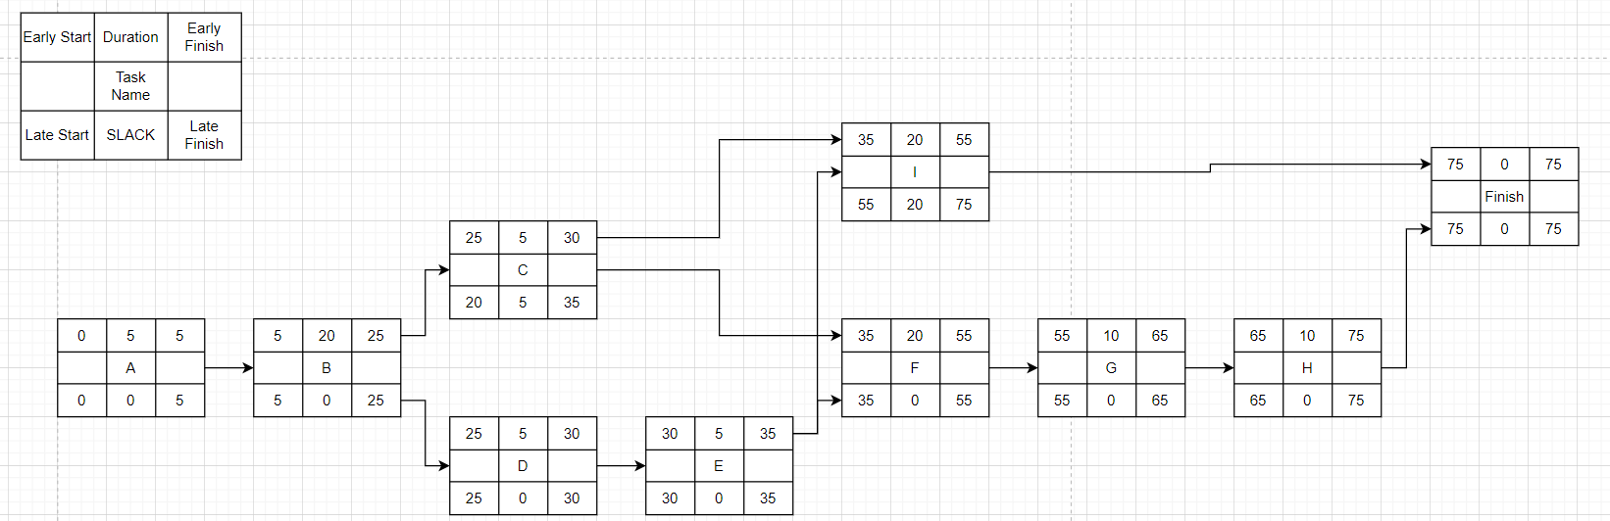
Considering actual values:.
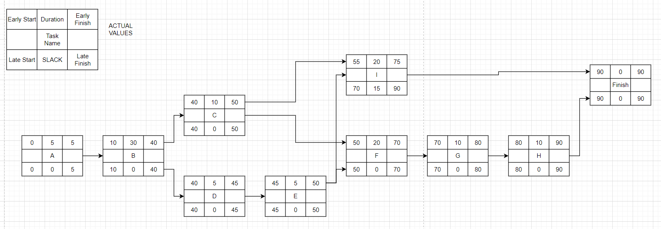
We have 2 critical paths now.
A B C F G H
A B D E F G H

END OF WEEK 13 => DAY 91 => project is DONE
BCWS = 500 + 10 000 + 1 500 + 1 000 + 1 000 + 2 000 + 8 000 + 5 000 + 8 000 = 37 000
BCWP = 500 + 10 000 + 1 500 + 1 000 + 1 000 + 2 000 + 10% * 8 000 = 16 800
ACWP = 1 500 + 9 000 + 2 500 + 1 000 + 1 000 + 750 + 1 000 = 16 750
SPI = BCWP / BCWS = 16.800 / 37.000 <1 => behind schedule
CPI = BCWP / ACWP = 16800 / 16750 >1 => under budget

SUBIECT 2019_1

- By 28/02/2021 adapt the framework to detect roughly 70-80% of obstacles in field of view and mark them with cuboids.
  - S – specific – obstacle detection (unit collision)
  - M – measurable – 70-80%
  - A – achievable – should be, got the framework, just need to work on it
  - R – relevant – it’s the starting point of the diploma project (challenging)
  - T – time bound – 28/02/2021
- By 28/04/2021 detect 80% of stop signs and semaphores and implement signalling to user by alert messages.
  - S – specific – sign detection detection and semaphore detection (maybe some ML techniques implied)
  - M – measurable – 80%
  - A – achievable – got the stereo images and framework running, just have to design the approach
  - R – relevant – middle part of diploma project (challenging)
  - T – time bound – 28/04/2021

- By 28/05/2021 write 75% of the thesis project in Latex.
  - S – specific – document writing
  - M – measurable – 75%
  - A – achievable – just to write down the steps and approaches
  - R – relevant – final part of diploma project (must be good because it will be presented)
  - T – time bound – 28/05/2021


 A B E H J = 2 + 4 + 3 + 6 + 5 = 20
A C F H J = 2 + 3 + 6 + 6 + 5 = 22 => critical path
A C G I J = 2 + 3 + 5 + 5 + 5 = 20
A D G I J = 2 + 2 + 5 + 5 + 5 = 19
To reduce the project duration, reduce activity H duration since it is on the critical path

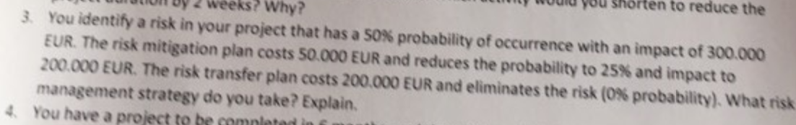
50% occurrence prob. Impact 300.000
EXPOSURE = 50% * 300.000 = 150.000

Mitigation plan costs 50.000, prob = 25%, impact 200.000
EXPOSURE = 50.000 + 25% * 200.000 = 100.000

Transfer plan cost = 200.000, prob = 0
EXPOSURE = 200.000 + 0 = 200.000

I would take the mitigation plan because it costs less and the probability of occurrence is quite low ( 25% ).

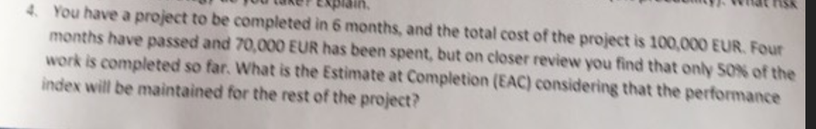
Project time = 6 months
Project cost = 100.000 => BAC = 100.000
4 months passed -> 70.000 spent , 50% work done
EAC = ?
EAC = AC + (BAC – BCWP)/CPI -> because the performance index will be maintained => typical variances
AC = ACWP = 70.000
BAC = 100.000
BCWP = 50% * 100.000 = 50.000
CPI = BCWP / ACWP = 50.000 / 70.000 = 0.714
- EAC = 70.000 + (100.000 – 50.000) * 0.714 = 140.000

SUBIECT 2019_2
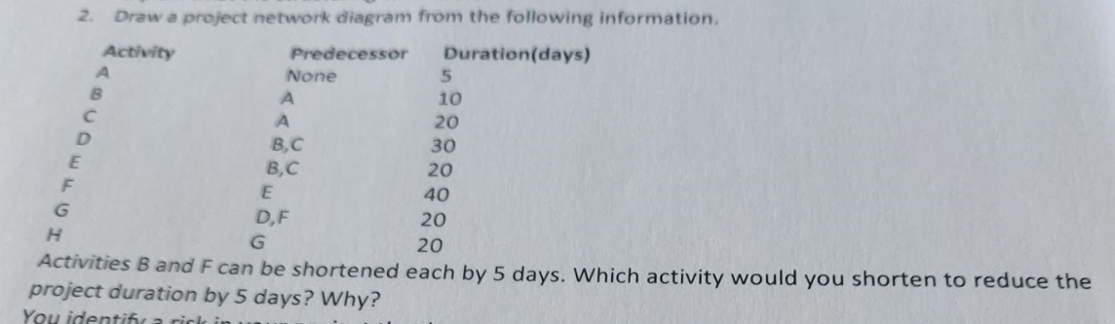
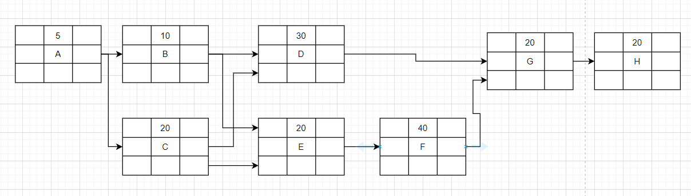
A B D G H -> 5 + 10 +30 + 20 +20 =85
A B E F G H -> 5 + 10 +20 +40 +20 +20 = 115
A C D G H -> 5 + 20 +30 +20 + 20 = 95
A C E F G H ->5 + 20 +20 +40 +20 +20 = 125 => CRITICAL PATH
We shorten activity F with 5 days since it is on the critical path => new critical path duration = 120

P = 60% , impact = 250.000
EXPOSURE = 60% * 250.000 = 150.000

Mitigation plan cost = 50.000
P=30%, impact 150.000
EXPOSURE = 50.000 + 30% * 150.000 = 100.000

Transfer cost = 150.000
P=0%
EXPOSURE = 150.000 +0 =150.000

I would choose the mitigation plan strategy because it costs less and it has a quite low risk probability (30%). Actually 0% risk is kind of overkill so not worth the costs.
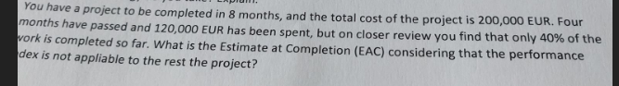
8 months, total cost = 200.000
4 months, 120.000 spent, only 40% done
EAC = ? knowing that performance index does not apply to the project.

EAC_2 = AC + (BAC – BCWP)
BAC = 200.000
ACWP = 120.000
BCWP = 40%*200.000 = 80.000
EAC_2 = ACWP + (BAC – BCWP)
EAC_2 = 120.000 + (200.000 – 80.000) = 240.000

