SUBIECTE 2020

COST
1.
BAC = $100.000 for 10 days project
Day 6, 70% performed, 65.000 spent
- BCWS = 6 / 10 * 100.000 = 60.000
- BCWP = 70% * BAC = 70.000
- ACWP = 65.000
EV = BCWP = 70.000
BAC = 100.000
CPI = BCWP / ACWP = 70.000 / 65.000 > 1 => under budget
SPI = BCWP / BCWS = 70.000 / 60.000 > 1 => ahead of schedule
2.
EV = BCWP = 600
AC = ACWP = 650
PV = BCWS = 560

SV = BCWP – BCWS = 600 – 560 = 40 > 0 => ahead of schedule
CV = BCWP – ACWP = 600 – 650 = -50 <0 => over budget
CPI = BCWP / ACWP = 600 / 650 = 0.92 <1 => over budget

3.
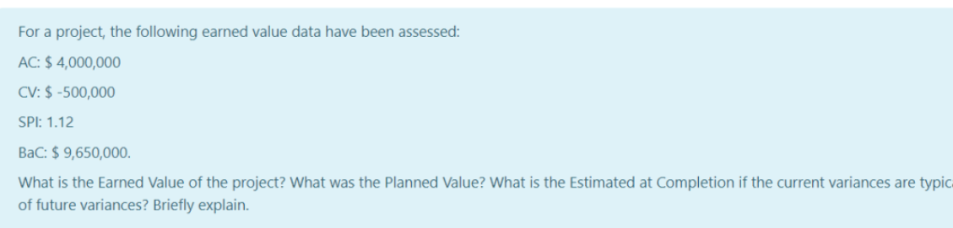
AC = ACWP = 4.000.000
CV = BCWP – ACWP = -500.000 => BCWP = CV + ACWP = 3.500.000
SPI = BCWP / BCWS = 1.12 => BCWS = BCWP / SPI = 3.125.000
BAC = 9.650.000

EV = BCWP = 3.500.000
PV = BCWS = 3.125.000
CPI = BCWP / ACWP = 3.500.000 / 4.000.000 = 0.875
Variance typical =>
EAC_3 = AC + (BAC – BCWP)/CPI
= 4.000.000 + ( 9.650.000 – 3.500.000 ) / 0.875 =~ 11.028.571

5.
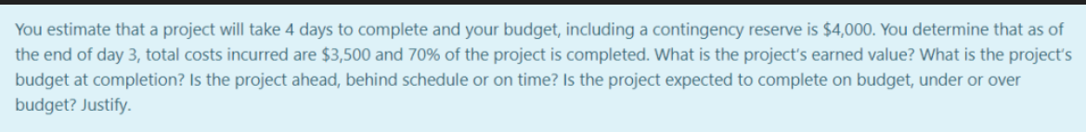
4 days, 4000
Day 3, 3500, 70%
BAC = 4000
BCWS = ¾ * 4000 = 3000
BCWP = 70% * 4000 = 2800
ACWP = 3500

EV = BCWP = 2800
BAC = 4000
SPI = BCWP / BCWS = 2800 / 3000 < 1 => behind schedule
CPI = BCWP / ACWP = 2800 / 3500 < 1 => over budget

6.
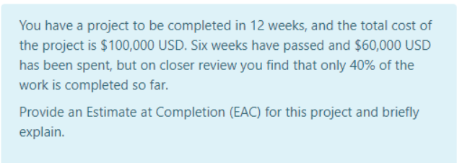
12 weeks
Total cost 100.000
6 weeks passed, 60.000, 40% done

BAC = 100.000
BCWS = 6/12 * 100.000 = 50.000
BCWP = 40% * 100.000 = 40.000
ACWP = 60.000
Performance index will remain the same =>
EAC_3 = ACWP + (BAC – BCWP) / CPI
CPI = BCWP / ACWP = 4/6 = 2/3 < 1 => over budget
EAC_3 = 60.000 + (100.000 – 40.000) * 3/2 = 150.000

NETWORK DIAGRAMS

1.
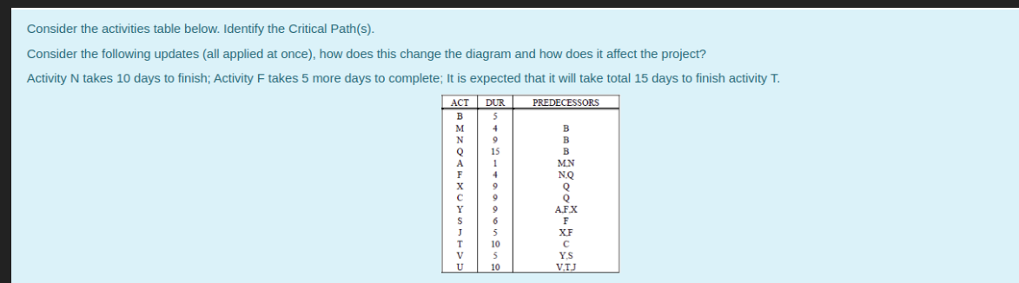
Possible critical paths:
1) B M A Y V U =34
2) B N A Y V U = 30
3) B N F Y V U = 43
4) B N F S V U = 39
5) B N F J U = 33
6) B Q F Y V U = 48
7) B Q F S V U = 45
8) B Q F J U = 39
9) B Q X Y V U = 53 -> critical path
10) B Q X J U =44
11) B Q C T U = 49

If n takes 10 days to finish => add 1 to all containing N
- 35
- 31
- 44
- 40
- 33
If F takes 5 more days, add 5 to all containing F
3) 49
4) 45
5) 38
6) 53
7) 50
8) 44
If T takes 15 days, add 5 to paths containing T
11) 54 => NEW CRITICAL PATH => B Q C T U

3.
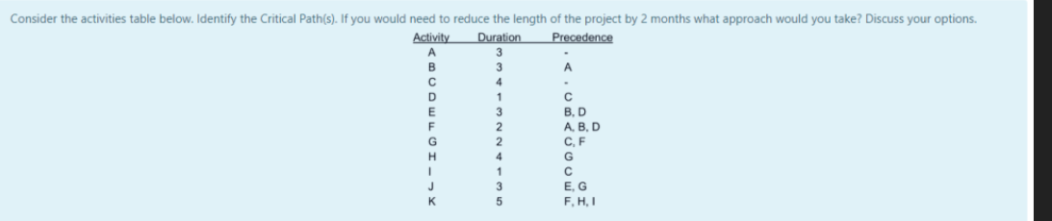
Possible critical paths:
A F K = 3+2+5 = 10
A F G J = 3+2+2+3 = 10
A F G H K = 3+2+2+4+5 = 16
A B F G J = 3 + 3+ 2 + 2+ 3 = 13
A B F G H K = 3+3+2+2+4+5 = 19 -> critical path
A B E J =3+3+3+3=12
C D F G J =4+1+2+2+3=12
C D F G H K = 4+1+2+2+4+5=18 -> ALMOST critical path
C D E J = 4+1+3+3 = 11
C G J = 4+2+3 = 9
C G H K = 4+2 +4+5=15
C I K = 4+1+5 =10

Reduce length by 2 months => reduce something on the critical path, BUT we have to take care that the activity that we want to reduce should also be on the almost critical path because if not, we will not reduce the duration of the project by 2 months, just by 1.
- We can reduce 2 months from: F G H K => For example reduce 2 months from K.

4.
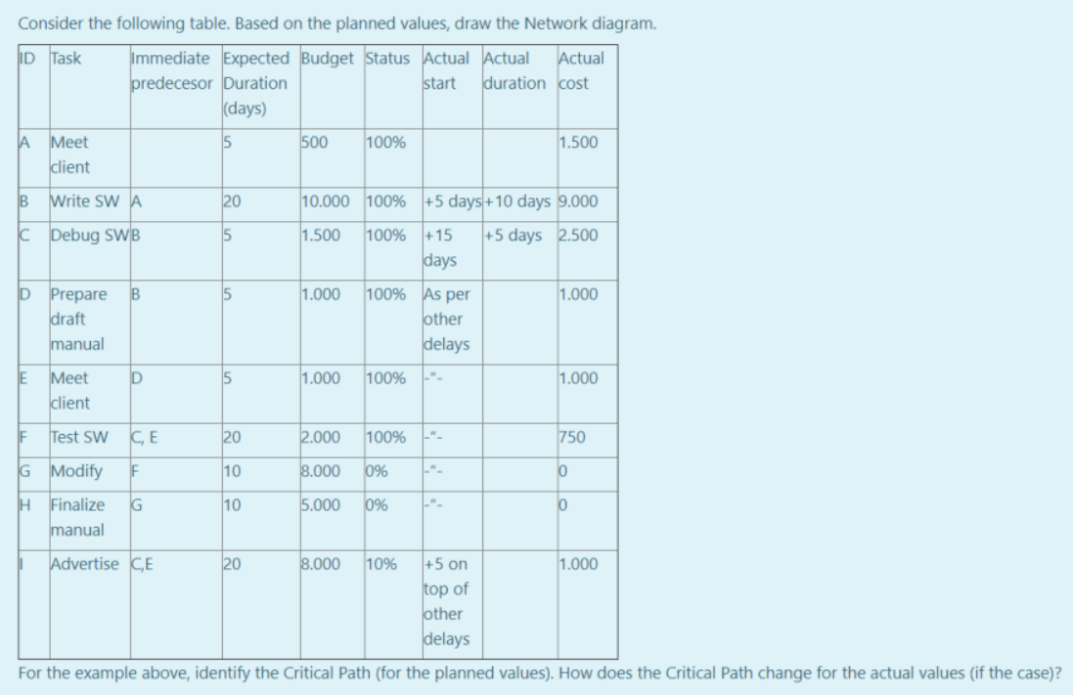
Critical path :
A B D E F G H = 5+20+5+5+20+10+10=75
Considering planned values:
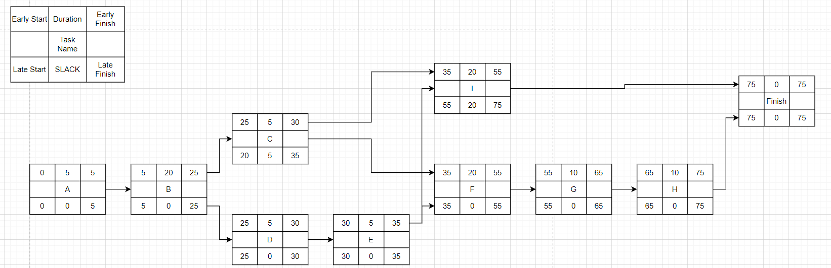
Considering actual values:.
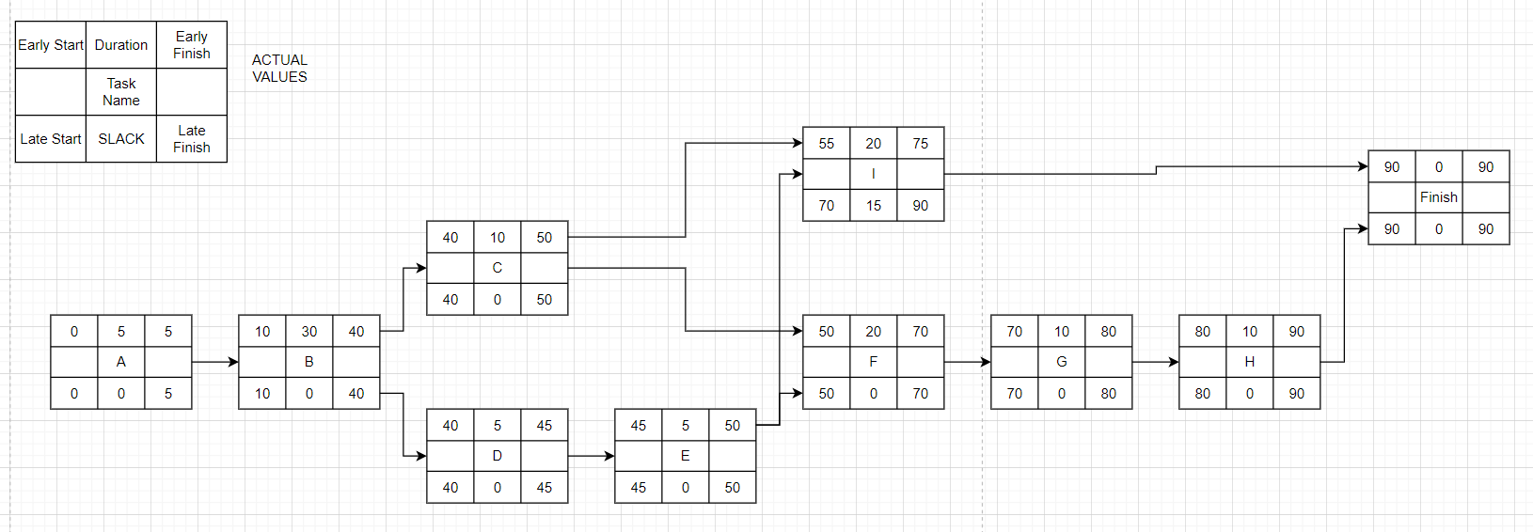
We have 2 critical paths now.
A B C F G H
A B D E F G H

END OF WEEK 13 => DAY 91 => project is DONE
BCWS = 500 + 10 000 + 1 500 + 1 000 + 1 000 + 2 000 + 8 000 + 5 000 + 8 000 = 37 000
BCWP = 500 + 10 000 + 1 500 + 1 000 + 1 000 + 2 000 + 10% * 8 000 = 16 800
ACWP = 1 500 + 9 000 + 2 500 + 1 000 + 1 000 + 750 + 1 000 = 16 750
SPI = BCWP / BCWS = 16.800 / 37.000 <1 => behind schedule
CPI = BCWP / ACWP = 16800 / 16750 >1 => under budget

5.
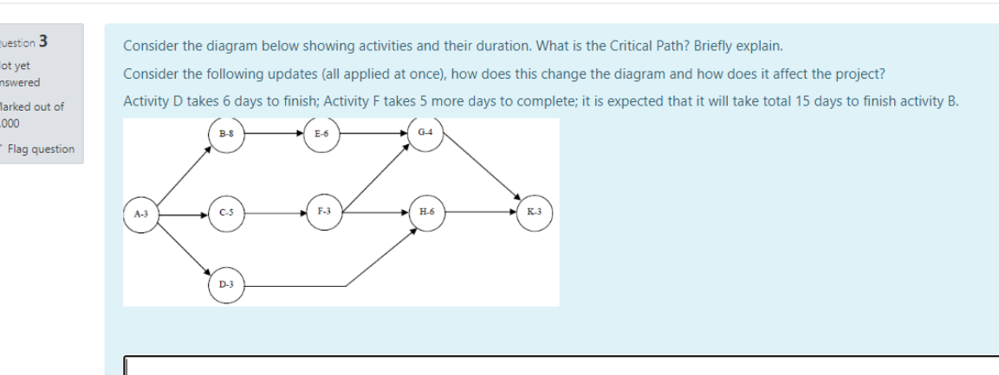
Possible critical paths:
- A B E G K =3+8+6+4+3=24 => Critical path
- A C F G K =3+5+3+4+3=18
- A C F H K =3+5+3+6+3=20
- A D H K =3+3+6+3=15
IF D takes 6 days => add 3 to 4) => 18
IF F takes 5 more days => add 5 to 2) and 3) => 2) 23, 3)25
IF B takes 15 days => add 7 to 1) => 1) 31
Same critical path, ABEGK (length 31)

7.
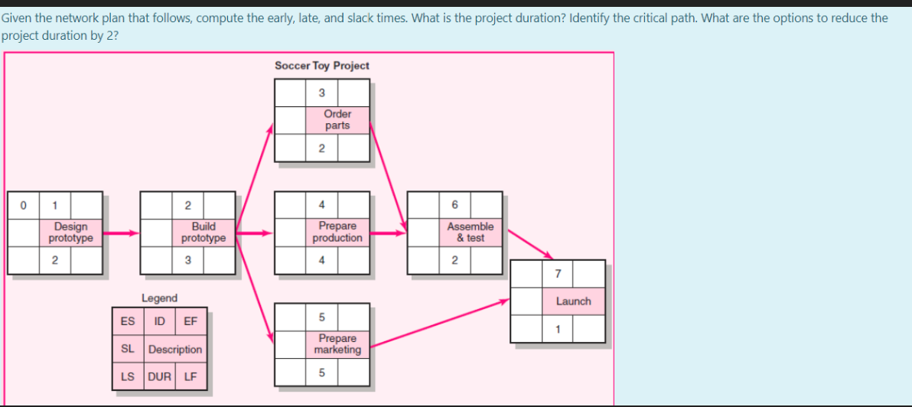

Possible critical paths:
1 2 3 6 7 = 2+3+2+2+1=10
1 2 4 6 7 = 2+3+4+2+1=12 -> critical path.
1 2 5 7 = 2+3+5+1=11
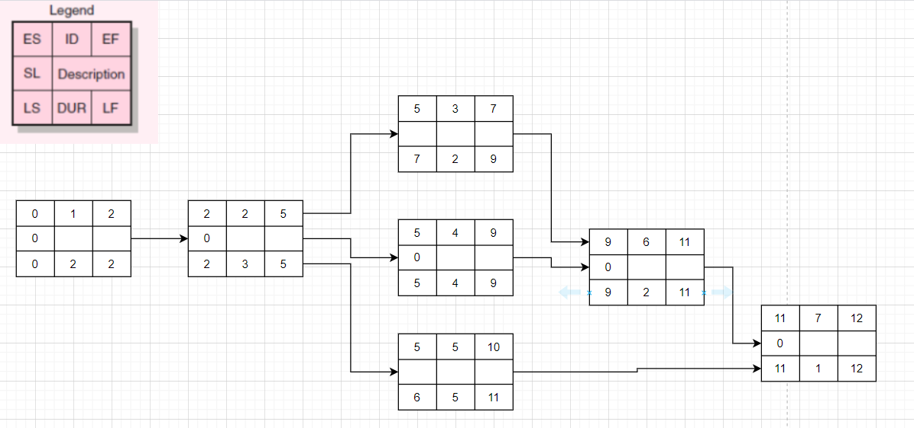
In order to reduce project duration by 2 we have to reduce 1 activity from the critical path.
Lets choose to reduce activity with ID =2 because it is present in all 3 possible paths and it does not modify the critical path format in this way.

PLAN_DRIVEN vs AGILE
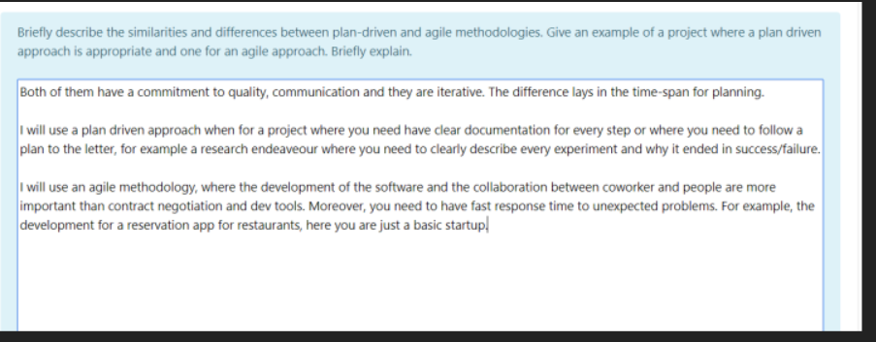
Both plan-driven and agile are methodologies that have as ultimate goal to ease the creation of projects. They basically offer some tips, some steps, some guidelines in order to successfully create and develop a certain project.
The similarities between the two refer to the fact that both of them have a commitment to quality, which refers to the quality of the final product, both of them are communication oriented and both of them are iterative. In addition, both of them take into account risks and try to manage them.
The differences between the two refer to the level of formalism and the time-span for planning.
The plan-driven approaches tend to have a planning session that takes far more time and the documentation created is more formal and rigorous. Agile approaches are not so rigorous, the time for planning is shorter and they are open to change anytime during the project.
For a plan-driven approach, an example project would be an online scraping application which would scrape data from different websites about certain dangerous people for example. The scraper would run daily, X times a day, for Y minutes and would perform the needed searches. All these would be documented very well and under control. The requirements of the system won’t change very often because the scraping websites tend to remain the same and also the data that the scrapers gather will still be the same (for example, name, family, job, salary etc).
For an agile approach, an example project should be open to change any time and with fast response to that change. Such a project could be some sort of personal trainer application in which the user should input what part of the body to exercise and the application should provide meaningful exercise for that part. If not provided, the application could have a default training routine to display to the user.

PROJECT PROCESS
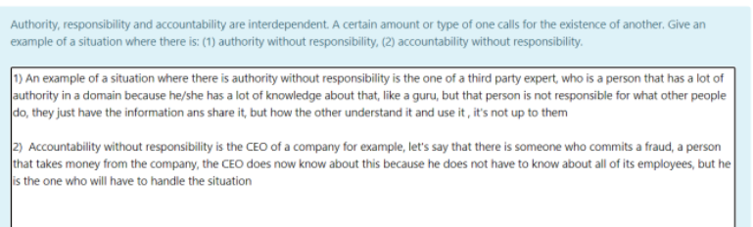
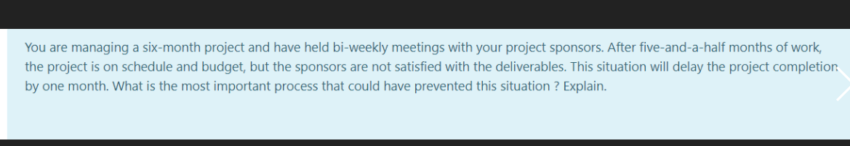

RISK
Mitigation – money on training for example so the people working at this could know more and so design the system so the components would integrate perfectly
Contingency - back up plan, keep the money until you really need to use them => if risk happens invest something and solve the issue by some refactoring or some kind of work-around
Transfer – assign the task to somebody else or some third party

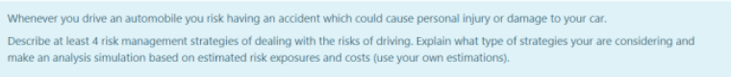
Lets assume that we drive a 100.000 car. Since the car was so expensive, it is pretty safe for the driver. So, let’s say that in an accident I don’t get hurt. But the car gets destroyed.
Taking into account regular accidents in town, let’s say that the reparation cost can go as high as 50.000. The probability of that happening would be 20% (I am quite an experienced driver)
EXPOSURE = 50.000 * 20% = 10.000

Lets take into account 4 risk management strategies: avoidance, mitigation, acceptance and transfer.
If we just accept the risk, that’s it, if it happens it happens. The good news is that if it is not my fault for the accident I will get the car repaired on the other guy’s RCA. But, if it is my fault, I have to repair my car, 10.000 and probably the other person’s car, let’s say 10.000 more => 20.000
If we try to avoid the risk, let’s say we forget about the car and take a walk. We can’t take walks every time… or use the public transport every time, because we are in a hurry. Taking walks would cost us at least 20.000 because we will always be late for things (for example let for job, do this several times and you will not have a job anymore => COST = 30-40.000)
If we try to mitigate the risk we can just drive safer or add some extra protection options on the car and on the insurance (for both life and car) => this would cost about 15-20.000
If we try to transfer the risk => we can hire a driver for us (we got a $100.000 car so we can afford a driver). We pay the driver 5000 and if something bad happens its his responsibility.
In this case, the best alternative is to hire a driver for you because it costs less.

USE CASE POINTS
Ceva nebunie

