SUBIECTE 2021
1.
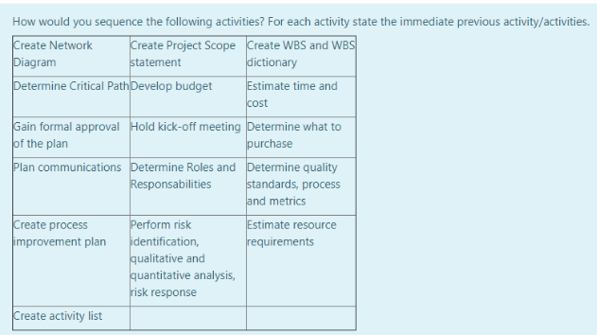
Let’s first see what the predecessors of each activity should be
Create Network Diagram | Create Activity List
Create Project Scope | -
Create WBS and WBS dictionary | Determine Quality Standards
Determine Critical Path | Create Network Diagram
Develop Budget | Estimate Time and Cost
Estimate Time and Cost | Determine What to Purchase
Gain Formal approval of the plan | Plan communication
Hold kick-off meeting | Gain formal approval of the plan
Determine what to purchase | Estimate resource requirements
Plan communications | Determine Roles and responsibilities
Determine Roles And Responsibilities | Estimate Time and Cost
Determine quality standards, process and metrics | Create project scope statement
Create Process Improvement Plan | Determine quality standards, process and metrics
Perform Risk Identification | Develop Budget
Estimate Resource requirements | Determine Critical Path
Create activity List | Create WBS

Activity | Previous activity
Create Project Scope Statement | -
Determine Quality Standards, process and metrics | Create Project Scope Statement
Create WBS and WBS dictionary | Determine Quality Standards, process and metrics
Create activity List | Create WBS and WBS dictionary
Create Network Diagram | Create activity List
Determine Critical Path | Create Network Diagram
Estimate resource requirements | Determine Critical Path
Determine what to purchase | Estimate resource requirements
Estimate time and cost | Determine what to purchase
Develop budget | Estimate time and cost
Perform risk identification, .... | Develop budget
Determine roles and responsibilities | Perform risk identification, ....
Plan communications | Determine roles and responsibilities
Gain formal approval of the plan | Plan communications
Create Process improvement plan | Gain formal approval of the plan
Hold kick-off meeting | Gain formal approval of the plan

2.
I think that the most important process the could have prevented this is the Continuous Delivery Process. This process would have assured the fact that the sponsors get the project at different stages and functioning standards weekly or so (depending on sprint time).
Having this opportunity, the sponsors could have said earlier that the product does not comply with their standards and some changes could have been done.
This leads us to the Continuous Delivery Agile process (embrace change) which could have also solved this situation.
Another process that could have prevented the incident is the QA process in which the product is tested and the “quality of the product is assured” meaning that the requirements (both functional and non-functional) have been checked and the system meets the requirements.

3.
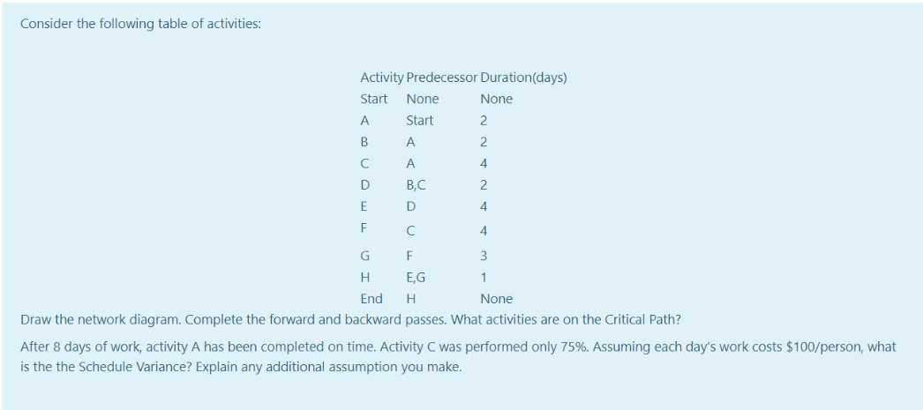
Possible critical paths:
A B D E H =2+2+2+4+1=11
A C D E H =2+4+2+4+1=13
A C F G H =2+4+4+3+1=14 => CRITICAL PATH
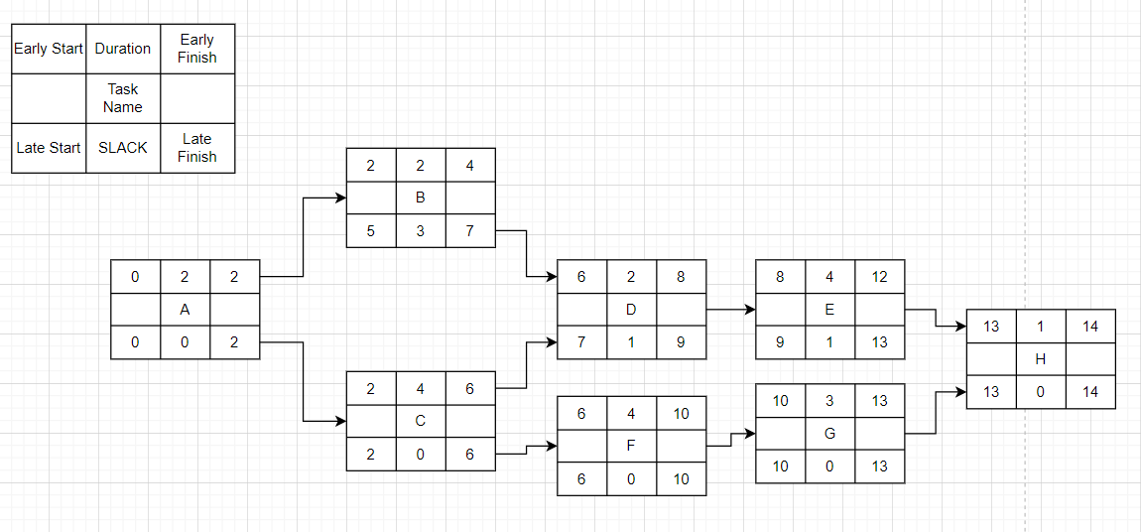
8 days passed, A completed, C only 75%
100/person/day

Scheduled: 8 days => 800/person , solve A, solve C, solve F 50% => BCWS = 800
Actual: 8 days => 800/person, solved A, solved C 75% => BCWP = 500 ( because, A=2 days => 200, 75%C = 3 days => 300)
SV = BCWP – BCWS = 500 - 800 = -300 <0 => behind schedule
4.
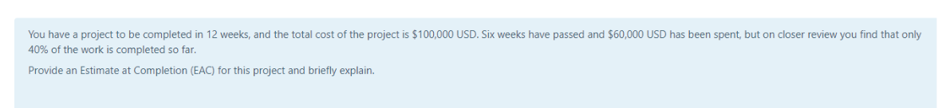
12 weeks, 100.000
6 weeks passed, 60.000 spent, 40% done
BAC = 100.000
BCWS = 6/12 * 100.000 = 50.000
BCWP = 40% * 100.000 = 40.000
ACWP = 60.000
SPI = BCWP / BCWS = 40.000 / 50.000 <1 => behind schedule
CPI = BCWP / ACWP = 40.000 / 60.000 <1 => over budget
For EAC assume the same performance index as until now.
EAC = ACWP + (BAC – BCWP)/CPI = 60.000 + (100.000 – 40.000) *3/2 =~ 150.000 (150.909–with 0.66)
5.
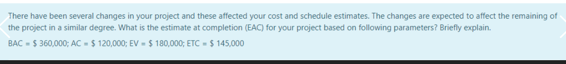
BAC = 360.000
AC = ACWP = 120.000
EV = BCWP = 180.000
ETC = 145.000

EAC = actuals to date + new estimate for remaining work
EAC = AC + ETC = 265.000

Or
CPI = BCWP / ACWP = 180.000 / 120.000 = 3/2 => under budget (>1)
EAC = AC + (BAC - BCWP)/CPI
= 120.000 + (360.000 – 180.000) * 2/3 = 240.000

6.
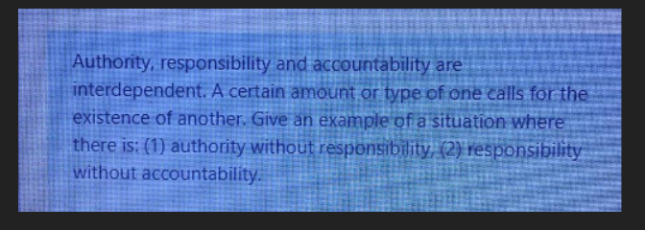

- Authority without responsibility

For example, an expert consultant which is not part of the organization has authority in his/her domain (knows a lot) but it is not responsible.

- Responsibility without accountability

From RACI we can say that the project team has the responsibility to take part in the project planning but the team is not accountable for that plan. The project manager is accountable for that one.

- Accountability without responsibility
For example, the General Manager of a company is accountable for everything that happens to the company. Lets say that an employee breaks some system of something in the company/organization. The one that is accountable for that is the manager, even if he was not the one responsible for the bad action.

7.
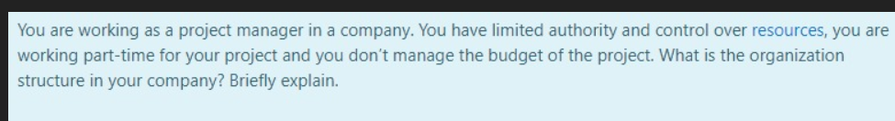
The organizational structure is weak matrix.
In such a structure, the Project Manager has limited authority and control over the resources, and works part-time.
Moreover, the budget is controlled by the Functional Manager.
8.
Use-cases:
- View depth information gathered from stereo video sequence
- View obstacles in the path
- Detect stop signs, traffic lights and dangerous situations which could imply an accident
UUCW
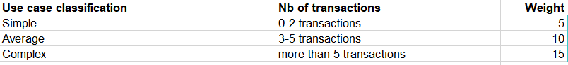
- UC1 -> simple
- UC2 -> average
- UC3 -> complex
- UUCW = 1*5 + 1*10 + 1*15 = 30
UAW
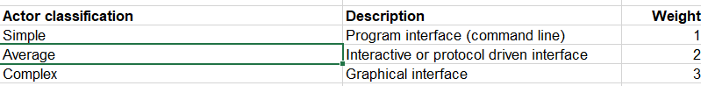
Only 1 actor, the end user, operates the application via cmd => UAW = 1
TCW

9.
CPI = ?
CPI = BCWP / ACWP
BCWS = 2
BCWP = 75% * 2 (the original task was for 2 persons) = 1.5
ACWP = 1 (only 1 person assigned to do the task)
CPI = 1.5 /1 = 1.5 => under budget (>1)
SPI = BCWP / BCWS = 1.5 / 2 = 0.75 => behind schedule (<1)

10.
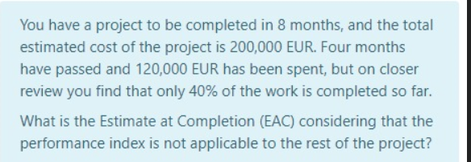
8 months, 200.000 total cost
4 months passed, 120.000 spent, 40% work done
Performance index not applicable => EAC_2
BAC = 200.000
BCWS = 4/8 * 200.000 = 100.000
BCWP = 40% * 200.000 = 80.000
ACWP = 120.0000
EAC = ACWP + (BAC – BCWP) = 120.000 + 120.000 = 240.000
11.
EV = BCWP = 600
AC = ACWP = 650
PV = BCWS = 560

SV = BCWP – BCWS = 600 – 560 = 40 > 0 => ahead of schedule
CV = BCWP – ACWP = 600 – 650 = -50 <0 => over budget
CPI = BCWP / ACWP = 600 / 650 = 0.92 <1 => over budget

12.
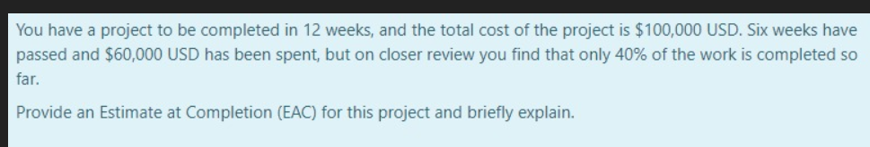
12 weeks
Total cost 100.000
6 weeks passed, 60.000, 40% done

BAC = 100.000
BCWS = 6/12 * 100.000 = 50.000
BCWP = 40% * 100.000 = 40.000
ACWP = 60.000
Performance index will remain the same =>
EAC_3 = ACWP + (BAC – BCWP) / CPI
CPI = BCWP / ACWP = 4/6 = 2/3 < 1 => over budget
EAC_3 = 60.000 + (100.000 – 40.000) * 3/2 = 150.000

13.
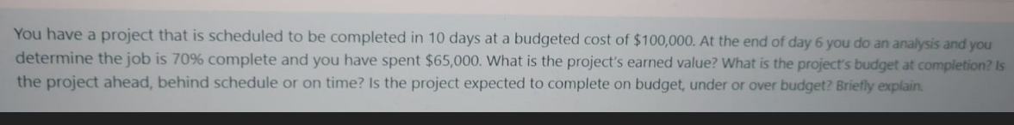
BAC = $100.000 for 10 days project
Day 6, 70% performed, 65.000 spent
- BCWS = 6 / 10 * 100.000 = 60.000
- BCWP = 70% * BAC = 70.000
- ACWP = 65.000
EV = BCWP = 70.000
BAC = 100.000
CPI = BCWP / ACWP = 70.000 / 65.000 > 1 => under budget
SPI = BCWP / BCWS = 70.000 / 60.000 > 1 => ahead of schedule

14.
4 days, 4000
Day 3, 3500, 70%
BAC = 4000
BCWS = ¾ * 4000 = 3000
BCWP = 70% * 4000 = 2800
ACWP = 3500

EV = BCWP = 2800
BAC = 4000
SPI = BCWP / BCWS = 2800 / 3000 < 1 => behind schedule
CPI = BCWP / ACWP = 2800 / 3500 < 1 => over budget

15.
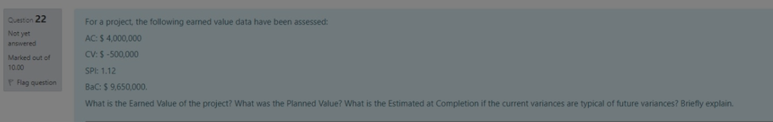
AC = ACWP = 4.000.000
CV = BCWP – ACWP = -500.000 => BCWP = CV + ACWP = 3.500.000
SPI = BCWP / BCWS = 1.12 => BCWS = BCWP / SPI = 3.125.000
BAC = 9.650.000

EV = BCWP = 3.500.000
PV = BCWS = 3.125.000
CPI = BCWP / ACWP = 3.500.000 / 4.000.000 = 0.875
Variance typical =>
EAC_3 = AC + (BAC – BCWP)/CPI
= 4.000.000 + ( 9.650.000 – 3.500.000 ) / 0.875 =~ 11.028.571

16.
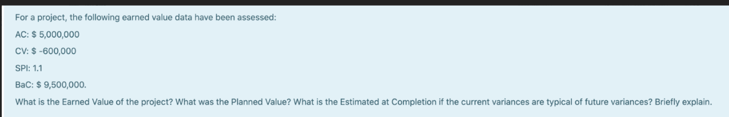
Same as 15.

WBS

