[2014, 2013] Give an example and explain shortly the following GUI (Graphical User Interface) development concept:
- Dialogue independence
  - Can develop the interface independent of the application
  - EXEMPLU: Front-backend web app.
  - Functional component mainly contains knowledge modelling. Used to properly convey data from users from the interactive part.
  - Dialog def – external dialogue; Dialog execution – internal dialogue->functional
  - Internal dialogue done via Data Structures

- Representation techniques
  - Provide a more detailed interaction between user and system
  - BNF, Regex, Context-free grammars, Multi-party grammar, State transition diagram, User action notation (async), Event based representation (async)
  - The interaction is presented a set of derivation rules
  - MPG – is a synchronous representation; Is a seq dialogue
- Control structures
  - how we can control how the code flows through our program based on a number of factors.
  - Can be based on seq and async dialogue
  - Functional/interface dominant control: who dictates what states the user goes through
In partea de dialog: userul dicteaza prin clickuri, selectii ce sa faca sistemul
In partea computationala: o bucla unde se executa operatii, de exemplu sistemul citeste sensori si afiseaza in partea de dialog?

Mixed/balanced: o bucla care se executa si in partea de dialog si in partea computationala
La balanced se poate controla raportul dintre dialog/partea computationala ?

Local/global: (control global al intregului ciclu?)
Sincron/asincron:

- Structure modelling
  - Separated into Task models and Structure Descriptions
  - GOMS:
    - GOALS, OPERATORS, METHODS, SELECTION RULES
    - GOALS: final state that user wants to reach
    - OPERATORS: low-lvl actions
    - METHODS: a seq of operators that reach a goal
    - SELECTION RUcontLES: IF THEN operation that chooses between methods to reach a goal
  - CLG (Command Language Grammar)
    - 3 levels: Conceptual, Communication, Physical
    - Based on tasks: things the user NEEDS to do
    - Semantic lvl: specifies operators that work with entities
    - Syntactic lvl: Command lang used by the user to communicate with the sys
    - Interactional lvl: Physical actions that are associated with the syntactic components.
    - Spatial layout lvl; Device lvl
  - TAG
    - TASK ACTION GRAMMAR
    - Similar to BNF; Has parameters for specifying a consistent order of arguments
    - Feature based representation of tasks
    - Generates necessary actions in order to complete certain tasks
    - Analyses the cognitive lvl of the user
  - Linguistic model
    - Languages based dialogue
    - 4 lvls: Conceptual/Semantic/Syntactic/Lexical
  - Non-Linguistic model
    - Has propter, user input, echo, value

[2014, 2013, 2012, 2010] Define, exemplify and explain for GUI:
- Event based interaction cycle
  - Has prompter (puts user in context) (ex. Button from a page), input (from the user)(user clicks button), symbol (what to tell the system) (user pressed specific button), echo (output of the sys), value (what is sent to the functional part)
  - Event based means that the cycle is triggered by a user event
EXEMPLU: orice aplicatie web care se triggeruieste cand userul face ceva
- Presenter concept / Presenters of the output communication concepts
  - Transform the sys output into an “image”
  - “Image” -> abstract representation of an output communication concept
  - Ex. Speedometer that can show the speed from 0-200
  - Presenter domain: the values that can be represented by the presenter
  - Knowledge is necessary in order to represent the next state according to the current one.
  - Domain knowledge is necessary in order to represent the domain in a suggestive manner.
EXEMPLU: speedometer
- Continue refresh output communication model
At a given timer the whole scene is reloaded -> bad cause sometimes work is done even if is not needed/ only good when we have a lot of changes
Functional part – less to do -> slower
EXEMPLU: video games, useful when a lot of content has been updated, not useful when displaying a static image
- Message based output communication model
Change occurs only when needed – the presenter does the change
EXEMPLU: Increase the speed with 50
Functional part – more to do -> faster
- Input gathering communication concept
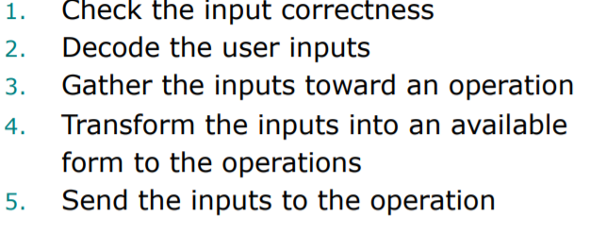
- User input processing by Recognizer and Command modules. tactic forms of user inputs.
Syntactic forms = prefix, infix, postfix

INFIX: select object MOVE to folder`
PREFIX: SET object
POSTFIX: object DELETE

- Invocation input communication concept

Set color red -> Ok (button): pana cand nu dau click comanda e inactive

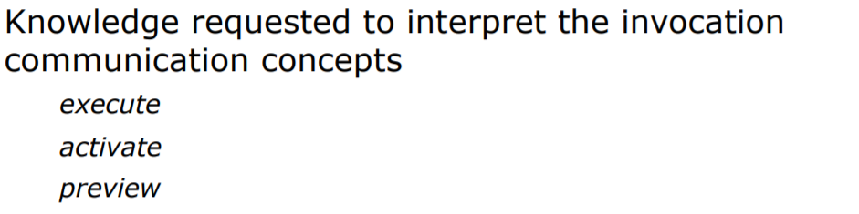

[2014, 2013, 2012, 2010] Explain a technical solution to implement in GUI the following features:
Can be found in slides + own thinking
- Preview – only in the interactive component(clone the state locally)
Preview: set color table blue (acum e red, in preview o vad albastra, dupa o perioada de timp se face iar red)
- Alternative inputs based on knowledge requested by command modules

- Alternatives for user inputs
- E.g. muti calul intr-un punct si daca e eroare, sa iti semnaleze alte variante, sa highlighuiasca variantele

- Undo - also in the functional component (stack/clone the state) -> reversible operation/irreversible operation (clonezi aplicatia, replicate the operation)
- Possible inputs based on knowledge requested by command modules
Autocomplete, Ex: Sah, highlight la mutari posibile
- Lexical, syntactical, and semantical feedback
Lexical-real time changes – building a word, e.g. type a character and it appears -> e.g. la sah, nu poti muta piesele adversarului
Syntactical – building the sentence, if the command is wrong, it tells, highlights it for example -> e.g. daca mut calul pe coloana si nu in L
Semantical – what the sentence actually means -> e.g. daca mut calul in L, insa pozitia unde vreau sa il las e ocupata
- Avoid lexical, syntactical, and semantical errors in user inputs
By validations, indications at different levels
- Correctness for user inputs (iti da un mesaj ca nu e okey, dialog box)
Validations again
- Possible user inputs (face highlight unde poti pune calul)
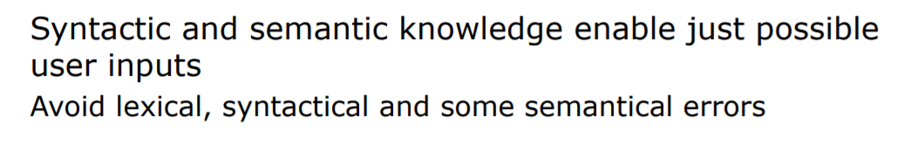
La alternative: daca vrei sa pui calul undeva unde ii ocupat, sa iti dea alternative unde sa il pui sa fie binev
[2014, 2012s, 2012, 2010] Describe and explain the following user oriented lifecycle model for GUI development highlighting their characteristics, advantages, and disadvantages:
- Scenario-Based Usability Engineering Model
  - Scenarios are detailed interaction stories
  - Formative and Summative evaluation is permitted,
  - good for low-medium projects(no going back between scenarios),
  - permits a cyclic approach inside each stage,
  - only used for prototypes(no deploy), user-centred (this is for all of them)
  - Not good for big projects (scenario-based)

- Simple Interaction Design Model
  - Flexible design, meant for experienced people,
  - has a clear starting and an end point,
  - used for smaller projects, has some order but not everywhere

- Univ. Calgary’s UID Methodology
  - No going back between stages is allowed,
  - quite detailed, good for small projects,
  - is iterative inside each stage
  - used at lab project
  - cyclic in fiecare faza
  - tells the goal in each phase

- Star Lifecycle Model
  - Real life based (=empirical)
  - Centered around evaluation (after each step)
  - Very flexible (going back is allowed if passing through eval. Stage)

- Waterfall Lifecycle Model

  - Good for bigger projects which have to be well documented,
  - Complex and heavy, low flexibility
  - Each step generates the data for the next one
  - going back only to previous stage is allowed (deduction, not verified)

- VUB model
Very detailed analysis part, no deployment part = strict for design
Can’t go back to analysis

[2014, 2013, 2012] Define and exemplify the following usability principles:
https://www.nngroup.com/articles/ten-usability-heuristics/
- Timely and accurate feedback
Ex: mouse cursor moves too slow, real time changes, accurate changes(indicate the change on the selected actions, when clicking on the brush in paint make sure to change cursor type and highlight brush and nothing else)
Accurate feedback = reprezentare cat mai sugestiva a starii interne a aplicatiei

- Error prevention
Ex: Don’t put the create button near to the delete button, have corresponding labels next to each input, additional information which helps the user understand the input type, validations, are you sure pop-ups, dialog boxes
- Match between system and real world
Ex: Metaphores: Deleting an item by moving it into the reclycle bin(metaphor), drag and drop files in order to change locations, user understandable language
- Recognition rather than recall
Ex: When editing a contact provide the existing data, when selecting a color from a pop-up/menu after finishing the selection keep the user informed of his selection, always indicate the page on where you’re currently at

[2012s, 2012, 2010] Define and exemplify for the GUI usability:
- Improvement techniques for learnability in GUI usability
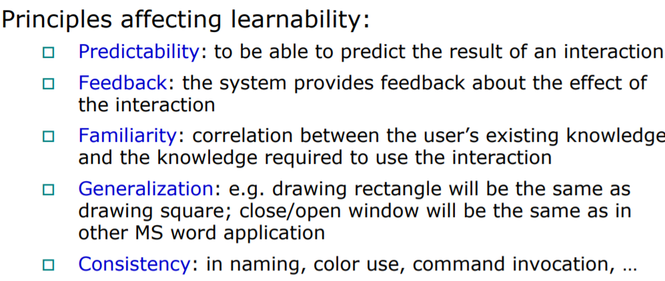
- Usability attributes
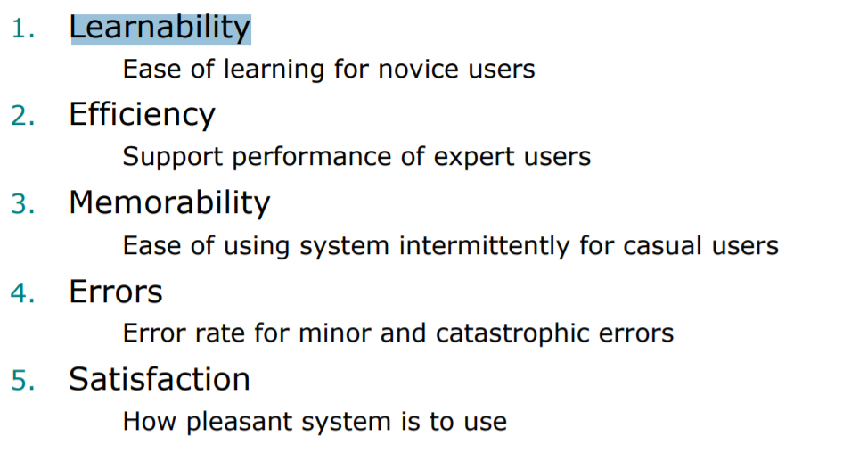
- Usability specification in GUI design
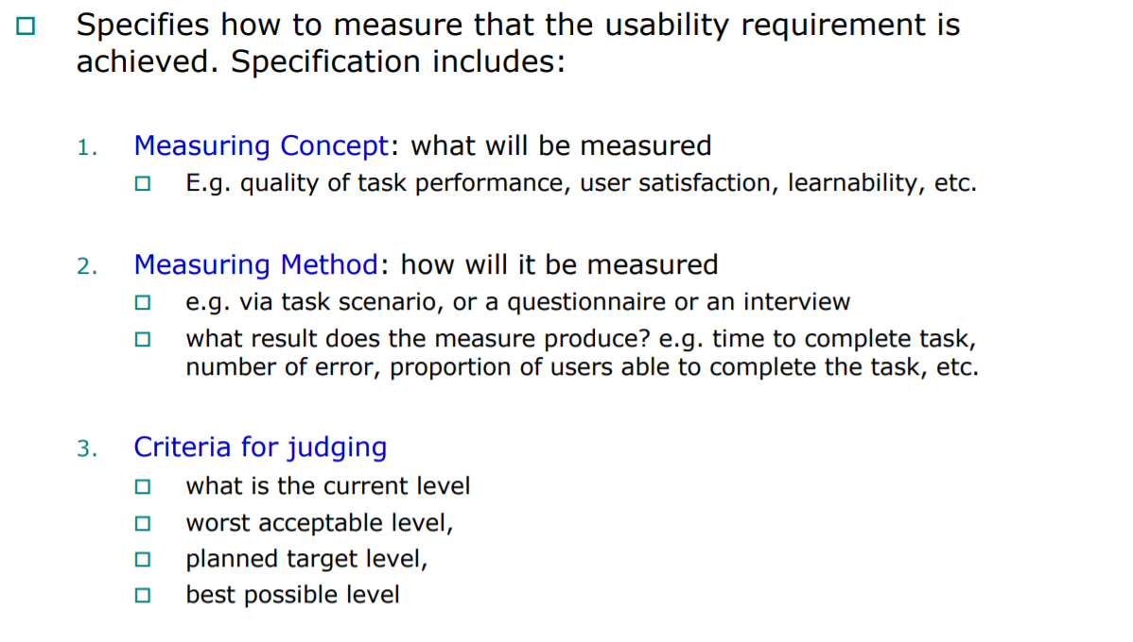

- Improvement techniques for efficiency in GUI usability
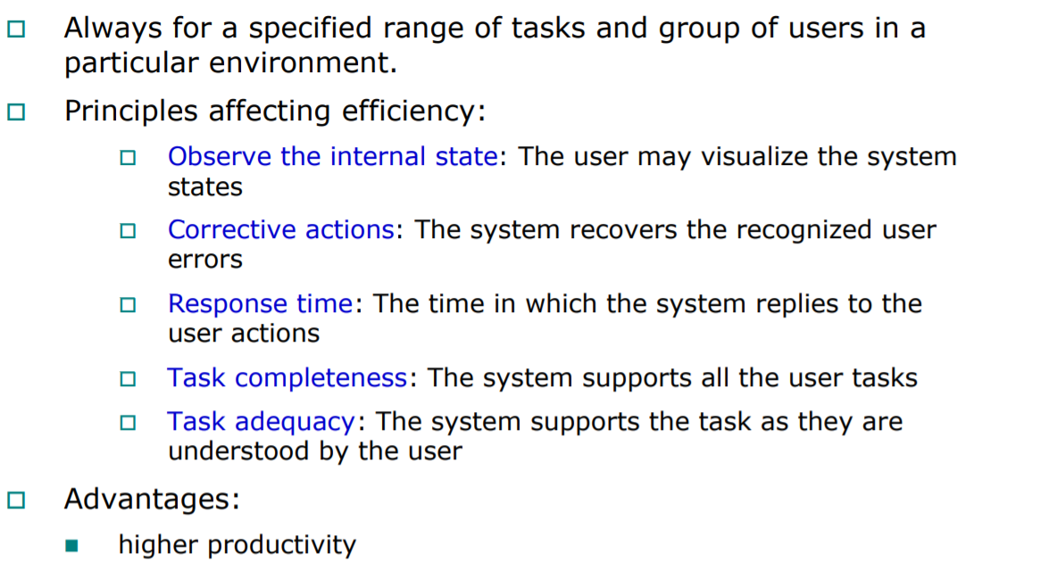
- Specification of usability evaluation in GUI development
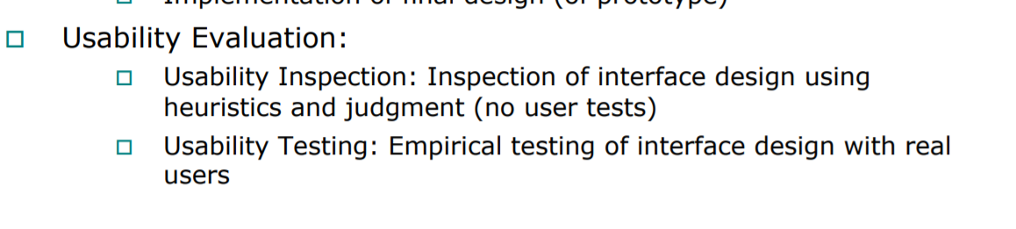
- Performance measurements for GUI usability evaluation
  - Can be many (in slides)ss
  - Need to choose what is relevant in our application and domain
Nb of tasks/ nb of errors/ time interval/ Time spent in errors/ Ratio of successes to failure, ...
- Ways to get the reference measurement levels
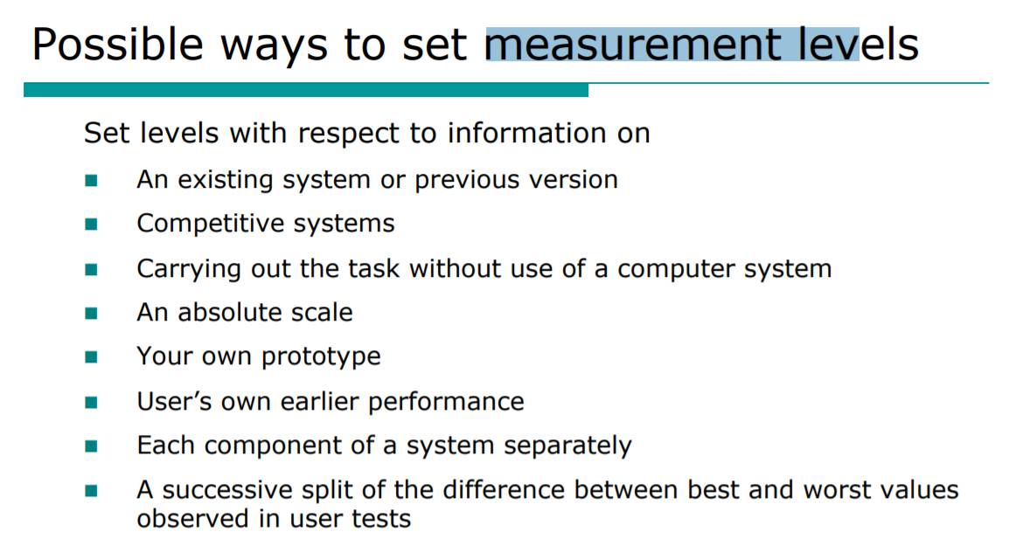
[2014, 2013] Exemplify and explain an experiment to specify and measure the usability throughout the GUI development methodology, by highlighting:
From slides directly
- Learnability
- Effenticiency
- Error previon
- Satisfaction (Stress)

(e.g. la efficiency: grupul experimentat l-a facut mai repede, userii se vor obisnui cu aplicatia iar apoi masuram cate taskuri fac complet)

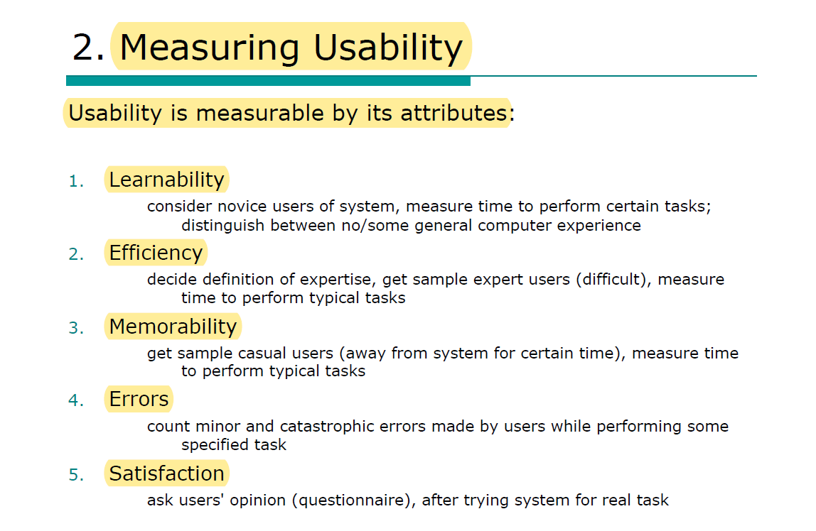

[2014, 2013, 2012, 2010] Describe and exemplify the WebQEM method. Exemplify and analyse the individual and global evaluation phases (applied to four university Web sites).
- 4 phases
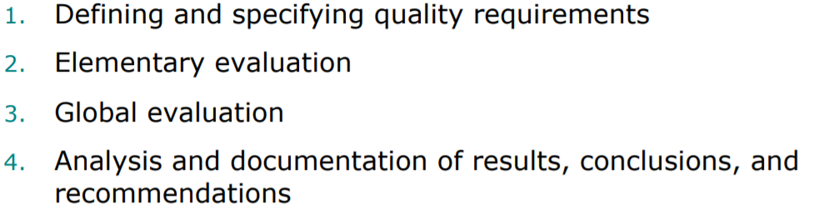

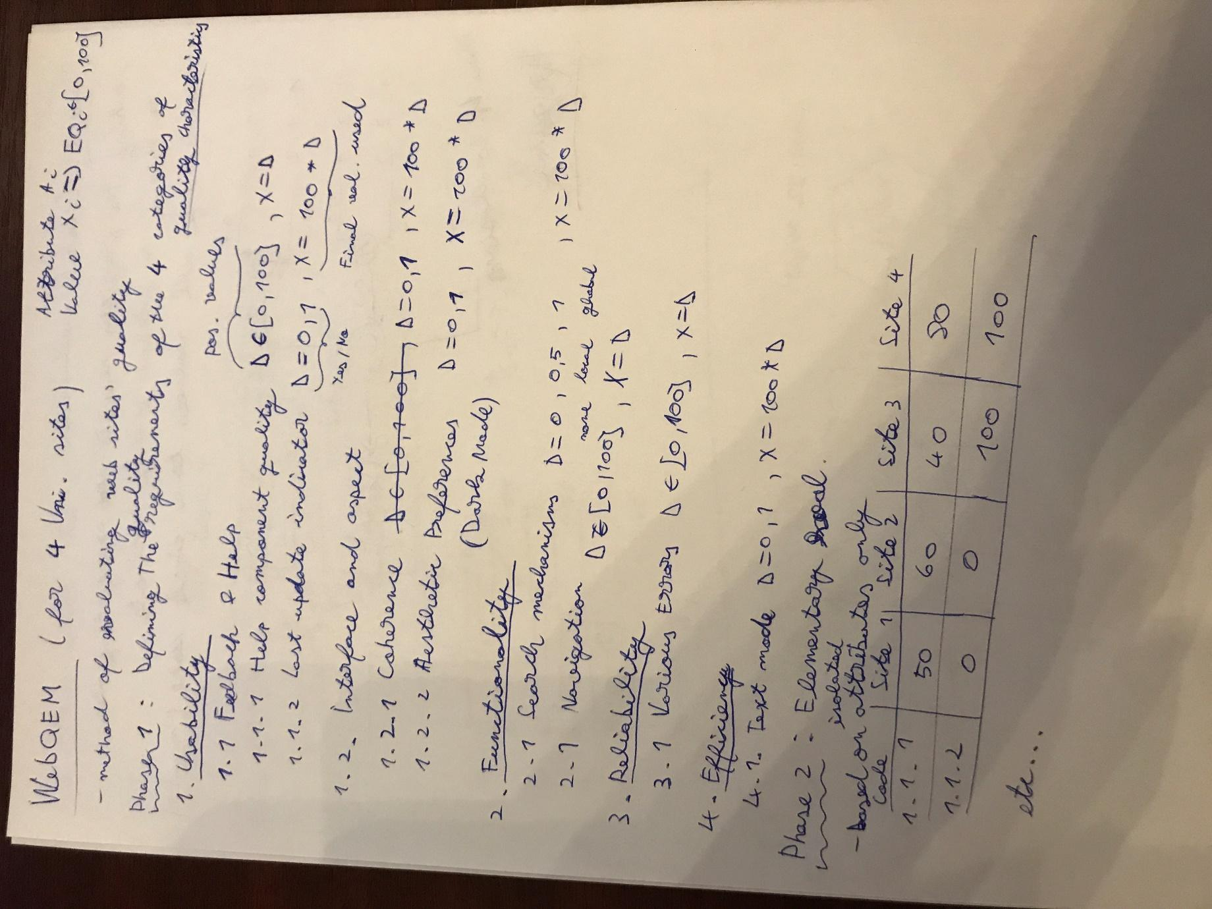

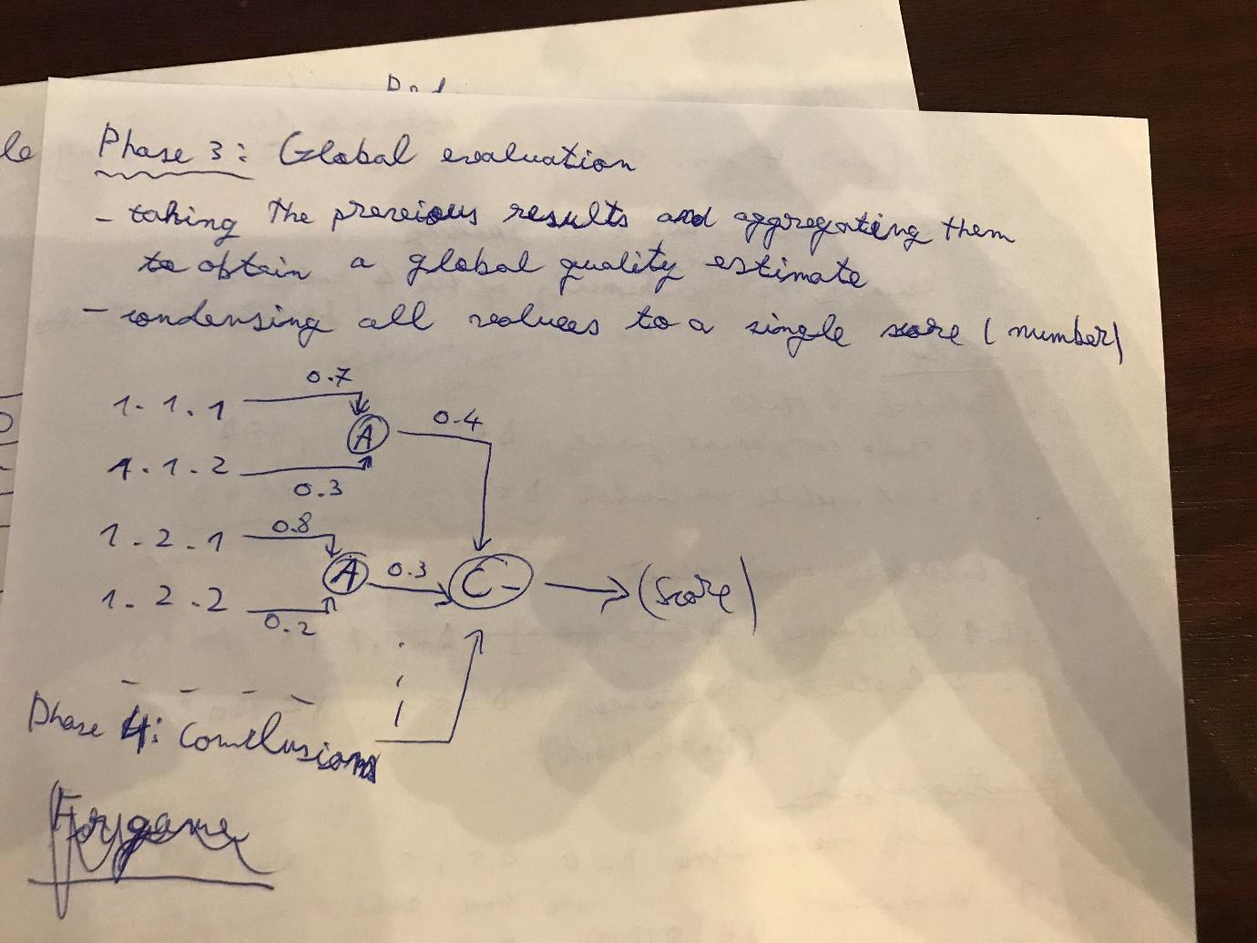

[2014, 2013] Define and exemplify the following technique of prototyping:
- Evolutionary prototype
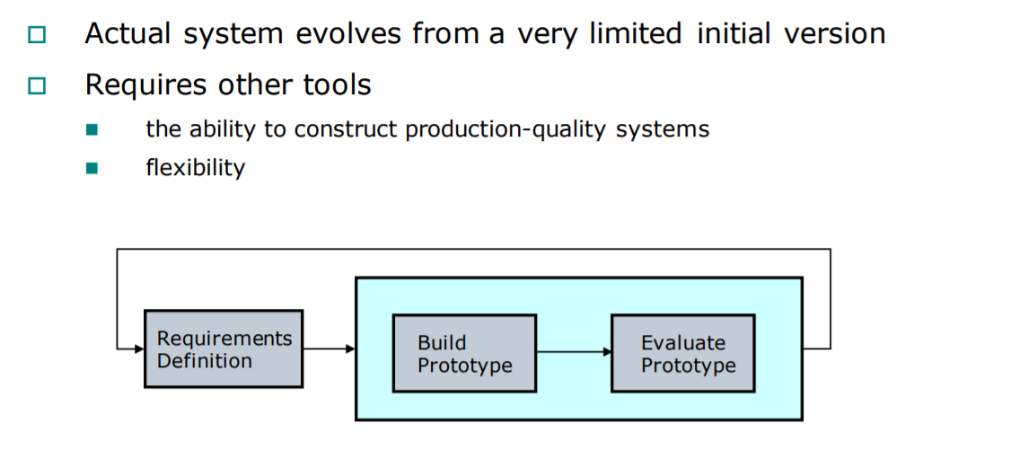
- Throwaway/ Revolutionary prototype
  - Discarding the prototype after completion
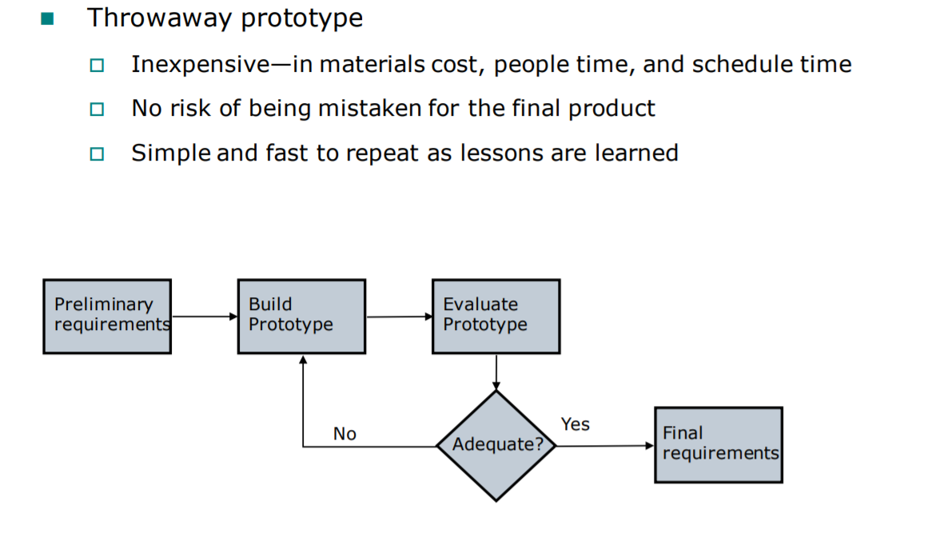
- Incremental prototype
- Daca ai ajuns pana aici… tot respectul +
- T = K log(2D/W) Fitts’s formula
- D- distance to chestie( de unde apesi pana la obiectul tau)
- W- width of object (ala pe care dam click)
- eu ma las ciao
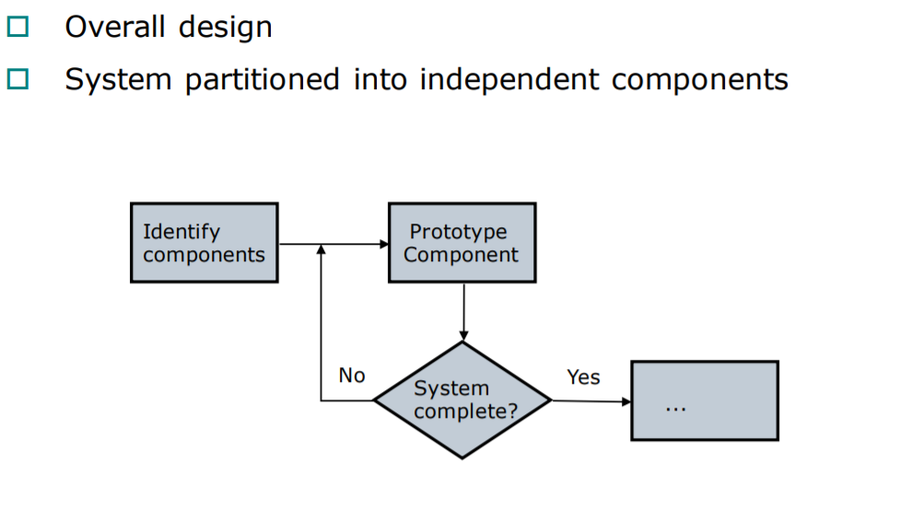

- Incremental vertical prototyping

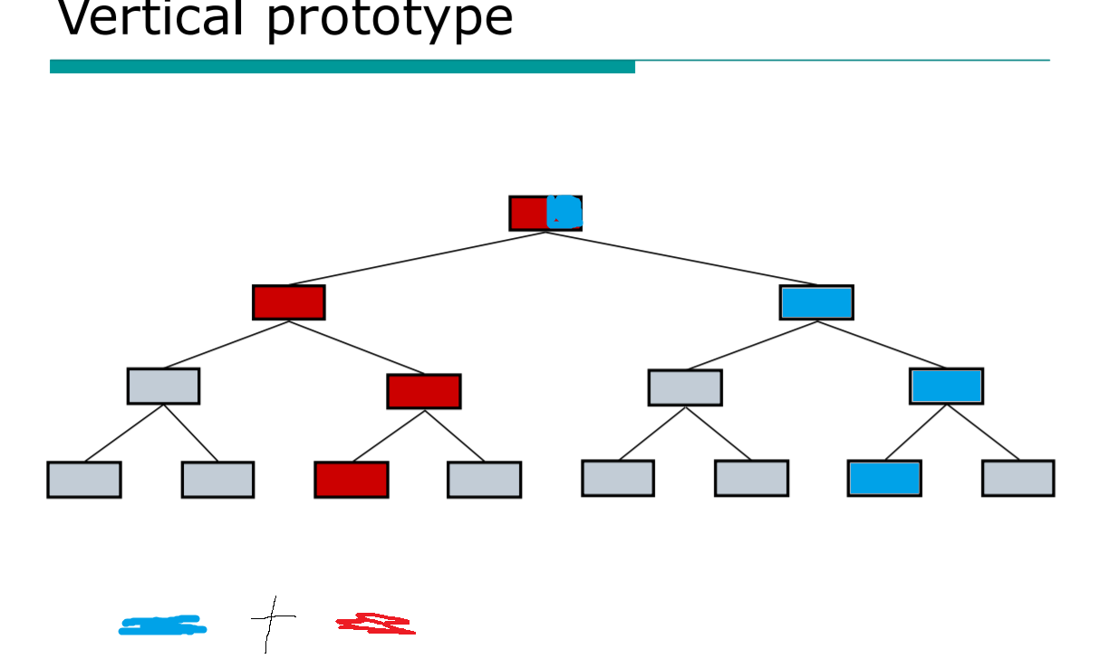

[2014, 2013] Exemplify an explain the Fitts Law based comparative evaluation of two GUI interfaces for the generic commands exemplified by:
- Move Chair to RelativePos(10, 21) than Table
  - sliders vs graphical area
  - add additional menu option of absolute and relative positioning

- Rotate Table around Position(15, 17) by 30°

- Set Color of Teapot to Green
  - Use a pie color selector (like in slides)

- Set Color of Teapot by Color of Book
  - Add extra menu item (cascade) for selecting color from pie or from another object

- Rotate chair by 30 degrees around point x,y

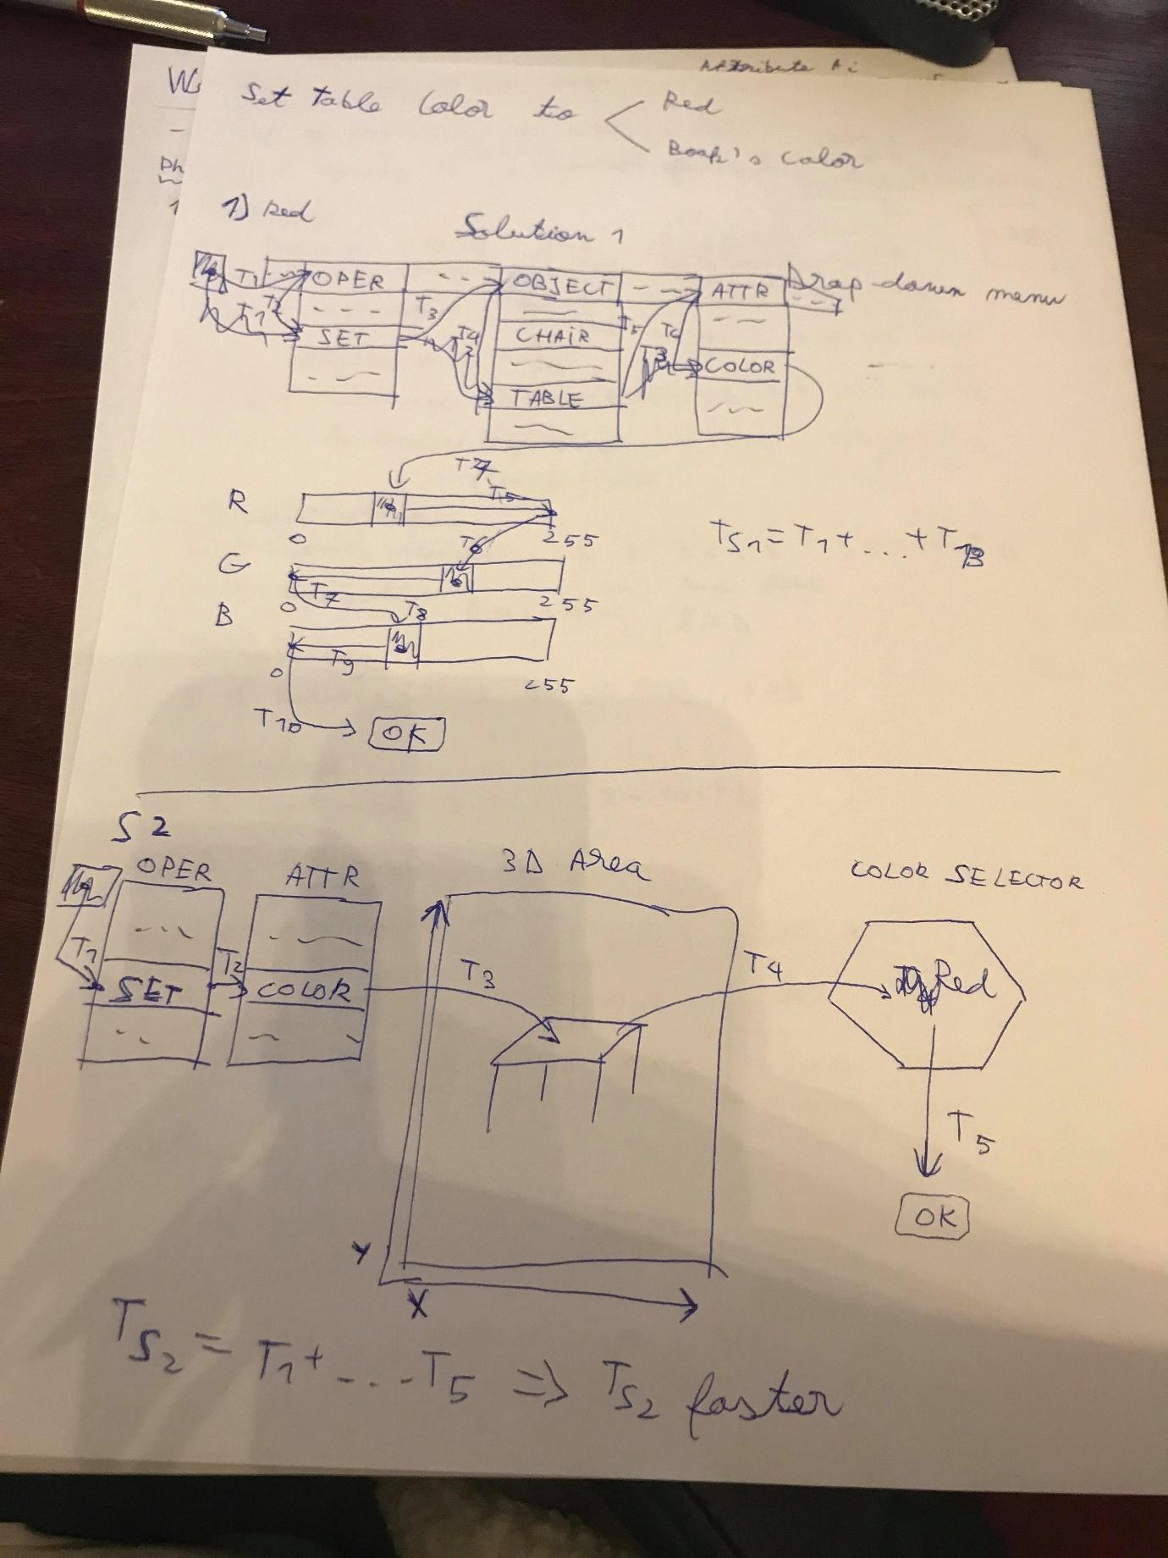

[2014] Exemplify and explain solutions to avoid lexical, syntactical, semantical errors in GUI, for the generic commands exemplified by :
(ideas on paper)
Can remove lexical errors completely by using a GUI instead of text-based commands. (eroare daca introduce numele obiectului gresit, culoarea)
Remove syntactical errors by disabling operators and/or objects that cannot be used together in the same operation
(x, y out of range introduse in text box)
Alert the user of semantical errors by error messages, and avoid these altogether by disabling (more or less).
De ex ca un obiect pica in afara window-ului
- Move Chair to RelativePos(10, 21) than Table
- Rotate Table around Position(15, 17) by 30° -> same
- Set Color of Teapot to Green
Lexical: sa avem un slider ptr RGB, Pie menu, selectie ptr teapot, selectie comanda
Syntactical: avem GUI si elementele comenzii se pot selecta, disable la color picker daca nu selectam obiectul, disable la obiect daca nu e selectata comanda
Semantic: nu sunt.
- Set Color of Teapot by Color of Book

[2013, 2012s, 2012] Describe the heuristic evaluation phases according with Jakob Nielsen’s principles. Exemplify each principle.

[2012, 2010] Exemplify and describe shortly the types of requirements for interactive applications. Detail usability requirements.

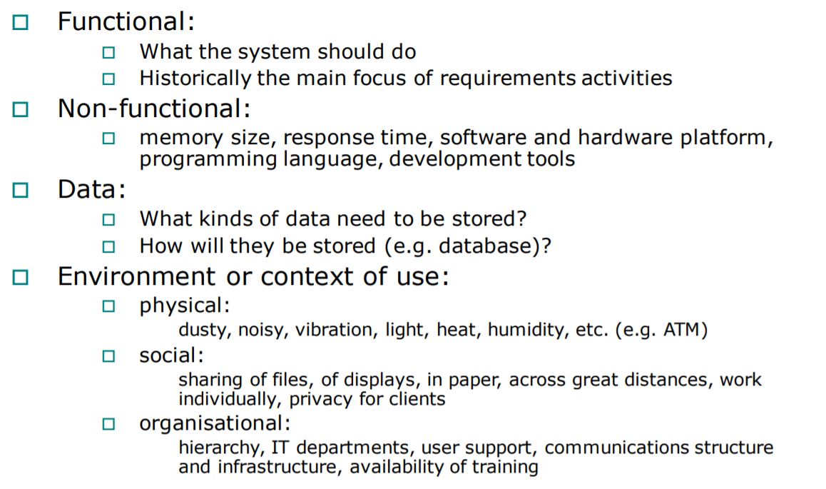
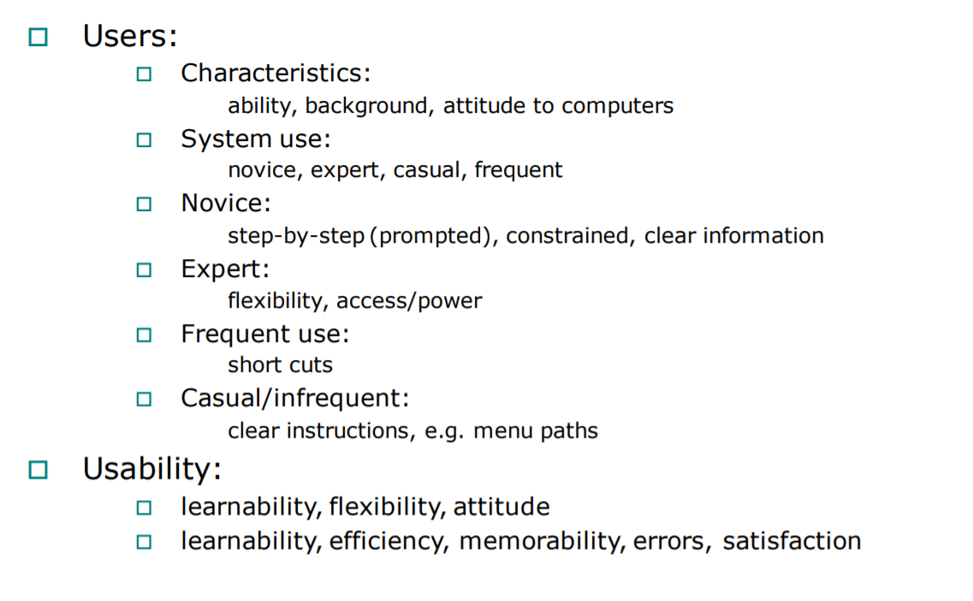
[2012s, 2012] Describe the methods for user requirements definition in interactive applications.
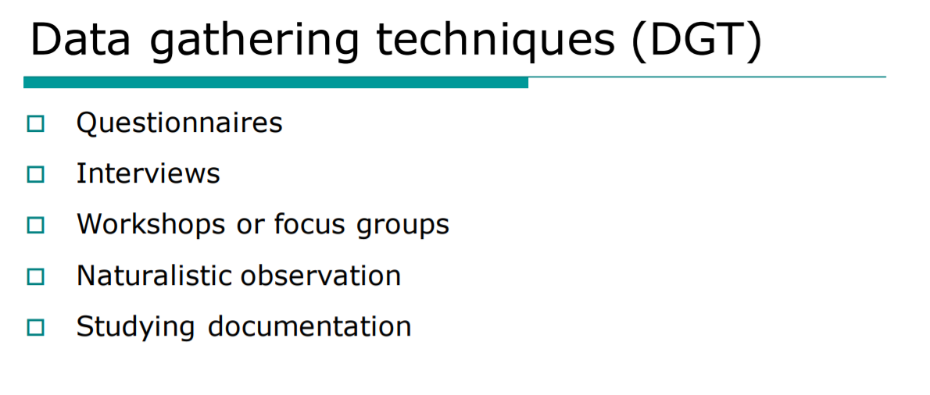

[2012s, 2012, 2010] Define the concept of metaphor in GUI. Exemplify and explain the components of a metaphor.
A metaphor is a way for users to more easily conceptualize the system, by using concepts they already know from real life.
Ex: dragging a file to the bin
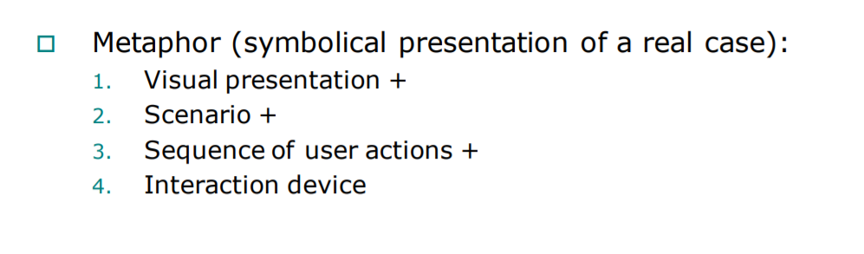

[2012s, 2012] Define and exemplify the concept of user interaction cycle.

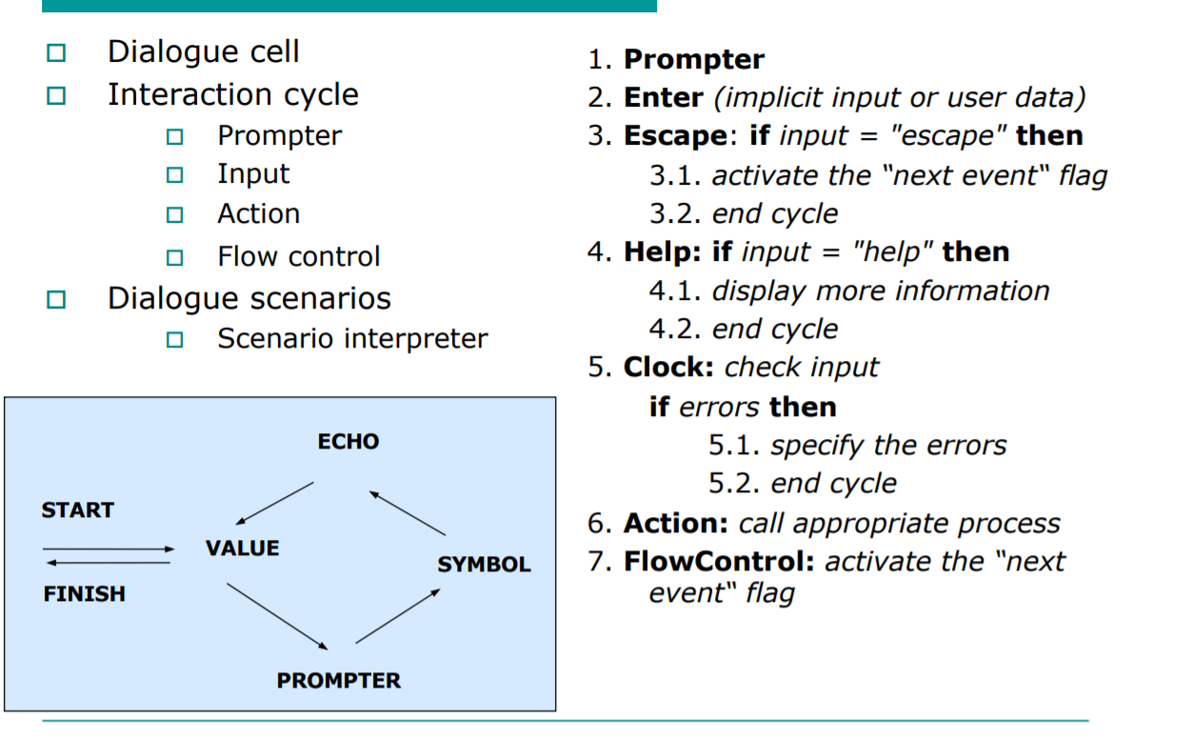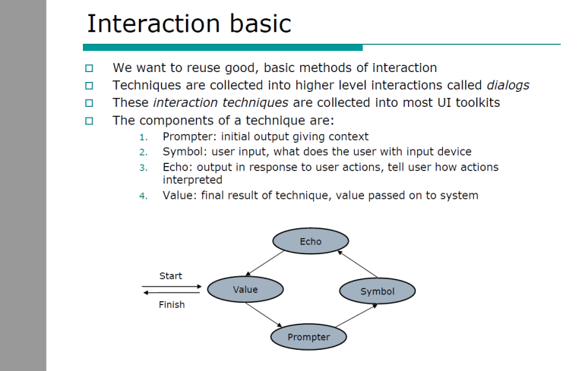
[2012s, 2012] Define and exemplify the following interaction technique:
- Press-timer Ex: Scroll bar clicks
- Range Ex: box area selection (desktop)
- Drag Ex: move item on screen
- Press-down Ex: select (click down)

[2013, 2012s, 2012] Define and exemplify the following user interaction technique for object selection:
- Gridding in mouse based selection accuracy -> when moving an icon with the mouse, releasing it will place it in a grid location
  - Discretize the location of items (pre-defined set of finite locations)
  - User Accuracy is not critical, objects gets snapped into place

- Gravity in mouse based selection accuracy ->
  - aim assist in shooters,
  - entities get pulled to other entities when close by (in CAD, you can snap a point to a line)

- Selection in object space (3d objects)
  - The problem of background and foreground (viewing, rotation)
  - The issue of selection (object, sub-components)

- Selection in image space (2d objects)
  - The issue of selecting the entire component or subcomponents (grouping)
  - Move up/down the hierarchy with successive clicks

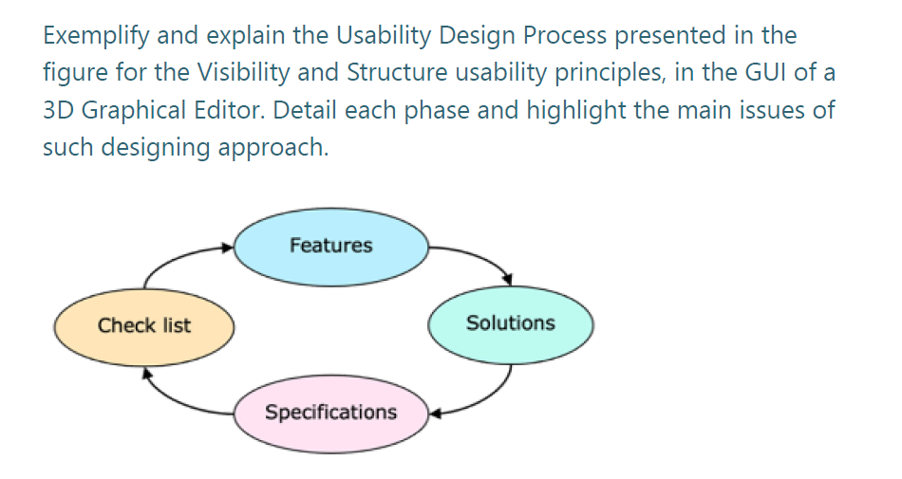

Check list: taskuri (ce sa faca aplicatia) e.g. edit a cube (resize - scale, rotate, change color, move – translate, vizualize in wireframe, photorealistic)

Features: must satisfy usability principles:
- Visibility – see the relevant controls and the current state of the system (cube) without elements which may distract the user
- Structure - interface clearly and consistently organized, related controls grouped together (for example having a menu with the operations and submenus for setting the parameters next to the workspace)

Solutii: sketch-uri (+/- ptr fiecare)
Specifications: descrierea celei mai bune solutii
-: zona de lucru mica, elemente care nu sunt necesare (sa nu pui settings langa operatii)
+: elemente bine grupate, vizibile, sa fie in relatie ptr a construi o forma sintactica, labels clare si concise, dimensiuni acceptabile ale butoanelor

