The recursive clause below of some predicate is designed with backward recursion because: 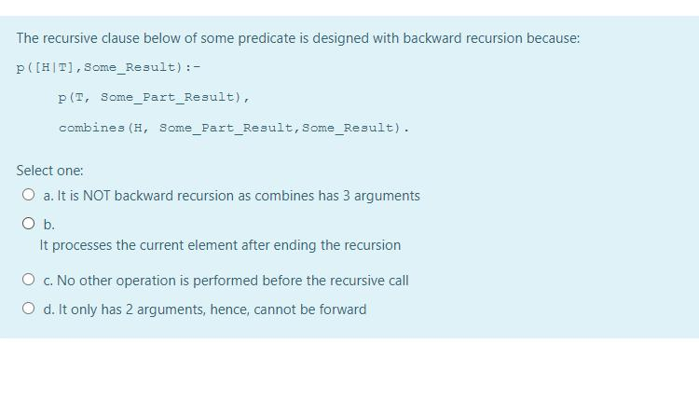
A cut never affects:
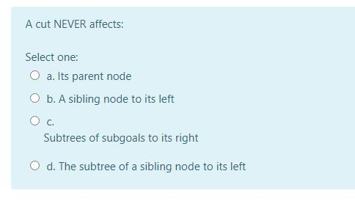

Which categories of nodes are frozen(prevented from backtracking) by a cut:
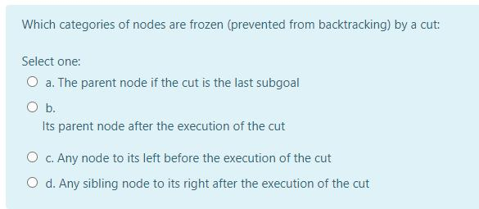

Consider a predicate having a recursive clause as the one below:
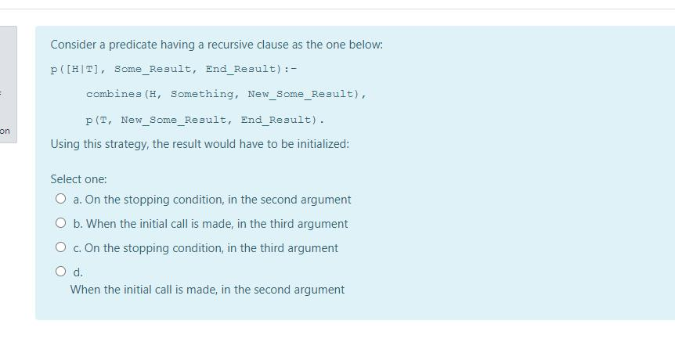
The following matching: f(A,g(B),4) with f(a,g,4) would fail because:
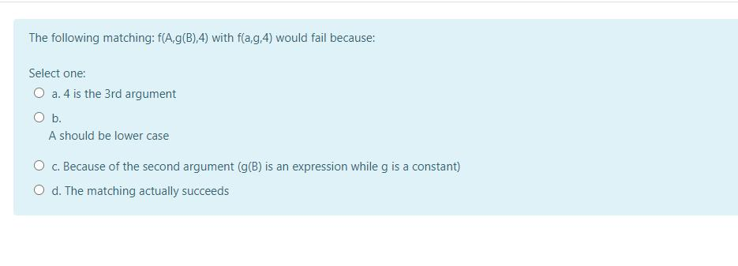
Which of the following clause heads will the query: ?- process([a,b,c], variable, Constant). NOT match?
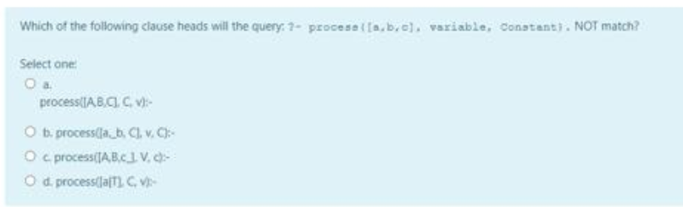
Given the compound term n(c(A,B), v, m(1, [2,3]))), which of the following terms it CANNOT unify with, and why?
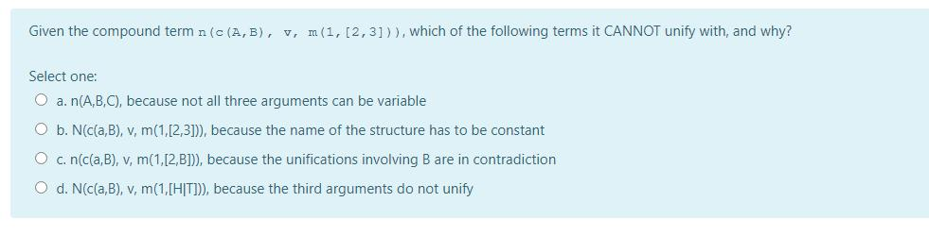

When matching [X|Y] with [1,2,b] the result is:
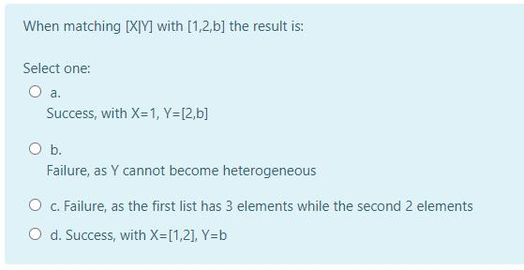
Consider a predicate having a recursive clause, as below:
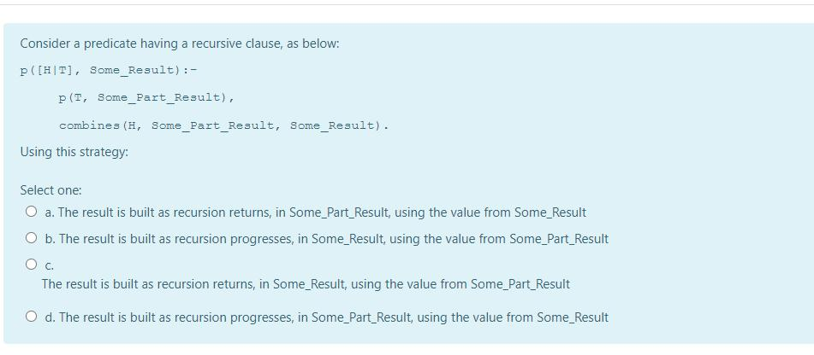
The following matching:[A,b|C] with [1,2,3,4] fails because:
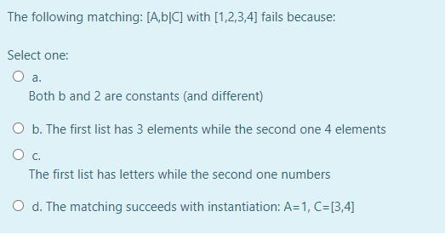

Consider a predicate having a recursive clause as the one below:
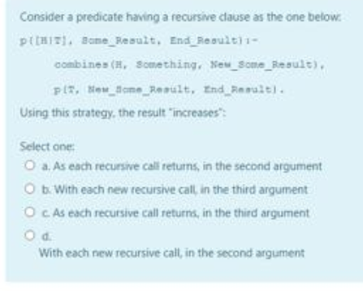
Which of the answers from below is correct and the most specific?:
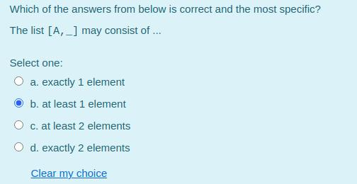

The following predicate should search for the first ocurrence of an element in an incomplete list:
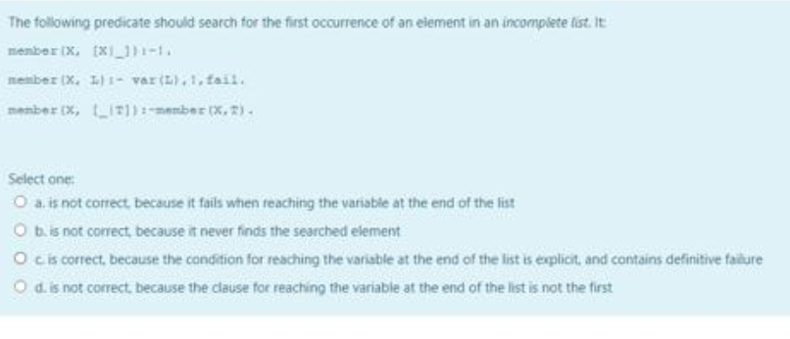
Which of the answers from below is correct and the most specific?:
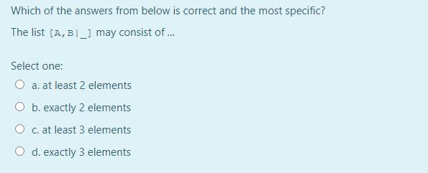

The following predicate is assumed to check if the tree is BST:
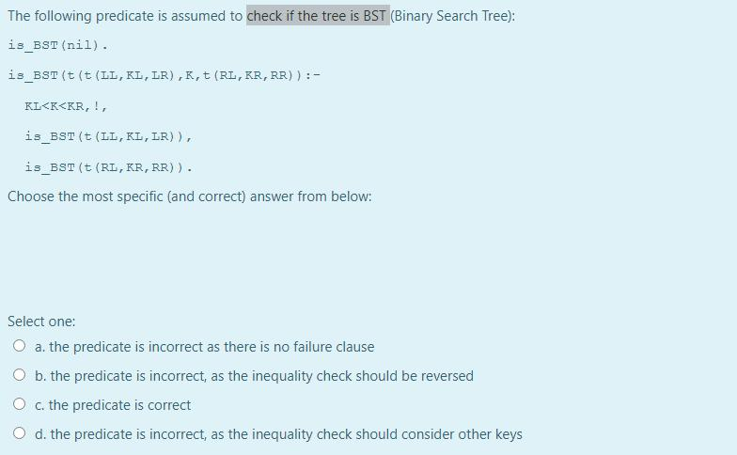

Sey we want to write a predicate which adds an element at the end of some incomplete list, given as an argument. The predicate should:
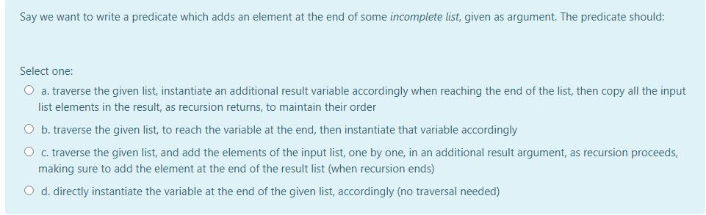
Consider a predicate having a recursive clause as the one below:
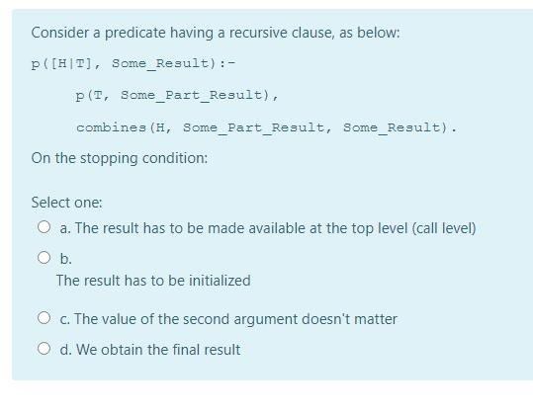
I want to write a predicate which partitions the elements of a list into two lists.....
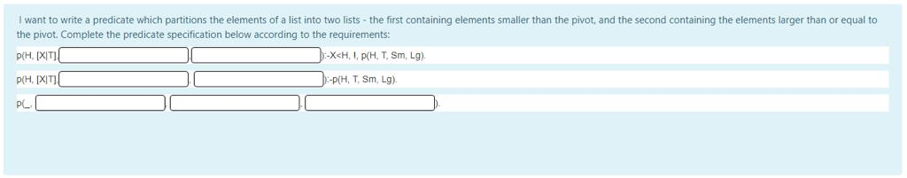

Complete the predicate below such that it performs the merge operation on two ordered lists:
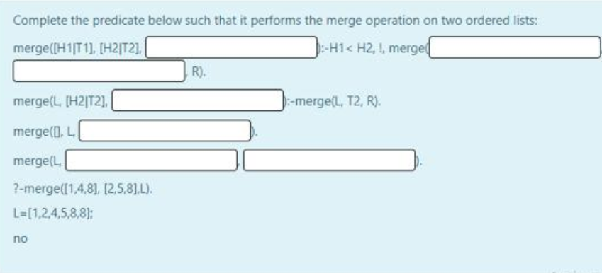

Which of the following assert sequence can generate the given clause order for the dynamic predicate insect/1:
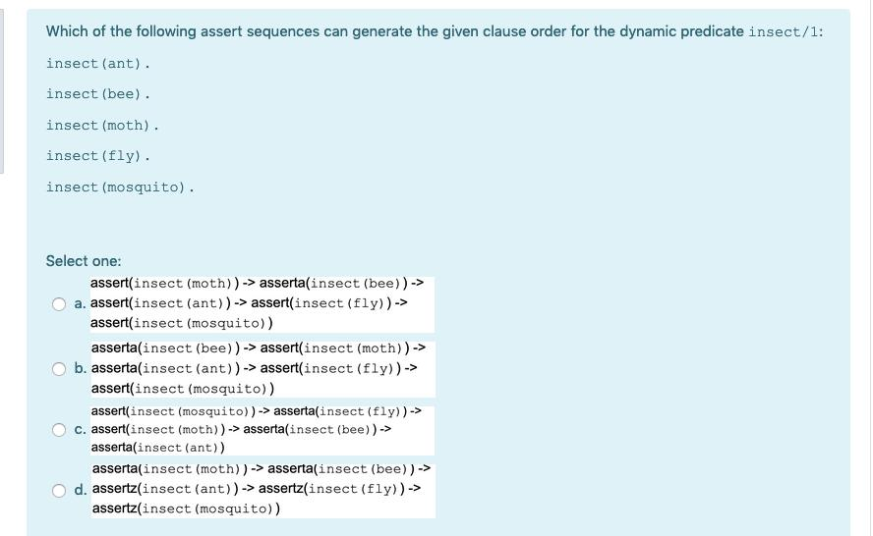

Which of the following clause heads will the query: ?-process(a,_b,c). NOT match?
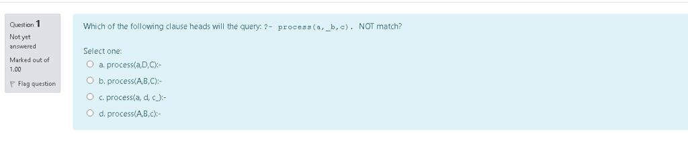
A cut would freeze(prevent from backtracking) some nodes in the tree. However, it is NOT freezing:
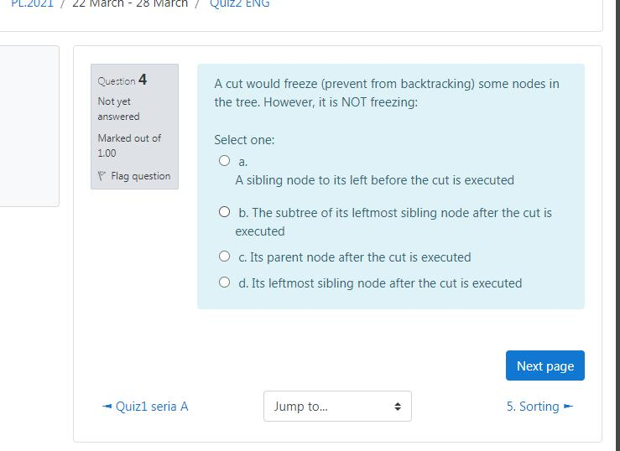
Say we want to write a predicate which receives as input a list of integers, and produces as output a list containing their squares, in reverse order. To obtain such...

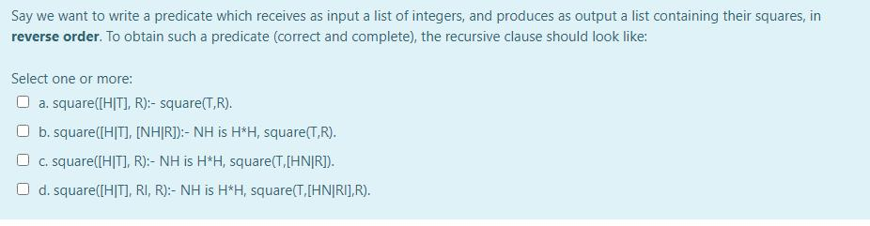
The predicate below is assumed to replace exactly one occurence(in turn) of the first argument, from the list given in the second argument, with the third argument, to generate the list in the fourth argument.
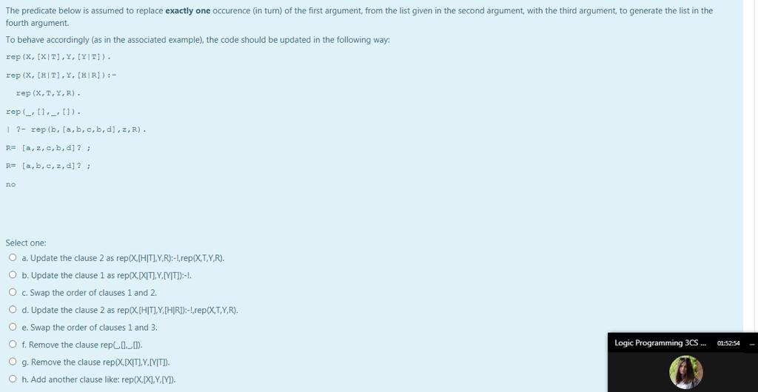
In search operation in an incomplete structure the following condition must hold true:
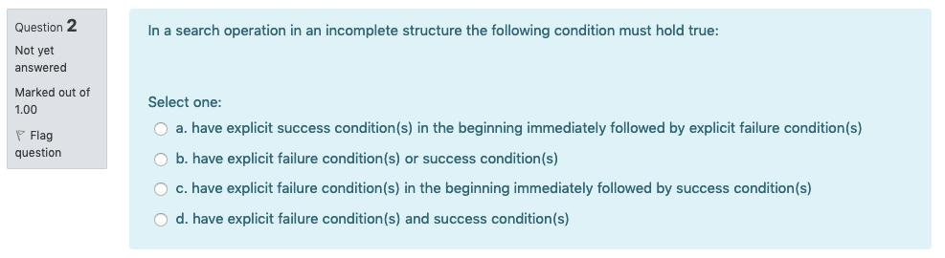

Fill in the gaps below such as to obtain a predicate which swaps adjacent numbers in a list, if their order is incorrect:
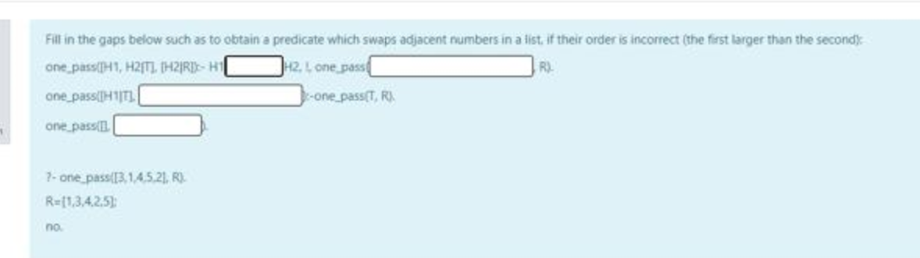
Which of the answers from below is correct and the most specific?:
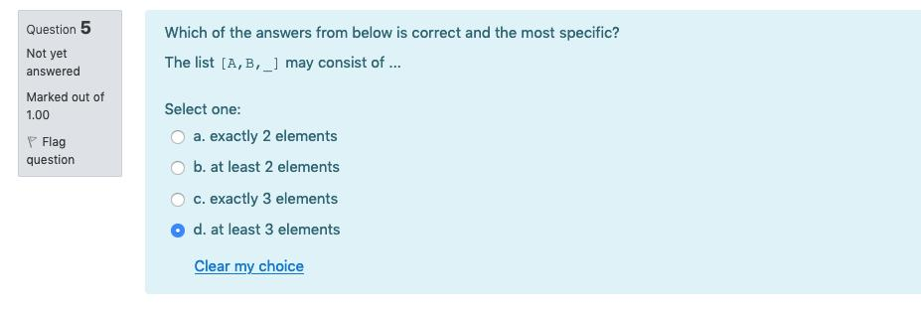
If we want a decreasing sorting by selection strategy(below), where max and delete are correct predicates to find the max value, and delete.....
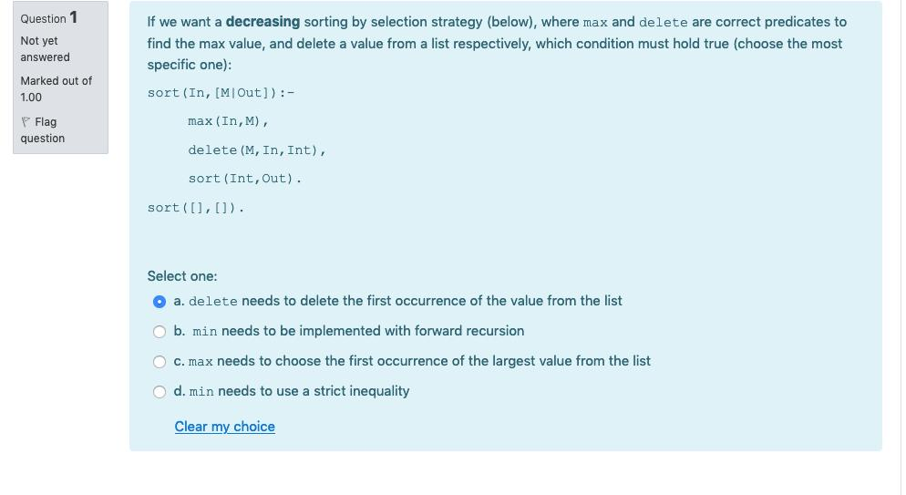
The following sequence is assumed to be used in a condition-controlled loop bubble sort.Would it be a sound choise.....
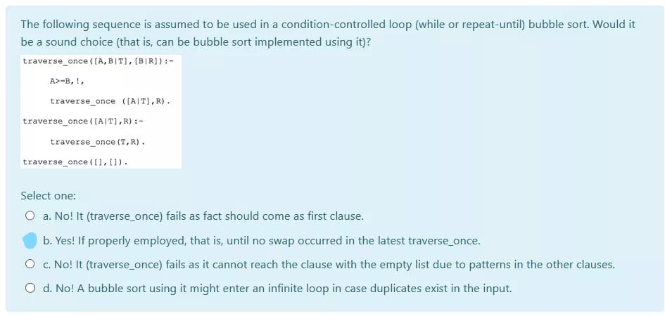
Which of the answers from below is correct and the most specific?:
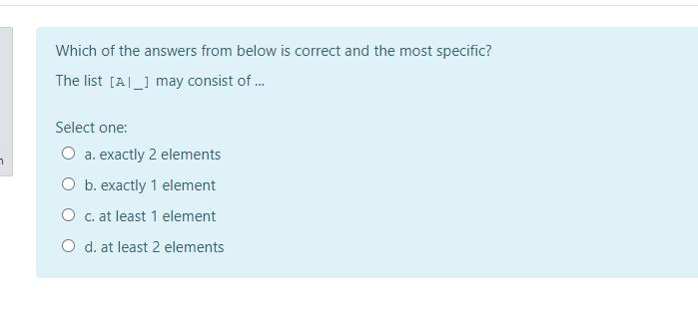The following sequence is assumed to be used in a condition-controlled loop bubble sort for an input without duplicates....
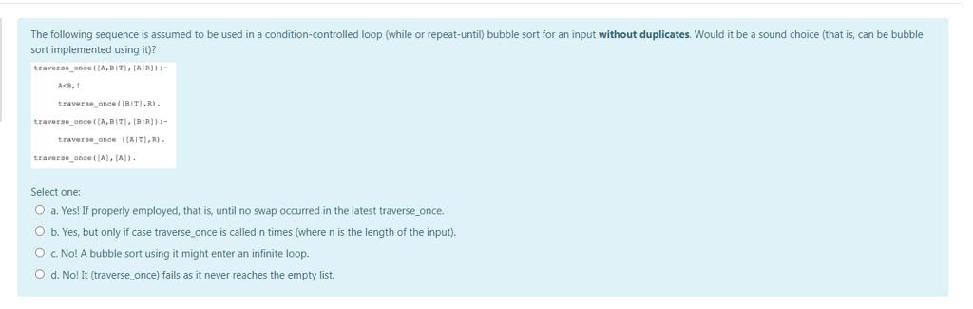If the code below uses append with the fact as the clause, for the input[3,5,7,4,6] what would be the second selection of A and B for swapping during execution?
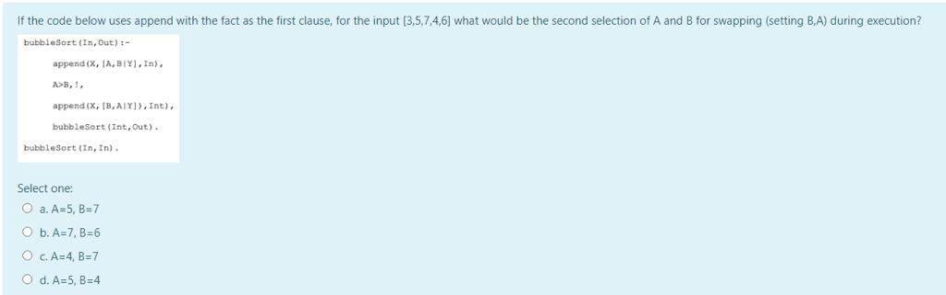

The predicate below should decreasingly sort by selection, using min and delete correct predicates to find the min value, and delete a value from a list.....
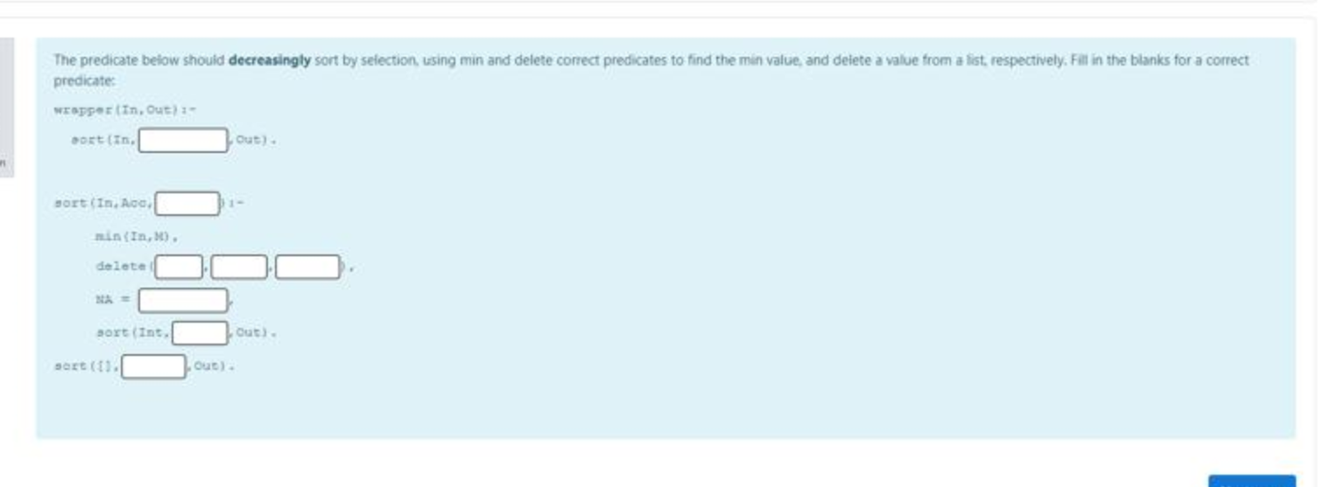
The following predicate should search for the first occurence of an element in a incomplete list:
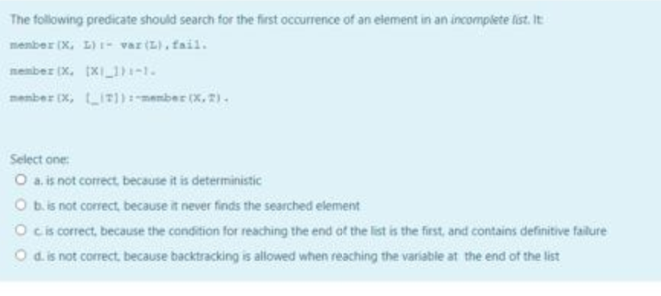
Say we want to write a predicate which inserts an element, in order, into an ordered list, as last occurance...
