# PROFESSIONAL TRAINING REPORT

**at**

**Sathyabama Institute of Science and Technology (Deemed to be University)**

Submitted in partial fulfillment of the requirements for the award of Bachelor of Engineering Degree in Computer Science and Engineering

By

## KUMAR APOORVA

**REG. NO. 39110545**



**DEPARTMENT OF COMPUTER SCIENCE AND ENGINEERING**

**SCHOOL OF COMPUTING**

**SATHYABAMA INSTITUTE OF SCIENCE AND TECHNOLOGY**

**JEPPIAAR NAGAR, RAJIV GANDHI SALAI,**

**CHENNAI – 600119, TAMILNADU**

**APRIL 2022**

|  |  |  |
| --- | --- | --- |
|  | **SATHYABAMA**  **INSTITUTE OF SCIENCE AND TECHNOLOGY** (DEEMED TO BE UNIVERSITY) **Accredited with Grade “A” by NAAC**  (Established under Section 3 of UGC Act, 1956)  JEPPIAAR NAGAR, RAJIV GANDHI SALAI  CHENNAI– 600119  [**www.sathyabama.ac.in**](http://www.sathyabama.ac.in) |  |

# DEPARTMENT OF COMPUTER SCIENCE AND ENGINEERING

**BONAFIDE CERTIFICATE**

This is to certify that this Project Report is the bonafide work of **KUMAR APOORVA (Reg. No: 39110545)** who carried out the project entitled “**MY TASK MANAGER**” under my supervision from February 2022 to April 2022.

## Internal Guide

## Dr.Sankari M

**Head of the Department**



## Submitted for Viva voce Examination held on

**InternalExaminer ExternalExaminer**

**DECLARATION**

I, **KUMAR APOORVA** hereby declare that the project report entitled **MY TASK MANAGER** done by me under the guidance of **Dr. Sankari M.** is submitted in partial fulfillment of the requirements for the award of Bachelor of Engineering Degree in Computer Science and Engineering.

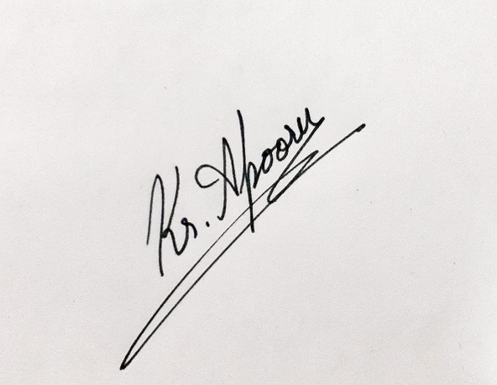

## DATE:

**PLACE:CHENNAI SIGNATURE OF THE CANDIDATE**

**ACKNOWLEDGEMENT**

I am pleased to acknowledge my sincere thanks to **Board of Management** of **SATHYABAMA** for their kind encouragement in doing this project and for completing it successfully. I am grateful to them.

I convey my thanks to **Dr. T. Sasikala M.E., Ph.D**, **Dean**, School of Computing, **Dr. S. Vigneshwari, M.E., Ph.D. and Dr. L. Lakshmanan, M.E., Ph.D., Heads of the Department** of **Computer Science and Engineering** for providing me necessary support and details at the right time during the progressive reviews.

I would like to express my sincere and deep sense of gratitude to my Project Guide **Dr. Sankari M., M.E., Ph.D.,** for his valuable guidance, suggestions and constant encouragement paved way for the successful completion of my project work.

I wish to express my thanks to all Teaching and Non-teaching staff members of the **Department of Computer Science and Engineering** who were helpful in many ways for the completion of the project.

**TRAINING CERTIFICATE**

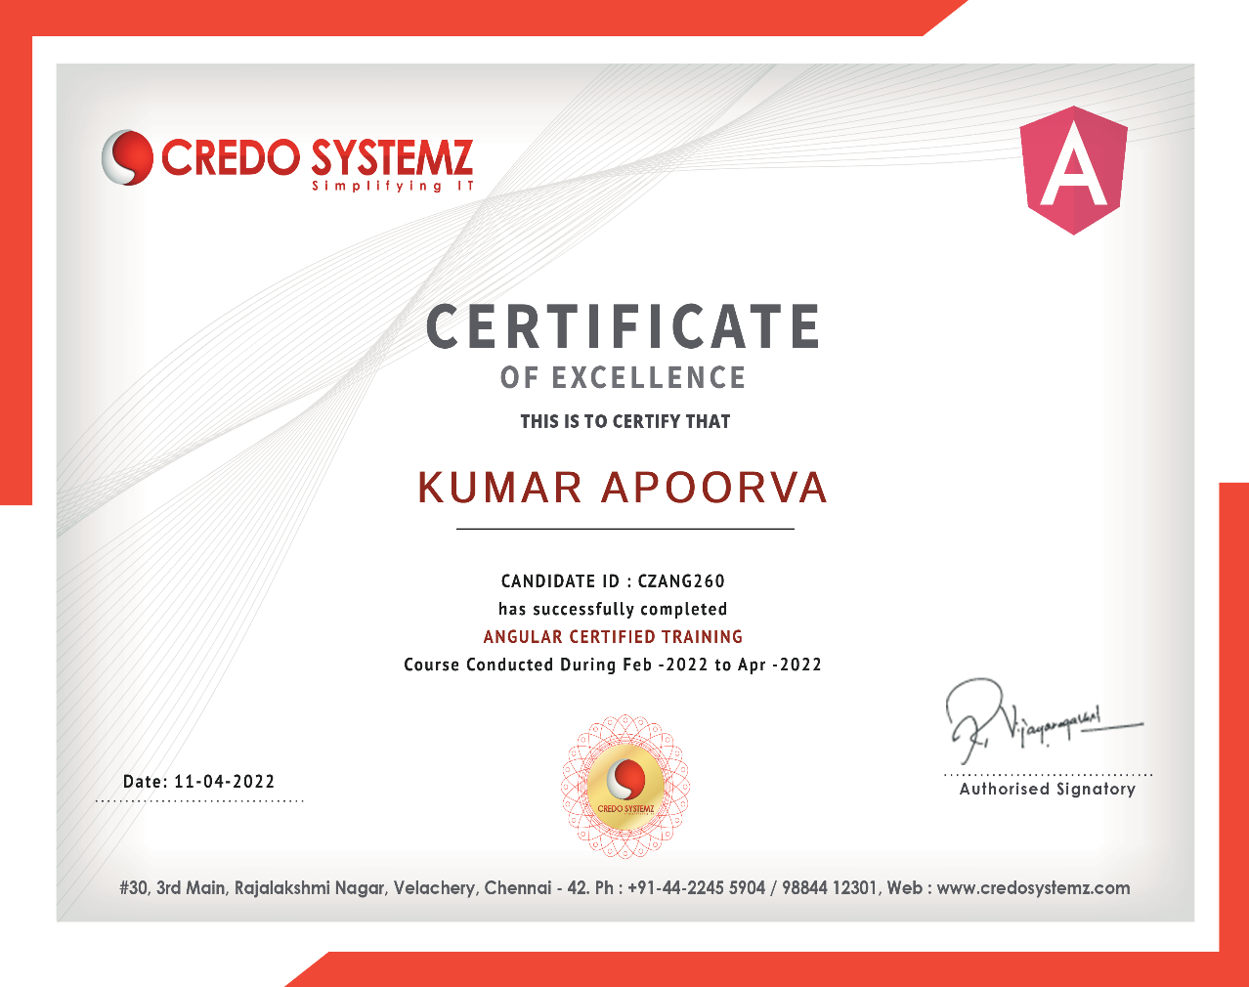

# ABSTRACT

1. It's sometimes hard to know which of the many items inyour Task Manager you should do now. This could be because you have other events coming up you need to attend, and there isn't time to do the most important things. Instead, you might find yourself wasting time or doing an unimportant smaller task, when there is something more important you could have completed if you knew about it.
2. Certain tasks require more concentration and effort than others. If at any given time you do not feel up to completing a task that requires significant focus, you should do the most important thing that requires the least effort. This type of prioritizing isn't often managed by task manager applications or calendars, and that's one of the major changes we hoped to have in ours.
3. Our goal was to create a user friendly and easy to use My Task Manager that rearranges itself around a calendar based on the due date and difficulty of each task. In addition, we wanted to familiarize ourselves with Angular Js, to rethink the role of the calendar and how mobile devices represent calendars, and to implement a basic auto-scheduling tool. There are existing task manager applications and calendar applications, but nothing that attempts to integrate the two in a useful manner. We decided that the best way to achieve our goals in the context of Software Engineering was to create a Web Application.

|  |  |  |
| --- | --- | --- |
|  | **TABLE OF CONTENTS** |  |
| **CHAPTER No.** | **TITLE** | **PAGE No** |
|  | ABSTRACT | i |
|  |  |  |
|  |  |  |
|  |
|  |  |
| **1** | **INTRODUCTION** | **1** |
|  |  |  |
|  |  |  |
| **2.** | **AIM AND SCOPE OF THE PRESENT INVESTIGATION** | **2** |
|  |  |  |
|  |  |  |
|  |  |  |

**3. EXPERIMENTAL IDEATION MAP,ARCHITECTURE DIAGRAM & METHODS USED. 3**

|  |  |  |
| --- | --- | --- |
|  | 3.1 | 3 |
|  | 3.2 | 4 |
|  | 3.3 | 5 |
|  |  |  |
| **4.** | **RESULTS AND DISCUSSION, PERFORMANCE ANALYSIS** | **6** |
|  | 4.1 | 6 |
|  | 4.2 | 7 |
| **5** | **SUMMARY AND CONCLUSIONS** | **8** |
|  | **REFERENCES** | **9** |
|  |  |  |
|  | SCREENSHOTS | 10 |
|  |  |  |

# 1.INTRODUCTION

People are very busy these days and it’s really very hard to keep everything in mind, they must need a web application where they can keep notes about the important tasks they have to do because everyone can’t hire a personal assistant to make them remind for everything.

Fear not — this idea of creating a task manager application can help you avoid drowning in a sea of tasks. I am aiming to help you get on top of your Task management which are important for you.

To design a web application to manage your daily tasks.

This application is for managing all your “Daily Tasks” for increasing your productivity. The user interface is a simple mix-up of Task Manager & To-Do app that helps you get stuff done in an organized way. Whether your task is like accomplish projects, work to-dos, learning languages, mastering skills, sports or travel, etc. This application will help you to collect, keep, organize and remind you about all your tasks you have to do on that day or in coming days.

**1.1 Features**

1. Keeps your daily tasks align.
2. Remind you about all your work with personalize notification.
3. One step to adding task, due date & set reminder.
4. Keeps your tasks according to your priority.
5. Very clean navigations, no more complexity.
6. Shift your old tasks to a new day.
7. Easy way to signup or login.
8. Categorize tasks which you want to keep separate from the list.
9. Minimalist and stylish design.
10. Increase productivity.

# 2. AIM OF THE PRESENT INVESTIGATION

# 

To design a web application to manage your daily tasks.

This application is for managing all your “Daily Tasks” for increasing your productivity. The user interface is a simple mix-up of Task Manager & To-Do app that helps you get stuff done in an organized way. Whether your task is like accomplish projects, work to-dos, learning languages, mastering skills, sports or travel, etc. This application will help you to collect, keep, organize and remind you about all your tasks you have to do on that day or in coming days.

**3. EXPERIMENTAL IDEATION MAP ,ARCHITECTURE DIAGRAM & METHODS USED.**

**3.1 Ideation Map**

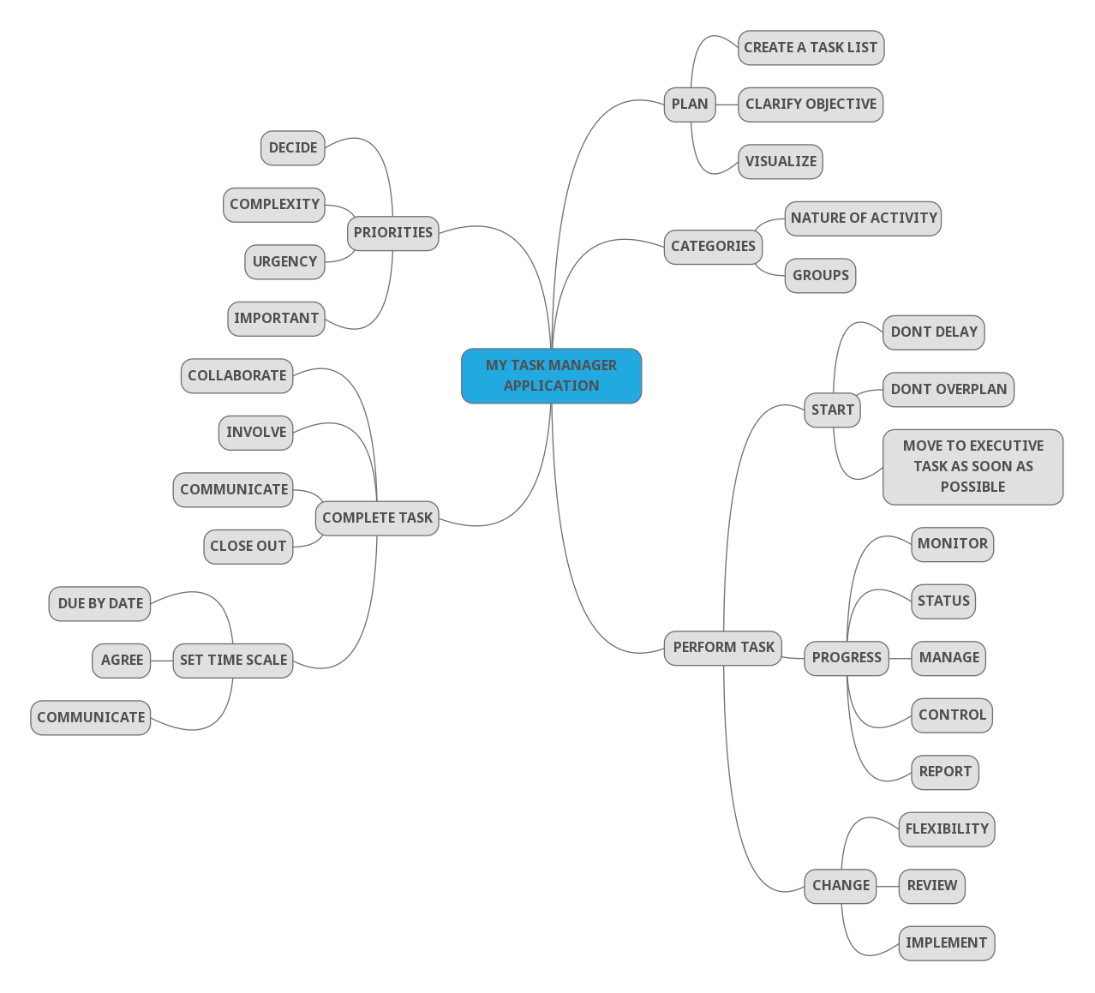

Ideation map is a diagram that helps to observe and study information in a visual manner. Ideation map is created around a single problem statement and all the ideas to solve the problem are written around it. The problem statement usually is written at the center of a blank page as a hub and branches shoot out in all directions representing the solutions.

**3.2 Architecture Diagram**

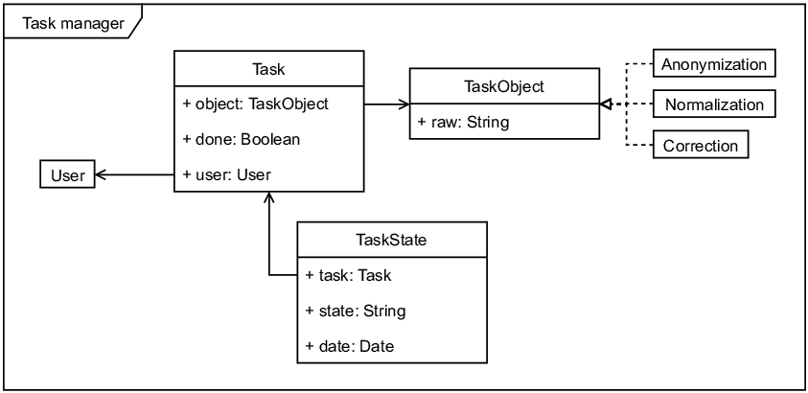

An architectural diagram is a visual representation that maps out the physical implementation for components of a software system. It shows the general structure of the software system and the associations, limitations, and boundaries between each element.

**3.3 Methods Used And Result**

The main topic of My project is “My task manager application” using Angular Js. To implement this program I’ve used HTML, CSS, Java Script and Angular Js.

A Task Management application,

***“MyTaskify- the Task Manager”***

**5. SUMMARY AND CONCLUSIONS**

Task management software is an organized tool to identify, allocate, manage, and monitor tasks for your day to day life.

There are many features, customization, and integration that modern task managers provide you with, so you can complete your project without getting exhausted.

But task manager application makes it easy with clear deadlines displaying against each task in your dashboard. You can also track the progress of each one of them and manage all the tasks and sub-tasks.

**6. REFRENCES**

**[1] AngularJs - Credo Systemz course.**

**[2] AngularJs - CodeWithHarry Youtube Channel**

**[3] AngularJs - Programming with Mosh Youtube Channel**

**[4] AngularJs -** [**www.angularjs.org**](http://www.angularjs.org) **Official Documentation**

**[5] HTML - Credo Systemz**

# 

# SCREENSHOTS

# MY TASKIFY HOME PAGE

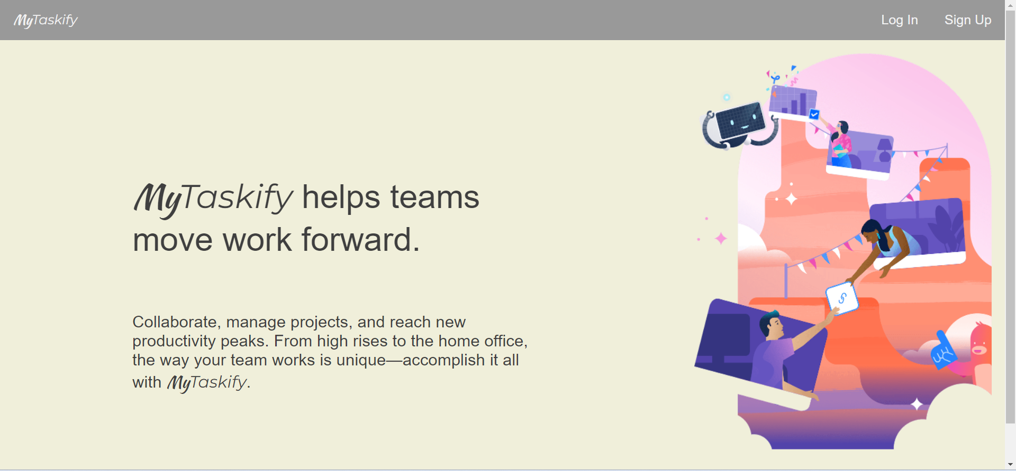

# LOGIN PAGE

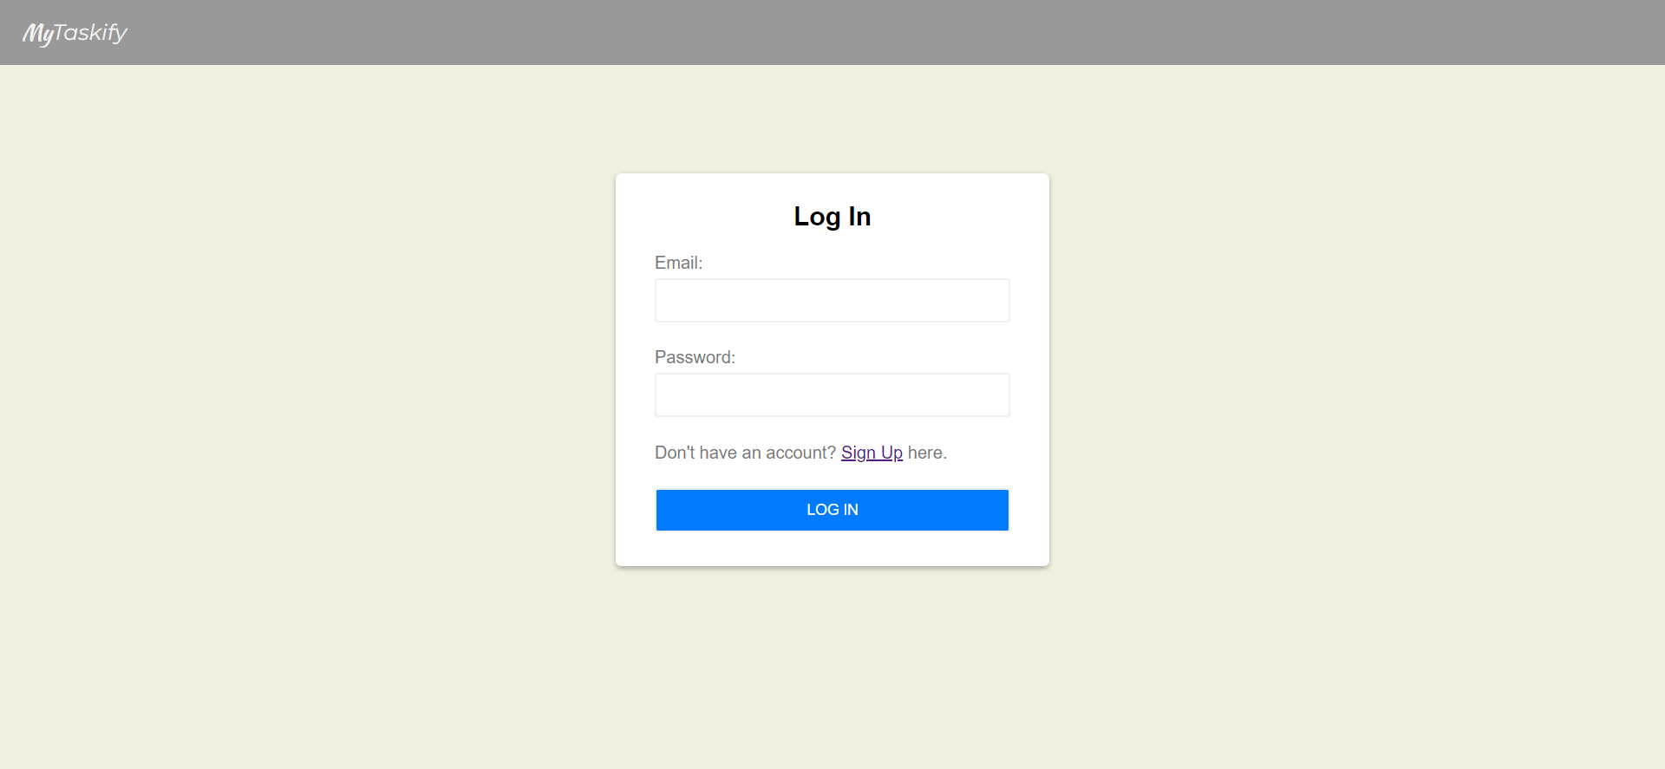

* **SIGNUP PAGE**

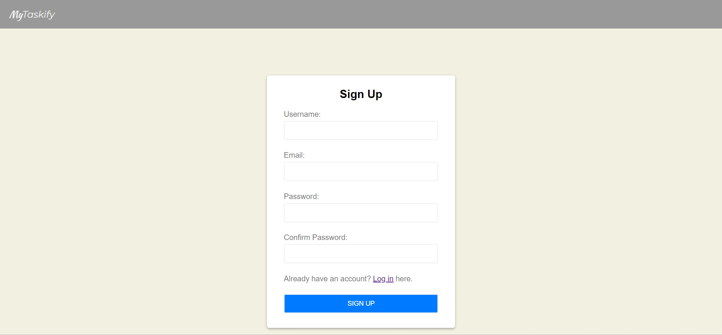

* **ABOUT TASKIFY( TASK MANAGER)**

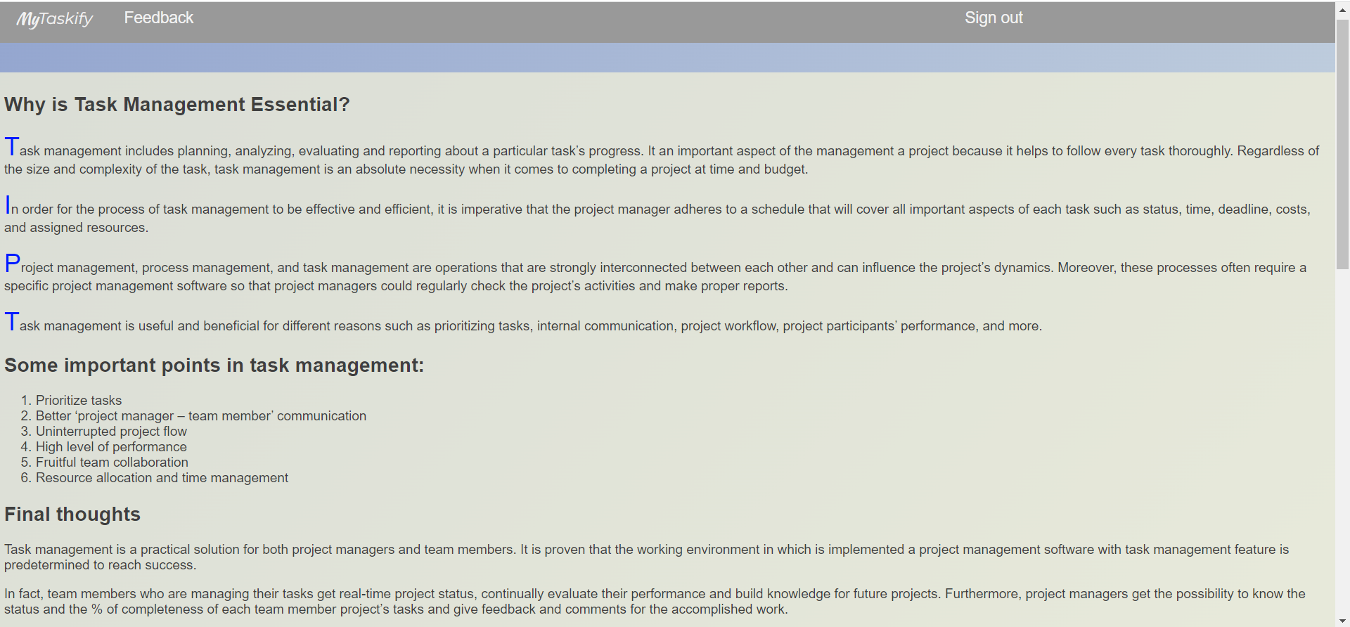

* **FEEDBACK FORM**

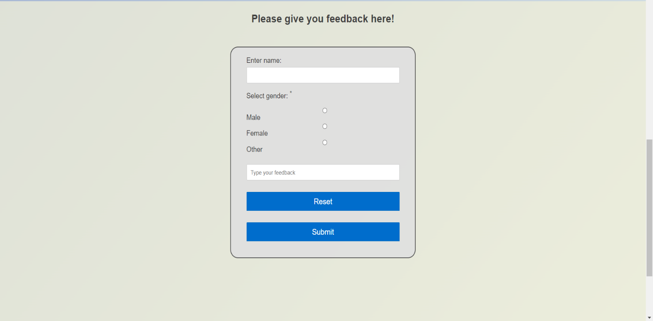

* **LIST OF TASKS**

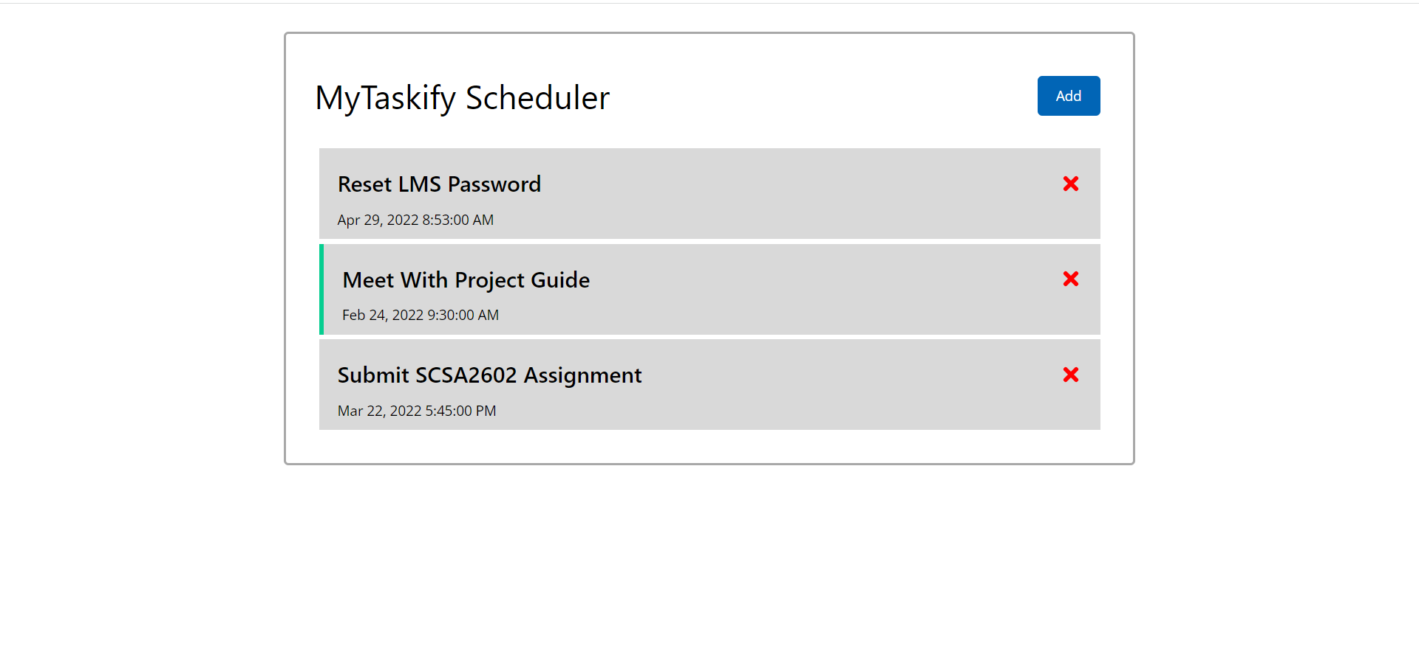

* **ADDING NEW SCHEDULE**

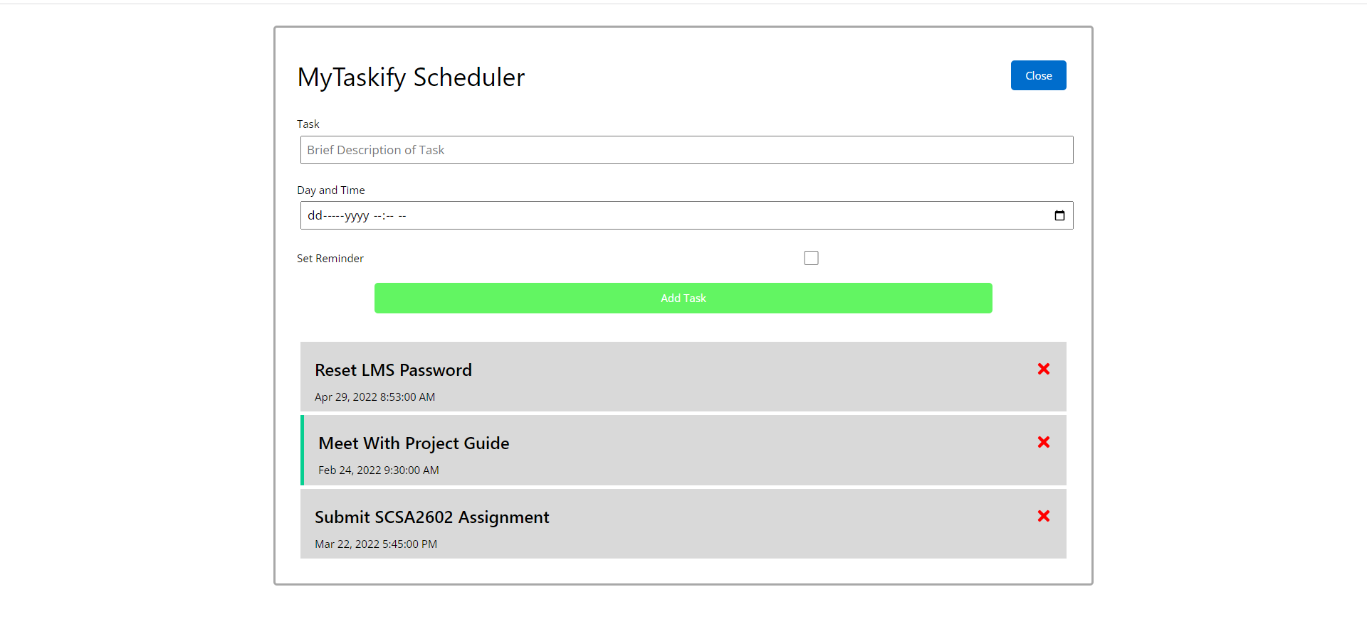

* **SCHEDULE ADDED**

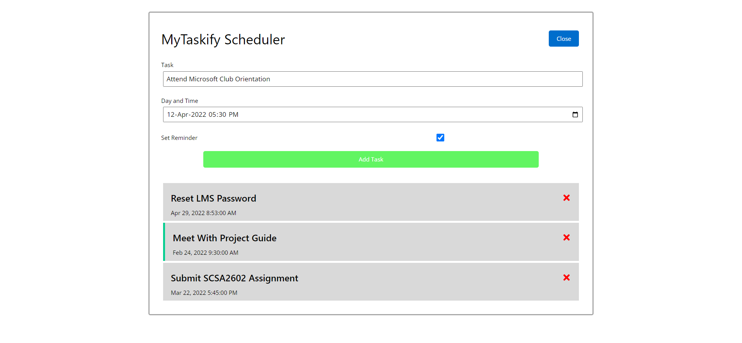

* **TOTAL SCHEDULE FOR DAY**

