Mirjana Bogosavljevic MScE
Senior Archivist,
Archives of Serbia, Karnegijeva 2, Belgrade, Serbia
email: bogosavljevicmirјаna@yahoo.com

Digitization in Archives-Archivematica, the Practical Rewiev of the Software for Managing Archival Records on the Example of the Personal Fonds Rista Odavic at the Archives of Serbia

This paper presents a concrete example of using Archivematica - a digital preservation system to incorporate, organize and manage digitized materials from the Personal Fonds Rista Odavic kept by the Archives of Serbia. The practical part includes the steps required to maintain long-term access to digital memory using the content management system AtoM.
Both Archivematica and AtoM systems described in this article were implemented exclusively to start working on this Fonds.
In order to maintain good traceability an excel document with the description of all the steps, notes on the execution results and a macro to automatically generate DC metadata was created.

Key words:
Archivematica, AtoM, Personal Fonds Rista Odavic, digitization, archives

Introduction
The theme of the paper is the application of Archivematica and AtoM software in the process of digitization, management and use of digitized content on the example of the the personal fonds Rista Odavic from the Archives of Serbia.
Archivematica is a free open source software package for storing digital data designed to provide standardized and reliable long-term access to collections of digital content (Van Garderen, 2012). It is a software that enables storage, processing, transfer of digital material and is in compliance with the Open Archival Information Standard, which will be discussed further in this text.
When digitized documents are stored in digital archives it is necessary to provide access to external users who in most cases are not professional archivists or IT professionals familiar with the entire scope of the technology digital data storages are based upon. Those are users who are focused on the content of documents; therefore, it is necessary to provide such a form of access to digital documents that is tailored to them.
For that purpose, AtoM, which allows the creation of elaborate description of contents of digital archives, was used.
In spite of the fact that Archivematica can connect to various systems for displaying data from digital archives, its connection to the AtoM package is logical and very functional. Examples of which are presented furthers in this paper. Most likely the prime reason for that lays in the fact that both software packages were developed by the same team of developers.
AtoM is also an open source software package that enables the creation of detailed descriptions (archives, fonds, collections), facilitates the discovery and exchange of information on archival records, allows the sharing of authoritative data, as well as the integration of descriptions from different locations into a single information system.
The paper does not describe the entire process of digitization, but one experience gained from the use of Archivematica and AtoM in the direction of input (storage) and digital document management.
In the course of the practical use of those programs it is of the utmost importance that all the data on the collection and its parts are prepared and consolidated well in advance. That definitely enables the most accurate and complete input of all the data important for the storage and subsequent access to digital collections.
For practical reasons, it was decided to enter all of these data into an Excel spreadsheet, which format is adapted to the input processes in Archivematica and AtoM.
Personal Fonds of Rista Odavic
Archival records that had formed the Personal Fonds of Rista Odavic were donated to the State Archives at Belgrade by Mr. Odavic’s spouse, Mrs. Angelina Odavic on two occasions, on May 9, 1939 and October 29, 1952.
The fonds consists of 19 boxes of material, covering the period from the year 1787 to 1949. The document’s signature is formed in the following way: the first letters of the name and surname (RO), box ordinal number in Roman numerals and the number of the item. Archival records are arranged in accordance with the list provided by Mrs. Angelina Odavic.
The rich legacy contains letters from local and foreign writers, members of cultural establishments, government officials, politicians and political workers, associations, institutions sent to Mr. Odavic, his original literary manuscripts, theater plays, drama, anthology of translations of Russian lyricists and German romantics, bibliography of theatrical works, collection of French songs about Serbia and Serbs, minutes on Jovan Sterija Popovic and Joakim Vujić, scraps from the newspaper about Nikolic Pasic, theater posters, photographs etc. The documents are in Serbian, French, German, Czech, Russian, Bulgarian, Italian, Slovenian and Hungarian language.
The personal fonds of Rista Odavić was proclaimed as a cultural asset of exceptional significance in 1994 .

Archivematica
The life span of digitized records can be surprisingly short, and the incredibly fast development of technologies can prevent future access.
What is it that is needed to maintain and store digital records for the long term?
This issue is still far from final answer, but OAIS as a reference model for archives allows for the preservation and long-term access to digital information.
In 2008, The Vancouver Archives had made an agreement with the company Artefactual for the design and development of an overhauling system for digital preservation of data. Because of that, the members of the Archivematica project had mapped the elements of the OAIS functional model onto practical software functions. One year later, in 2010, Mr. Peter Van Garderen, at that time the Artefactual president, had presented the Archivematica software to the international community.
Archivematica is a software that takes OAIS (Open Archival Information System) as a model that is always open for entering new data while at the same time allowing for their availability at the long run (Klindt, Amrhein, 2015).
The purpose of OAIS is to provide a better understanding of the concept that is important for archiving digital data, to illuminate the terminology and the concept of describing and comparing digital data and archival records, to expand knowledge about processes that are crucial for digital information and its preservation as well as to create a framework for proper and long-term development of standards.
The OAIS environment is created through the interaction of four crucial elements: producers of information, consumers of information, management, and the archives itself.
It is very important to understand that the management component of the OAIS environment is not an entity that carries out day-to-day maintenance of an archive but a person or group that sets policies for the content contained in the archive.
The OAIS model also defines an information model. Physical or digital items, which contain information are known as data objects. Members of the Designated Community for an archive should be able to interpret and understand the information contained in a data object either because of their established knowledge base or with the assistance of supplementary "representation information" that is included with the data object.
The OAIS consists of six functional units (Figure 1) which perform the information management from the producer to the archive and from the archive to the user. Those are:
- Ingest: receives information from producers and packages it for storage.
- Archival Storage: stores, maintains, and retrieves Archival Information Packages (AIPs).
- Data Management: coordinates the Descriptive Information of the AIPs and the system information that supports the archive.
- Administration: manages daily operations of the archive. This function attains submission agreements from information producers, performs system engineering, audits Submission Informaion Packages (SIPs) to ensure compliance with submission agreements and develops policies and standards.
- Preservation Planning: supports all tasks to keep the archival records accessible and understandable over long terms even if the original computing system becomes obsolete.
- Access: this function includes the user interface that allows users to retrieve information from the archive.
The OAIS model is basically an informational model. In that model, data objects are all physical or digital items which contain information.
An information package includes the following information objects:
- Content Information: this includes the data object and its representation information
- Preservation Description Information: contains information necessary to preserve its affiliated content
- Packaging Information: holds the components of the information package together
- Descriptive Information: metadata about the object which allows the object to be located at a later time using the archive's search or retrieval functions

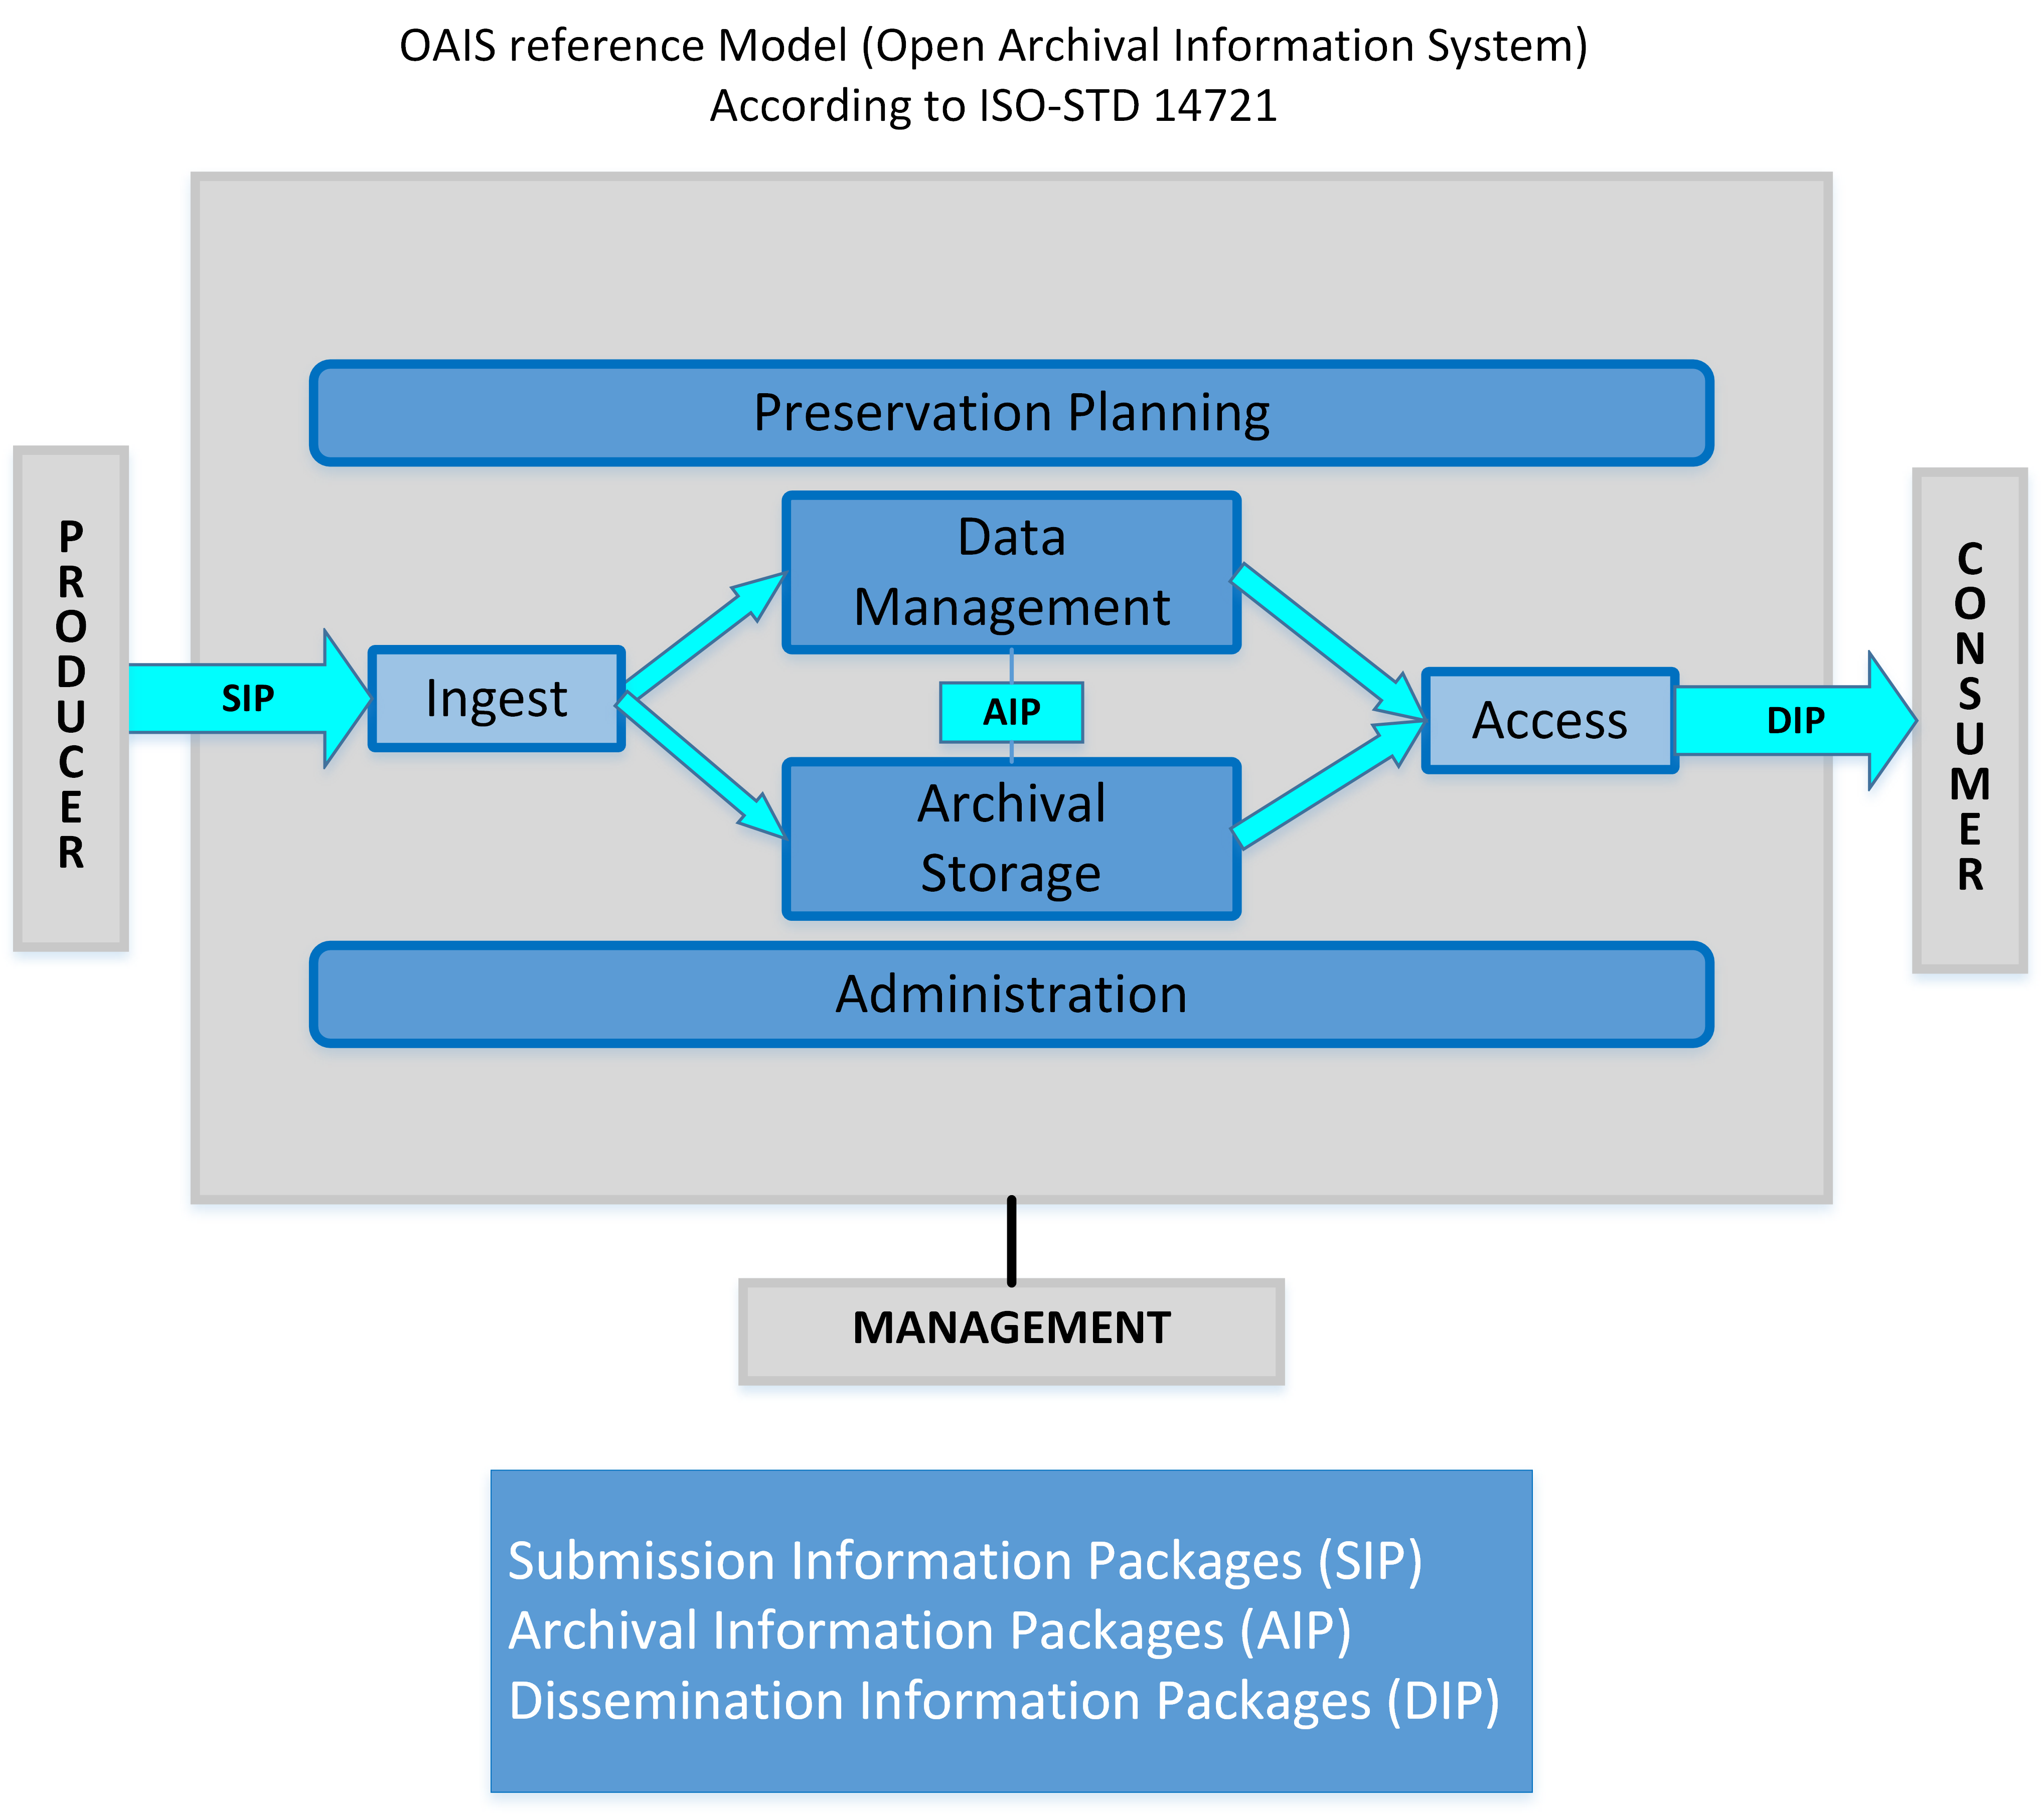
There are three types of information package in the OAIS reference model:
- Submission Information Package (SIP): which is the information sent from the producer to the archive
- Archival Information Package (AIP): which is the information stored by the archive
- Dissemination Information Package (DIP): which is the information sent to a user when requested
In essence, the Archivematica software is an example of full direct implementation of the relevant ISO standard for digital preservation, as presented by the OAIS reference model.
AtoM

AtoM software package name is an abbreviation derived from „Access to Memory “. It was developed as an open source web application ICA-AtoM under the influence of the International Council of Archives with an idea to enable standardized and controllable creation of different levels of descriptions of archival collections holding all relevant information about the them. Hence, this program contains all general rules for archival descriptions irrelevant of the type and form of the archival records. In addition,it provides means for preparation of very detailed descriptions of fonds as whole and their parts through the following seven entity types and their interactions:
- Accession record - provide administrative and descriptive information that identifies the contents, provenance and disposition of the materials from the moment they are transferred to the archival institution.
- Archival descriptions - provide contextual information about archival records and are arranged into hierarchical levels (fonds, series, files, items, etc.). The default archival description edit template contains data elements based on the ICA’s General International Standard Archival Description (ISAD). Other edit templates are also available: Dublin Core, MODS, DACS, and RAD.
- Authority records - provide descriptions of the actors (corporate bodies, persons, and families) that interact with archival records as creators, custodians, subject access points, etc. The edit template is based on the ICA’s International Standard Archival Authority Records (Corporate bodies, Persons, Families) (ISAAR). Those records are associated with corresponding archival descriptions through the connections established between ISAAR records and ISAD records
- Archival institutions records – provide descriptions of repositories that preserve and provide access to archival records. The edit template is based on the ICA’s International Standard for Describing Institutions with Archival Holdings (ISDIAH).
- Functions describe activities linked to records creation, maintenance, and use. They based on the ICA International Standard for Describing Functions (ISDF). Functions are linked to authority records and other functions.
- Rights records provide rights related restrictions that can be linked to accession records, archival descriptions and digital objects. AtoM Rights metadata elements use PREMIS rights elements.
- Terms provide controlled vocabularies used throughout the system (e.g. as access points or in drop-down value lists). They are organized into separate taxonomies. All edit templates typically contain terms that may be selected from the ready-made value lists based on standards governing the actual records.

An Example of Practical Use of Archivematica and AtoM Software
Archivematica and AtoM software packages are both developed under the Linux operation system environment and as such they are implemented on Linux servers. Therefore, their implementation requires a certain level of understanding the Linux administration. Because the manuals are clear and accurate, that process is seamless and straightforward so the installation and configuration of both servers may be finished in one day.
The software packages are provided with very clear user guides, therefore, they are not too complicated to use. We have learned that those programs will not prevent partial insertion of digitalized contents with incomplete information. Hence, good organization of the digital archives is dependent on beforehand preparation of all available information about the original material (reference code, location, formats, descriptions, creators etc.). We realized that the most practical and the most efficient way of preparation and maintenance of the relevant data is in the form of Excel spreadsheets formatted in a way that will provide particular inputs into the forms in Archivematica and AtoM programs and subsequently generate files containing metadata.
Because this work was focused on the digitization of a fonds, we needed a spreadsheet with the fond’s’ data that had the broadest possible scope of all elements required for the creation of a new digitalized fonds and entering of its content. Therefore, we have created a spreadsheet template with the following tables:
- Collection, with the following fields for input of the all basic data about a fonds: Identifier, Title, Creators, Date, Subject, Description, Type, Format, Source, Language, Relation, Coverage, Rights.
- Content, with the fields for entering the information about the fonds’ content that will be transferred to the digitalized form into Archivematica and AtoM: Filename, Title, Date Issued, Publisher, Contributor, Subject, Date Created, Description, Notes, Format
- Metadata, is an automatically generated table with most significant data from the tables Collection and Content; its fields are directly taken from the Dublin Core standard 1.1: filename, dc.title, dc.creator, dc.subject, dc.subject, dc.subject, dc.subject, dc.subject, dc.description, dc.publisher, dc.contributor, dc.date, dc.type, dc.format, dc.identifier, dc.source, dc.language, dc.relation, dc.coverage, dc.rights. The purpose of this table is to be used for automatic generation of the metadata files.
- Transfer & Ingest, is a table which contains the exact information for processing of the digitalized content in Archivematica Transfer process: name, type, source directory, accession number; and the ingest process (limited to the AtoM archival description slug, required for DIP upload to AtoM)
- Atom, key filed in the metadata which descript digital archive and its parts: reference code, identifier, title, level of description, extent and medium, repository. Those values are taken back from AtoM after the successful entering of all descriptions and are kept in the spreadsheet for auditing purposes.

Practical Work – Part Performed in Archivematica
Transfer process
The processing of digitized content in Archivematica starts with the Transfer process. The minimum requirement to start with it is to have an Archivematica server (Artefactual, 2017) installed and configured with the adequate folder that will be used as a transfer source directory containing all digitized content and relevant metadata.
In the concrete example of the work with the Personal Fonds of Rista Odavic we have split the available digitized documents into folders in accordance with their corresponding reference codes. Moreover, we have used reference codes as unique references in all parts of the process in order to maintain the connection with the original (source) documents. Consequently, we have distributed the digitized content and the matching metadata into the Transfer source folders in the following manner:
/REFERENCE CODE /objects - folder for digitalized content
/metadata - folder for metadata.csv
/logs - folder for process logs
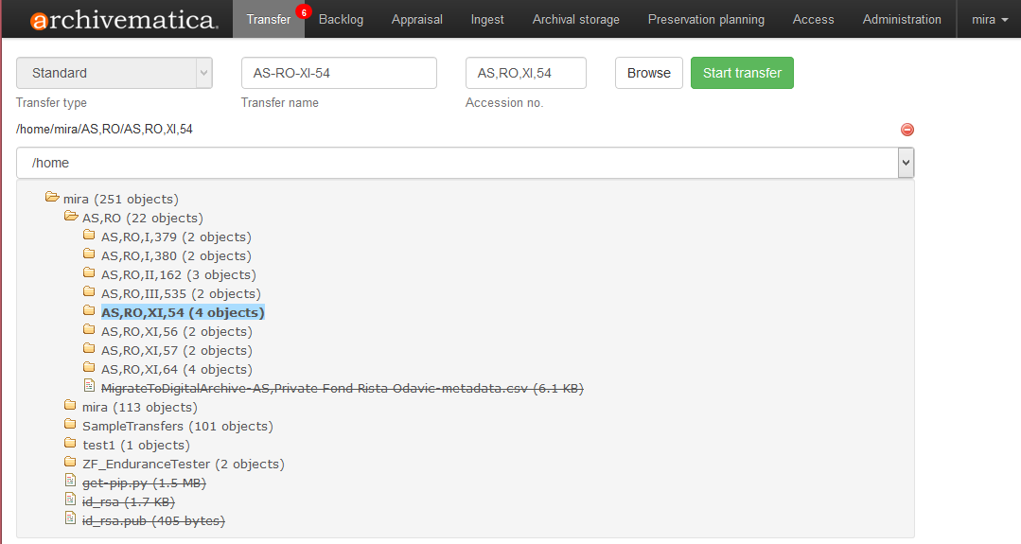
The Figure 2 shows the example of starting the Transfer process for the content linked to the reference code AS,RO,XI,54. We have selected the “Standard” transfer type. The transfer name was set to AS-RO-XI-54. The accession no. set to the reference code, and the source directory was set to AS,RO/AS,RO,XI,54.
Figure 2: Start transfer

After starting the Transfer process the user gets hold of the process by deciding in every critical stage about the process continuance, revision or termination.
If the decision is made to continue the Transfer process, the digitized content is made ready for upload to Storage (anti-virus scan is mandatary part of that), selection of the format identification method, decision about creation of the unique SIP. When the user decides to approve creation of the SIP the Transfer process successfully ends its part.
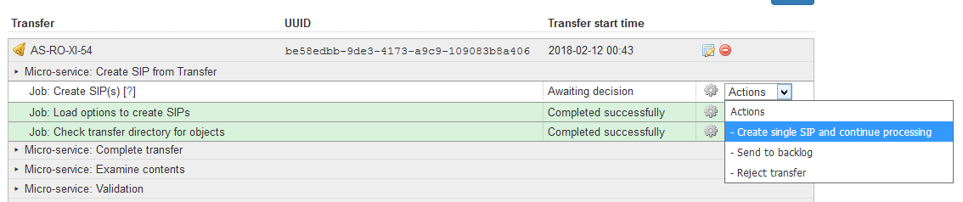
The Figure 3 shows the moment of the SIP creation in the Transfer process.
Figure 3: SIP creation stage

The end of the Transfer process is shown in the following Figure 4.
If all the micro services had successfully performed their functions, the work continues with the Ingest process.
Figure 4: Transfer finished
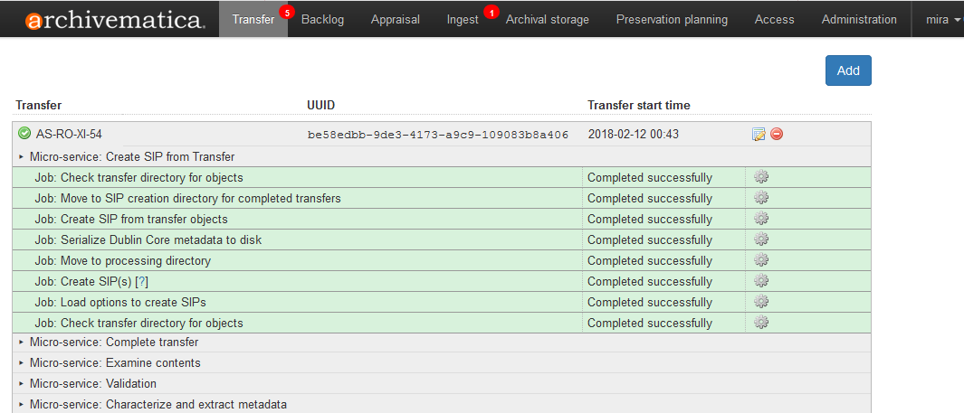
Ingest
Ingest is in principle the first step of inserting digitalized documents into Archivematica because at this stage the SIP is fully created– which is the basic requirement of the OAIS standard.
Ingest starts with the selection of the form of the SIP normalization or its rejection. A series of micro services will then perform their function up to the point where the user is asked to decide to select the file format identification method. After that, AIP and DIP packets are being prepared. The user then decides to accept and store the AIP or reject it and what will happen with DIP. At that stage, we have decided to activate the DIP upload to the AtoM web server.

The AS-RO-XI-54 DIP processing selection stage example is shown in Figure 5.
Figure 5: Ingest - DIP upload stage
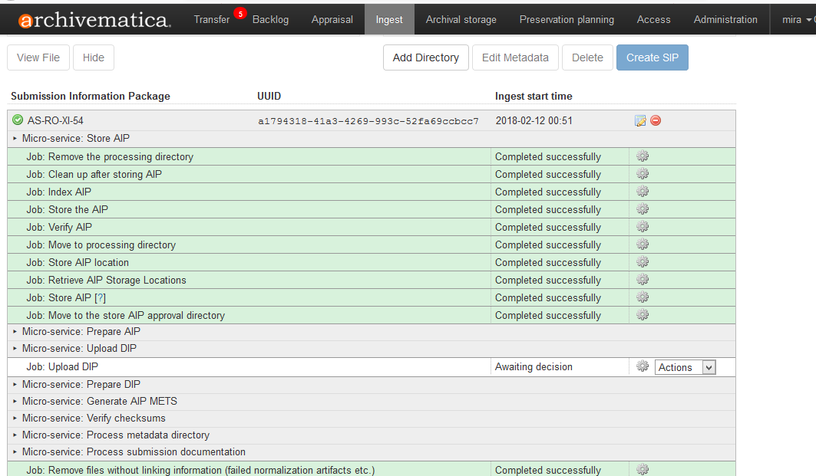
In order to fully systematize the complete process of transferring digitized fonds into Archivematica and their further upload into AtoM, it is highly recommended to prepare in advance all the corresponding archival descriptions in AtoM. Hence, we have prepared archival descriptions for each and every reference code in a form of parts of the main archival description of the Personal Fonds of Rista Odavic. Again, we used the reference codes as unique identifiers linking them all to the digitalized content in Archivematica and all the way back to the original archival records.
We have learned that the descriptions should contain exhaustive information about the content attached to reference codes, because this will later enable much easier searching and discovery to the end users of the digitized archive.

The above mentioned example with the reference code AS,RO,XI,54 has the title ”Uputstva za restauraciju arhivskog materijala”. After entering the title into the appropriate field in the AtoM archival description form a link information required for DIP upload was automatically generated by AtoM from the entered text. In Archivematica and AtoM terminology, the name for that link information is “slug”. In the case of AS,RO,XI,54 the slug was: “uputstva-za-restauraciju-arhivskog-materijala”.

After the Ingest process is finished, authorized archivists may browse through the contents, view digitized documents, add and edit metadata, download, etc. We found the submenu “Archival storage” and its functions the most useful for the purpose. For example, it is very useful for searching for the digitized content based on keywords. However, we have found out that the keyword search tool in Archivematica is limited in its function in comparison to AtoM capabilities. In Archivematica, the portal we have mainly reduced our searches to, use of the reference code as a keyword. The Figure 6 provides an example of the list of the content that may be viewed and/or downloaded from our Archivematica server’s storage when the reference code AS,RO,XI,54 is entered as a search criterion.
Figure 6: Archival storage search results
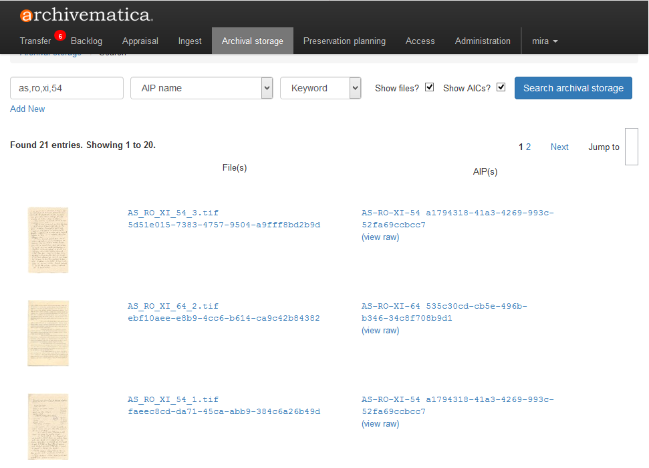

Practically, for professional archivists, there is already plentiful information particularly because each of the digitized documents may be viewed and downloaded independently. Frankly, that environment is not overly comfortable for use and from that perspective, the full implementation of AtoM program brings significant advantages. On the first look it is easy to discover that the Archivematica “does not know” that the above mentioned signature AS,RO,XI,54 is actually a part of the Personal Fonds of Rista Odavic. That is because during the upload into Archivematica the focus was placed on the consistent and methodical micro structuring of each transfer while taking into account that the digitized archives will be accessed to via AtoM and that the complete work on fonds’ structuring will be performed there. More details about that part will be provided in the next chapter.

Practical Work – Part Performed in AtoM
After the process of DIP upload from Archivematica into AtoM is successfully finished, the information and the content contained within the reference code AS,RO,XI,54 is presented in the AtoM user portal as shown in the Figure 7.
Figure 7: Reference code AS,RO,XI,54 presented in AtoM
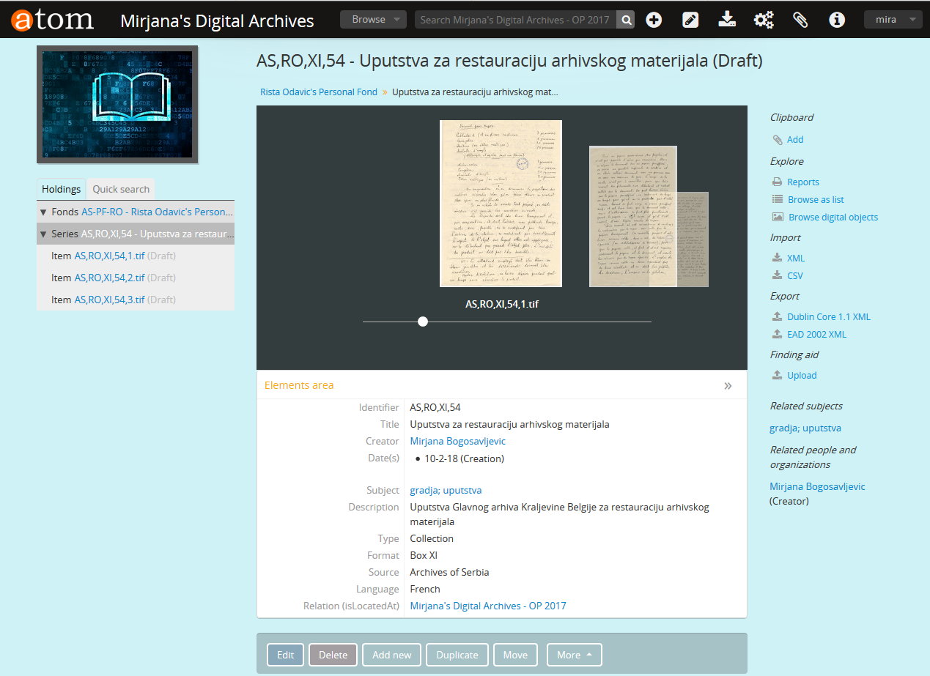
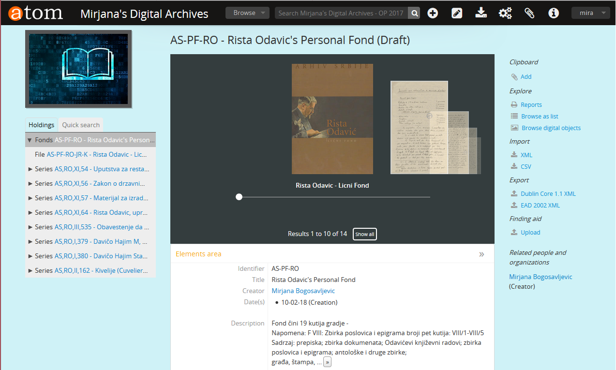
The next Figure 8, shows the top page of the presentation of the Personal Fonds of Rista Odavic with the all referece codes and their linked content and information that was entered into AtoM up to the moment the screen capture was taken.
Figure 8: Fond Rista Odavic top page in AtoM
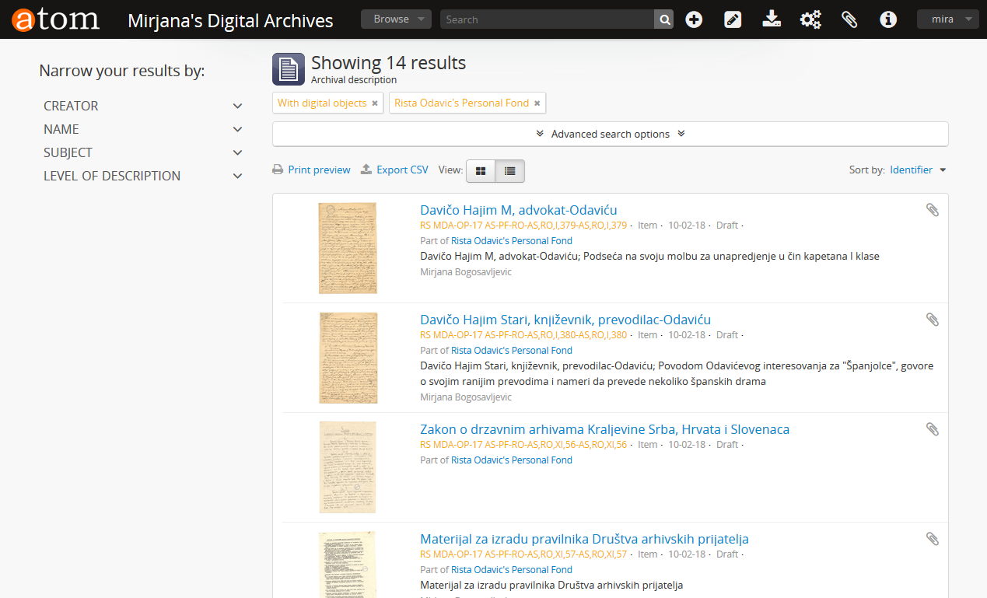
AtoM provides means for finding the documents using the keyword searching or simply by browsing through the tree of descriptions/signatures. The Figure 9 shows a practical example of results of the keyword search through the Personal Fonds of Rista Odavic.
Personalized Procedure
After the time working on uploading and processing of the digitized archive in the Archivematica and AtoM programs, it was concluded that the most productive way to adhere meticulously to the following recipe, we have compiled a checklist based on our own experience:
- Review all the accessible data about the fond and enter the information into the table Collection
- Review all the prepared digitized documents, check their formats, align the information about them with the signatures and enter all the information into the table Content.
- Create the folders in accordance with the signatures
- Copy the digitalized documents into the appropriate objects folders
- Generate metadata.csv files from the table Metadata (based on data from the tables Collection and Content) and distribute them into appropriate metadata folders in accordance with the signatures
- Prepare the data for the Transfer process and enter into the table Transfer&Ingest
- Create archival descriptions in AtoM
- Copy slugs from AtoM into the table Transfer&Ingest
- Copy all the folders that contain files ready for upload into the digitalized archive in to the appropriate Transfer source folder at the Archivematica server
- Start the Transfer process for each particular signature, meticulously using one by one each portion of the data prepared in the table Transfer&Ingest.
- Upon finishing the Transfer process for each of the signatures continue with the Ingest process
- Start the DIP upload into AtoM from Ingest using the already defined slugs from the table Transfer&Ingest
- Check the results of the Ingest process in the AtoM
- Repeat all the steps starting with the step 10 until you are finished with all signatures.
- (optional) When all the content linked to all signatures is fully entered into the digitalized archives show the results in AtoM to your colleagues.

SOURCES AND LITERATURE
- Artefactual, Archivematica Documentation, Retrieved from: https://www.archivematica.org/en/docs/archivematica-1.6.
- ISO 14721:2012 -Space data and information transfer systems --Open archival information system (OAIS) --Reference model–Edition 2. (2012). International Standards Organization/ Technical Committee: ISO/TC 20/SC 13.
- Klindt, M., Amrhein, K. (2015). One Core Preservation System for All your Data. No Exceptions!. iPRES 2015 - Proceedings of the 12th International Conference on Preservation of Digital Objects. Chapel Hill, North Carolina, USA: School of Information and Library Science.
- Van Garderen, P. et al. (2012). The Archivematica project: Meeting digital continuity's technical challenges. Retrieved from: https://wiki.archivematica.org/images/e/e1/2012-09-26-Mumma-UNESCOMoW-lowres.pdf.
- Reljic, J. (2008). Rista Odavić, Lični fond, 1787-1949, Sumarni inventar, Analiticki inventar. Beograd: Arhiv Srbije.
- Odluka o utvrđivanju arhivske građe od izuzetnog značaja koja se čuva u arhivima. (1998). Službeni glasnik Republike Srbije, br. 42.

SUMMARY
The paper presents an overview of the experience I have gained through the practical use of Archivematica and AtoM software packages in the process of uploading and managing digitalized documents. I have presented the operation of those two programs using the scanned documents belonging to the Personal Fond Rista Odavic from the Archives of Serbia.
The level of successful functioning of both Archivematica and Atom is directly dependent upon the meticulous preparation and organization of the information about the fond’s documents in the form that will afterward enable precise and comprehensive input of all data important for the digital preservation and subsequent use for the end user access. For that purpose, I have created an Excel spreadsheet with appropriate tables structured in accordance with the stages of processing and filled it up with all the data prior to starting any uploads.
The paper describes the actual process of upload of the digitalized documents into Archivematica and AtoM including the graphical details from those two portals.
The practical experience had shown that it is feasible to maintain the connection between the paper originals and their digitalized counterparts.
It is particularly important to point out the fact that neither Archivematica nor AtoM require that the material of the fonds that will be treated is fully arranged and processed, or for that matter, fully and completely scanned. Those two programs both enable phased inserting of the information and digitalized content and not necessarily in the same order they appear in the physical archives, but rather in the order based on a criterion which may be ad-hoc selected, such as in accordance with their significance or priority.
Archivematica itself is good for realization the principles of the OAIS functional model – that is to serve as an excellent environment for digital preservation. It is adapted for use by professional archivists. Processing of digitized documents takes relatively short time and control can be shared between several participants in the project. On the other hand, as for the Archivematica users themselves, multipurpose software is not structured to be easily accessible by external archival users. Which is why Archivematica is typically integrated with other open source packages, such as AtoM which I have used in my work. AtoM, among other features, facilitate access to digital archives to external end users.
While processing the digitalized documents from Personal Fond Rista Odavic in Archivematica and AtoM I kept a log of all required steps. I learned quickly that it could be very useful to convert that log into a “recipe” describing the exact procedure which will assure successful outcome of the process.
AUTHOR BIOGRAPHY
Mirjana Bogosavljević, MScE, Senior Archivist at the Archives of Serbia, Belgrade
Graduated from the Faculty of Philosophy, University of Belgrade, Department of Sociology. She completed her postgraduate studies at the Faculty of Economics at the University of Belgrade, where she gained her academic title master of demographic science. Master thesis on "Demographic and socioeconomic aspects of the population of Belgrade during the occupation of 1941-1944". During and after the completion of studies, she worked at the Institute for Sociological Research at the Faculty of Philosophy in Belgrade. In that period, she conducted a research titled: "The views of the young about marriage and parenting and expectations of young people in transition on behalf and under the grants of Open Society Institute and the Institute for Sociological Research.
Since 1995, Mirjana works at the Archives of Serbia mainly on archiving of fonds from the old and the new period, preparation of exhibitions and catalogs, production of information resources and inventory. She is the author of several articles in magazines and publications.
The field I am currently engaged in is the use of Archivematica and AtoM software in the process of digitizing archival documents.
Published works:
- Arhivski pregled Beograd, 1998-1999 “Pravilnik društva za uređenje grada Beograda iz 1890 godine”;
- Knjiga Arhiv Srbije 1900-2000, Beograd, 2000, “Grupa fondova finansija I privrede”;
- Knjiga Arhivska gradja kao izvor za istoriju, Medjunarodni naučni skup 15-16 maj 2000 godine, Beograd, 2000 “Osvrt na poreski system u Srbiji 1891. godina ;
- Naša prošlost, Zbornik radova, Narodni Muzej Kraljevo, Istorijski Arhiv Kraljevo, 2012, br. 13 “Škole u Kraljevačkom okrugu za vreme okupacije 1941.1944”;
- Zapis, Godišnjak Istorijskog Arhiva Požarevac, god. V, br. 5, “Ekonomski odnosi Srbije I nemačke pre I za vreme okupacije 1941-.1944”;
- Arhivska gradja u teoriji I praksi, Zbornik radova sa Medjunarodnog savetovanja “Tara 2016” , Arhivističko društvo Srbije, Beograd, 2016. “Arhivista, čuvar istorije ili njen uobličitelj: iskustva valorizacije arhivske građe nasuprot proceduralnoj”;
- The international Conference Technical and Field Related Problems of Traditional and Electronic Archiving, Radenci, Pokrajinski arhiv Maribor 2017. „Тhe experience in arranging archives of the Ministry of finance fonds at the Archives of Serbia- Таx administration department collection”;
- Arhivska prošlost, Archives of Tuzla Canton, 2017.,br.20 “Archivematica: An example of a software for digitalization adjusted to archivists“

Participation in conferences:
- International Conference 100th Anniversary of the Archives of Serbia, “Arhivska građa kao izvor za istoriju”, Belgrade, May 2000;
- Summer School of Archivistics, Belgrade 2009, Exhibition-Vraćanje dokumenata u život;
- Seminar, Program Kultura 2007-2013., Belgrade 2000;
- The international conference Technical and Field Related Problems of Traditional and Electronic Archiving, Radenci, Pokrajinski arhiv Maribor 2017 ;
- 30. Internationl archival conference “Arhivska praksa 2017”, Archives of Tuzla Canton, Tuzla, 2017

Exhibitions:
- Svetozar Marković, povodom stopedesetogodišnjice rođenja 1846-1996;
- Srbija i Hilandar u dokumentima srpskih arhiva – u susret 800 godina
- Ustanička Srbija 1804-1813,
- Through life and thought – bequest of Dr. Zoran Đinđić

email: bogosavljevicmirjana@yahoo.com

Rista Odavić left a testament stating that he leaves his records (books, correspondence, manuscripts) to the State Archives in Belgrade (Sumarium No. 315,406).
By the Decree on proclaiming archival records of special importance (Odluka, 1998).

