JobsheetMaker Manual

Table of Contents

Overview 2

Quickstart 3

How input files work 4

Setting a custom folder 4

The file list 5

The status bar 5

Special features 6

Show Export Prompt 6

Consume Input Files 6

Preserve Duplicates 6

The command line and silent mode 7

# Overview

JobsheetMaker is a program that takes **CSV (comma-separated values) files downloaded from Malinko as inputs** and produces **PDF jobsheet documents as outputs.** It can be used to create jobsheets for many workers at a time.

Here is a diagram that shows how JobsheetMaker fits into the current work environment at JobQuest:

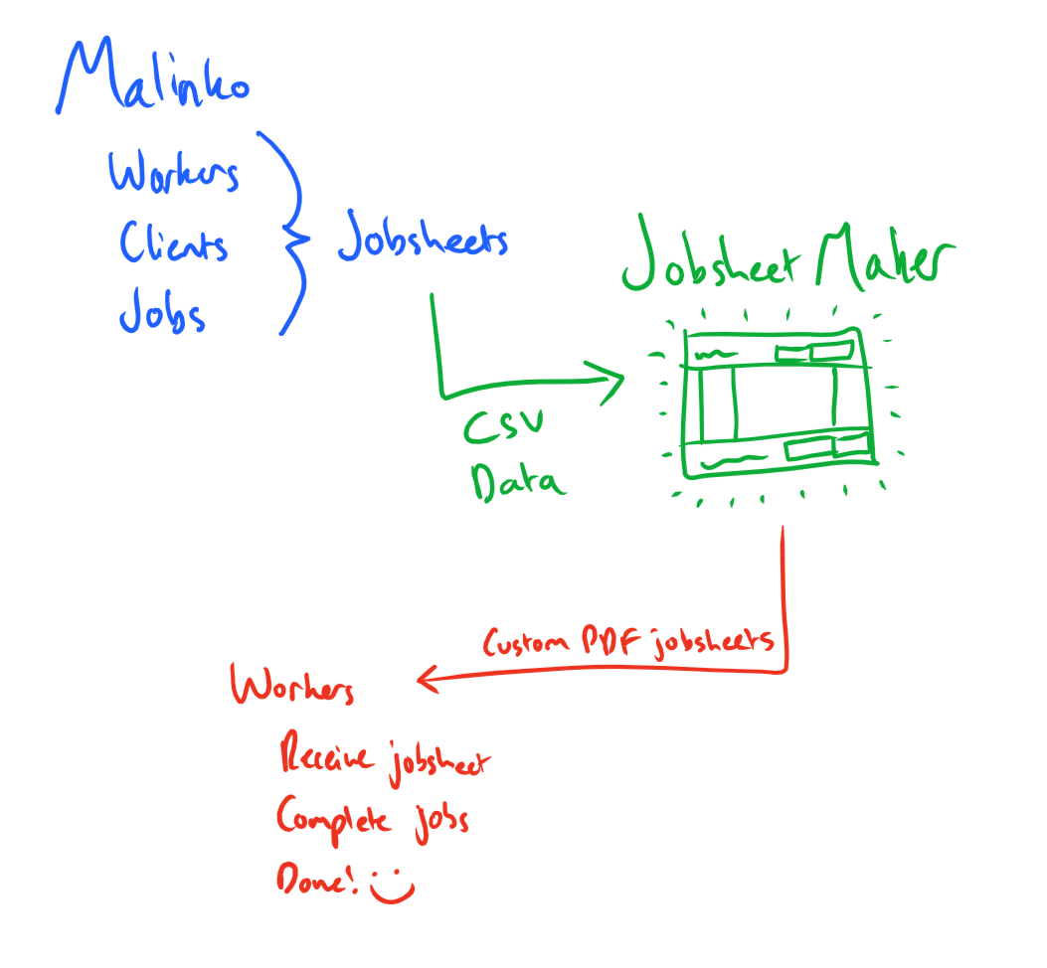

# Quickstart

**Doubleclick “JobsheetMaker.jar” to open the program.**

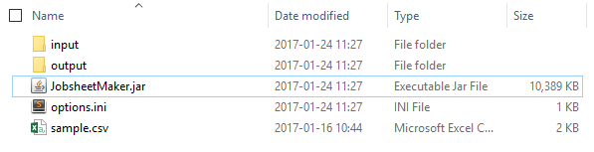

It will load all valid input files found in its local folder, the “input” folder in the local folder, and the user-specified “custom folder” (which defaults to the Downloads folder). **Your files must be in one of these locations to be found by the program.**

Verify that the files you want to export are present, then **click the green Export button** pictured below.

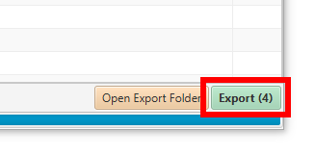

Your files will be created in the export folder. To quickly access the export folder, **click the orange Open Export Folder button** pictured below.

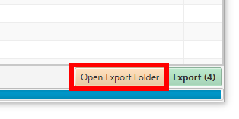

This will open a window that looks something like this:

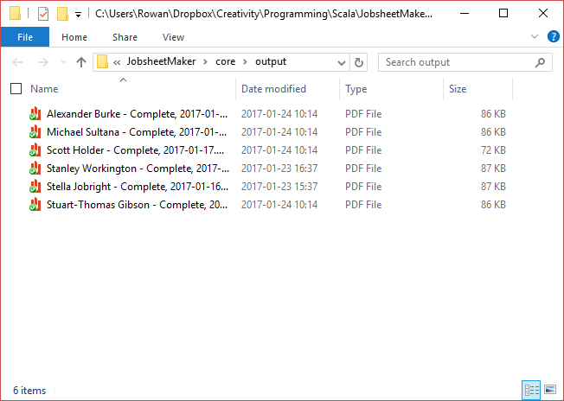

Your exported files will be in the folder. From here, you can print them or attach them to an email.

# How input files work

Input files are loaded when the program starts, when a new custom folder is selected or when the blue Refresh button is clicked. When this happens, JobsheetMaker will check each of the following folders:

* The **custom folder** specified by the user (defaults to **%USERPROFILE%\Downloads**)
* The **local folder**, the folder the program lives in
* The **local\input folder**, the folder named “input” in the local folder

The files **MUST** match the format of exported CSV files from Malinko’s “Day Overview”, **otherwise they will not be loaded.**

# Setting a custom folder

JobsheetMaker allows a “custom folder” to be specified for locating input files. By default, it is set to the Downloads folder (as this is usually where new files show up), but it can be changed to another location if desired.

You can see what the current custom folder is by looking at the text at the top-right of the program window:

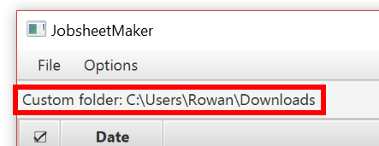

To change the custom folder to a different one, **click the yellow Set Custom Folder button:**

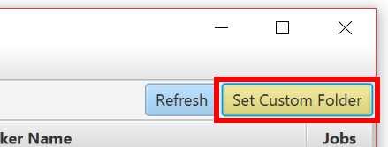

This will open a prompt asking you to select a folder. **Select (single-click) your desired folder, then click the Select Folder button**.

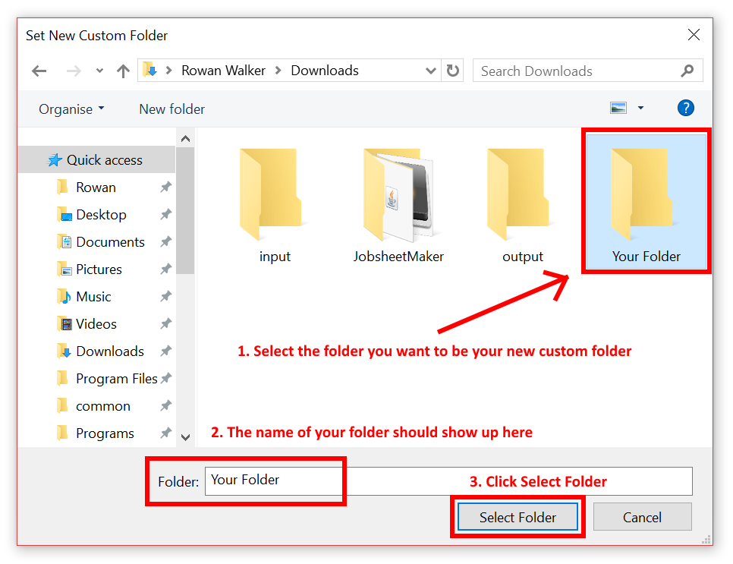

Once you have done this, the text at the top-left should update to show the location of your newly selected folder.

# The file list

The file list is the list of files in the centre of the program window:

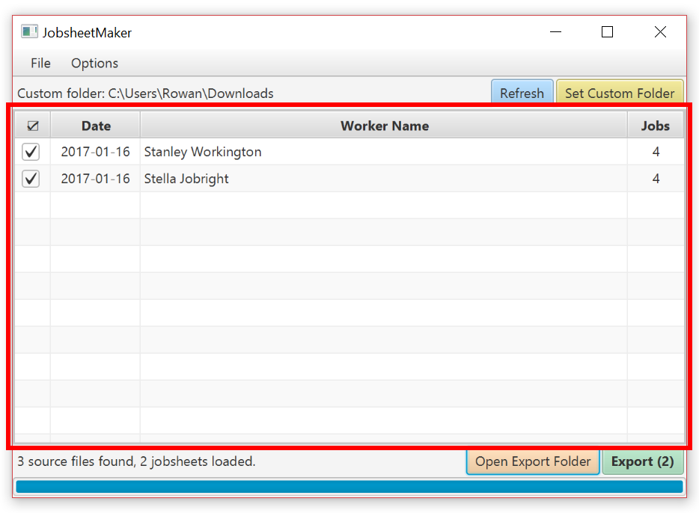

It provides an overview of the currently-loaded files, and allows you to selectively export files by ticking or unticking the box next to each file:

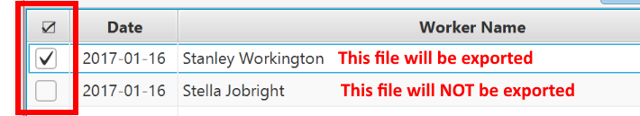

In addition, the green Export button will update its number based on how many files will be exported:

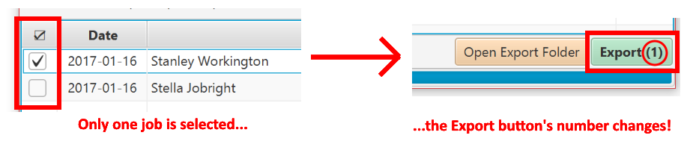

You can also select a file in the list and hit the Space Bar to toggle its checkbox. This works with multiple lines, too!

# The status bar

The status bar is a line of text that changes to indicate the status of the program:

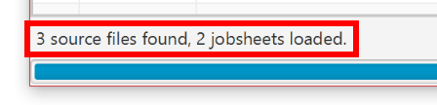

Hovering over a button will change the status bar to an explanation of what that button does:

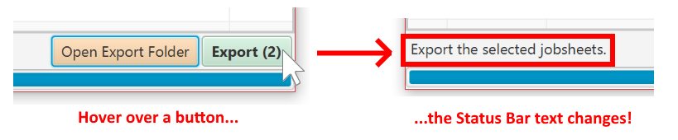

If you are ever unsure of what a button does, check out the status bar!

# Special features

These features are for advanced use. Each feature can be enabled or disabled via the Options menu at the top of the program window:

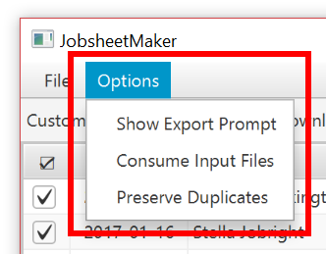

## Show Export Prompt

This option enables or disables a prompt that notifies users when an export has completed: It is enabled by default.

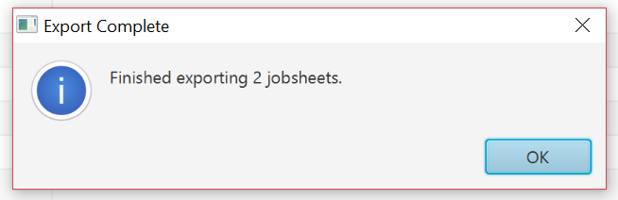

Without the prompt, it is still possible to tell when an export has finished by examining the colour of the progress bar at the bottom of the interface. If it is green, the export has completed, and the status bar’s text will change to “Finished exporting X jobsheets”.

## Consume Input Files

**WARNING: This option will delete input files. Only enable it if you are certain you want this to happen!**

If enabled, the Consume Input Files option will, after an export, delete any input files used to produce output files. It is disabled by default.

This feature is useful if input files would ordinarily be deleted by the user after use. With this feature enabled, the program effectively “cleans up after itself”, which can be desirable when handling large quantities of input files on a regular basis.

## Preserve Duplicates

This feature allows the program to check for any previously-exported jobsheets and prevent overwriting. It is disabled by default.

When enabled, a special column will appear in the file list:

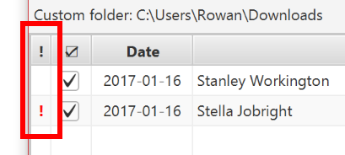

Any files with a red “**!**” next to them **will not be exported** as they would overwrite an existing output file.

# The command line and silent mode

JobsheetMaker may also be run via a **command line**. To do so, navigate to the program folder and type the following into the command prompt:

**java -jar JobsheetMaker.jar**

This will provide additional information about the state of the program that are useful for debugging.

Running JobsheetMaker via a command line has the added advantage of being able to use **silent mode**. This runs the application without an interface, which is useful for setting up a scheduled task to automatically process files at a certain time each day.

To run JobsheetMaker in silent mode, type the following:

**java -jar JobsheetMaker.java /nogui**

This will run the program (load all input files and export all valid jobsheets, then close) without an interface appearing.

END OF FILE