

For Examiner’s Use

Examiner’s Initials

Question | Mark
1
2
3
4
5
6
7
8
9
10
11
12
13
TOTAL | 93

Centre number |  |  |  |  |  | Candidate number
Surname | Mahajan
Forename(s) | Vaibhav
Candidate signature
Programming Language | PYTHON (7517/1D)

A-LEVEL COMPUTER SCIENCE
Paper 1

Monday 3 June 2019
Morning
Time allowed: 2 hours 30 minutes

Instructions
- This is the Electronic Answer Document (EAD). Answer all questions by entering your answers into this document on screen. You must save this document at regular intervals.
- Before the examination begins, type the information needed in the boxes at the top of this page.
- Before the examination begins, type the information needed in the boxes in the footers (page 2 onwards) of this EAD.

During the examination
- You may print pages of your EAD. A print monitor will collect and deliver your print-out to you. You must not collect your own print-out.

Exceptions
- If you experience difficulty inserting screen shots into your EAD then you may print these separately and attach them to the back of the EAD with a reference in the correct place in the EAD. Ensure that your Centre Number, Candidate Name and Candidate Number are on each sheet.

At the end of the examination
- Save for the last time and print your EAD on one side only (not double-sided). A print monitor will collect and deliver your print-out to you. Check that your details are in the footers of every page. Write them in if they are not.
- Enter your signature on the front cover.
- Staple or tie all pages together in the top left-hand corner of the EAD.
- Hand in all pages of the EAD to the Invigilator.

Warning
- No extra time is allowed for printing and collating.
- It may not be possible to credit an answer if your:
– details are not printed on every page as instructed above
– screen captures are not legible to the Examiner.
Answer all questions.
You must save this document at regular intervals or you may lose your work.

Section A
 |  |  |  |  |  | Leave blank
Question 01
0 | 1 | . | 1 | The upper limit of the inner for loop could be changed to N – Count1.  Using a Boolean variable, the while loop could have the added condition to only continue if the last pass actually swapped any values; if it did not, then the list is sorted and the algorithm can terminate. Reset flag variable each pass |  | 3
0 | 1 | . | 2 | An intractable problem is a problem that cannot be solved in polynomial time or better; sorting algorithms exist (such as quicksort and mergesort) which have time complexity of n log n, which is better than polynomial time, so sorting is not an intractable problem. Problem does not change from tractable to intractable |  | 1
0 | 1 | . | 3 | Use heuristic methods to produce an approximate answer that may not be optimal, but is good enough. |  | 2
 |  |  |  |  |  | 6
 |  |  |  |  |  | 8

 |  |  |  |  |  |  | Leave blank
Question 02
0 | 2 | . | 1 | 0 # 1* 0 1 0 0  0 #* 1 0 1 0 0  0 # 1* 0 1 0 0  0 # # 0* 1 0 0  0 # # 0 1* 0 0  0 # # 0 1 0* 0  0 # # 0 1* 1 0  0 # # 0* 1 1 0  0 # #* 0 1 1 0  0 # # 0* 1 1 0  0 # #* 0 1 1 0  0 #* 1 0 1 1 0  0* 1 1 0 1 1 0  0 1* 1 0 1 1 0 |  | S4  S4  S0  S1  S2  S2  S3  S3  S4  s0  S5  S5  S5  S6 | 5
0 | 2 | . | 2 | Makes a copy of a string of ones |  |  | 0
0 | 2 | . | 3 | To transition to the halting state if a 0 is found on the left Move r/w head back to start |  |  | 0
0 | 2 | . | 4 | A Turing Machine that acts as an interpreter: it can run any program by reading it from the tape. Simulate the behaviour of any Turing machine |  |  | 2
 |  |  |  |  |  |  | 7
 |  |  |  |  |  |  | 9

 |  |  |  |  |  | Leave blank
Question 03
0 | 3 | . | 1 | I E H  C A B  G D F |  | 1
0 | 3 | . | 2 | Where the actual implementation is hidden by a representation of the problem, which is often simpler to work with Unnecessary details |  | 0
0 | 3 | . | 3 | Where the specific details of a problem are hidden to make a more general problem than can be solved. |  | 0
0 | 3 | . | 4 | The fact that is actually a grid of cells, with rows and columns |  | 1
0 | 3 | . | 5 | When the graph is not sparse, or the edges are being changed a lot. |  | 2
0 | 3 | . | 6 | A directed graph |  | 1
 |  |  |  |  |  | 5
 |  |  |  |  |  | 7

 |  |  |  |  |  | Leave blank
Question 04
0 | 4 | . | 1 | 0 or more repetitions |  | 1
0 | 4 | . | 2 | 0 or 1 repetitions; it is optional |  | 1
0 | 4 | . | 3 | Y  N  Y  Y  N  N  N |  | 3
 |  |  |  |  |  | 5
 |  |  |  |  |  | 5

Section B

 |  |  |  |  |  | Leave blank
Question 05
0 | 5 | . | 1 | word1 = input("Enter first word...").upper()  word2 = input("Enter second word...").upper()  word2_characters = []  for char in word2:  word2_characters.append(char)  success = True  for char in word1:  if char in word2_characters:  word2_characters.remove(char)  else:  success = False  print(f"The first word can{'' if success else 'not'} be made from the second") |  | 12
0 | 5 | . | 2 | 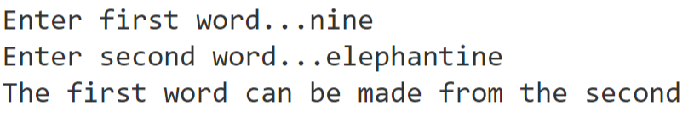  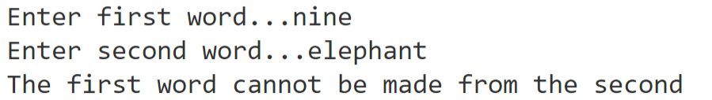 |  | 1
 |  |  |  |  |  | 13
 |  |  |  |  |  | 13

Section C

 |  |  |  |  |  | Leave blank
Question 06
0 | 6 | . | 0 | Binary file will be more compact  Harder to a player to edit the file and change the gameplay |  | 2
 |  |  |  |  |  | 2

 |  |  |  |  |  | Leave blank
Question 07
0 | 7 | . | 1 | The item was not found does not exist |  | 1
0 | 7 | . | 2 | If ItemIdtoGet is -1, then it uses the name, otherwise it uses the id |  | 1
0 | 7 | . | 3 | O(n) |  | 1
0 | 7 | . | 4 | If there are multiple items with the same name (or id), later occurrences will never be found. |  | 2
0 | 7 | . | 5 | The key is hashed, which produces a number. This is used as an index to access the entries of the hash table. If the key matches the key of the item at the index, then the item has been found. Otherwise, a rehashing algorithm is used to find the next index to look at; often, this is just a linear search to search through all the slots after the first one generated by the original hash function.
0 | 7 | . | 6 | The items are all objects with multiple properties, and so there is no specific unique key that can be used.
 |  |  |  |  |  | 10

 |  |  |  |  |  | Leave blank
Question 08
0 | 8 | . | 1 | The intersection of D and B in union with E: (D intersect B) union E
0 | 8 | . | 2 | A, B
0 | 8 | . | 3 | Because if the item is already in the inventory, it cannot be got.
0 | 8 | . | 4 | A proper subset is when the two sets are not equal to each other, whereas if A is a subset of B, it is either a proper subset of B or it is equal to B.
 |  |  |  |  |  | 6

 |  |  |  |  |  | Leave blank
Question 09
0 | 9 | . | 1 | Main |  | 1
0 | 9 | . | 2 | PlayGame |  | 1
0 | 9 | . | 3 | LoadGame |  | 1
0 | 9 | . | 4 | A global variable can be accessed anywhere in the program, whereas a local variable can only be accessed inside the subroutine that defines it. |  | 1
0 | 9 | . | 5 | It is much harder to figure out where a global variable has been changed from, and using local variables mean that the side effects of functions are reduces, which makes the code easier to understand. |  | 1
 |  |  |  |  |  | 5
 |  |  |  |  |  | 5

Section D

 |  |  |  |  |  | Leave blank
Question 10
1 | 0 | . | 1 | def PlayGame(Characters, Items, Places):  StopGame = False  Moved = True  while not StopGame:  if Moved:  print()  print()  print(Places[Characters[0].CurrentLocation - 1].Description)  DisplayGettableItemsInLocation(Items, Characters[0].CurrentLocation)  Moved = False  Instruction = GetInstruction()  Command, Instruction = ExtractCommand(Instruction)  if Command == "get":  StopGame, Items = GetItem(Items, Instruction, Characters[0].CurrentLocation)  elif Command == "use":  StopGame, Items = UseItem(Items, Instruction, Characters[0].CurrentLocation, Places)  elif Command == "go":  Characters[0], Moved = Go(Characters[0], Instruction, Places[Characters[0].CurrentLocation - 1])  elif Command == "read":  ReadItem(Items, Instruction, Characters[0].CurrentLocation)  elif Command == "examine":  Examine(Items, Characters, Instruction, Characters[0].CurrentLocation)  elif Command == "open":  ResultOfOpenClose, Items, Places = OpenClose(True, Items, Places, Instruction, Characters[0].CurrentLocation)  DisplayOpenCloseMessage(ResultOfOpenClose, True)  elif Command == "close":  ResultOfOpenClose, Items, Places = OpenClose(False, Items, Places, Instruction, Characters[0].CurrentLocation)  DisplayOpenCloseMessage(ResultOfOpenClose, False)  elif Command == "move":  MoveItem(Items, Instruction, Characters[0].CurrentLocation)  elif Command == "say":  Say(Instruction)  elif Command == "playdice":  Items = PlayDiceGame(Characters, Items, Instruction)  elif Command == "quit":  Say("You decide to give up, try again another time.")  StopGame = True  else:  randnum = random.randint(0,1)  if randnum == 0:  print("Sorry, you don't know how to " + Command + ".")  else:  print("Sorry, I don't know what " + Command + " means.")  input() |  | 4
1 | 0 | . | 2 | 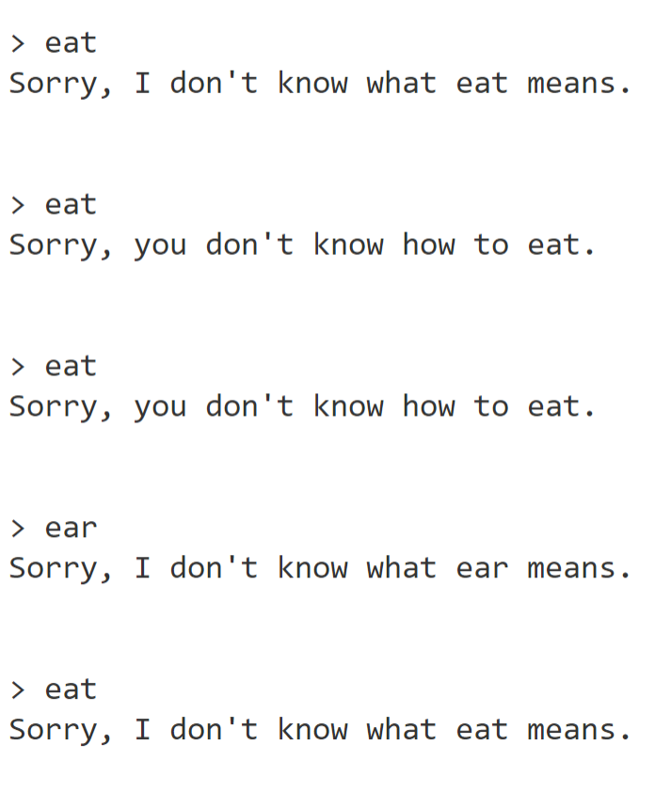 |  | 1
 |  |  |  |  |  | 5

 |  |  |  |  |  | Leave blank
Question 11
1 | 1 | . | 1 | def GetItem(Items, ItemToGet, CurrentLocation):  SubCommand = ""  SubCommandParameter = ""  CanGet = False  IndexOfItem = GetIndexOfItem(ItemToGet, -1, Items)  num_items = 0  for Thing in Items:  if Thing.Location == INVENTORY: # Count the number of items in the inventory  num_items += 1  if IndexOfItem == -1:  print("You can't find " + ItemToGet + ".")  elif num_items >= 5:  print("You cannot carry more than five items")  elif Items[IndexOfItem].Location == INVENTORY:  print("You have already got that!")  elif not "get" in Items[IndexOfItem].Commands:  print("You can't get " + ItemToGet + ".")  elif Items[IndexOfItem].Location >= MINIMUM_ID_FOR_ITEM and Items[GetIndexOfItem("", Items[IndexOfItem].Location, Items)].Location != CurrentLocation:  print("You can't find " + ItemToGet + ".")  elif Items[IndexOfItem].Location < MINIMUM_ID_FOR_ITEM and Items[IndexOfItem].Location != CurrentLocation:  print("You can't find " + ItemToGet + ".")  else:  CanGet = True  if CanGet:  Position = GetPositionOfCommand(Items[IndexOfItem].Commands, "get")  ResultForCommand = GetResultForCommand(Items[IndexOfItem].Results, Position)  SubCommand, SubCommandParameter = ExtractResultForCommand(SubCommand, SubCommandParameter, ResultForCommand)  if SubCommand == "say":  Say(SubCommandParameter)  elif SubCommand == "win":  Say("You have won the game")  return True, Items  if "gettable" in Items[IndexOfItem].Status:  Items = ChangeLocationOfItem(Items, IndexOfItem, INVENTORY)  print("You have got that now.")  return False, Items |  | 7
1 | 1 | . | 2 | 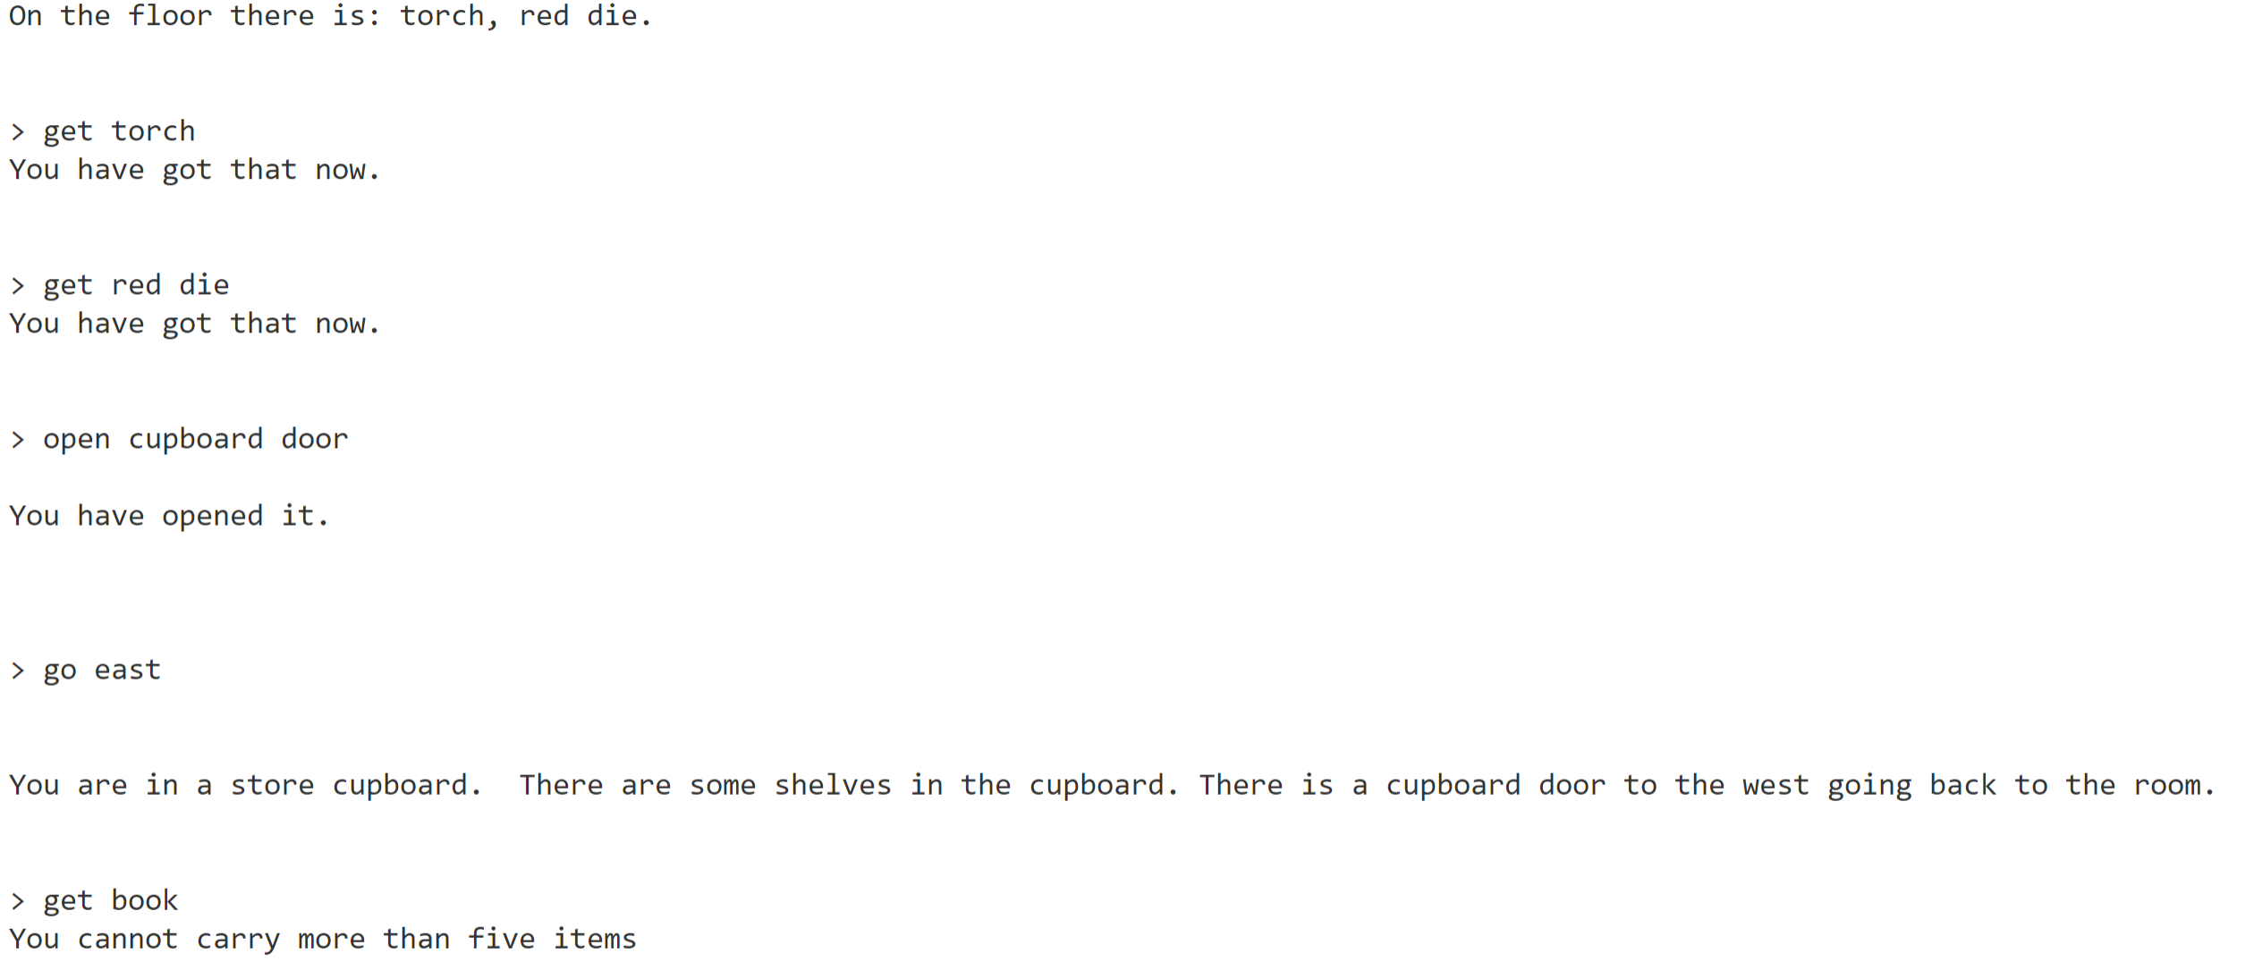 |  | 1
 |  |  |  |  |  | 8

 |  |  |  |  |  | Leave blank
Question 12
1 | 2 | . | 1 | def DropItem(Items, ItemToDrop, CurrentLocation):  IndexOfItem = GetIndexOfItem(ItemToDrop, -1, Items)  if IndexOfItem == -1:  print("You can't find " + ItemToDrop +".")  return  Item = Items[IndexOfItem]  if Item.Location != INVENTORY:  print(ItemToDrop +" not in inventory.")  elif "fragile" in Item.Status:  Item.Location = 0  print("Item broke when dropped")  else:  Item.Location = CurrentLocation  print("Item dropped")  def PlayGame(Characters, Items, Places):  StopGame = False  Moved = True  while not StopGame:  if Moved:  print()  print()  print(Places[Characters[0].CurrentLocation - 1].Description)  DisplayGettableItemsInLocation(Items, Characters[0].CurrentLocation)  Moved = False  Instruction = GetInstruction()  Command, Instruction = ExtractCommand(Instruction)  if Command == "get":  StopGame, Items = GetItem(Items, Instruction, Characters[0].CurrentLocation)  elif Command == "use":  StopGame, Items = UseItem(Items, Instruction, Characters[0].CurrentLocation, Places)  #Q12  elif Command == "drop":  DropItem(Items,Instruction, Characters[0].CurrentLocation)  #/Q12  elif Command == "go":  Characters[0], Moved = Go(Characters[0], Instruction, Places[Characters[0].CurrentLocation - 1])  elif Command == "read":  ReadItem(Items, Instruction, Characters[0].CurrentLocation)  elif Command == "examine":  Examine(Items, Characters, Instruction, Characters[0].CurrentLocation)  elif Command == "open":  ResultOfOpenClose, Items, Places = OpenClose(True, Items, Places, Instruction, Characters[0].CurrentLocation)  DisplayOpenCloseMessage(ResultOfOpenClose, True)  elif Command == "close":  ResultOfOpenClose, Items, Places = OpenClose(False, Items, Places, Instruction, Characters[0].CurrentLocation)  DisplayOpenCloseMessage(ResultOfOpenClose, False)  elif Command == "move":  MoveItem(Items, Instruction, Characters[0].CurrentLocation)  elif Command == "say":  Say(Instruction)  elif Command == "playdice":  Items = PlayDiceGame(Characters, Items, Instruction)  elif Command == "quit":  Say("You decide to give up, try again another time.")  StopGame = True  else:  randnum = random.randint(0,1)  if randnum == 0:  print("Sorry, you don't know how to " + Command + ".")  else:  print("Sorry, I don't know what " + Command + " means.")  input() |  | 11
1 | 2 | . | 2 | 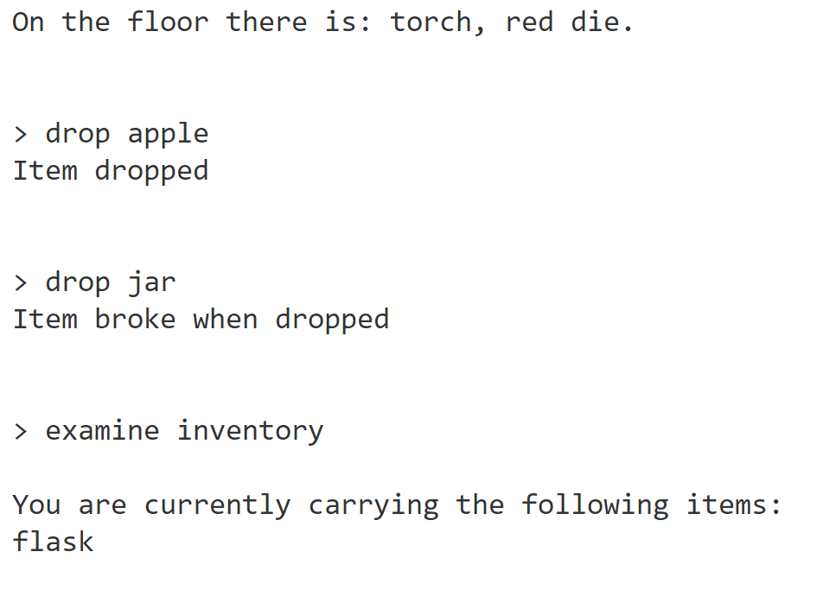  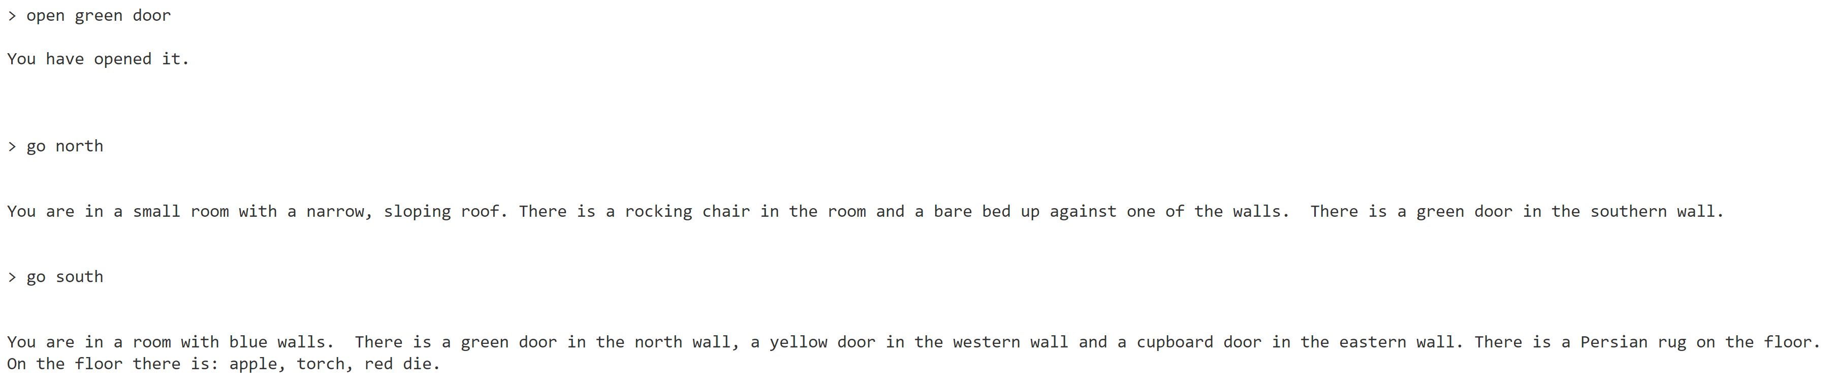 |  | 1
 |  |  |  |  |  | 13

 |  |  |  |  |  | Leave blank
Question 13
1 | 3 | . | 1 | def PlayDiceGame(Characters, Items, OtherCharacterName):  PlayerScore = 0  OtherCharacterScore = 0  player_rolls = []  DiceGamePossible, IndexOfPlayerDie, IndexOfOtherCharacter, IndexOfOtherCharacterDie = CheckIfDiceGamePossible(Items, Characters, OtherCharacterName)  if not DiceGamePossible:  print("You can't play a dice game.")  else:  #Q13  for i in range(3): # Repeat three times  Position = GetPositionOfCommand(Items[IndexOfPlayerDie].Commands, "use")  ResultForCommand = GetResultForCommand(Items[IndexOfPlayerDie].Results, Position)  roll = RollDie(ResultForCommand[5], ResultForCommand[7])  print("You rolled a " + str(roll) + ".")  player_rolls.append(roll)  Position = GetPositionOfCommand(Items[IndexOfOtherCharacterDie].Commands, "use")  ResultForCommand = GetResultForCommand(Items[IndexOfOtherCharacterDie].Results, Position)  other_roll = RollDie(ResultForCommand[5], ResultForCommand[7])  print("They rolled a " + str(other_roll) + ".")  OtherCharacterScore += other_roll * 10 ** i # Increment score  max_roll = max(player_rolls)  min_roll = min(player_rolls)  player_rolls.remove(max_roll)  player_rolls.remove(min_roll)  mid = player_rolls[0] # Only 1 item left  PlayerScore = max_roll * 100 + mid * 10 + min_roll  print(f"Your score is {PlayerScore}")  print(f"Their score is {OtherCharacterScore}")  #/Q13  if PlayerScore > OtherCharacterScore:  print("You win!")  Items = TakeItemFromOtherCharacter(Items, Characters[IndexOfOtherCharacter].ID)  elif PlayerScore < OtherCharacterScore:  print("You lose!")  Items = TakeRandomItemFromPlayer(Items, Characters[IndexOfOtherCharacter].ID)  else:  print("Draw!")  return Items |  | 8
1 | 3 | . | 2 | 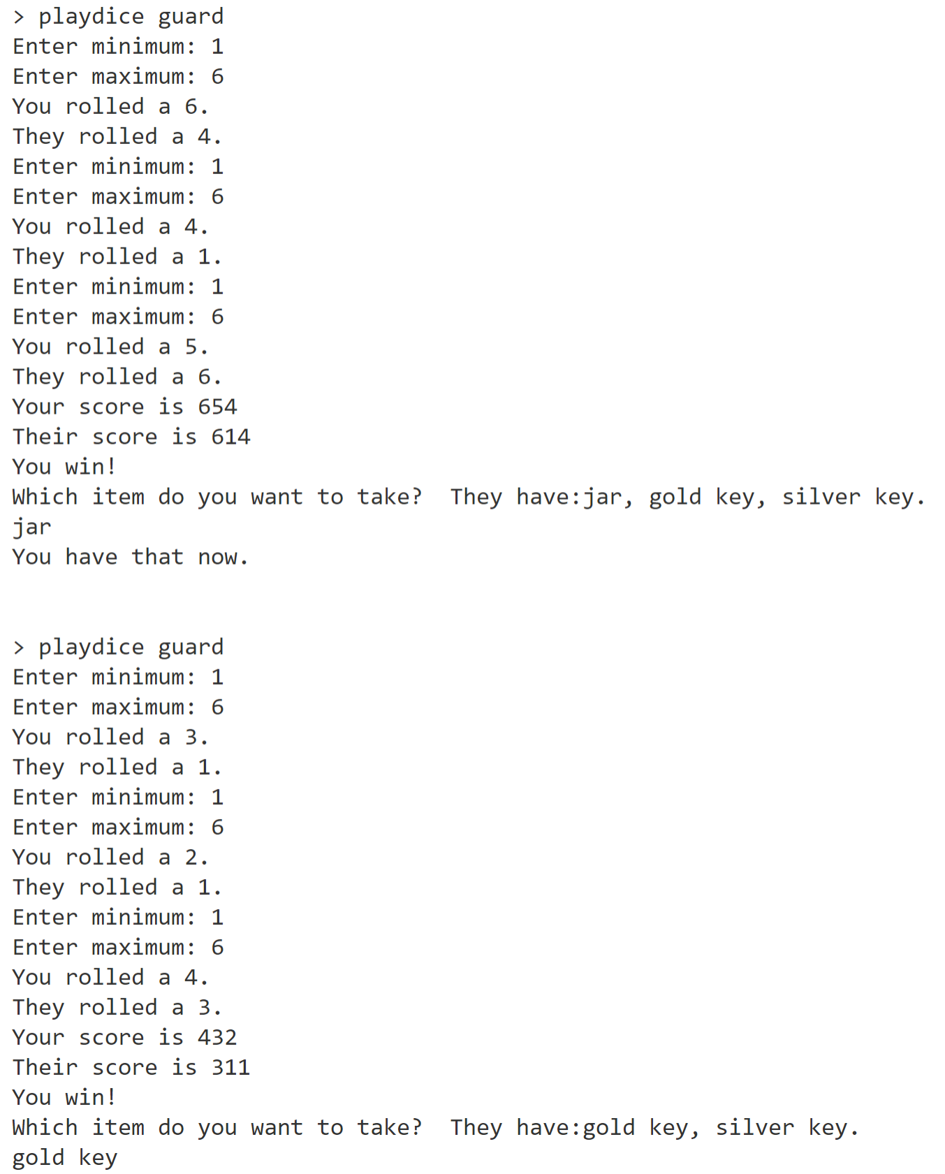 |  | 1
 |  |  |  |  |  | 9

If you have made any separate screen captures, put a reference in the correct place in this Electronic Answer Document.

Ensure that your Centre Number, Candidate Name and Candidate Number are on each sheet.

Attach them to the back of this document.

NB: The AQA logo is provided for use only in the Electronic Answer Document for the 2019 A-level Computer Science Paper 1 (7517/1) examination and must not be used for any other purpose.

Copyright © 2019 AQA and its licensors. All rights reserved.

