Naïve Bayes Classifier Report
- This Program is written in Java and code is attached as an Eclipse Package.
- The data has been converted into a convenient format for processing .All the reviews have been merges to as ingle doucment delimited by a newline
- The code implements Naive bayes classifier and the following two extensions
1Removing stop words
2.Binary Naive Bayes

- The comparision of their performance in terms of accuracy, precision, recall, F-measure can be seen in the following screenshot:
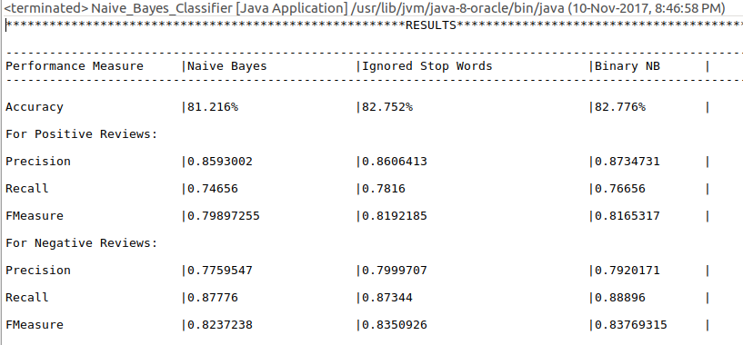

- For both the extensions there is an improvement in the accuracy, precision and recall from the basic naive bayes. Stop words do not give any new infor to the classifer and may confuse the classifier too, there for removal of stop words has improved the performance of the classifier
- For sentiment analysis,whether a word occur or not in a document matters more than the frequency of the word.Therefore in case of Binary Naive bayes not considering the word count in the document improves the accuracy.

