Heuristic Analysis

My own heuristic functions are based on “AB_Improved function” and I consider the place where the player is. The logic is simple: the more closed to the center of board, the more extra score the player get.

The board scores are show in the below figure.

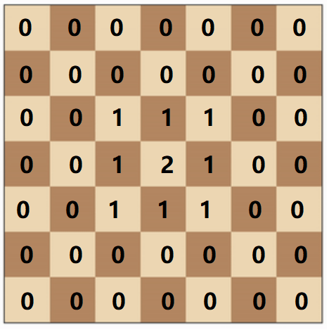

If the player is in the middle area, the player will get extra position score.

The details of custom heuristic functions:

* “custom_score function”: return “extra position score + open_move”
* “custom_score2 function”: return “extra position score + open_move - opp_moves”
* “custom_score3 function”: return “extra position score + open_move – 2 *opp_moves”

open_move is the player number of moves left.

opp_moves is the opponent number of moves left.

I set 40 matches for every match, and the results are below:

*************************

Playing Matches

*************************

Match # Opponent AB_Improved AB_Custom AB_Custom_2 AB_Custom_3

Won | Lost Won | Lost Won | Lost Won | Lost

1 Random 38 | 2 37 | 3 38 | 2 38 | 2

2 MM_Open 30 | 10 33 | 7 33 | 7 33 | 7

3 MM_Center 32 | 8 36 | 4 37 | 3 37 | 3

4 MM_Improved 23 | 17 20 | 20 26 | 14 28 | 12

5 AB_Open 23 | 17 19 | 21 20 | 20 24 | 16

6 AB_Center 24 | 16 22 | 18 26 | 14 22 | 18

7 AB_Improved 21 | 19 19 | 21 17 | 23 21 | 19

--------------------------------------------------------------------------

Win Rate: 68.2% 66.4% 70.4% 72.5%

In fact, the results of my own heuristic functions are as good as “AB_Improved”.

In the end, I recommend “AB_Custom_3” (“custom_score3”function) as my final player, the reason are:

1. Due to the extra position score, the player is encourage to occupy the central area of the board in the beginning.
2. Because the AB_Custom_3 give the more weights to opp_moves, our player is more willing to chase the opponent and block the opponent‘s way.
3. The experimental results show the “AB_Custom_3”win in all rounds, and get highest score – 72.5%