1. The result of executing steps 1-3 in part 2 of 1st task was appearing file as indexed and non-indexed, because file name was same, but content was different.
2. Task 1234 – log:

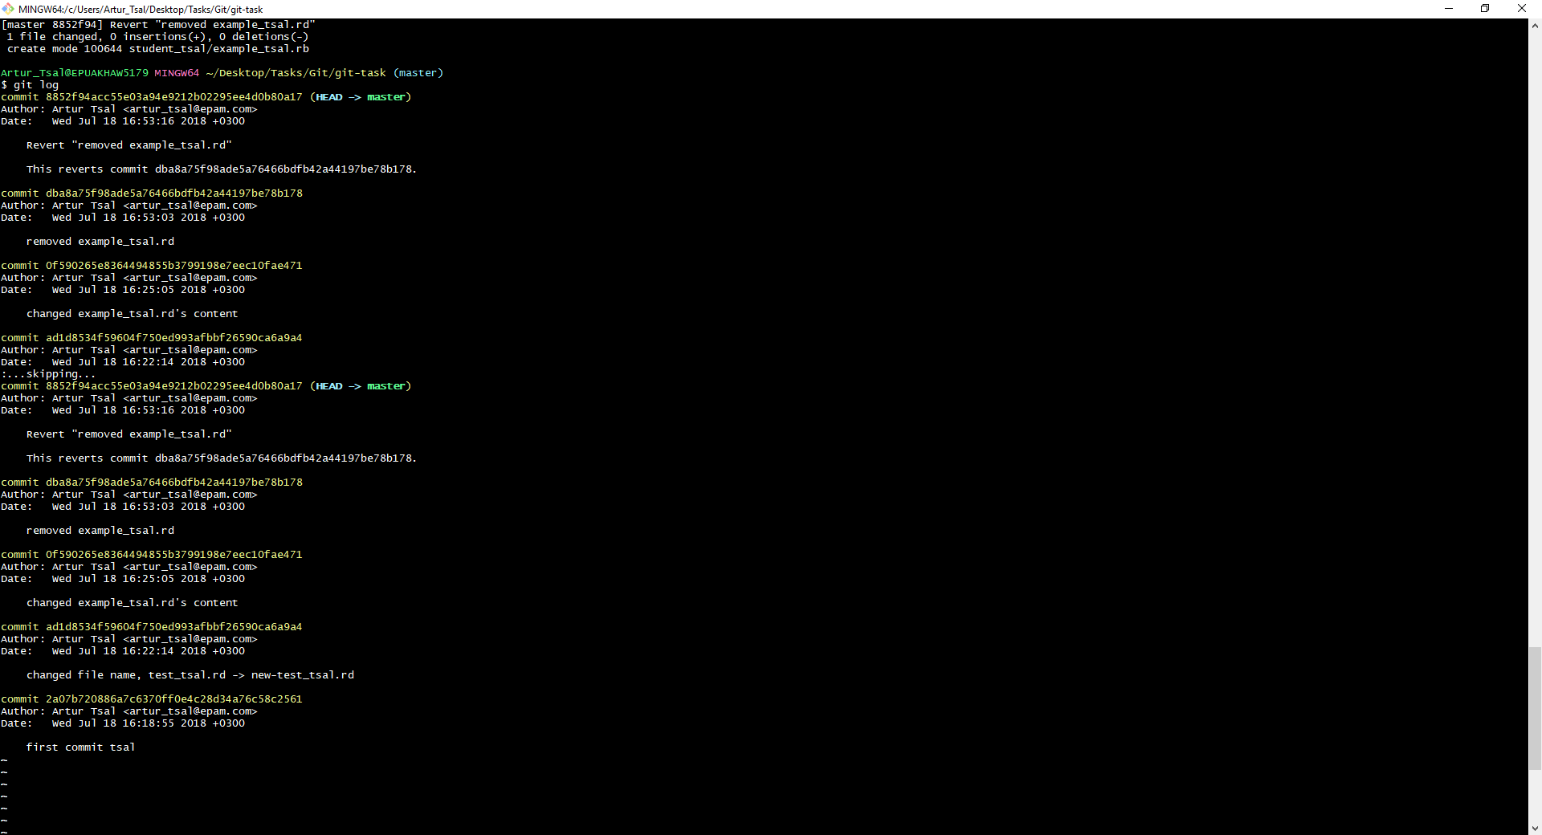

1. 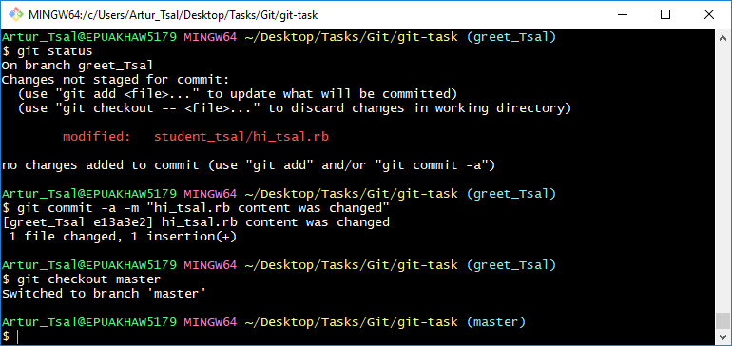Switching on master
2. Fast Forward merge was impossible, because I created commits on branch Master after creating new branch.
3. Commits graph after merging

**Here was added Readme file in master**

MASTER

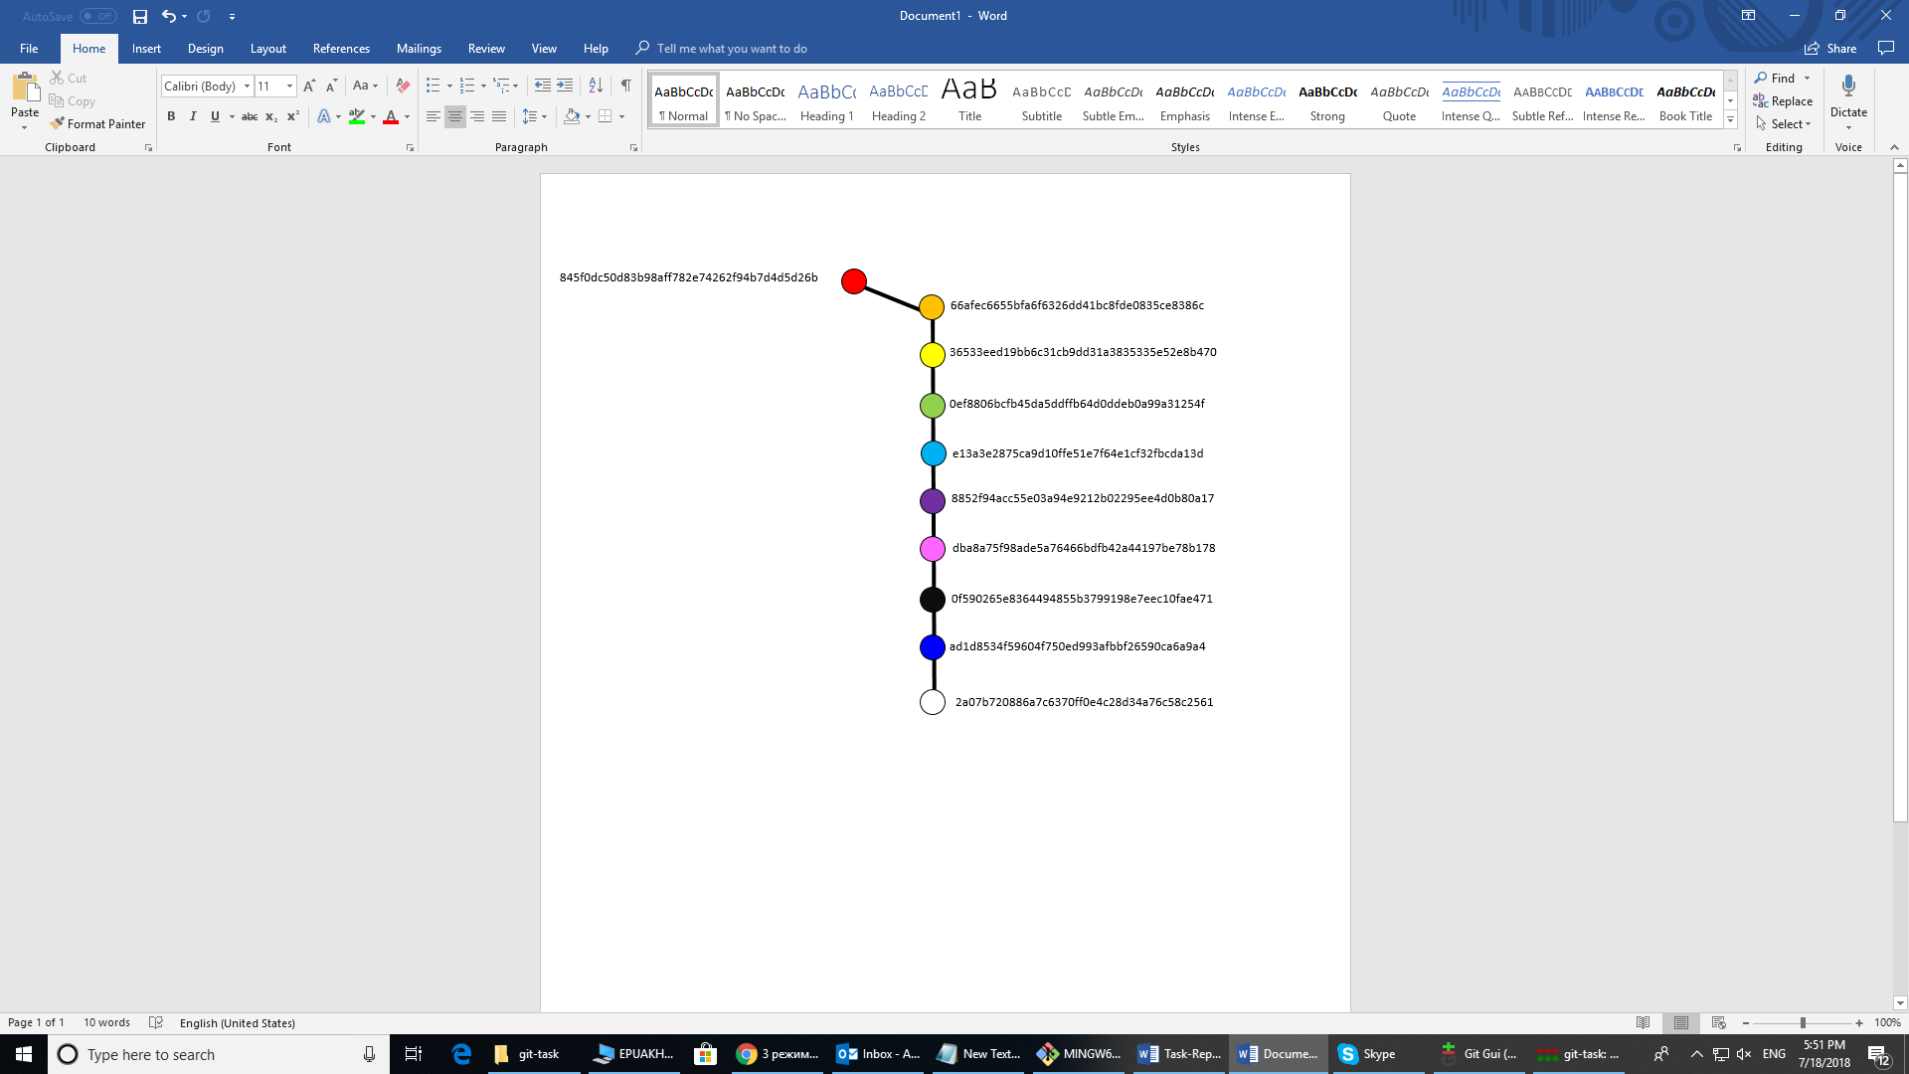

1. 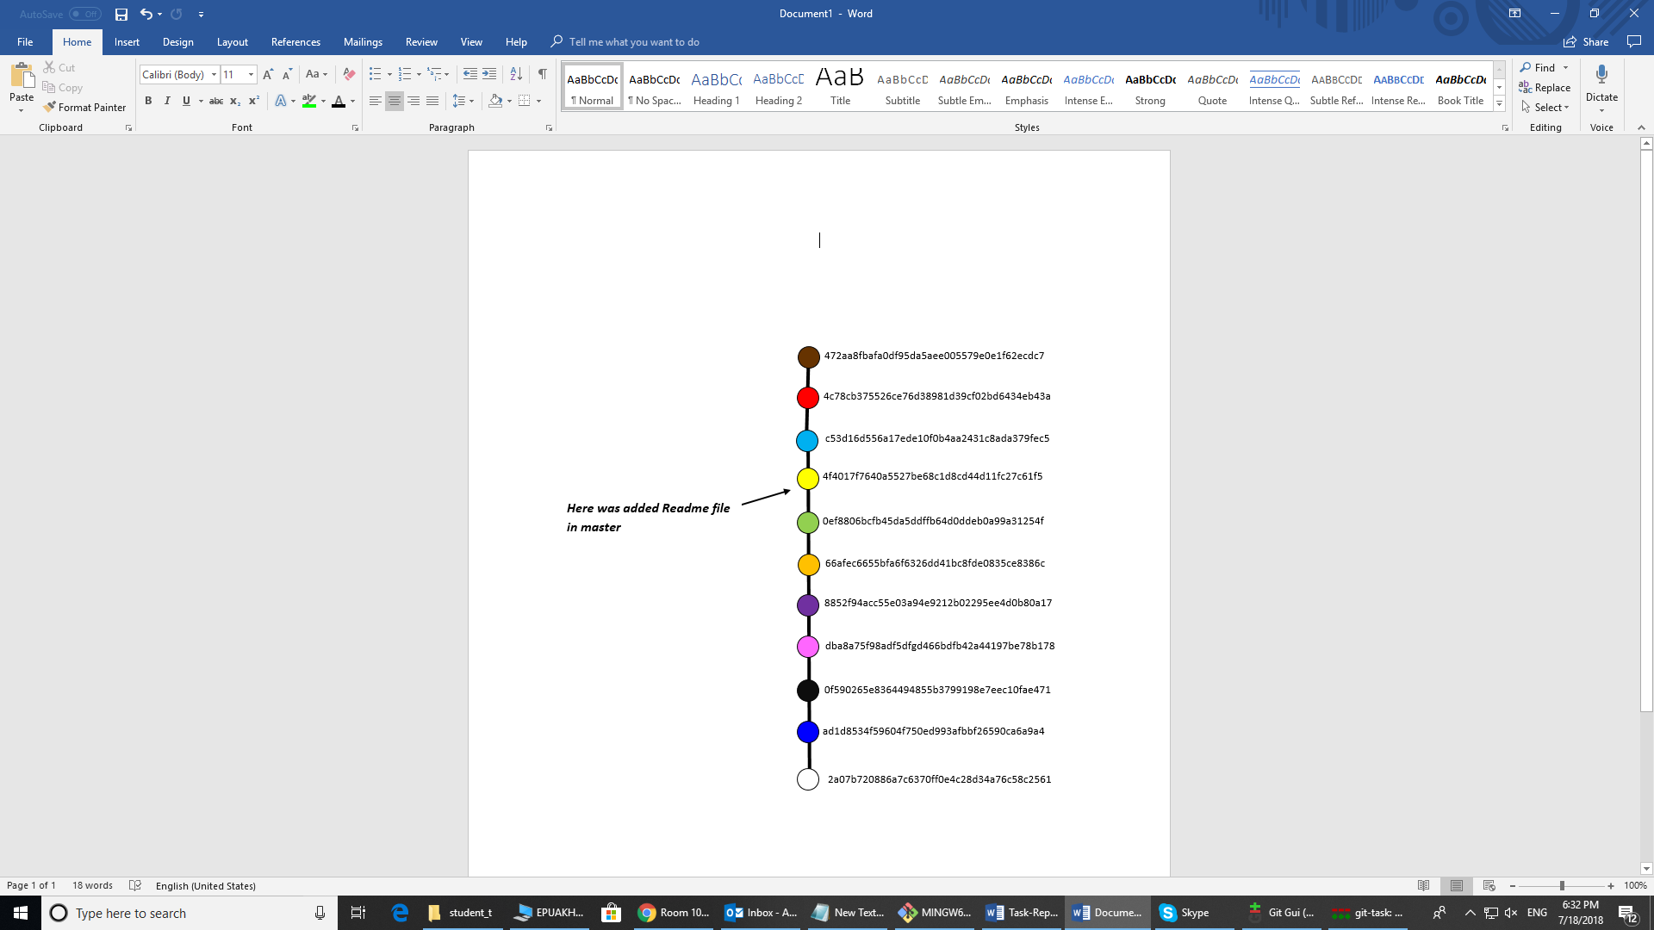Rebased second branch to master:
2. I didn’t catch one thing, why wasn’t there conflict after rebase?