DS3
Hyperspectral Viewer & Analysis Tool
User Guide
How to open, explore, label and classify hyperspectral images
Created by Kapih Team
Version 1.0 · October 2026 · program file: HyperVista.py

About this guide
DS3 is a desktop program for looking at hyperspectral images (ENVI format), marking regions of interest, and running analyses such as clustering, unmixing, signal-to-noise checks and several kinds of classification. This guide explains every part of the program, step by step, in the order you will normally use it.
You do not need programming knowledge to use DS3 once it is installed. Words that may be new are explained in the glossary at the end.
Section | What you will find
1. What DS3 does | A short overview and a map of all tabs.
2. Installing and starting | Python, packages, and how to launch the program.
3. The main window | What every area of the screen is for.
4. Opening your data | Loading an ENVI image, and what to check if it fails.
5. Looking at the image | Bands, color composites and pixel spectra.
6. Regions of interest (ROIs) | Drawing, naming, managing, saving and loading ROIs.
7. Exploration tools | Anomaly map, band math, k-means and PCA.
8. Spectral unmixing | Linear unmixing from ROIs, and automatic NMF unmixing.
9. Signal-to-noise ratios | Checking data quality.
10. Classification | Spectral Angle Mapper, random forest and SVM, cross-validation, 2D CNN, and how to read the reports.
11. Typical workflows | Four ready-made recipes.
12. Themes and settings | Dark and light appearance.
13. Troubleshooting | Common problems and fixes.
Appendices | Working with large images, current limitations, glossary.

1 What DS3 does
A hyperspectral image is a “cube”: every pixel holds a full spectrum measured in many narrow wavelength bands, not just red, green and blue. DS3 lets you move through that cube, inspect spectra, label examples of different materials, and let the computer map those materials across the whole image.

Main capabilities
- Open ENVI images (. hdr header plus binary data file) and browse them band by band or as an RGB color composite.
- Click any pixel to see its spectrum; draw rectangle or polygon ROIs to see average spectra.
- Organize ROIs into named classes, and save and reload them.
- Explore the data with an anomaly map, band math, k-means clustering and PCA.
- Separate mixed materials with linear unmixing (from your ROIs) or automatic NMF unmixing.
- Measure signal-to-noise ratio per band and per pixel.
- Classify the image with the Spectral Angle Mapper, random forest, SVM or a 2D convolutional neural network, with accuracy reports and cross-validation.
- Switch between a dark and a light appearance.

The tabs at a glance
Tab | Used for
ROI / Anomaly | Draw ROIs, add them to the ROI list or as an endmember; compute the anomaly map.
Band Math / Clustering | Evaluate your own band expressions; k-means clustering.
Unmixing | Linear unmixing from ROI endmembers; automatic NMF unmixing with abundance maps.
PCA | Principal components, PCA color image, scree plot.
ROI Manager | List, delete, relabel, plot, save and load ROIs.
Classification | Spectral Angle Mapper; random forest / SVM; k-fold cross-validation.
2D CNN | Patch-based deep-learning classification (needs TensorFlow).
SNR | Signal-to-noise ratio curve and map.

2 Installing and starting

2.1 What you need
Package | Why it is needed
Python 3.10 or 3.11 | The language DS3 runs on.
PyQt5 | The program window and controls.
matplotlib, NumPy | Plots, images and all numerical work.
spectral | Reads ENVI images.
scikit-learn | k-means, NMF, random forest, SVM, PCA for classification.
TensorFlow (optional) | Only for the 2D CNN tab. A large download; skip it if you do not need the CNN.

2.2 Step by step (Windows)
- Install Python 3.10 or 3.11 from python.org. During setup, tick “Add Python to PATH”. Check with python --version in Command Prompt.
- Put HyperVista.py (and hypervista.ico) in one folder. Open that folder in File Explorer, click the address bar, type cmd and press Enter.
- Optional but recommended: create a clean environment with python -m venv venv and activate it with venv\Scripts\activate.
- Install the packages: pip install PyQt5 matplotlib numpy spectral scikit-learn
- Optional, for the 2D CNN tab: pip install tensorflow
- Start the program: python HyperVista.py
Tip: If python is not recognized, try py and py -m pip install .... If the window closes immediately, run it from Command Prompt as above so you can read the error message.

2.3 Building a stand-alone .exe (optional)
The build package that came with the program uses PyInstaller to create dist\HyperVista\HyperVista.exe. Build on Windows, not macOS. If you include TensorFlow, the result becomes very large; remove the tensorflow line from the requirements file if you do not need the CNN.

3 The main window
The window has an image view on the left, a plot area and an information box on the right, and a row of tabs along the bottom. Figure 1 shows where everything is; the sections below explain each part.

Menus
Menu | Items
File | Open ENVI... loads an image. Save ROIs... and Load ROIs... store and restore your ROIs.
View → Theme | Dark or Light (original). Your choice is remembered.
Help | About DS3 shows the program name, credit and feature list.

Background jobs
Training a classifier, cross-validation, the CNN and NMF run in the background, so the window stays usable. While one runs, the information box shows progress, the other action buttons are disabled, and Stop task appears in the status bar. Stopping takes effect when the current step finishes. Smaller operations (k-means, PCA, anomaly map, SAM, SNR, linear unmixing) run directly and show a waiting cursor.

The areas of the window
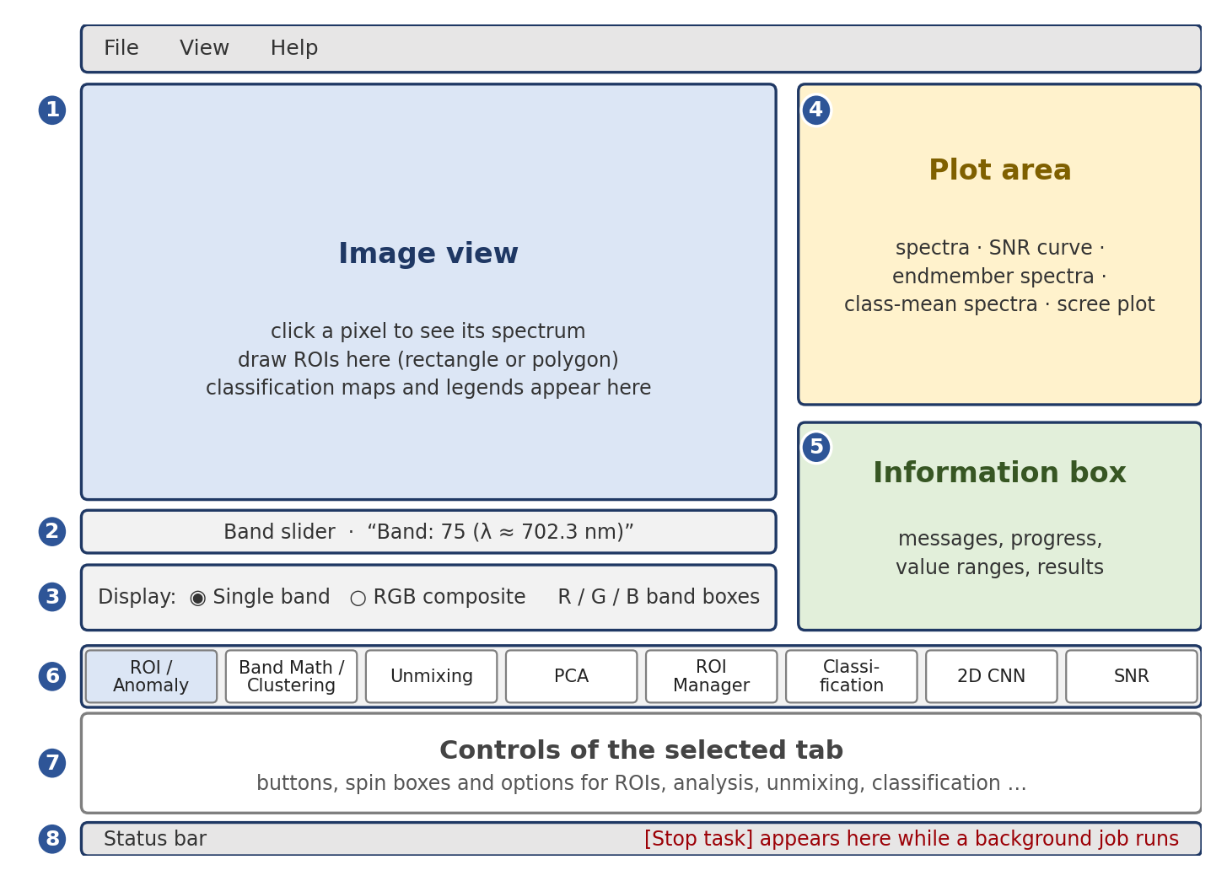
Figure 1 The main window. Numbers refer to the table below.
# | Area | What it does
1 | Image view | Shows the current band, color composite, or analysis result. Click a pixel to see its spectrum. Draw ROIs here. Classification maps appear here with a legend.
2 | Band slider | Chooses which band is shown in single-band mode. The label shows the band number and wavelength.
3 | Display | Switch between Single band and RGB composite; choose the R, G and B bands.
4 | Plot area | Spectra, SNR curve, endmember spectra, class-mean spectra, scree plot.
5 | Information box | Messages, progress, value ranges and results. Read it after every action.
6 | Tabs | Eight groups of tools (see section 1).
7 | Tab controls | The buttons and settings of the selected tab.
8 | Status bar | A red Stop task button appears here while a background job is running.

4 Opening your data
- Choose File → Open ENVI....
- Select the .hdr header file (not the data file).
- Wait for the image to appear. The information box reports the size as rows × columns × bands.
The binary data file (often .img, .raw or .dat, or no extension) must be in the same folder as the header and have the same base name, for example scene.hdr and scene.img.

What happens when an image loads
- The middle band is shown, and the slider and band boxes are set to the image’s band range.
- Wavelengths are read from the header’s wavelength field. If it is missing, bands are numbered 0, 1, 2 …
- Bands that contain only missing values (NaN) are removed, and a message tells you which.
- Everything from the previous image is cleared: ROIs, class maps, PCA, endmembers, NMF and SNR results. Save your ROIs first if you want to reuse them.
Warning: If DS3 says it failed to open the file, open the .hdr in Notepad. A real header starts with the line ENVI and lists fields such as samples, lines, bands, data type, interleave and byte order. A file of about 130 bytes that starts with version https://git-lfs.github.com/spec/v1 is only a Git LFS pointer, not real data. Download the actual files from GitHub (Download raw file) or use git lfs pull.

5 Looking at the image

5.1 Single band
Choose Single band in the Display box and move the band slider. The image is stretched from its minimum to its maximum value so that it always uses the full range of grey.

5.2 RGB composite
Choose RGB composite and set the R band, G band and B band boxes. At first, they are set to about 70 %, 50 % and 30 % of the band range. For a natural-color look, pick bands near 650 nm (red), 550 nm (green) and 470 nm (blue). Any other combination gives a false-color image that can make particular materials stand out.

5.3 Pixel spectra
Click any pixel in the image view and its spectrum is plotted in the plot area, titled with the row and column. Bands with missing values are left out. Clicking only works while Enable ROI selection is switched off, because in ROI mode clicks are used for drawing.
Note: The single-band and RGB views use a plain minimum-to-maximum stretch. Band math, PCA images, the anomaly map and the SNR map use a 2nd–98th percentile stretch, which ignores extreme pixels. The information box tells you the real value range whenever these matters.

6 Regions of interest (ROIs)
An ROI is a region you mark as an example of one material. Each ROI belongs to a named class such as “Water” or “Healthy leaf”. ROIs are the training data for supervised classification and the source of reference spectra for the Spectral Angle Mapper.

6.1 Drawing an ROI
- Open the ROI / Anomaly tab and tick Enable ROI selection.
- Choose the shape. Rectangle (drag): press and drag on the image. Polygon (click points): click to place corners, then click the first corner to close the shape. Hold Shift to move the whole polygon; press Esc to restart it.
- A yellow dashed outline appears and the mean spectrum of the selection is plotted. The label under the shape shows its size and number of valid pixels.
- Type a class name in the Class box, or pick an existing one from the drop-down.
- Press Add selection to ROI list. The outline becomes a colored, numbered ROI. Each class has its own color.
- Repeat for more regions. Untick Enable ROI selection when finished so that clicking shows spectra again.
The button Add current ROI mean as endmember (same tab) copies the selection’s mean spectrum into the endmember list used by linear unmixing and, optionally, by SAM.

6.2 The ROI Manager tab
Control | What it does
ROI list | Shows each ROI as number, name, class, shape and pixel count. Click to highlight it on the image; use Ctrl or Shift to select several.
Delete selected / Clear all | Remove chosen ROIs, or all of them after a confirmation.
Set class of selected... | Rename the class of the chosen ROIs, for example to fix a labelling mistake.
Plot selected ROI spectra | Overlay the mean spectra of the selected ROIs (all ROIs if none is selected).
Plot class mean spectra | One curve per class. Use this to check that your classes really differ.
Save ROIs... / Load ROIs... | Store the ROIs in a small .json file and bring them back later.
Show ROI outlines on image | Hide or show the outlines on every image.

6.3 Saving and loading ROIs
Save ROIs... (here or in the File menu) writes the shapes, names and classes to a .json file. Load ROIs... reads it back. If the file was made for an image of a different size, DS3 warns you and clips shapes that fall outside. If ROIs already exist, you choose between replacing them (Yes) or adding to them (No).

6.4 Good ROI practice
- Draw ROIs on pure pixels. Avoid mixed pixels at edges between materials.
- Make several ROIs per class, in different parts of the image, covering sunlit and shaded areas and natural variation.
- Make ROIs of similar size across classes, or cap the number of training pixels per class (section 10.2).
- If two classes have almost identical class-mean spectra, no classifier will separate them reliably.
- Pixels that lie inside ROIs of two different classes are ambiguous; DS3 leaves them out of training and tells you how many.

7 Exploration tools

7.1 Anomaly map
On the ROI / Anomaly tab press Compute anomaly map. For every pixel DS3 computes the straight-line (L2) distance between its spectrum and the image’s average spectrum. Bright pixels are unusual compared with the rest of the scene. The information box gives the raw range and the stretch used.

7.2 Band math
On the Band Math / Clustering tab, type an expression using band names B0, B1 … B(N-1), where the number is the band index, then press Apply band math expression. The result is shown as an image.
Purpose | Example expression
Normalized difference (like NDVI) | (B80 - B40) / (B80 + B40 + 1e-6)
Band ratio | B80 / (B40 + 1e-6)
Logarithm | np.log (B50 + 1)
Tip: Add a tiny number such as 1e-6 to denominators to avoid division by zero. Use band indices (as shown in the band label), not wavelengths.
Warning: The expression is evaluated as Python code. Only type expressions you wrote or trust.

7.3 k-means clustering
k-means groups pixels with similar spectra without any labels. Set Number of clusters (K) (2–20) and Cluster on: Full spectra, or First 3 PCs (compute PCA first). Press Run k-means clustering. The result is a color map; the information box lists the number of pixels in each class. Try several values of K and compare.

7.4 PCA
Principal component analysis compresses the many bands into a few components that capture most of the variation.
- Open the PCA tab, set Compute first N PCs (3–20, default 6), and press Compute PCA.
- The information box reports how much variance the first three components explain.
- Use Show PC1, Show PC2, Show PC3 to view single components, Show PCA RGB to see PC1/PC2/PC3 as a color image, and Show Scree Plot to see the variance explained by each component.
Computed PCs can also be used for k-means and as features for supervised classification.

8 Spectral unmixing
Most pixels contain a mixture of materials. Unmixing estimates how much of each pure material (endmember) is in each pixel. DS3 offers two approaches, both on the Unmixing tab.

8.1 Linear unmixing from your ROIs
- Enable ROI selection and select a region of one pure material.
- Press Add current ROI mean as endmember (ROI / Anomaly tab). Repeat for at least two materials.
- On the Unmixing tab press Run unmixing (dominant endmember map).
The result is a color map showing which endmember is largest in each pixel, with pixel counts per endmember. Clear endmembers empty the list. This method uses unconstrained least squares, so estimated amounts can be slightly negative; treat the map as a guide to the dominant material.

8.2 Automatic unmixing (NMF)
Non-negative matrix factorization finds the endmembers for you, without any ROIs. It splits the data into a small number of non-negative spectra (endmembers) and a map of how much of each is present (abundance).
Setting | Meaning
Number of endmembers | How many components to extract (2–20, default 5).
Random seed | Starting point of the algorithm (default 42). NMF is not unique: a different seed can give a different but equally valid result. If a map looks odd, change the seed and run again.
Bands from / to | Band range used. Leave at full range, or exclude noisy bands at the ends.
Fit on up to (px) | Endmembers are learned from a random subset of pixels (default 100 000; 0 uses all) to keep large images fast. Abundances are then computed for every pixel.
- Set the options and press Run NMF unmixing. Progress is shown in the information box; use Stop task to cancel.
- The result appears as a color class map (each pixel assigned to its strongest endmember) and the endmember spectra are plotted.
- Use Abundance map of endmember with Show to view one endmember’s abundance (brighter = more of it), All abundance maps (window) for a grid you can zoom and save as PNG, and Plot endmember spectra to redraw the spectra.
Note: NMF needs non-negative data. If your image contains negative values, they are set to 0 for this analysis and the information box tells you how many.

9 Signal-to-noise ratio (SNR)
The SNR tab gives two quick quality measures.
- Spatial domain: for each band, the mean divided by the standard deviation over the image. The result is a curve of SNR against wavelength.
- Spectral domain: for each pixel, the mean divided by the standard deviation of its spectrum across all bands. The result is a map.
- Optionally tick Spatial-domain SNR from ROI pixels only. Using ROIs drawn on uniform areas gives a more meaningful per-band figure than the whole image, which also contains real scene variation.
- Press Compute SNR. The label shows both averages and the curve are plotted.
- Use Show SNR vs wavelength and Show spectral SNR map to switch views, and Save SNR curve (CSV)... to export the curve (columns: band, wavelength if available, snr).
Note: Dips in the curve usually mark noisy sensor edges or atmospheric absorption bands; consider leaving those bands out of NMF or classification. Both figures are relative indicators for comparing bands and pixels. The spectral-domain value also reflects how much a spectrum varies, so it is not a laboratory noise measurement.

10 Classification
Classification assigns every pixel to a class. DS3 provides three families of methods, all based on your labelled ROIs.
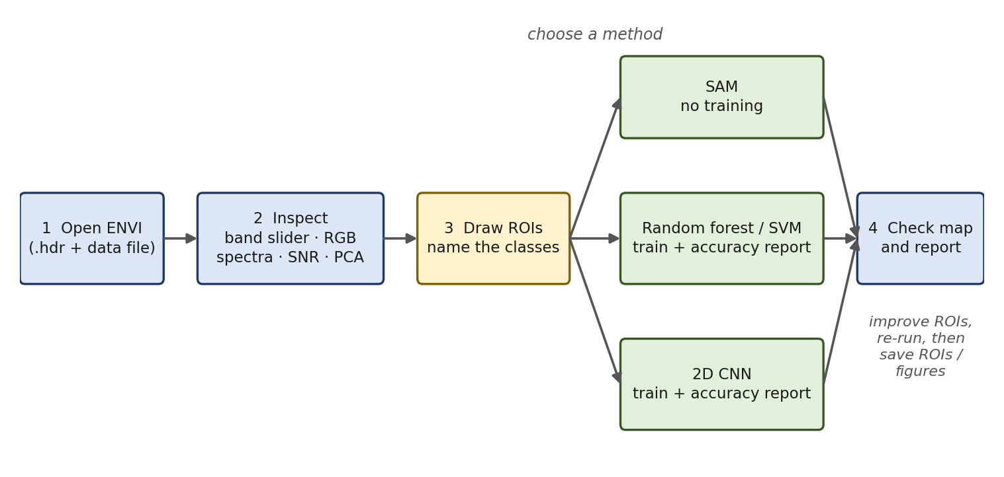
Figure 2 Classification workflow.

10.1 Spectral Angle Mapper (SAM)
SAM needs no training. It compares the shape of each pixel’s spectrum with a reference spectrum and picks the reference with the smallest angle. Because it ignores overall brightness, it copes well with shadows and illumination differences.
- Create ROIs for each class (section 6).
- On the Classification tab, choose Reference spectra: ROI classes (mean per class), or Endmember list (Unmixing tab).
- Set Max angle (deg, 0 = none). At 0 every pixel is classified. A value such as 3–10 degrees marks poor matches as Unclassified (black).
- Press Run SAM classification. The map appears with a legend and pixel counts.
- Press Show best-match angle map to see how well each pixel matched (dark = close match). Use its range to choose a sensible maximum angle, then run SAM again.
Note: With only one reference spectrum you must set a maximum angle above 0; otherwise every pixel would simply be assigned to it.

10.2 Random forest and SVM
These methods learn from the pixels inside your ROIs, then classify the whole image.
Setting | Meaning
Classifier | Random forest – fast and robust; a good first choice.  SVM (RBF kernel) – standardises the data, often accurate, slower on large training sets.  SVM (PCA + poly kernel) – reduces to up to 100 principal components, then a polynomial-kernel SVM.
Features | Full spectra, or PCA components (compute PCA first).
Validation split | Hold out whole ROIs – some ROIs of each class are kept aside for testing. Strict and honest.  Random pixels – quicker, but usually gives an over-optimistic accuracy because neighboring pixels are nearly identical.
Test fraction (%) | Share of labelled data kept for testing (0–50, default 30). At 0, DS3 trains on everything and gives no accuracy figures.
Max pixels per class | Caps training size per class (default 5 000). Lower it if training is slow.
- Make ROIs for at least two classes; ideally two or more ROIs per class.
- Pick the options above and press Train and classify image. Progress appears in the information box.
- When finished, the class map is shown and the accuracy report opens automatically. Reopen it any time with Show accuracy report.

10.3 k-fold cross-validation
Cross-validation tests how well a classifier generalizes by splitting the labelled data into several folds, training on all but one and testing on the one left out, then averaging the results.
- Choose the classifier, features and validation split as above, and set Cross-validation folds (2–10, default 5).
- Press Run k-fold cross-validation (accuracy only).
- The report lists the accuracy of each fold, the average ± standard deviation, and a combined confusion matrix. No map is produced.
With Hold out whole ROIs, every class needs at least two ROIs, and the number of folds is limited to the smallest ROI count per class. A fold is skipped if one of its test classes has no training pixels, and the report says so. With Random pixels the folds are balanced per class.

10.4 2D CNN
The 2D convolutional neural network works on small image patches around each pixel, so it uses spatial context as well as spectra. DS3 first reduces the bands with a whitened PCA, then trains the network on patches centered on your ROI pixels. It requires TensorFlow (pip install tensorflow).
Setting | Meaning
PCA components (whitened) | Number of components fed to the network (3–100, default 30).
Patch size | Width of the square patch in pixels (odd, 9–31, default 15).
Epochs / Batch size | Passes over the training data (default 20) and patches per step (default 64).
Network | Reference (64-128-256-512) is the full network. Compact (32-64-128) is lighter and much faster on a normal computer.
Validation split, Test fraction | Same meaning as for the other classifiers (default: hold out whole ROIs, 30 %).
Max patches per class | Caps training patches per class (default 3 000).
Classify | Whole image (slow on large images) or Labelled ROI pixels only.
- Create ROIs for at least two classes.
- Choose the settings and press Train 2D CNN and classify. The first step loads TensorFlow, which can take a while.
- Watch the epoch-by-epoch progress in the information box. Use Stop task to cancel.
- When finished, the class map appears and the report opens. It includes accuracy figures and a training log (loss, training accuracy and validation accuracy per epoch). Show report / training log reopens it.
Tip: On a first try, choose the Compact network, fewer epochs and Labelled ROI pixels only. If the validation accuracy is much lower than the training accuracy, the network is memorising your ROIs: add more and more varied ROIs.

10.5 Reading the report
Item | Meaning
Overall accuracy | Percentage of test pixels classified correctly.
Cohen’s kappa | Accuracy corrected for chance agreement. 1 is perfect, 0 is no better than guessing; above about 0.8 is generally considered strong.
Precision (per class) | Of the pixels predicted as this class, the share that truly belong to it.
Recall (per class) | Of the pixels that truly belong to this class, the share that were found.
F1 | A single score combining precision and recall.
Support | Number of test pixels of that class.
Confusion matrix | Rows are the true classes, columns the predicted classes. Numbers off the diagonal show which classes are being mixed up.
Warning: High accuracy with Random pixels but much lower accuracy with Hold out whole ROIs means the classifier is partly memorising neighbouring pixels. Trust the lower number.

10.6 Choosing a method
Method | Training needed | Speed | Best for
SAM | No | Very fast | First look; scenes with strong illumination differences.
Random forest | Yes | Fast | A dependable default with several ROIs per class.
SVM | Yes | Medium | Smaller training sets, often high accuracy.
2D CNN | Yes | Slow | Cases where spatial context matters and you have many labelled pixels.

11 Typical workflows

A Quick look at a new image
- Open the .hdr. Switch to RGB composite and choose natural-colour bands.
- Click a few pixels to see typical spectra.
- On the SNR tab, compute SNR to spot noisy bands.
- On the PCA tab, compute PCA and show PCA RGB to reveal hidden structure.

B Map known materials with ROIs
- Draw several ROIs per material and give each a class name.
- In ROI Manager, press Plot class mean spectra to confirm the classes differ.
- Run SAM for a quick map.
- Train Random forest with Hold out whole ROIs and read the report. Add or correct ROIs where classes are confused, then train again.
- Save ROIs so that the work can be repeated.

C Discover materials without labels
- Compute PCA, then run k-means on the first 3 PCs for a rough segmentation.
- Run NMF unmixing with a first guess of the number of endmembers; view the abundance maps and spectra.
- Use what you learn to draw ROIs, then continue with workflow B.

D Compare classifiers fairly
- Use the same ROIs and the same validation split (preferably whole ROIs) for every method.
- Run k-fold cross-validation for random forest, each SVM and, if wanted, compare with the CNN report.
- Pick the best average accuracy and kappa, then press Train and classify image with that classifier to produce the final map.

12 Themes and settings
Choose View → Theme → Dark or Light (original). The whole window, the image view and the plot area change immediately, with no restart. DS3 remembers your choice for the next start (the first start uses Dark). Pop-up figure windows, such as the abundance-map grid, use the theme that was active when they opened; close and reopen them after switching.
Pop-up figure windows have a toolbar for zooming, panning and saving the figure as PNG.

13 Troubleshooting
Problem | Likely cause | What to do
“Failed to open ENVI file” | Header is a Git LFS pointer, the data file is missing or renamed, or the header is incomplete. | Check the header starts with ENVI; place the data file beside it with the same base name; re-download real files (section 4).
“No module named …” on start | A package is not installed in the Python you are using. | Run the pip command from section 2 in the same Command Prompt, then start again.
Window closes immediately | An error at start-up. | Start from Command Prompt with python HyperVista.py and read the message.
k-means / classifiers disabled or “Install scikit-learn” | scikit-learn is missing. | pip install scikit-learn
“TensorFlow not found” | The CNN needs TensorFlow. | pip install tensorflow (Python 3.10 or 3.11).
“Compute PCA first” | PCA features or First 3 PCs chosen, but PCA not computed. | Compute PCA on the PCA tab.
“Add ROIs for at least 2 different classes” | Fewer than two classes in the ROI list. | Add ROIs with at least two different class names.
Cross-validation says each class needs 2 ROIs | Whole-ROI mode needs two or more ROIs per class. | Add ROIs or switch to Random pixels.
Clicking the image does nothing | ROI selection is switched on. | Untick Enable ROI selection.
Polygon will not close | The closing click was not on the first point. | Click on the first vertex, or press Esc and start over.
Training or classifying is slow | Large image, SVM, or the reference CNN. | Lower Max pixels per class; use Random forest; use the Compact CNN; classify ROI pixels only.
NMF map looks wrong | NMF is not unique. | Change the random seed or the number of endmembers; exclude noisy bands.
Everything is “Unclassified” in SAM | Maximum angle is too small. | Look at the best-match angle map and raise the limit, or set it to 0.
Light theme looks slightly different | It uses your computer’s native style. | This is expected; switch back to Dark if you prefer.

Appendix A Working with large images
DS3 keeps the whole image in memory as 64-bit numbers (8 bytes per value), and several analyses make temporary copies. For example, 1000 × 1000 pixels with 200 bands needs about 1.6 GB for the image alone.
- Close other programs and use a 64-bit Python.
- Lower Max pixels per class, use a smaller NMF Fit on up to value, and use the Compact CNN.
- For the CNN, classify Labelled ROI pixels only while experimenting; classify the whole image only for the final run.
- Exclude noisy bands with the NMF band range, or use PCA features for classification.

Appendix B Current limitations
- The main image view has no save button. Use a screenshot (Windows + Shift + S), or the PNG save in pop-up figure windows.
- Loading a new image clears ROIs and results, so save ROIs first.
- Only rectangle and polygon ROIs are available; there is no freehand tool.
- Trained classifiers are not saved; each run trains from scratch.
- SAM, k-means, PCA and linear unmixing run on the main thread and may briefly pause the window on very large images.

Appendix C Glossary
Term | Meaning
ENVI | A common file format for hyperspectral images: a text header (.hdr) plus a binary data file.
Band | One narrow wavelength slice of the image.
Cube, spectrum | The cube is the image seen as rows × columns × bands. A spectrum is the values of one pixel across all bands.
ROI, class | A region of interest is an area you mark on the image. A class is a named group of ROIs for one material or category.
Endmember, abundance | An endmember is the spectrum of a pure material. Its abundance is how much of it is present in a pixel.
SAM | Spectral Angle Mapper: classifies by the angle between spectra.
PCA | Principal component analysis: compresses bands into a few components.
NMF | Non-negative matrix factorisation: automatic unmixing.
SNR | Signal-to-noise ratio: signal level relative to its variability.
k-means | A clustering method that groups similar pixels without labels.
Cross-validation, kappa | Repeated training and testing on different splits to estimate accuracy; kappa is accuracy corrected for chance.
CNN | Convolutional neural network, a deep-learning model for images.

