Report

Investigating the Causal Effect of Extreme Heat (T) on Respiratory Disease Mortality(Y)
Research Report
CUSP-GX 9113E Special Topics in Urban Science & Informatics
“From Correlation to Causation: Data Science for Decision Making
December 19, 2024
Author
Linuode Ye (ly2549)
Ruolin Wu (rw3763)
Yaqi Guo (yg3481)

Instructor
Takahiro Yabe

Introduction
Background
During the 2024 Climate Week event (Tailwind Climate, 2024), a Turner Construction manager highlighted a critical gap: "I’d like to support the implementation of climate adaptation in the built environment… But we don’t have causal knowledge between extreme heat and labor mortality." This underscores a broader issue: while extreme heat’s health impacts are acknowledged, robust causal evidence linking it to specific outcomes remains scarce, hindering evidence-based interventions.
Outdoor workers, particularly in physically demanding roles, face disproportionate risks. For example, construction workers, just 6% of the U.S. workforce, account for over one-third of heat-related occupational deaths (U.S. Environmental Protection Agency, 2024). Despite recommendations like hydration breaks and shaded rest periods, inconsistent implementation leaves many workers unprotected.
However, heat-related deaths are often underreported or misclassified due to contributing health conditions, off-site fatalities, or underreporting in industries employing undocumented or temporary workers. Death certificates rarely attribute fatalities directly to heat, creating systemic data gaps. These challenges undermine efforts to establish causal links and implement effective public health measures. This pressing need to address the knowledge gap has motivated our current investigation.
Literature review
Studies on the relationship between temperature and mortality generally use direct attribution or statistical methods (U.S. Global Change Research Program, 2016). Direct attribution links deaths to temperature extremes using medical records, but often underestimates heat-related deaths. Statistical studies, like Bobb et al. (2014), examine temperature-mortality associations in large datasets, revealing higher temperature-related deaths despite increased resilience. However, these studies have limitations such as seasonality and biases. To improve accuracy and overcome these issues, we will use causal inference techniques to estimate the causal effect of extreme heat on mortality, offering more reliable results and policy recommendations.
To better understand the relationship between extreme heat and health outcomes, various studies have employed different methodologies and approaches. Wu (2023) developed a causal inference framework using an incremental time-varying propensity score (ItvPS) to estimate the causal effects of heat alerts on reducing deaths and hospitalizations in time series data. In a complementary study, Schwarz et al. (2021) revealed spatial variability in the respiratory health impacts of extreme heat and ozone, highlighting how socioeconomic disparities in vulnerable California communities drive stronger health effects. Building on the importance of urban form, Calhoun et al. (2022) proposed a methodology to estimate causal relationships between urban form changes and the Urban Heat Island (UHI) effect using convolutional neural networks and causal inference matching, identifying potential instrumental variables (IVs) for mitigating UHI effects. Similarly, Calhoun et al. (2024) extended this work by using spatial causal inference to estimate the effects of urban greening and cool roofs on reducing the urban heat island effect, showing potential temperature reductions of 0.7–0.9°C. Collectively, these studies provide valuable insights into mitigating the adverse effects of extreme heat and offer a foundation for actionable policy interventions.

Research question
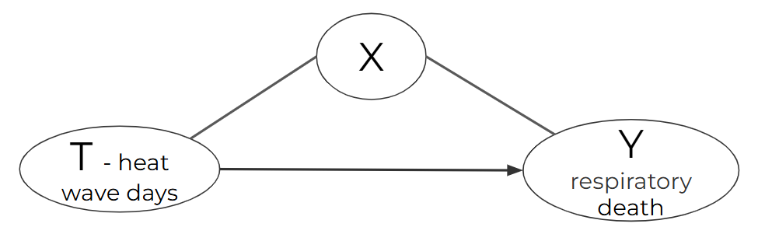
In our study, we first establish a general causal inference framework where T (the treatment variable) represents extreme heat, and Y (the outcome variable) represents mortality. Based on the literature review, we narrow T to heat wave days and Y to respiratory-related deaths. Heat wave days serve as a concrete measure of extreme heat events, which provides a more accurate indication of health impacts compared to daily temperatures. Wet bulb temperature and other meteorological variables are better predictors of human health effects; however, heat wave days are chosen as T because they quantify persistent extreme weather events. Respiratory deaths are chosen as Y to reduce confounding factors and improve the accuracy of our causal estimates by focusing on a specific health outcome.
Figure 1. Causal model of extreme heat and mortality
Our research question is: "Investigating the Causal Effect of Extreme Heat (T) on Respiratory Disease Mortality (Y)." We hypothesize that:
- Heat wave days causally increase respiratory disease mortality, after controlling for confounding factors.
- Heat waves have a nonlinear effect: short durations show minimal impact, while moderate increases and extreme durations decrease mortality rates.
- IPW reduces outlier influence, leading to smoother mortality trends and more reliable estimates across extreme heat wave durations.
- Albedo can serve as an instrumental variable (IV) to address the issue of confounding variables in the causal inference model between extreme heat (T) and respiratory deaths (Y).

Data
Data level
We chose county-level data to control geographical differences, account for regional health disparities, and utilize reliable, accessible data for accurate analysis. This level enables targeted policy recommendations, while reducing confounding effects from varying local climates and socioeconomic factors.
Another point to note is that we chose data from 2005 to 2010 to eliminate geographic bias. As shown in the heatmap (Figure 2), the hottest regions vary across years. By including data from multiple years, we can effectively remove these geographical and temporal discrepancies.
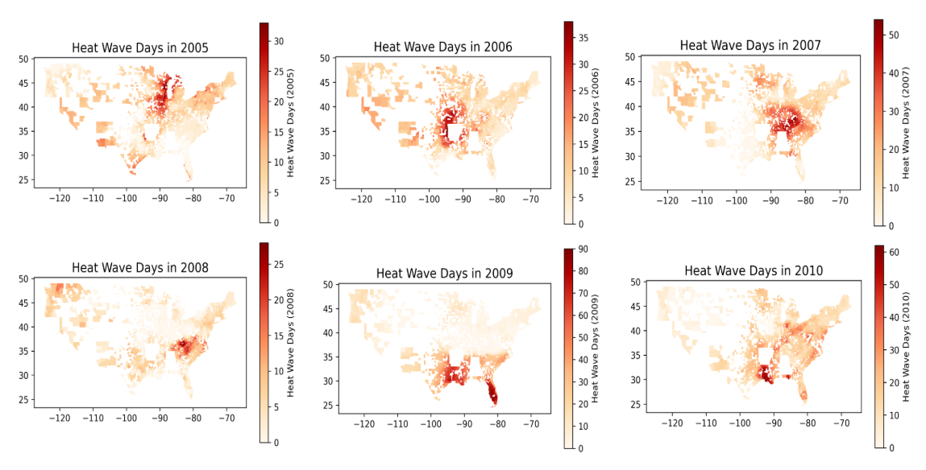
Figure 2. Distribution of heat wave days from 2005 to 2010
T: heat_wave_days
We selected the variable heat_wave_days from the CDC WONDER database (Centers for Disease Control and Prevention, n.d.), which provides heatwave data from 1981 to 2010. This dataset can be aggregated by county and year to calculate the total number of heatwave days. The data is essential for examining the frequency and distribution of extreme heat events across different regions and years.
Y: respiratory_deaths
We obtained the mortality data from the CDC WONDER Underlying Cause of Death database (Centers for Disease Control and Prevention, n.d.), which contains mortality and population counts for all U.S. counties. The data are derived from death certificates, detailing the underlying cause of death, demographic information, and specific conditions like age, race, gender, and cause of death (ICD-10 codes). For our analysis, we focused on respiratory deaths and normalized these by the population to compute the crude death rate. Additionally, we performed data cleaning tasks, including extracting county-level geospatial data through the 'county_code' and ensuring that respiratory deaths were adjusted for population size by calculating the 'crude_rate.'
X: Confounding variables
In our study, selecting the right confounding variables was crucial for GPS analysis. We started with a large dataset county level health ranking that had many county-level variables about health, environment, and social factors. Our main task was to find which variables were true confounders between heat waves and respiratory deaths.
To select variables, we used two main rules from propensity score matching theory. First, we removed colliders - variables that could be affected by both heat waves and deaths, like Years of Potential Life Lost (YPLL Rate). Next, we removed mediators - variables that might be in the middle of the pathway from heat waves to deaths, such as "Physically Unhealthy Days" and "Mentally Unhealthy Days."
After this filtering process, we kept variables that could affect both heat wave exposure and respiratory health, but weren't caused by either one. This led us to select six main confounders:
- Smoking rates and binge drinking (health behaviors)
- Number of diabetics (existing health conditions)
- PM Days (environmental quality)
- Healthy food access (community resources)
- Unemployment rate (economic status)
We chose these variables because they had good data quality and were available for all counties. They represent different aspects of community health that could affect both how people experience heat waves and their respiratory health outcomes.
Z: albedo
We first use albedo as our instrumental variable, as it can capture more nuanced differences in regional climate patterns by representing the fraction of incoming solar radiation reflected back into the atmosphere. These albedo data are available from NASA Earth Observations in standardized formats such as tiff file, and may be provided on a daily or monthly basis from approximately 2015 to 2020. For our analysis, we focus on July data from each year, which is the middle month from May to September. We also considered the Normalized Difference Vegetation Index (NDVI) as an alternative variable. NDVI is a widely used remote-sensing metric for quantifying vegetation density and health, typically ranging from -1 to +1. Higher positive values indicate healthier and denser vegetation, while lower values represent barren areas or built environments. Our NDVI data come from the NOAA National Centers for Environmental Information, which maintains continuous records from 1981 to the present. To compute county-level averages of these geospatial data, we rely on cartographic boundary files that serve as a fundamental spatial framework for mapping, integrating spatial data, and linking demographic or socio-economic information to administrative units. The county shapefiles from the United States Census Bureau, specifically those from 2010, offer a stable baseline for spatial analysis. By integrating these datasets, it becomes possible to examine how vegetation (NDVI) and surface reflectivity (albedo) vary across U.S. counties.

Methods
Inverse propensity score weighting
For our analysis of how heat waves affect respiratory deaths, we chose to use Generalized Propensity Score (GPS) with Inverse Probability Weighting (IPW). We picked this method because it works well with continuous treatments like heat wave days, unlike traditional matching methods that only work with yes/no treatments.
Our GPS analysis had three main steps. First, we estimated propensity scores using a model that considered all our confounding variables. This score tells us the likelihood of experiencing a certain number of heat wave days based on county characteristics. Next, we calculated weights using these scores - this helps make counties with different heat wave exposures more comparable. Finally, we used these weights in our regression models to estimate how heat waves affect death rates.
When checking if our method worked well, we looked at balance - whether counties with different heat wave days became more similar in terms of our confounding variables after weighting. We did this by comparing correlations before and after applying our weights. Since our model involves a continuous treatment, traditional balance checking methods, such as comparing covariate distributions between “treated” and “untreated” groups, are not applicable. Instead, we assess balance by examining the correlation between covariates and the treatment variable. By minimizing these correlations, we ensure that the covariates are as independent as possible from the treatment, which improves the quality of the Generalized Propensity Score (GPS) estimation. This approach aligns with the goal of reducing confounding and simulating conditions akin to random assignment, enabling more accurate estimation of treatment effects.
Instrumental variable
As mentioned above, the PSM can calculate the actual casualty to address selection bias and confounding. However, given the complexity of our setting and the substantial number of confounding variables, such as air quality, socio-economic conditions, and pre-existing health vulnerabilities, we also considered using Instrumental Variables strategy. By incorporating IV, we seek a source of variation in T that is not directly related to the multitude of social, economic, and environmental confounding variables. Instead of relying solely on observational adjustments, we use instruments—variables that affect the likelihood of experiencing extreme heat events but do not directly influence respiratory mortality except through T. This approach helps to isolate the “pure” effect of extreme heat on mortality, providing more credible causal estimates.
By using albedo as the instrument, we exploit a source of variation in the likelihood and intensity of heat waves that is not primarily driven by demographic or healthcare differences. Albedo—essentially the surface’s reflectivity—shapes local thermal environments independently of direct health policies or economic conditions, making it well-suited to isolate the causal impact of persistent extreme heat events on health outcomes. Its availability in a standardized geospatial framework also facilitates seamless integration with county-level mortality data and other key variables, ensuring that the instrument aligns with the spatial and temporal dimensions of the research question. We also considered NDVI as an alternative instrument, if albedo is not a good IV, but it still remains our primary choice because it more directly captures local variations in the underlying climatic conditions that lead to sustained heat events.

Results and Discussion
Inverse propensity score weighting
Our GPS analysis revealed some interesting findings about how heat waves affect respiratory deaths. First, let's look at how well our weighting worked. Before weighing, some confounders showed concerning imbalances. For example, smoking rates had a correlation of 0.101 with heat wave days, and binge drinking had an even stronger correlation of -0.155. After applying our weights, these correlations dropped - smoking decreased to 0.026 and binge drinking to -0.039. This improvement in balance gives us more confidence in our results.
When we looked at the actual effect of heat waves on deaths, we found something surprising. Our basic linear model showed a small positive effect - about 0.06 more deaths per heatwave day. However, after applying our GPS weights, this changed to a decrease of 0.11 deaths per heat wave day.
We also found that the relationship isn't simple. Our non-linear model showed that the effect changes depending on how many heat wave days there are. Initially, there's a decrease in deaths (-0.97 per day), but this effect becomes less strong as heat wave days increase (shown by our positive quadratic term of 0.038), and then changes again at high levels (cubic term of -0.0004).
One important note is that our models had low R² values (between 0.001-0.005). This suggests that while heat waves do affect respiratory deaths, they're just one part of a bigger picture - many other factors also influence mortality rates.
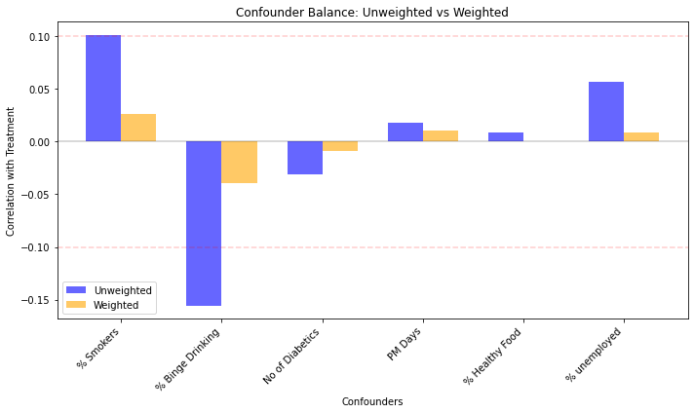
Figure 3: correlation between covariates and treatment before and after IPW
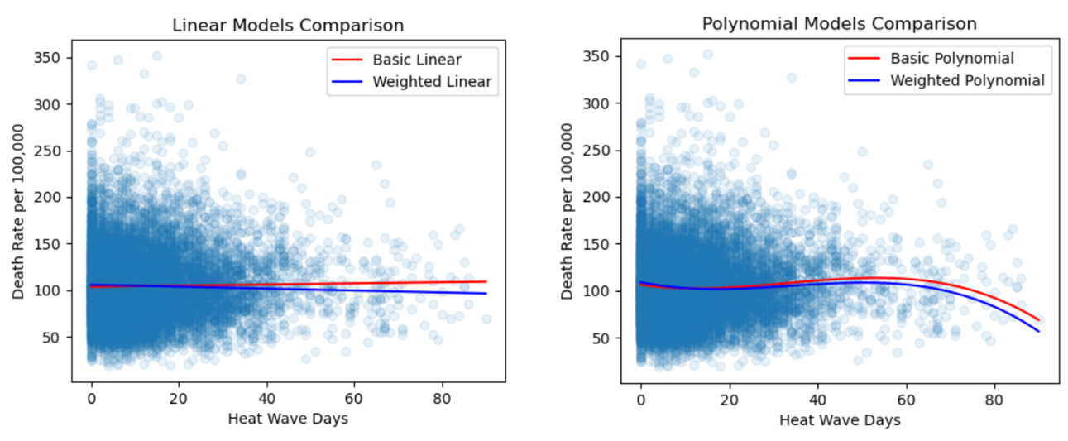
Figure 4: Treatment effect fitting result comparison coControlled vs uncontrolled. (Left: linear; right: Polynomial with degree 3)

Instrumental variable
Table.1 Albedo Second Stage Regression
===================================================================================
coef std err t P>|t| [0.025 0.975]
-----------------------------------------------------------------------------------
Intercept 9.3833 0.115 81.410 0.000 9.157 9.609
C(YEAR)[T.2006] -0.6745 0.051 -13.238 0.000 -0.774 -0.575
C(YEAR)[T.2007] -0.5718 0.051 -11.266 0.000 -0.671 -0.472
C(YEAR)[T.2008] 0.2267 0.050 4.504 0.000 0.128 0.325
C(YEAR)[T.2009] -0.2338 0.051 -4.628 0.000 -0.333 -0.135
C(YEAR)[T.2010] -0.1806 0.050 -3.581 0.000 -0.279 -0.082
Albedo 9.2485 0.786 11.769 0.000 7.708 10.789
===================================================================================
Wald Estimator: -0.16526384997935958
First-stage regression F-test:
F-statistic: 339.4801063598388
p-value: 0.0
Second-stage regression F-test:
F-statistic: 16.32684287188696
p-value: 8.106569686438839e-19
The first-stage regression yields a very high F-statistic of about 339.48 (p < 0.0001), indicating that albedo is strongly correlated with the endogenous variable (heat wave days). This suggests that the instrument is not weak, albedo has a robust predictive power for the treatment variable. From the second-stage regression, the instrumented regression suggests a strong and statistically significant coefficient on the albedo variable. The Wald estimator, derived from the ratio of reduced-form and first-stage coefficients, is -0.1653. However, the exclusion restriction—the requirement that the instrument affects the outcome only through the treatment—appears problematic. When tested directly, albedo remains strongly associated with respiratory mortality even after controlling for heat wave days:
Table.2 Exclusion Restriction
===================================================================================
...... ... ... ... ... ...
Albedo 10.1068 1.932 5.232 0.000 6.320 13.893
heat_wave_days 0.0153 0.003 4.825 0.000 0.009 0.022
===================================================================================
This suggests that albedo may have a direct effect on mortality independent of its influence on heat wave exposure, violating the key IV assumption. While the first-stage strength is encouraging, the lack of a clean exclusion restriction implies that albedo is not serving as a valid instrument in this context.
In addition to albedo, we also considered the Normalized Difference Vegetation Index as an alternative instrument. However, the NDVI-based instrument also did not yield satisfactory results in the exclusion restriction. While the strong first-stage relationship is promising, the direct association of albedo with mortality, which is beyond its effect on heat wave exposure, undermines the IV approach.The current limitation lies primarily in the choice of the IV. The inability of albedo to satisfy the exclusion restriction limits the credibility of the causal inference. What’s more, relying on yearly mortality data may obscure temporal patterns, such as seasonal effects or other weather extremes like cold spells.
As we only consider stable land cover characteristics as our IV, identifying and testing alternative instruments—such as topographic factors or proximity to large water bodies—may help address the limitations of our IV approach.

Conclusion and Limitations
Conclusion
Our analysis provides robust evidence of a causal effect of extreme heat (T) on respiratory deaths (Y). Surprisingly, the results reveal a negative association, suggesting that extreme heat events are linked to fewer respiratory deaths—a finding that is both statistically significant and counterintuitive. This challenges prevailing assumptions about the direct health impacts of extreme heat and invites deeper exploration of potential mediating factors.
IPW
- Nonlinear Relationship Captured by the Model
In the polynomial model, linear terms dominate at low heat wave days, leading to a slight decrease in respiratory mortality. As heat wave days increase, quadratic terms take over, causing mortality to rise. At extreme heat wave levels, cubic terms reverse the trend, showing a decline. This highlights the effectiveness of polynomial models in capturing nonlinear relationships.
- Balance Assessment for Covariate Alignment
The balance assessment confirms that weighting or matching successfully aligns treatment and control groups on covariates, ensuring a robust foundation for causal inference.
- Adjustment for Extreme Values
Mortality rates remain stable for 0–40 heat wave days but decline at higher levels, possibly due to data sparsity and unique distributions. The smoother weighted line (IPW) suggests that the method effectively adjusts for outliers.
IV
- Instrumental Variable Performance
Albedo fails to meet the exclusion restriction, leading to biased results in the Wald estimator and 2SLS. Therefore, it cannot serve as a valid instrumental variable in addressing confounding in the causal model between extreme heat and respiratory deaths.
Limitations
Complexities in Confounder Selection
The elimination of confounders in causal inference is inherently complex. Wu et al. (2024) highlight the challenge of narrowing down broad causal questions, such as assessing the effectiveness of heat alerts in preventing deaths, emphasizing the importance of a more focused approach. On the other hand, Fang and Liang (2024) discuss how high-dimensional complex data pose difficulties in confounder selection, where careful consideration of each variable is essential, as increased dimensions can significantly impact matching results. Deep learning techniques might be necessary for better handling such issues.
Limitations of Albedo as an Instrumental Variable
Finding a valid instrumental variable (IV) is a significant challenge in causal inference. A good IV must satisfy both the relevance condition and the exclusion restriction. However, identifying an IV that meets these criteria is often difficult, and weak or invalid IVs can lead to biased and unreliable estimates.
Geospatial Considerations in Causal Inference

Incorporating geospatial factors into causal inference presents challenges, especially when working with county-level data. While geographic variables may influence both the treatment (extreme heat) and the outcome (respiratory death), understanding and accounting for spatial dependence is complex. The relationship between spatial factors and causal effects is not always straightforward, and failing to properly adjust for geospatial dependencies may lead to biased or imprecise estimates.

Reference
Tailwind Climate. (n.d.). Extreme heat & health innovation (Tailwind Climate Week NYC event). Retrieved December 18, 2024, from https://www.tailwindclimate.com/events/extreme-heat-health-innovation-tailwind-climate-week-nyc-event/
U.S. Environmental Protection Agency. (n.d.). A closer look: Heat-related workplace deaths. Retrieved December 18, 2024, from https://www.epa.gov/climate-indicators/closer-look-heat-related-workplace-deaths
U.S. Global Change Research Program. (2016). Temperature-related death and illness. U.S. Global Change Research Program. Retrieved from https://health2016.globalchange.gov/temperature-related-death-and-illness
Bobb, J. F., Peng, R. D., Bell, M. L., & Dominici, F. (2014). Heat-related mortality and adaptation to heat in the United States. Environmental Health Perspectives, 122(8), 811–816. https://doi.org/10.1289/ehp.1307392
Wu, X., Weinberger, K. R., Wellenius, G. A., Dominici, F., & Braun, D. (2024). Assessing the causal effects of a stochastic intervention in time series data: Are heat alerts effective in preventing deaths and hospitalizations? Biostatistics, 25(1), 57–79. https://doi.org/10.1093/biostatistics/kxad002
Schwarz, L., Hansen, K., Alari, A., Ilango, S. D., Bernal, N., Basu, R., Gershunov, A., & Benmarhnia, T. (2021). Spatial variation in the joint effect of extreme heat events and ozone on respiratory hospitalizations in California. Proceedings of the National Academy of Sciences, 118(22), e2023078118. https://doi.org/10.1073/pnas.2023078118
Calhoun, Z. D., Jiang, Z., Bergin, M., & Carlson, D. (2022). Urban Heat Island detection and causal inference using convolutional neural networks. In NeurIPS 2022 Workshop on Tackling Climate Change with Machine Learning. https://www.climatechange.ai/papers/neurips2022/105
Calhoun, Z. D., Willard, F., Ge, C., et al. (2024). Estimating the effects of vegetation and increased albedo on the urban heat island effect with spatial causal inference. Scientific Reports, 14(540). https://doi.org/10.1038/s41598-023-50981-w
Centers for Disease Control and Prevention. (n.d.). National Climate Assessment heat wave days historical data. CDC WONDER. Retrieved from https://wonder.cdc.gov/NCA-heatwavedays-historic.html
National Centers for Environmental Information (NCEI). (n.d.). Normalized Difference Vegetation Index (NDVI) CDR (1981-2024). National Oceanic and Atmospheric Administration. Retrieved from https://www.ncei.noaa.gov/access/metadata/landing-page/bin/iso?id=gov.noaa.ncdc:C01558#:~:text=The%20NDVI%20CDR%20summarizes%20the,(AVHRR)%20provide%20NDVI%20values.
NASA Earth Observing System. (n.d.). Albedo (MCD43C3). NASA Earth Observing System. Retrieved from https://neo.gsfc.nasa.gov/view.php?datasetId=MCD43C3_M_BSA&year=2009.
U.S. Census Bureau. (2010). Cartographic boundary files - Shapefile. U.S. Department of Commerce. Retrieved from https://www.census.gov/geographies/mapping-files/time-series/geo/carto-boundary-file.2010.html#list-tab-1556094155.
Wu, X., Weinberger, K. R., Wellenius, G. A., Dominici, F., & Braun, D. (2024). Assessing the causal effects of a stochastic intervention in time series data: Are heat alerts effective in preventing deaths and hospitalizations? Biostatistics, 25(1), 57-79.
Fang, Y., & Liang, F. (2024). Causal-StoNet: Causal inference for high-dimensional complex data. arXiv preprint arXiv:2403.18994.

Todo
Notes - key takeaways from this course?
- Why Propensity Scores Should Not Be Used for Matching
- 👇knowledge map 来自 Nord
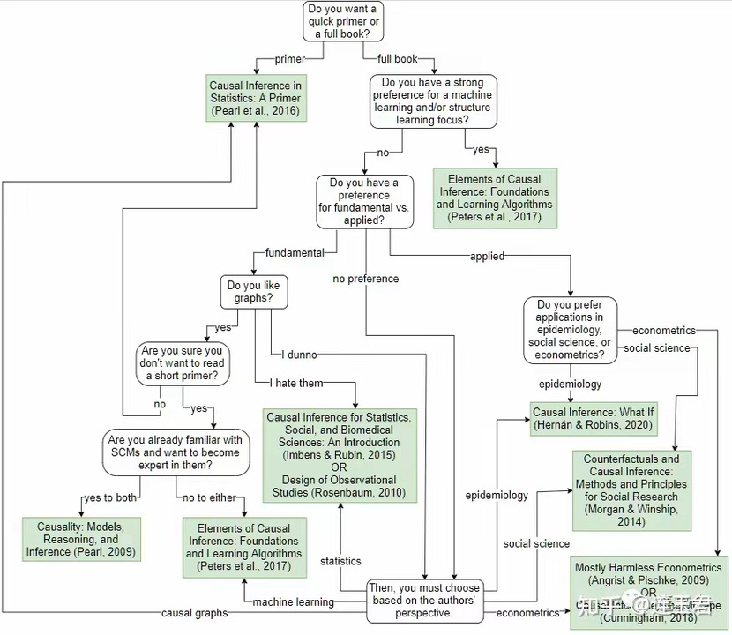

General guide for writing your final project paper
Deadline: December 19th 2PM EST

Write a final paper that summarizes your final project. No strict word/page counts etc., but make sure to clearly communicate the following items in your final paper. Following the writing styles you read during this class (e.g., the Paper Share assignment):

1. Title
- This is super important! Think of a concise but informative title that captures the essence of your project.
2. Introduction
- Background on the topic
- What is the general problem you are addressing in this project?
- Why is it important? What are its broader societal implications?
- Have other researchers worked on a related problem? If so, what have they done and found? How do these related works motivate your project?
3. Research questions and hypotheses
- What are the research questions you are addressing? What is the causal question you are testing in this study?
- For each research question, list hypotheses based on knowledge acquired from the related works listed in the Introduction.
4. Data
- List and describe the datasets you used for this project. Make sure to list sources.
- Descriptive statistics, spatial and temporal granularity if applicable.
- Possible limitations of the datasets.
5. Methods
- What methods are you using?
- Why did you use that method? How is it adequate for your research question and/or dataset?
6. Results
- Report estimation results, confidence intervals, etc.
- Validation: placebo tests, negative outcome tests, etc.
7. Discussion
- Interpret your results: did you obtain results that you hypothesized?
- What are the broader scientific and/or societal implications of this project?
- What are some limitations of the project? What would you do next as future work?
8. Conclusion
- Summarize the questions, approach, findings of the study in a paragraph.

