ARCIGA, Erica Aurelle P. 2ECE-D

BOBIS, Allen Joseph M.

**Machine Problem 1 Output (MATLAB)**

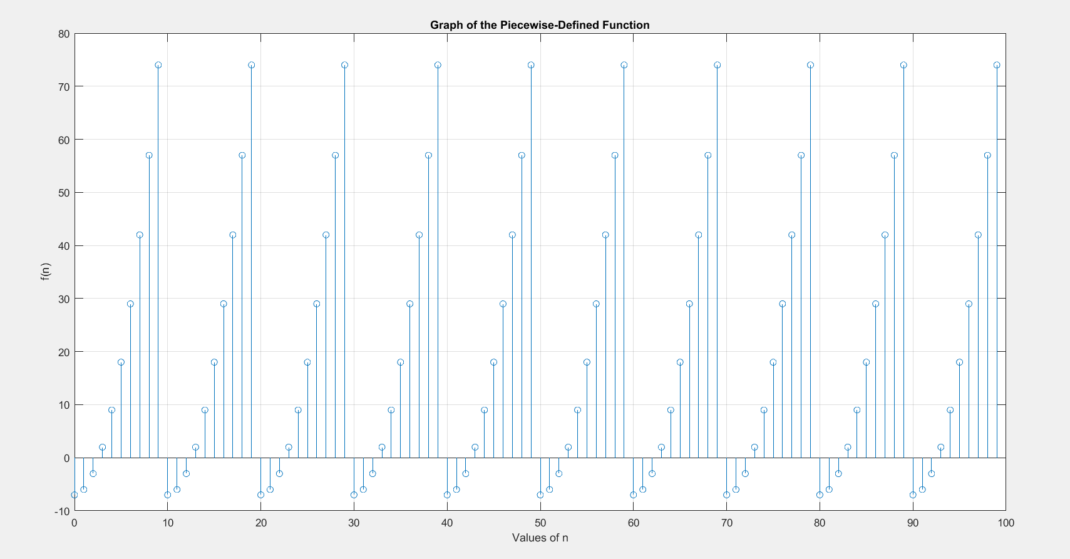

Comment/Observation: The graph of the piecewise function is repetitive.